environment.nsw.gov.au

Department of planning, Industry & ENVIRONMENT

Bird of Prey Rehabilitation Training Standards for the Volunteer Wildlife Rehabilitation Sector

Trainers’ guide

© 2021 State of NSW and Department of Planning, Industry and Environment

With the exception of photographs, the State of NSW and Department of Planning, Industry and Environment are pleased to allow this material to be reproduced in whole or in part for educational and non-commercial use, provided the meaning is unchanged and its source, publisher and authorship are acknowledged. Specific permission is required for the reproduction of photographs.

The Department of Planning, Industry and Environment (DPIE) has compiled this report in good faith, exercising all due care and attention. No representation is made about the accuracy, completeness or suitability of the information in this publication for any particular purpose. DPIE shall not be liable for any damage which may occur to any person or organisation taking action or not on the basis of this publication. Readers should seek appropriate advice when applying the information to their specific needs.

All content in this publication is owned by DPIE and is protected by Crown Copyright, unless credited otherwise. It is licensed under the [Creative Commons Attribution 4.0 International (CC BY 4.0)](http://creativecommons.org/licenses/by/4.0/deed.en), subject to the exemptions contained in the licence. The legal code for the licence is available at [Creative Commons](http://creativecommons.org/licenses/by/4.0/legalcode).

DPIE asserts the right to be attributed as author of the original material in the following manner: © State of New South Wales and Department of Planning, Industry and Environment 2021.

Cover photo: Barking Owl (*Ninox connivens*). Ken Stepnell /DPIE

Published by:

Environment, Energy and Science   
Department of Planning, Industry and Environment  
Locked Bag 5022, Parramatta NSW 2124  
Phone: +61 2 9995 5000 (switchboard)  
Phone: 1300 361 967 (Environment, Energy and Science enquiries)  
TTY users: phone 133 677, then ask for 1300 361 967  
Speak and listen users: phone 1300 555 727, then ask for 1300 361 967  
Email: [info@environment.nsw.gov.au](mailto:info@environment.nsw.gov.au)   
Website: [www.environment.nsw.gov.au](http://www.environment.nsw.gov.au)

Report pollution and environmental incidents  
Environment Line: 131 555 (NSW only) or [info@environment.nsw.gov.au](mailto:info@environment.nsw.gov.au)  
See also [www.environment.nsw.gov.au](http://www.environment.nsw.gov.au)

ISBN 978-1-922672-85-8  
EES 2021/0365  
September 2021

Find out more about your environment at:

www.environment.nsw.gov.au

Contents

Summary 1

Part 1: Introduction to training design, delivery and assessment 2

Training requirements of the Code 2

Designing training 3

Providing training 8

Assessment 13

Record keeping 14

Part 2: Understanding the bird of prey rehabilitation training standards 15

Introduction 15

Understanding the format of the training standards 15

Standard 1: The framework for bird of prey rehabilitation in New South Wales 16

Standard 2: Work health and safety requirements of bird of prey rehabilitation 21

Standard 3: Record keeping 23

Standard 4: Biology and behaviour of birds of prey 26

Standard 5: Stress management in birds of prey 30

Standard 6: Rescue of birds of prey 32

Standard 7: Transport of birds of prey 41

Standard 8: Assessment of birds of prey 42

Standard 9: Rehabilitation of birds of prey 48

Standard 10: Rehabilitation of bird of prey chicks 52

Standard 11: Release of birds of prey 57

Further reading 61

Appendix A: Training and assessment mapping tool 62

List of figures

Figure 1 The four different learning styles of the VARK model 5

Figure 2 Reducing hazards in the training environment 9

Figure 3 Using pictures and dot points to illustrate key messages on a PowerPoint slide 11

Figure 4 Bird of prey with suspected traumatic injury 45

Figure 5 Juvenile bird of prey 46

Figure 6 Injured adult bird of prey 46

Figure 7 Intermediate care enclosure 52

# Summary

This trainers’ guidehas been developed as a companion resource to the Department of Planning, Industry and Environment, NSW National Parks and Wildlife Service (NPWS) *Bird of Prey Rehabilitation Training Standards for the Volunteer Wildlife Rehabilitation Sector* (the bird of prey training standards). Training developers, trainers and assessors within the volunteer wildlife rehabilitation sector can use the guide to assist them with ensuring their bird of prey rehabilitation training complies with the training standards.

The standards ensure compliance with the NSW [Code of Practice for Injured, Sick and Orphaned Birds of Prey](https://www.environment.nsw.gov.au/research-and-publications/publications-search/code-of-practice-for-injured-sick-and-orphaned-birds-of-prey) (DPIE 2021) and a minimum level of care for birds of prey across the NSW wildlife rehabilitation sector.

The guide is divided into two parts:

* **Part 1: Introduction to training design, delivery and assessment** provides helpful hints for planning and delivering training and assessing competency. This section of the guide has been designed to provide an overview of training, introduce adult learning, and explain how to engage learners in productive and efficient ways.
* **Part 2: Understanding the bird of prey rehabilitation standards** suggests topics to include in training programs, and assessment types applicable to individual standards. There are two example assessments provided for each standard. These assessments can be used to determine competency related to individual standards.

The guide has been developed as a resource to support the sector in implementing the training standards.

# Part 1: Introduction to training design, delivery and assessment

## Training requirements of the Code

The first thing you will need to look at when designing or evaluating your training is the NSW [Code of Practice for Injured, Sick and Orphaned Birds of Prey](https://www.environment.nsw.gov.au/research-and-publications/publications-search/code-of-practice-for-injured-sick-and-orphaned-birds-of-prey) (the Bird of Prey Code).The following notes on **Section 11 – Training**, explains what is required:

Content to be included in training

Bird of prey rehabilitation courses must teach these things and ensure that training is competency-based.

This standard is saying that there must be formal induction training for new members.

Refresher training must be completed within three years from the time your last course was completed.   
Refresher training should include advanced topics and developments in rehabilitation practices and scientific research.

There **must** be an assessment completed in writing for anyone undertaking bird of prey rehabilitation training. The exception is for people who are working in temporary supervised facility-based roles.

Assessing someone as competent means the person has been assessed as capable to perform their duties (in this case rehabilitate birds of prey). This means that learners must meet the relevant learning outcomes listed in the training standards.

Coordinators, mentors or experienced bird of prey rehabilitators must be available to help new members.

The objectives explain the overall purpose of bird of prey rehabilitation training, which is to ensure the welfare of birds of prey that come into rehabilitation.

You must have experience rehabilitating native birds before progressing to rehabilitating birds of prey.



## Designing training

Whether you are designing a new course or updating an existing course, there are several questions to ask to determine what your new training should look like. The best way to answer these questions is to organise them into a learning plan before jumping into the training content. To help you get started with designing your course, this section discusses what you might consider and how you might answer the broad questions: what, who, how and when.

### What is the purpose of the course?

Are you designing a course that will combine all the training standards and look at bird of prey rehabilitation holistically, or will it cover individual or multiple standards aimed at certain topics, for example bird of prey rescue or chick rehabilitation?

The 12 training standards have been grouped into three core areas:

* **Foundations of bird of prey rehabilitation – Standards 1 to 5** are mostly theoretical or cover multiple aspects of bird of prey rehabilitation. These standards are foundational for bird of prey rehabilitation training.
* Rescue of birds of prey – Standards 6 to 8 address bird of prey rescue.
* **Rehabilitation of birds of prey – Standards 9 to 11** cover the rehabilitation and release of birds of prey, including chicks.

While you do not have to design your training according to these areas, you may want to consider if they fit with the purpose of your training.

Perhaps you are updating training that already exists. If so, consider whether all areas of the training standards are covered. Do you have assessments in place to determine competency and achieve the learning outcomes? If not, identify the gaps in your current program to work out what to include to ensure your updated version will meet the standards. Appendix A is a mapping tool to assist you with this exercise.

By understanding the reasons behind your training, you can also be clear on the pathways learners can take throughout the learning process. These pathways can then be clearly communicated to the learners, so they understand their responsibilities and you can manage their expectations. Questions to ask include:

* will there be prerequisites and what are they?
* what will the learner be able to do upon completion of this training?
* what, if any, further training will be required?

Once you understand the purpose of the training you can start to incorporate other elements of training design into your plan.

### Who is the training designed for?

Understanding the ‘who’ is very important to developing successful training.

The audience for a program aimed at bird of prey rehabilitation can be diverse and include people across genders, age groups, ethnicities and education levels. Consider what you can put in place to account for this diversity and help learners who may have special learning requirements. One way to do this is to understand what skills are required for the role the learner is undertaking training for, and ensure the content and assessments are compatible with this skill level, i.e. don’t make training harder than it needs to be.

Some other ways to help learners include:

* Include some questions or an interview as part of the enrolment process, so you can determine whether a learner will require additional or alternative help throughout the training.
* Use simple and succinct language; for written materials use short, concise sentences.
* Use visuals such as pictures, diagrams and graphs.
* Factor in time for asking questions and evaluating information.
* Where appropriate, make reasonable adjustments to the assessment. For example, if a learner struggles with reading you could change a written test to a verbal one to determine competency.

#### Adult learning

One thing we do know about our learners is that they are all adults.

There are several theories surrounding adult learning with one of the most well-known being andragogy, which was popularised by [Malcolm Knowles](http://infed.org/mobi/malcolm-knowles-informal-adult-education-self-direction-and-andragogy/) in the 1970s. Andragogy refers to adult learning, in contrast to pedagogy, which is child learning. What the theory of andragogy tells us is that adults:

* are self-directed learners
* need to know why they are learning something
* have a problem-centred approach to learning
* bring life and work experiences, skills and biases to learning
* are more willing to learn when they think it will provide skills to develop their life situations, i.e. it is relevant to them.

Adults learn best by being involved in their learning process, feeling respected, and through a hands-on approach to learning. The trainer is a facilitator of learning rather than a director, providing guidance while allowing the learner greater ownership of the learning experience.

Understanding these concepts is important for developing effective and engaging adult learning programs.

#### Learning styles

Another important thing to know about your learners is their learning style. While it may not be possible to always know and account for every participant’s learning style, understanding the styles and incorporating them into your training will allow you to be a more effective trainer.

The VARK model separates learning styles into four types (see Figure 1), although learners don’t have to be restricted to just one learning type.

For more information about the VARK model, including a quiz for you to find out your preferred learning styles, see [The VARK Modalities](http://vark-learn.com/introduction-to-vark/the-vark-modalities/).

Figure 1 The four different learning styles of the VARK model

### How will training be delivered?

Three of the most common delivery methods are face-to-face, online or one-on-one training. The different delivery methods suit different learning styles and there is no one method better than the others. When designing your program, you need to consider what resources are available and the methods that best suit your trainers’ and learners’ needs.

#### Face-to-face delivery

Face-to-face learning is the more traditional method for delivering training and includes presentations, lectures and demonstrations.

|  |  |
| --- | --- |
| Pros | Cons |
| * + - * Traditional, well-known to most learners       * Can be completed at a faster rate than other methods       * Additional learning can occur through interactions and exchanges between learners       * Easier to adapt based on learner needs       * Can be activity-based and increase learning by doing       * Can build personal relationships and networks that continue to facilitate learning outside the structured training       * Can be easier to ask questions and seek clarification from the trainer | * + - * Can remind adult learners of school classrooms and create disinterest       * Must be completed at a certain pace, which can leave some learners behind       * Not very flexible, courses must happen at certain times with specific agendas       * Can be expensive to attend and to run       * Certain learners can monopolise conversations and more timid learners may be unable to engage well with the content |

#### Online delivery

Online or eLearning is broadly defined as learning that takes place using a computer or electronic resource. eLearning has grown in popularity in recent years and has both advantages and disadvantages.

|  |  |
| --- | --- |
| Pros | Cons |
| * + - * Learning is self-paced, and can be completed in the comfort of your own home or other convenient location       * Flexible – can be accessed at any time and fit with learners’ schedules       * There is consistency in what is learnt as the content is the same for every learner       * Can be easy to pull statistics and provide feedback       * Can be more cost-effective than other types of delivery       * Can improve the learner’s electronic and technical skills | * + - * Little opportunity to engage with the trainer or other learners       * Can be too flexible – leading to a lack of motivation, commitment and ultimately lack of course completion       * Can require more of the student, e.g. more reading requirements or additional assessments       * Can be discouraging for people who are not confident with computers       * Lacks opportunities for hands-on learning       * Can be impacted by poor internet connection or technical issues       * Can require more instructions and detailed explanations than other methods where a trainer is present |

One option used by training providers is ‘blended delivery’ which combines online learning with face-to-face learning to obtain the advantages of both delivery methods.

#### One-on-one delivery

One-on-one delivery is also known as mentoring and usually occurs in the workplace. It involves a more experienced person sharing knowledge, skills and expertise with the learner.

|  |  |
| --- | --- |
| Pros | Cons |
| * + - * Sole focus is on the learner, allowing learning to be tailored to their strengths and weaknesses       * Usually practical in nature       * Feedback between mentor and learner can be instant       * Self-directed learning       * Can broaden the learner’s network quickly       * Can be flexible to allow for personal circumstances | * + - * Can be difficult to incorporate training into day-to-day tasks       * May not allow for diversity of opinions or the ability for learner to engage with other learners       * Providing feedback can be awkward and taken more personally       * Appropriate mentors can be difficult to find       * Can take longer to complete training because of both learner and mentor schedules |

#### Tips for delivery

When designing your learning plan it can be helpful to consider these tips:

* Effective communication is key to effective training.
* Write for your learner – don’t use jargon or big words without explaining them. Remember to consider your audience, e.g. is it a refresher course where learners will be familiar with the terminology or is it an introductory course where learners have no experience with rehabilitation and will need the terminology explained?
* Manage learner expectations by being clear at the beginning of the training what their responsibilities are and what they will be able to do upon completion of the course.
* Designing training to be accessible to all learning types will make the information more engaging and likely increase the success of the program.
* Think about your own experiences as a learner – what did you like? What didn’t you like?
* More information on delivery can be found in the training section of this document.

### What content will be included in the training?

Organising training content can be one of the most enjoyable aspects of designing your training plan. It is also crucial to ensuring you are creating relevant, engaging and accurate training.

When deciding what will go into your training the first thing you should do is consider existing materials. This can include:

* regulatory documents for the sector including the NSW Code of Practice for Injured, Sick and Orphaned Birds of Prey and the training standards
* relevant and useful organisational policies and procedures including standard operating procedures, constitutions, codes of ethics, work health and safety (WHS) policies, role descriptions and risk management plans
* legislative requirements including the [*Biodiversity Conservation Act 2016*](https://www.legislation.nsw.gov.au/#/view/act/2016/63)
* existing materials – manuals, fact sheets, PowerPoint presentations, handouts and research papers; consider whether these are still relevant or if they need updating, and who needs to be involved in this process
* previous feedback – have you received feedback about previous courses that you could incorporate into the update of training materials?

Using the training standards will be vital to ensuring your content is compliant and assesses competency at the required level. A way of confirming your content aligns with the standards is to use the standards as headings during your planning phase, putting existing content under these headings. From here you can see which areas require additional information.

When developing resources, you need to determine what the learners will need in order to complete their training and become competent, and whether any further materials could assist them in their role. For example, home-based rehabilitators might require more take-home reference material than facility-based rehabilitators who are supervised and have access to materials at their facility. The method of delivery will also affect the type of resources required. For example, online training will require more instructional and detailed information than face-to-face or one-on-one learning where a trainer is present to discuss content, answer questions and provide clarification.

### When will training occur?

This is largely up to you and your organisation’s needs. You should consider whether the training is ongoing, requiring regular attendance, and the frequency of the training. You need to consult with your trainers on their availability.

If the training requires prerequisites, is there enough time to complete the required training first?

## Providing training

As a trainer your role is to provide a productive, safe and supportive learning environment. As discussed in the previous section, with adult learning, trainers take on less of a director or teacher role and become more of a facilitator of learning. A facilitator is a trainer who encourages participation and takes a learner-centred approach.

The table below lists some common actions that trainers should and should not do.

|  |  |
| --- | --- |
| Do | Don’t |
| * + - * Know your subject matter       * Be organised       * Communicate clearly       * Apply active listening skills and use positive non-verbal communication, e.g. maintaining eye contact, using gestures, nodding, paraphrasing       * Encourage questions and ensure enough time has been set aside for discussion       * Take feedback on board and adjust accordingly | * + - * Be unprepared       * Use unnecessarily difficult words or jargon       * Use negative non-verbal communication, e.g. stare, roll your eyes, cross your arms, stand too close       * Be dismissive and discourage interaction       * Get defensive if feedback is provided |

In addition to these behaviours it is also important to think about the environment the training will occur in and how you can maximise its advantages and minimise its disadvantages. For example, if you are doing one-on-one training in a facility you will have access to birds of prey and be able to reinforce learning by having the learner complete tasks in a practical setting. Conversely, there may be emergencies that require attention, or frequent interruptions from other people.

In a venue designed for face-to-face training, you can encourage ideas and discussions between learners but you will not have access to real-life situations and may need to simulate these environments to keep the learners engaged in the topic.

### Ways to engage learners

Presentations are great for face-to-face training, however, an extended time without engaging the learners can create disinterest and learners may tune out altogether. Integrating more activities and engaging learners in other ways can incorporate different learning styles and enhance overall learning.

Some additional methods for encouraging learner participation include:

* demonstrations
* group activities
* case studies and scenarios
* group discussions
* brainstorming sessions
* blended delivery (combination of online, face-to-face and mentor training)
* videos, graphs, images and other visual aids.

The following advice is based predominantly on face-to-face training but could be adapted to fit other methods of delivery as required.

### Preparation

Being prepared is vital to creating an effective and engaging learning environment. Develop a checklist for yourself that includes all the resources you need on the day and who is responsible for them, e.g. electronics (laptops, projectors, USB drives), training materials (presentations, handouts, manuals, reference materials), keys to the venue, catering organised, pens, notepads, power cords, backup presentations, equipment for any activities. The list can be long and will be specific to your training but having a checklist can ensure the day starts off in a positive and organised manner.

Another aspect of being prepared is ensuring you are familiar with all the technology needed to get started. If you don’t have access to this before the course, ensure you arrive early enough to give yourself plenty of time to work it out.

### On the day

#### Setting up

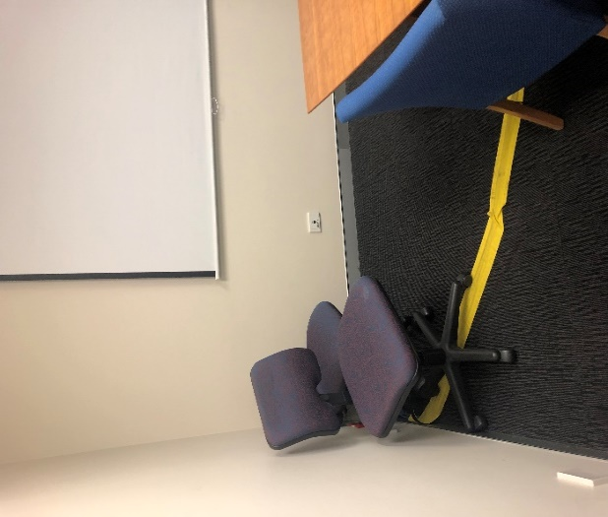It is important you arrive before the learners and with adequate time to prepare yourself and the venue. As the trainer, you are responsible for providing a safe learning environment. You should identify and minimise any risks as they arise and where this is not possible, bring them to the attention of your learners. For example, if there is an extension cord that could be a tripping hazard, tape it to the floor and ask learners to avoid the area (Figure 2). Chairs can be placed in a way that channels learners away from the hazard.

Other hazards to be mindful of include slippery or uneven surfaces, poor lighting, inadequate ventilation and excess or broken furniture in the room. Locate the emergency exits, notify learners of their location and keep access to them clear.

Arriving early also gives you an opportunity to set up the room. Consider how you want the tables to be arranged. See the table below for some examples.

Figure 2 Reducing hazards in the training environment

Photo: Hannah Ryan.

| Layout | Description | Suitability |
| --- | --- | --- |
|  | Typical classroom layout with tables set out in rows facing the trainer | Suited best to presentation or lecture-based training |
|  | Tables are set up in a u-shape or semi-circle shape | Suited best to training that has a lot of discussion and learner interaction |
|  | Tables are clustered into groups | Suited best to training that has a lot of group discussion and activities |

#### Agendas

Agendas are useful tools for organising a session. An agenda should include the day’s goal and a breakdown of what participants can expect. Be sure to allow enough time for questions and incorporate this into your agenda. No-one minds their training finishing early, but many learners become frustrated and distracted when the day diverges from the agenda.

#### Icebreakers

An icebreaker is a good way of starting any training program because it allows participants to relax, feel motivated and connect with other learners. The possibilities for icebreakers are endless. You can be specific to the topic and ask ‘What is your favourite species of bird of prey?’, ‘Why have you decided to come today?’ or ‘What are you hoping to get out of today?’. Alternatively, icebreakers don’t have to be about the course at all. Some other common icebreakers include ‘What is your favourite colour and why?’, ‘List two truths about yourself and one lie’ and ‘What would be your ideal holiday destination and why?’. There are many online resources with icebreaker suggestions. For example, to get started and work out which icebreakers work for you, see [The Best Ice Breakers for Meetings and Training Classes](https://www.thebalancecareers.com/best-ice-breakers-for-meetings-and-training-classes-1918430).

#### Presenting

Presenting training requires skill, enthusiasm and continual practice. Your presentation will be vital to the learner feeling engaged and energised by the content. To deliver an engaging presentation.

* If you are using PowerPoint, don’t just read from your presentation, use it as a guide only. You can use the ‘Notes’ feature to remind you of your points without overloading your slide. Don’t put too much text on your slides. Use brief dot points and pictures to make slides more interesting. (See Figure 3: which one do you find easier to read?)
* Summarise and question learners on key points.
* Ensure the technology is working – double check embedded videos before starting the presentation.
* Look for visual cues from the audience – are learners reciprocating eye contact, are they interested in the content or are they looking bored or distracted? Adapt your approach accordingly.
* Go at an appropriate pace. If you feel nervous, breathe and slow down.
* Ensure all learners can hear you. Project your voice and adjust your tone.
* Be honest – if you don’t know the answer to someone’s question tell them, don’t try to fumble your way through. If you offer to find something out for them, make sure you do.
* Be positive. Smile and make eye contact.
* 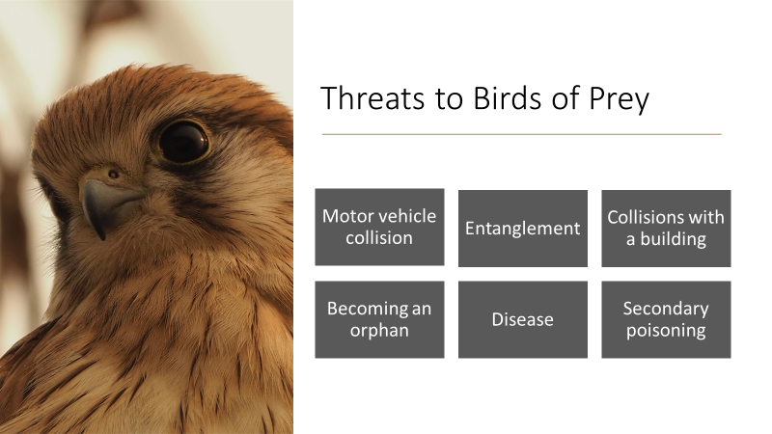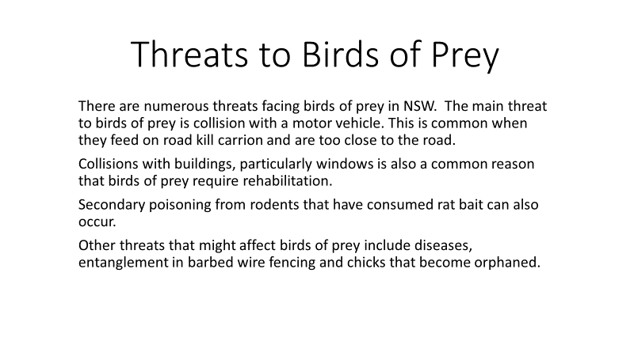 Be passionate. Share your experiences and anecdotes to reinforce learning.

Figure 3 Using pictures and dot points to illustrate key messages on a PowerPoint slide

#### Dealing with difficult behaviour from learners

There are many different types of difficult behaviours that can crop up during training, and they can range from a one-off incident to disrupting the whole day. Some of the common difficult behaviours encountered during training sessions include:

**Have you ever witnessed these behaviours during a training session?**

* Repeatedly disrupting the trainer to contradict points.
* Talking to other learners during a presentation.
* One individual monopolising the discussion and not giving other learners an opportunity to speak.
* Not paying attention to the training e.g. appearing bored, using their phone.
* Pushing an agenda and bringing up the same argument repeatedly.
* These behaviours can be addressed using different strategies and it can be useful to ascertain what’s causing the behaviour. For example, does the learner know the subject matter to a more advanced level, are they shy and afraid to speak to the entire group, or are they just passionate about a particular topic?
* Setting out the ground rules at the start of the day can assist with mitigating some of these behaviours. Ground rules can include everyone showing respect for others’ opinions, or clarifying whether questions are allowed during the presentation or only at the end of each section. What do you expect from the learners and what can they expect from you?

Other methods you can use to manage difficult behaviours include:

* Ask the learner to hold their opinion until the end of the section.
* Address the learner who is talking to other learners by asking them their opinion on the topic, e.g. ‘What do you think, Karen?’
* Thank the learner for their opinion and ask other learners for their thoughts, e.g. ‘Thank you for sharing your opinion, what does everyone else think about this?’
* If there is a point that cannot be agreed upon, or that keeps getting brought up, you could say ‘We have spent some time on this topic and have to move on. If we have time at the end of the day, we can discuss it further.’
* If the behaviour is repeated, direct the learner to stop, e.g. ‘You are interrupting a lot, so I am going to have to stop you there and give others a chance to speak.’
* If the behaviour continues pull the learner aside during a break and ask them why they continue to do it and request that they stop.
* If the behaviour continues and you feel it’s appropriate, ask the learner to leave the training session.

#### Getting feedback

Feedback is a valuable tool to evaluate your entire training program and your skills as a trainer. Don’t take feedback too personally, instead see it as an opportunity to learn, grow and improve your training.

There are numerous ways to obtain feedback; we will discuss a few of them here. One way to evaluate the overall effectiveness of your training and determine if your learners have obtained the relevant information is to quiz learners on the content, in accordance with the intended learning outcomes. Provide the quiz to the participants at the start of the day and then again at the end. This can be self-assessed by students, as a group or by the trainer alone. A consistent increase in scores indicates the training has been successful.

Feedback can also be based on informal or formal discussion throughout the day or at the end of the training. Ask learners what parts of the training they enjoyed and what could be done better. If using this method, be sure to ask specific questions and not just ones with yes or no answers. Find out why and how things can be improved.

* A common type of feedback is asking people to complete a written questionnaire. When written well, this can be very useful for evaluating training programs. It can also be a good resource to refer back to when updating a training program, to see what worked well and what could be done better. Some tips for writing questionnaire-style feedback forms include:
* Use a sliding scale (i.e. numbered 1–5: strongly agree – strongly disagree).
* Ask questions you want to know the answer to and that are relevant to the training.
* Don’t use language that is vague or unclear.
* Don’t rely on people writing their own answers or responses, many learners will leave this section blank.
* Keep it simple – don’t have too many questions or a busy format.

Some questions to consider adding to your feedback form include:

* Do you feel like you achieved the learning objectives of this training?
* Were the instructions clear and easy to follow?
* Are the course materials helpful to your learning?
* Was the facility appropriate for the training?
* Did the trainer demonstrate knowledge of the subject matter?
* Did the trainer communicate clearly?
* What did you like most about the training?
* What could be improved on?
* Would you recommend this course to a friend?
* Please provide any additional feedback in the space below.

Be sure to make use of your feedback. Unused feedback benefits no-one.

## Assessment

What is competency-based assessment?

Competency-based assessment assesses a learner based on whether they can perform a task or have acquired the knowledge required for their workplace, i.e. do learners have the knowledge and skills required for their role in bird of prey rehabilitation. There is no grade in competency-based assessment, rather the learner is assessed as either competent or not yet competent.

In accordance with the Bird of Prey Code, all bird of prey rehabilitation training requires an assessment of competency and at least one written assessment component.

Assessment is required to collect evidence that shows a learner is competent in an area and can perform the relevant tasks required of their role. For example, if you were running a training course on bird of prey rescue, without assessing the learner you have no way of knowing if they can apply the knowledge to bird of prey rescue, or use the skills they have learnt to safely rescue a bird of prey according to the learning outcomes in the standards.

[Standards for Registered Training Organisations (RTOs) 2015](https://www.legislation.gov.au/Details/F2019C00503) has principles of assessment and rules of evidence that are required of the vocational education and training (VET) sector. While your training may not be a VET-accredited course, these two tools are useful for ensuring your assessment methods are effective and ethical. These are summarised below.

### Principles of assessment

There are 4 principles of assessment:

**Fairness** – Individual needs of the learners are taken into account and an assessment method must not discriminate against specific learners or groups.

**Flexibility** – Assessments are flexible to accommodate individual learners through reflecting their needs, applying reasonable adjustments where appropriate and using multiple assessment methods.

**Validity** – Assessment is based on and assesses to the required benchmark, i.e. assessments meet the requirements in the standards. Assessment must also be based on evidence that demonstrates the learner can apply the skills and knowledge required of their role.

**Reliability** – Evidence is interpreted consistently and accurately regardless of who the trainer or assessor is.

### Rules of evidence

When assessing the competency of a learner you must consider the following four rules of evidence:

**Validity** – You are confident the learner has the skills and knowledge outlined in the standards.

**Sufficiency** – There is enough quality evidence to assess competency.

**Authenticity** – You are confident the work submitted is that of the learner and no-one else.

**Currency** – The assessment evidence has been compiled within a suitable time frame and reflects the learner’s current level of skill and knowledge. This could be applied to the refresher time frame where further training is required to be completed every 3 years.

### Types of assessment methods

* **Questioning** – written or oral, e.g. conducting interviews, multiple choice quizzes, written short-answer questions
* **Direct observation** – observing performance during simulated or real-world tasks
* **Product-based methods** – structured activities, e.g. presentations, role plays, reports and work-based projects
* **Third-party evidence** – involves having a supervisor, manager or equivalent attest to the competency of your learner or providing a supporting statement or letter
* **Portfolio** – a collection of evidence compiled by the learner to demonstrate competency, e.g. a logbook, photographs or videos.

Use a variety of methods to ensure the assessment is valid and allows the learner to demonstrate competency in different ways. This also makes the assessment process more interesting and engaging for the learner.

Some methods such as questioning and product-based methods are more suited to assessing competency of knowledge, whereas other methods such as direct observation and third-party evidence can be used to assess competency in skill or practical application.

## Record keeping

Record keeping is an important aspect of training. Having accurate records that are easily available to authorised people will go a long way to ensuring you have a smooth process in place for knowing who is trained in your organisation. As a minimum you should keep a signed attendance register and a record of whether competency was achieved by the learner for each training session. In addition to this you should keep records of each assessment event and whether competency was achieved.

Having these records will assist your organisation in knowing who is trained, who is due for refresher training, and when training was last held. It is also useful information to maintain in the event your organisation is audited and needs to demonstrate compliance with the codes of practice and training standards.

Also consider what record you might provide to the learner so they can demonstrate competency and completion of a particular training session. A certificate of competency is a useful record for the learner as they can keep it in their personal files and provide it as evidence of training completed if needed.

# Part 2: Understanding the bird of prey rehabilitation training standards

## Introduction

This section looks at the bird of prey rehabilitation training standards in more detail.

This includes possible topics that could be included in training courses (listed under the heading ‘Training areas’for each standard). Not all these topics will need to be covered, as your training may be specific to a particular type of role and certain areas may not be applicable. The suggested training areas are intended to guide you in thinking about what may be considered in the context of each standard.

There are also recommendations for the types of assessments. Each standard is accompanied by 2 examples of assessments that could be used to assess competency. The assessments are examples only and do not have to be used. You may want to use them as ideas to create your own assessments. If you do use these assessments though, you must have covered the topics in your content to ensure your assessment process is fair and accurate.

## Understanding the format of the training standards

**Standard 1: The framework for bird of prey rehabilitation in NSW**

Each standard has a heading that describes the overall topic of the standard.

The objective of a standard explains what the standards are trying to achieve, i.e. its aim.

These points explain what must be included within training for it to be compliant with the training standards. The organisation or trainer is responsible for ensuring this information is included in training.

Learning outcomes describe what a learner will be able to do upon completion of a standard. A learner is deemed competent when they can demonstrate the learning outcomes.

**Objective:** To familiarise learners with the relevant policies and procedures of bird of prey rehabilitation and provide them with an understanding of the framework that exists to support and regulate bird of prey rehabilitation in New South Wales. Learners must be aware of and understand the NSW Code of Practice for Injured, Sick and Orphaned Bird of Prey (the Bird of Prey Code).

To be compliant with this standard, a rehabilitation organisation must:

Discuss the Bird of Prey Code.

Ensure organisational policies and procedures applicable to bird of prey rehabilitation are defined and understood by learners.

|  |  |
| --- | --- |
| Learning outcomes | Sections in the Code |
| Upon completion of this module, learners will be able to:   * identify and demonstrate understanding of the Bird of Prey Code * identify organisational policies and procedures for bird of prey rehabilitation * recognise the objectives of bird of prey rehabilitation. | All |

## Standard 1: The framework for bird of prey rehabilitation in New South Wales

**Objective:** To familiarise learners with the relevant policies and procedures of bird of prey rehabilitation and provide them with an understanding of the framework that exists to support and regulate bird of prey rehabilitation in New South Wales.

Learners must be aware of and understand the NSW Code of Practice for Injured, Sick and Orphaned Birds of Prey.

To comply with this standard, a rehabilitation organisation must:

1.1 Discuss the Bird of Prey Code.

1.2 Ensure organisational policies and procedures applicable to bird of prey rehabilitation are defined and understood by learners.

|  |  |
| --- | --- |
| Learning outcomes | Sections in the code |
| Upon completion of this module, learners will be able to:   * + - * identify and demonstrate understanding of the Bird of Prey Code       * identify organisational policies and procedures for bird of prey rehabilitation       * recognise the objectives of bird of prey rehabilitation. | All |

### Training areas

* The Bird of Prey Code can be accessed online: [Code of Practice for Injured, Sick and Orphaned Birds of Prey](https://www.environment.nsw.gov.au/research-and-publications/publications-search/code-of-practice-for-injured-sick-and-orphaned-birds-of-prey).
* Organisational policies and procedures relevant to bird of prey rehabilitation could include:
  + standard operating procedures
  + organisational overview
  + work health and safety policies
  + role descriptions
  + constitution
  + code of ethics
  + code of conduct
  + conflict resolution
  + bullying and harassment
  + reimbursement
  + working with vets and building strong relationships
  + reporting requirements and reporting chain of command
  + protocols for contacting veterinarians and experienced wildlife rehabilitators.

### Suggested assessments

The information covered in this standard is largely theory and so is best suited to written or verbal assessment.

#### Standard 1: Assessment 1 – the Bird of Prey Code quiz

##### Trainer/Assessor instructions:

This is an example of the type of assessment tool that could be used to assess competency in relation to Standard 1.

##### Learner instructions:

Use the Bird of Prey Code to complete the following multiple choice quiz.

1. The development of the Bird of Prey Code was guided by four key principles. From the list below, select the 4 key principles which apply to all aspects of bird of prey rescue, rehabilitation and release.
2. Prioritise the welfare of birds of prey
3. Contribute to research on bird of prey behaviour
4. Avoid harm to wild bird of prey populations and other wildlife communities
5. Minimise the risks to human health and safety
6. Optimise capacity to care

Answer: A, C, D and E.

1. Which of the following describes the mandatory specific actions for bird of prey rehabilitation, as described by the Code?
2. Guidelines
3. Standards
4. Objectives
5. Notes

Answer: B. standards.

1. Birds of prey must be assessed by a veterinarian or veterinary nurse within 24 hours of rescue.
2. True
3. False

Answer: B. False. Birds of prey must be assessed by a veterinarian or experienced bird of prey rehabilitator within 24 hours of rescue.

1. Which of the following must not be used to capture a bird of prey? Select the correct answers from the list below.
2. A hoop net
3. A rope with a noose
4. Towel or blanket
5. Darting

Answer: B and D.

1. Birds of prey must be transferred to an appropriately licensed rehabilitation group and into the care of a bird of prey rehabilitator within 24 hours.
2. True
3. False

Answer: A. True.

1. When transporting a bird of prey, what must you do? Select the correct answers from the list below.
2. Use newspaper to line the transport container
3. Regularly monitor the temperature
4. Provide a perch for the bird to stand on
5. Cover the transport container with a towel or sheet.

Answer: A, B and D. Perches must not be provided during transport, but a rolled-up towel can be used as a substitute.

1. In which of the following scenarios would euthanasia be considered mandatory?
2. A bird of prey chick found abandoned and cold
3. A bird of prey with an injured wing
4. A bird of prey with a confirmed diagnosis of avian tuberculosis
5. A bird of prey with feather abnormalities

Answer: C. a bird of prey with a confirmed diagnosis of avian tuberculosis.

1. Stunning followed by cervical dislocation is an appropriate method of euthanasia for a nankeen kestrel weighing 170 grams.
2. True
3. False

Answer: A. True.

1. If an unusual disease or mortality event is suspected, the wildlife rehabilitator must contact the DPI Emergency Animal Disease Hotline.
2. True
3. False

Answer: A. True.

1. How frequently must a bird of prey in intensive care be monitored?
2. Every hour
3. Once a day
4. As many times as necessary
5. During feeding and treatment procedures

Answer: D. during feeding and treatment procedures.

1. Within 24 hours of admission, birds of prey must undergo a veterinary assessment or examination by an experienced bird of prey rehabilitator.
2. True
3. False

Answer: True.

1. Which of the following statements regarding quarantine and controlling disease transmission between animals is false?
2. When handling animals, start with the sickest animal and finish with the healthiest
3. Newly arrived birds of prey must be isolated in a separate area
4. Animals suspected to be carrying an infectious disease must be kept under strict quarantine
5. Transport containers and enclosures must be thoroughly cleaned and disinfected between occupants

Answer. A: When handling animals, start with the sickest animal and finish with the healthiest. When handling animals, start with the healthiest and finish with the sickest to reduce the risks of disease transmission.

1. Which of the following statements regarding the provision of food for birds of prey in care is correct?
2. Feral pigeons and parrot species should not be fed to birds of prey in care
3. Avian protein must form the majority of the diet for peregrine falcons
4. Ospreys require fish as the bulk of their diet
5. All of the above

Answer. D: All of the above.

1. Bird of prey chicks are extremely prone to imprinting.
2. True
3. False

Answer: A. True.

1. Once out of intensive care housing, birds of prey require which of the following elements:
2. Wooden perches
3. Clean drinking water
4. Sufficient space to move around freely
5. Substrate must include small pebbles or washed river sand
6. All of the above

Answer: E. all of the above.

1. Which of the following means a bird of prey is behaviourally ready for release? Select the correct answers from the list below.
2. It can recognise wild food
3. Its plumage is adequate for survival
4. It is able to maintain flight for a prolonged period of time
5. It has recovered from injury

Answer: A, B and D.

1. Where possible, a bird of prey’s release should be assessed by a veterinarian.
2. True
3. False

Answer: A. True. This is a guideline in the Bird of Prey Code.

1. Which of the following is not a minimum mandatory requirement for reporting?
2. Encounter location
3. Species name
4. Fate
5. Type of release

Answer: D. type of release. While this is good information to record it is not part of the minimum mandatory reporting requirements.

#### Standard 1: Assessment 2 – Organisational policies on bird of prey rehabilitation, questionnaire

##### Trainer/Assessor instructions:

This is an example of the type of assessment that could be used to assess competency in relation to Standard 1. This assessment can be provided as a written or verbal activity. The answers provided for each question are examples only; answers provided by learners must be specific to their organisation.

##### Learner instructions:

Provide answers to each of the questions below.

1. List 3 policies or documents you need to be familiar with to rehabilitate birds of prey.

Answers could include:

* + standard operating procedures
  + code of practice, ethics or conduct
  + constitution
  + petrol reimbursement policy
  + release policies
  + WHS procedures and policy

1. Who do you need to report a bird of prey rescue to?

Answers could include:

* + supervisor
  + bird of prey species coordinator
  + care coordinator.

1. What are your organisation’s protocols for seeking veterinary assistance?

Answers could include:

* + calling first to make an appointment
  + any expensive procedures or medications must be approved by the coordinator
  + required for any rescued bird of prey within 24 hours of rescue.

1. List 2 positions within the organisation and explain their role in bird of prey rehabilitation.

Answers could include:

* + bird of prey coordinator – oversees rescues and animals brought into care, provides advice on release of birds of prey
  + mentor – assists new volunteers with rehabilitation, providing ongoing advice and support
  + rescue coordinator – coordinates roster and rescues from the hotline
  + training officer – updates bird of prey training and informs members of when training is available.

1. What are some of the WHS protocols relevant to bird of prey rehabilitation?

Answers could include:

* + use of appropriate personal protective equipment (PPE)
  + quarantine protocols
  + incident reporting.

## Standard 2: Work health and safety requirements of bird of prey rehabilitation

**Objective:** To ensure that learners are able to prioritise their safety and that of the people around them when undertaking bird of prey rescue and rehabilitation.

To comply with this standard, a rehabilitation organisation must:

2.1 Explain the Work health and safety (WHS) risks associated with the site, equipment or activity and how they can be minimised.

2.2 Explain the WHS risks associated with handling and restraining birds of prey and how they can be minimised.

2.3 Discuss the WHS risks associated with zoonotic diseases relevant to birds of prey and how they can be minimised.

2.4 Discuss rehabilitator wellbeing and the potential mental health impacts of wildlife rehabilitation.

|  |  |
| --- | --- |
| Learning outcomes | Section in the Code |
| Upon completion of this module, learners will be able to:   * + - * identify WHS risks associated with bird of prey rehabilitation       * employ techniques to minimise the WHS risks to themselves and other people. | 3. Rescue  5. Euthanasia  6. Care procedures  7. Husbandry |

### **Training areas**

* WHS risks associated with the site, equipment or activity could include:
  + traffic
  + uneven surfaces
  + falling branches
  + weather and extremes of temperature
  + broken equipment
  + working in low light conditions and working with heights
  + chemicals and other hazardous agents.
* WHS risks associated with handling and restraining birds of prey could include:
  + physical injury from a bird of prey including bites, scratches and puncture wounds
  + injury from heavy lifting.
* WHS risks associated with zoonotic diseases could include:
  + zoonoses associated with birds of prey (e.g. mycobacteriosis, salmonellosis)
  + personnel safety (hygiene and disinfection practices, PPE).
* Minimising WHS risks could include:
  + ensuring correct training has been completed before undertaking a task
  + wearing correct PPE
  + using correct equipment
  + using the correct technique to restrain a bird of prey
  + minimising handling.

### Suggested assessments

For this standard, assessment is best suited to written or verbal methods, practical assessment, or a combination of these.

#### Standard 2: Assessment 1 – WHS requirements of bird of prey rehabilitation

##### Trainer/Assessor instructions:

This is an example of the type of assessment that could be used to assess competency in relation to Standard 2.

##### Learner instructions:

For each of the three activities listed below, explain the WHS risks associated with them and three things you could do to minimise these risks.

1. Rescuing a wedge-tailed eagle found next to a moderately busy road. The wedge-tailed eagle will need to be transported to a veterinarian to assess its injuries.

|  |  |
| --- | --- |
| WHS risks | How will you minimise these risks? |
|  |  |
|  |  |
|  |  |

1. Rescuing a recently fledged powerful owl. The powerful owl is on a branch approximately two metres off the ground and seems to have a drooping right wing.

|  |  |
| --- | --- |
| WHS risks | How will you minimise these risks? |
|  |  |
|  |  |
|  |  |

1. Rehabilitating a recently rescued peregrine falcon with nasal discharge and respiratory distress.

|  |  |
| --- | --- |
| WHS risks | How will you minimise these risks? |
|  |  |
|  |  |
|  |  |

#### Standard 2: Assessment 2 – Rehabilitator wellbeing

##### Trainer/Assessor instructions:

This is an example of the type of assessment that could be used to assess competency in relation to Standard 2. Split the learners into smaller groups with fewer than 10 learners to a group, and ask them to discuss and answer the questions below. When the groups have completed their discussions, come together and discuss what each group came up with.

##### Learner instructions:

In your group discuss and answer the questions below. Once this has been completed, choose a representative to speak on behalf of your group to share your ideas.

1. What is wellbeing?
2. What are some of the potential impacts on wellbeing for rehabilitators?
3. What are the signs of these impacts?
4. How can you minimise these impacts?
5. Who should you talk to in these situations?
6. What processes does your organisation have in place to support rehabilitator wellbeing?

## Standard 3: Record keeping

**Objective:** To explain the record keeping requirements for bird of prey rehabilitation.

To comply with this standard, rehabilitation organisations must:

3.1 Explain the NPWS reporting requirements.

3.2 Explain organisational reporting requirements.

|  |  |
| --- | --- |
| Learning outcomes | Sections in the code |
| Upon completion of this module, learners will be able to:   * + - * keep records in accordance with NPWS and organisational requirements. | 12. Record keeping |

### Training areas

* The code can be accessed online: [Code of Practice for Injured Sick and Orphaned Birds of Prey](https://www.environment.nsw.gov.au/research-and-publications/publications-search/code-of-practice-for-injured-sick-and-orphaned-birds-of-prey).
* NPWS [reporting requirements](https://www.environment.nsw.gov.au/research-and-publications/publications-search/volunteer-wildlife-rehabilitation-sector-data-reporting-instructions) could include:
  + detailed record report
  + combined report
  + licence conditions
  + discussing the benefits of collecting robust data
  + an overview of where the data is being used and why it is important
  + [annual reports](https://www.environment.nsw.gov.au/research-and-publications/publications-search/nsw-wildlife-rehabilitation-annual-report-2018-19) and the [NSW Wildlife Rehabilitation Dashboard](https://www.environment.nsw.gov.au/topics/animals-and-plants/native-animals/rehabilitating-native-animals/wildlife-rehabilitation-reporting/wildlife-rehabilitation-data).
* Organisational reporting requirements could include:
  + husbandry plans
  + body weight
  + veterinary-prescribed medications and treatment plans
  + feeding charts
  + rescue details
  + release details.

### Suggested assessments

The information covered in this standard is largely theory and so is best suited to written or verbal assessment.

#### Standard 3: Assessment 1 – Record sheet

##### Trainer/Assessor instructions:

This is an example of the type of assessment that could be used to assess competency in relation to Standard 3.

##### Learner instructions:

Read the case study and complete the corresponding NPWS report sheet.

A juvenile white-bellied sea-eagle (ID number: WBSE123456) was found on Monday 01/03/2021 on the main highway at 2 Seaview Road, Coastville, 4542. The bird had been found alone on the ground with a drooping right wing and broken tail feathers. She was hypothermic and dehydrated when found. After veterinary assessment and treatment, you have rehabilitated the white-bellied sea-eagle and released her 25 days later. Her release site was in more suitable habitat at 12 Beach Way, Coastville, 4542. Before release, the sea-eagle was microchipped with the number 0098787 and banded with a leg band with a unique identifier WBS123.

NPWS report sheet:

|  |  |
| --- | --- |
| Species name |  |
| ID number |  |
| Date of encounter |  |
| Encounter type |  |
| Location address |  |
| Location suburb/town |  |
| Location postcode |  |
| Animal condition |  |
| Sex |  |
| Life stage |  |
| Initial weight |  |
| Rehabilitator name |  |
| Fate |  |
| Date of fate |  |
| Release location address |  |
| Release location suburb |  |
| Release location postcode |  |
| Tag/band colour and number |  |
| Microchip number |  |

#### Standard 3: Assessment 2 – Record keeping in your organisation

##### Trainer/Assessor instructions:

This is an example of the type of assessment that could be used to assess competency in relation to Standard 3.

##### Learner instructions:

Answer the following questions regarding your organisation’s record keeping requirements.

1. List 5 types of information your organisation records for birds of prey in care:

|  |
| --- |
|  |
|  |
|  |
|  |
|  |

1. Design a record sheet that could be used to comply with your organisation’s record keeping procedures. Your record sheet could include weights, observations and treatment schedules.

## Standard 4: Biology and behaviour of birds of prey

**Objective:** To ensure detailed knowledge of birds of prey is taught to learners. This is done by providing learners with the foundational tools to understand bird of prey biology and behaviour and how these aspects inform interactions with birds of prey undergoing rehabilitation.

To comply with this standard, a rehabilitation organisation must:

4.1 Explain features of bird of prey biology including anatomy, physiology, flight mechanics, social structure, stages of development and relate them to bird of prey rehabilitation.

4.2 Provide a basic understanding of bird of prey ecology including population dynamics, habitat selection, competition and predator–prey interactions.

4.3 Provide the tools and understanding required to identify different species of birds of prey recorded in New South Wales.

4.4 Provide the tools and understanding required to identify normal behaviour in birds of prey.

4.5 Provide the tools and understanding required to recognise signs of abnormal behaviour in birds of prey.

|  |  |
| --- | --- |
| Learning outcomes | Sections in the code |
| Upon completion of this module, learners will be able to:   * + - * relate bird of prey biology, ecology and behaviour to bird of prey rehabilitation       * identify various species of birds of prey found in New South Wales       * recognise signs of normal behaviour in birds of prey       * recognise signs of abnormal behaviour in birds of prey. | All |

### **Training** areas

* Features of bird of prey biology could include:
  + gastrointestinal anatomy and physiology in relation to diet
  + respiratory anatomy and physiology
  + musculoskeletal anatomy and physiology
  + variation in anatomy between species
  + feather development and moulting
  + reproduction
  + social behaviour and home range.
* Basic understanding of bird of prey ecology could include:
  + habitat and species preferences
  + breeding and life cycle
  + diet and competition.
* Tools and understanding required to identify species could include:
  + bird of prey identification guides
  + distinguishing features of different species
  + identifying species in early development (i.e. nestlings)
  + species that are known to occur in the local area.
* Normal behaviours for birds of prey could include:
  + social and solitary species
  + nocturnal and diurnal activity
  + breeding behaviour (e.g. monogamous)
  + thermoregulatory behaviours
  + preening
  + preservation reflex.
* Abnormal behaviours for birds of prey could include:
  + not fleeing when approached
  + being on the ground for prolonged periods
  + fluffed up, inactive.

### Suggested assessments

The information covered in this standard is largely theory and so is best suited to written or verbal assessment.

#### Standard 4: Assessment 1 – Bird of prey behaviour in rehabilitation

##### Trainer/Assessor instructions:

This is an example of the type of assessment that could be used to assess competency in relation to Standard 4.

##### Learner instructions:

Explain why it is important for bird of prey rehabilitators to understand bird of prey behaviour. In your answer provide at least one example of normal behaviour and one example of abnormal behaviour.

|  |
| --- |
|  |
|  |
|  |
|  |
|  |
|  |
|  |
|  |

#### Standard 4: Assessment 2 – Bird of prey biology and behaviour quiz

##### Trainer/Assessor instructions:

This is an example of the type of assessment tool that could be used to assess competency in relation to Standard 4.

##### Learner instructions:

Complete the following quiz by selecting the correct choice for multiple choice questions and providing a written response for the short-answer questions.

1. Birds of prey regurgitate pellets, which generally contain less digestible portions of their prey.
2. True
3. False

Answer: True.

1. Most diurnal birds of prey are monogamous.
2. True
3. False

Answer: True.

1. Which of the following statements regarding feather condition in birds of prey is incorrect?
2. Birds of prey undergo a catastrophic moult to replace all their feathers
3. Birds of prey moult feathers in a sequential pattern
4. Damaged feathers are naturally replaced during moult
5. The uropygial or preen gland produces a waxy secretion which is spread through the bird’s plumage as it preens

Answer: A. Birds of prey undergo a catastrophic moult to replace all their feathers.

1. Which of the following is true about the musculoskeletal system in birds of prey. Select the correct answers from the list below.
2. Some of the bones in the skeletal system are pneumatic
3. The pectoral muscles are the major flight muscles in birds
4. Birds of prey have a specialised tendon locking mechanism which allows them to grip and perch
5. All of the above

Answer: D. All of the above.

1. All birds of prey build nests.
2. True
3. False

Answer: False. Falcons and owls do not build true nests.

1. Which of the following statements about respiratory anatomy in birds of prey is incorrect?
2. Birds of prey have external nares
3. Birds have a diaphragm which functions to move air into and out of the lungs
4. The external nares communicate with the choana within the mouth
5. Birds use a system of air sacs to move air into and out of the lungs

Answer: B. Birds do not have a diaphragm and use their intercostal muscles (rib muscles) to expand their chest during respiration.

1. For a bird of prey species of your choice, list three signs you may observe if the animal is healthy:

|  |
| --- |
|  |
|  |
|  |

1. For a bird of prey species of your choice, list three signs you may observe if the animal was distressed:

|  |
| --- |
|  |
|  |
|  |

1. Detail the three components of mutes in birds of prey and why it is important to monitor mutes when rehabilitating birds of prey.

|  |
| --- |
|  |
|  |
|  |
|  |
|  |
|  |
|  |
|  |
|  |
|  |

## Standard 5: Stress management in birds of prey

**Objective:** To communicate the importance of managing stress in birds of prey and to provide mechanisms for minimising this stress.

To comply with this standard, rehabilitation organisations must:

5.1 Explain the effects of stress on birds of prey at various stages of rescue and rehabilitation and any differences between species.

5.2 Provide the tools and understanding required to recognise signs of stress in a bird of prey.

5.3 Discuss methods for minimising stress in birds of prey at various stages of rescue and rehabilitation.

|  |  |
| --- | --- |
| Learning outcomes | Sections in the code |
| Upon completion of this module, learners will be able to:   * + - * recognise signs of stress in birds of prey and its impact       * apply methods for minimising stress in birds of prey. | 3. Rescue  4. Transport  5. Euthanasia  6. Care procedures  7. Husbandry  8. Housing  10. Release considerations |

### **Training areas**

* Effects of stress could include:
  + death
  + poor body condition
  + decreased immune function and concurrent disease (e.g. aspergillosis)
  + physiological impacts.
* Signs of distress could include:
  + vocalisations
  + open-mouth breathing
  + inappetence, weight loss
  + increased heart and respiratory rate.
* Methods for minimising stress could include:
  + minimising handling
  + correct handling techniques
  + covering the animal’s head during handling
  + providing a warm, dark and quiet environment
  + pain relief
  + sedation
  + limiting exposure to stressors such as domestic animals, loud noises, noxious smells
  + getting appropriate and prompt help for the bird of prey
  + covering the cage or box while maintaining good ventilation
  + controlling temperature
  + driving carefully, i.e. no sudden movements
  + stopping activity if the bird of prey is too stressed.

### Suggested assessments

Assessment relating to this standard is best suited to written or verbal methods, practical assessment, or a combination of these.

#### Standard 5: Assessment 1 – Signs of stress

##### Trainer/Assessor instructions:

This is an example of the type of assessment that could be used to assess competency in relation to Standard 5.

##### Learner instructions:

Use the space provided to explain the effects of stress in birds of prey. In your answer include examples of the effect stress has on the body of a bird of prey, what indications you would be looking for to determine if a bird of prey is stressed, and what you would do to minimise this stress.

|  |
| --- |
|  |
|  |
|  |
|  |
|  |
|  |
|  |
|  |

#### Standard 5: Assessment 2 – Minimising stress

##### Trainer/Assessor instructions:

This is an example of the type of assessment that could be used to assess competency in relation to Standard 5. This assessment can be provided as a written or verbal activity.

##### Learner instructions:

For each of the scenarios below, explain how you would minimise stress for the bird of prey.

1. Rescuing an injured barn owl trapped in a shed. The owners of the house and neighbours are huddled around the shed, and you can see the barn owl is injured and will need veterinary attention.
2. A whistling kite is being transported to a pre-release facility that is two hours away.
3. Two southern boobook owl chicks have been handed in by members of the public. The chicks had been kept in the family home for a day before being transferring to a wildlife rehabilitator in your organisation.

## Standard 6: Rescue of birds of prey

**Objective:** To ensure learners have the skills to safely, efficiently and humanely rescue a bird of prey.

To comply with this standard, a rehabilitation organisation must:

6.1 Outline common reasons for bird of prey rescue.

6.2 Detail how to perform a situational assessment, including the use of the decision tree in the Bird of Prey Code, to establish the appropriate course of action.

6.3 Detail the correct method and equipment required to capture, handle and rescue a bird of prey, as suitable to common rescue situations, species, age and condition of the bird of prey.

6.4 Detail how to rescue a bird of prey to humanely minimise pain, stress and potential injury.

|  |  |
| --- | --- |
| Learning outcomes | Sections in the code |
| Upon completion of this module, learners will be able to:   * + - * list the common reasons why birds of prey require rescue       * assess a rescue situation and plan the rescue of a bird of prey       * safely rescue a bird of prey using correct equipment       * determine the type of intervention required at a rescue site. | 2. Case assessment  3. Rescue  4. Transport  5. Euthanasia |

### Training areas

* The Bird of Prey Code can be accessed online: [Code of Practice for Injured, Sick and Orphaned Birds of Prey](https://www.environment.nsw.gov.au/research-and-publications/publications-search/code-of-practice-for-injured-sick-and-orphaned-birds-of-prey).
* Guidelines can be accessed online: Guidelines for the Initial Treatment and Care of Rescued Birds of Prey.
* Common reasons birds of prey need to be rescued include:
  + motor vehicle accidents
  + collision with objects (e.g. windows)
  + disease
  + entanglement
  + being orphaned
  + attacked by birds.
* Performing a situational assessment could include:
  + assessing the situation – is it safe?
  + ensuring the correct equipment is available
  + ensuring the correct number of trained people are available to conduct the rescue
  + identifying obstacles and WHS risks
  + identifying escape routes and risks to the bird of prey
  + performing a distance examination before approaching the animal.
* An appropriate course of action could include:
  + rescue
  + monitoring the bird of prey
  + euthanasia on site
  + safely and securely transporting the animal to a vet
  + safely and securely transporting the animal to an experienced bird of prey rehabilitator.
* Methods for rescuing birds of prey could include:
  + enveloping the animal in a towel or blanket
  + use of nets
  + having two rescuers when dealing with complex entanglements.
* Equipment to rescue birds of prey could include:
  + towels or blankets
  + heat source
  + PPE (e.g. gloves)
  + scissors
  + secure, well-ventilated transport container appropriate to the species
  + a net.
* Minimising pain, stress and further injury could include:
  + ensuring correct training has been completed before undertaking a task
  + performing the correct rescue and handling technique for the species and condition of the animal
  + covering the animal’s head to minimise stress
  + removing onlookers and domestic pets
  + use of pain relief and anaesthetics
  + reducing auditory and visual stimuli.

### Suggested assessments

Assessment in relation to this standard is best done through a practical assessment or in a simulated environment that accurately represents rescue conditions.

#### Standard 6: Assessment 1 – Bird of prey rescue case studies

##### Trainer/Assessor instructions:

This is an example of the type of assessment that could be used to assess competency in relation to Standard 6.

##### Learner instructions:

Read each of the rescue case studies and complete the corresponding questions.

##### Case study 1:

You have been called out to rescue an adult osprey, found on a beach and appearing to have fishing line entangled around its right leg and body. When you arrive, there is a crowd of approximately 10 people gathered near the beach. The osprey is attempting to fly, but is unable to extend its right wing.

1. What WHS risks have you identified for the rescue site?

|  |
| --- |
|  |
|  |
|  |

1. What WHS risks have you identified for handling the osprey?

|  |
| --- |
|  |
|  |
|  |

1. What will you do to minimise the WHS risks associated with this rescue scenario?

|  |
| --- |
|  |
|  |
|  |

1. What information do you obtain from your visual assessment of the animal?

|  |
| --- |
|  |
|  |
|  |

1. What outcome do you get when using the decision tree in the Bird of Prey Code?

|  |
| --- |
|  |
|  |
|  |

1. Describe how you will rescue the osprey.

|  |
| --- |
|  |
|  |
|  |

1. What equipment will you use?

|  |
| --- |
|  |
|  |
|  |

1. How do you intend to minimise further stress or injury to the osprey?

|  |
| --- |
|  |
|  |
|  |

##### Case study 2:

You are called out to check on a wedge-tailed eagle found next to a busy road. It appears to be behaving abnormally and lying on its back when approached.

1. What WHS risks have you identified for the rescue site?

|  |
| --- |
|  |
|  |
|  |
|  |

1. What WHS risks have you identified for handling the eagle?

|  |
| --- |
|  |
|  |
|  |
|  |

1. What will you do to minimise the WHS risks associated with this rescue scenario?

|  |
| --- |
|  |
|  |
|  |
|  |

1. What information do you obtain from your visual assessment of the animal?

|  |
| --- |
|  |
|  |
|  |
|  |

1. What outcome do you get when using the decision tree in the Bird of Prey Code?

|  |
| --- |
|  |
|  |
|  |
|  |

1. Describe how you will rescue the eagle.

|  |
| --- |
|  |
|  |
|  |
|  |

1. What equipment will you use?

|  |
| --- |
|  |
|  |
|  |
|  |

1. How do you intend to minimise further stress or injury to the eagle?

|  |
| --- |
|  |
|  |
|  |
|  |

##### Case study 3:

You have been called to rescue a powerful owl sitting on a pool fence in a suburban backyard. The owl seems fluffed up and quiet.

1. What WHS risks have you identified for the rescue site?

|  |
| --- |
|  |
|  |
|  |
|  |

1. What WHS risks have you identified for handling the owl?

|  |
| --- |
|  |
|  |
|  |
|  |

1. What will you do to minimise the WHS risks associated with this rescue scenario?

|  |
| --- |
|  |
|  |
|  |
|  |

1. What information do you obtain from your visual assessment of the owl?

|  |
| --- |
|  |
|  |
|  |
|  |

1. What outcome do you get when using the decision tree in the Bird of Prey Code?

|  |
| --- |
|  |
|  |
|  |
|  |

1. Describe how you will rescue the owl.

|  |
| --- |
|  |
|  |
|  |
|  |

1. What equipment will you use?

|  |
| --- |
|  |
|  |
|  |
|  |

1. How do you intend to minimise further stress or injury to the owl?

|  |
| --- |
|  |
|  |
|  |
|  |

#### Standard 6: Assessment 2 – Bird of prey rescue practical assessment logbook

##### Trainer/Assessor instructions:

This is an example of the type of assessment that could be used to assess competency in relation to Standard 6.

##### Learner instructions:

To complete this assessment learners must:

* complete a minimum of three bird of prey rescues under the supervision of an appropriately qualified member of a wildlife rehabilitation organisation
* demonstrate competency in the required rescue skills
* complete the relevant section of the logbook for each rescue event and ensure the supervising member has signed and completed the relevant section for each rescue event
* return the completed logbook to the training officer.

|  |  |
| --- | --- |
| Name: | Signature: |
| Supervisor name: | Supervisor signature: |
| Date completed: | |

|  |  |  |  |  |  |
| --- | --- | --- | --- | --- | --- |
| Rescue 1 | | | | | |
| **Rescue/Call log number:** | **Unique ID number of the bird of prey:** | | **Date:** | | |
| **Location:** | | | | | |
| **Rescue skill** | **Learner details/Observations**  Learner to provide response to the rescue skills and an explanation of what was done for each skill | **Competency achieved** | | | **Supervisor initial and comment**  Supervisor to initial and where applicable provide constructive feedback |
| **Yes** | | **No** |
| Risks associated with the rescue situation are assessed and options to minimise risks are evaluated and employed as appropriate |  |  | |  |  |
| Appropriate equipment is selected for the rescue |  |  | |  |  |
| Appropriate rescue method is chosen for the rescue situation |  |  | |  |  |
| Options for assisting the animal are evaluated in accordance with the decision tree in the Bird of Prey Code |  |  | |  |  |
| Bird of prey is safely rescued and action is taken to minimise stress and the potential for further injury to the animal |  |  | |  |  |

|  |  |  |  |  |  |
| --- | --- | --- | --- | --- | --- |
| Rescue 2 | | | | | |
| **Rescue/Call log number:** | **Unique ID number of the bird of prey:** | | **Date:** | | |
| **Location:** | | | | | |
| **Rescue skill** | **Learner details/Observations**  Learner to provide response to the rescue skills and an explanation of what was done for each skill | **Competency achieved** | | | **Supervisor initial and comment**  Supervisor to initial and where applicable provide constructive feedback |
| **Yes** | | **No** |
| Risks associated with the rescue situation are assessed and options to minimise risks are evaluated and employed as appropriate |  |  | |  |  |
| Appropriate equipment is selected for the rescue |  |  | |  |  |
| Appropriate rescue method is chosen for the rescue situation |  |  | |  |  |
| Options for assisting the animal are evaluated in accordance with the decision tree in the Bird of Prey Code |  |  | |  |  |
| Bird of prey is safely rescued and action is taken to minimise stress and the potential for further injury to the animal |  |  | |  |  |

|  |  |  |  |  |  |
| --- | --- | --- | --- | --- | --- |
| Rescue 3 | | | | | |
| **Rescue/Call log number:** | **Unique ID number of the bird of prey:** | | **Date:** | | |
| **Location:** | | | | | |
| **Rescue skill** | **Learner details/Observations**  Learner to provide response to the rescue skills and an explanation of what was done for each skill | **Competency achieved** | | | **Supervisor initial and comment**  Supervisor to initial and where applicable provide constructive feedback |
| **Yes** | | **No** |
| Risks associated with the rescue situation are assessed and options to minimise risks are evaluated and employed as appropriate |  |  | |  |  |
| Appropriate equipment is selected for the rescue |  |  | |  |  |
| Appropriate rescue method is chosen for the rescue situation |  |  | |  |  |
| Options for assisting the animal are evaluated in accordance with the decision tree in the Bird of Prey Code |  |  | |  |  |
| Bird of prey is safely rescued and action is taken to minimise stress and the potential for further injury to the animal |  |  | |  |  |

## Standard 7: Transport of birds of prey

**Objective:** To ensure learners have the skills to safely, efficiently and humanely transport a bird of prey.

To comply with this standard, a rehabilitation organisation must:

7.1 Demonstrate how to appropriately contain a bird of prey for transport based on species, size, age and condition.

7.2 Outline how to secure the transport container to prevent escape and further injury.

7.3 Detail suitable transport conditions, including ambient temperature, to safely transport a bird of prey.

7.4 Discuss the most suitable person or location that a bird of prey should be transported to, based on species, age, condition and organisational policies.

|  |  |
| --- | --- |
| Learning outcomes | Sections in the code |
| Upon completion of this module, learners will be able to:   * + - * prepare a carrier for transport       * outline the transport conditions required to safely transport a bird of prey       * understand the appropriate person or location to transport a bird of prey to, based on species, age, condition and organisational policies. | 2. Case assessment  3. Rescue  4. Transport  5. Euthanasia |

### Training areas

* Containing a bird of prey for transport could include:
  + using towels
  + using secure, well-ventilated transport containers
  + covering the container
  + including a substrate and soft towel for grip.
* Transport conditions could include:
  + maintaining and monitoring ambient temperature
  + avoiding noise disturbance
  + using sturdy and secure transport containers.
* Transporting to the most suitable person or location would depend on the animal’s species, age and condition and could include:
  + a veterinary practice
  + experienced wildlife rehabilitator
  + rehabilitation facility
  + warm, dark and quiet location.

### Suggested assessments

Assessment in relation to this standard is best done through a practical assessment or in a simulated environment that accurately represents rescue conditions.

#### Standard 7: Assessment 1 – Transporting birds of prey, scenarios

##### Trainer/Assessor instructions:

This is an example of the type of assessment that could be used to assess competency in relation to Standard 7. Ensure there is enough equipment available to complete this assessment.

##### Learner instructions:

Select one of the scenarios below. Once you have chosen your scenario you will be asked to prepare a carrier for transport using the available equipment. Once you have your carrier set up you will be asked to explain why you have set the carrier up the way you have, and where you will be transporting the animal to:

1. an adult nankeen kestrel with a dropped right wing
2. two eastern barn owl chicks have just been rescued from a farmer’s property – the chicks do not appear to have any external wounds but seem quiet
3. a white-bellied sea-eagle in poor body condition with wounds on the base of the feet.

#### Standard 7: Assessment 2 – Transporting birds of prey, short-answer questions

##### Trainer/Assessor instructions:

This is an example of the type of assessment that could be used to assess competency in relation to Standard 7. This assessment can be completed verbally or as a written assessment.

1. List the equipment you might need to transport an adult wedge-tailed eagle with a broken wing and who you would transport the bird to following rescue.

|  |
| --- |
|  |
|  |
|  |
|  |

1. What are some things you can do during transport to minimise stress to a bird of prey?

|  |
| --- |
|  |
|  |
|  |
|  |

## Standard 8: Assessment of birds of prey

**Objective:** To equip learners with the skills necessary to assess the health status of a bird of prey.

To comply with this standard, a rehabilitation organisation must:

8.1 Explain how to conduct an initial assessment of a bird of prey.

8.2 Explain the requirements of a thorough assessment of a bird of prey.

8.3 Emphasise the need to seek prompt advice and assistance for a bird of prey from a coordinator, veterinarian or other relevant person, as appropriate to its condition.

8.4 Distinguish signs of and ways to determine common diseases and injuries affecting birds of prey.

8.5 Explain how to manage an injured or diseased bird of prey based on the severity of its condition.

8.6 Outline criteria and approved methods for humane euthanasia.

|  |  |
| --- | --- |
| Learning outcomes | Sections in the code |
| Upon completion of this module, learners will be able to:   * + - * conduct an initial assessment of a bird of prey       * assess the health status of a bird of prey and recognise stages, signs and severity of common diseases and injuries       * determine the appropriate course of action for a bird of prey based on its age and condition       * outline criteria for and approved methods of euthanasia. | 5. Euthanasia  6. Care procedures  7. Husbandry  8. Housing |

### **Training areas**

* The Bird of Prey Code can be accessed online: [Code of Practice for Injured, Sick and Orphaned Birds of Prey](https://www.environment.nsw.gov.au/research-and-publications/publications-search/code-of-practice-for-injured-sick-and-orphaned-birds-of-prey).
* Guidelines can be accessed online: Guidelines for the Initial Treatment and Care of Rescued Birds of Prey.
* Initial assessment of a bird of prey could include:
  + distance examination
  + species identification
  + demeanour
  + handling and restraining for assessment
  + signs of stress during handling
  + body weight and body condition
  + eyes, mouth, beak
  + external wounds or injury
  + hydration status
  + respiratory rate
  + palpation of wings and limbs
  + feather condition.
* Thorough assessment could include:
  + veterinary assessment
  + pain relief, sedation or anaesthesia prescribed by a veterinarian for a thorough physical examination
  + radiographs, blood tests, faecal examination.
* Advice and assistance could include:
  + relevant coordinator
  + veterinarian
  + experienced bird of prey rehabilitator.
* Signs of common diseases and injuries could include:
  + demeanour
  + wing droop
  + feather abnormalities
  + lameness
  + dehydration
  + oral plaques
  + increased respiratory rate, open-mouth breathing
  + fixed, dilated pupils
  + nodules on cere, eyelids, limbs.
* Common conditions, injuries and diseases could include:
  + dehydration
  + hypothermia and poor body condition
  + musculoskeletal trauma (puncture wounds, fractures)
  + infectious disease (e.g. aspergillosis, pox virus)
  + head trauma, neurological abnormalities
  + ocular trauma and blindness.
* Managing birds of prey based on the severity of their condition could include:
  + initial treatment and stabilisation
  + minimising movement
  + reducing stress
  + veterinary assistance.
* Criteria for euthanasia are provided in Section 5 of the Bird of Prey Code. Further training could be provided to discuss the role of the coordinator and seeking assistance with making this decision.

### Suggested assessments

Assessment in relation to this standard is best done using written or verbal methods, practical assessment, or a combination of these.

#### Standard 8: Assessment 1 – Assessing birds of prey, case study, group exercise

##### Trainer/Assessor instructions:

This is an example of the type of assessment that could be used to assess competency in relation to Standard 8.

##### Notes about the photos:

Figure 4: Bird of prey with suspected traumatic injury.

Figure 5: Juvenile bird of prey.

Figure 6: Injured adult bird of prey.

##### Learner instructions:

In groups of three to 5 people, discuss the images on the following pages (Figures 4 to 6) and answer the questions below. Each group will need to present their findings for one image.

Questions for Standard 8 – Assessment 1:

1. Name the species of bird of prey
2. What signs of injury or disease can you see?
3. What internal issues might you suspect in relation to this injury or disease?
4. What is the likely prognosis for this animal?
5. If you just rescued this animal, what would be your next steps?

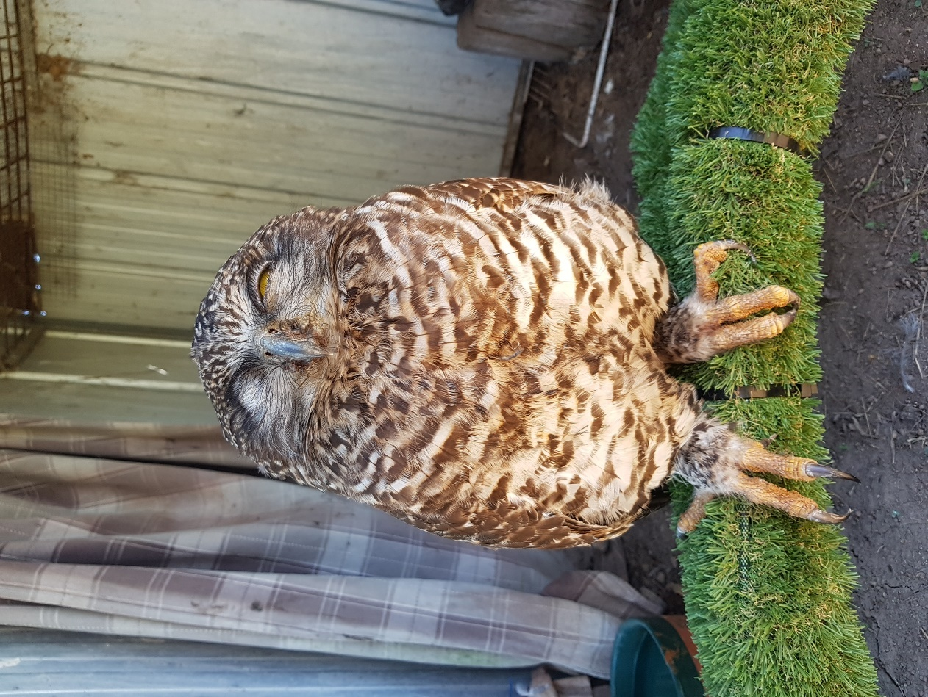

Figure 4 Bird of prey with suspected traumatic injury

Photo: Meredith Ryan/FAWNA.

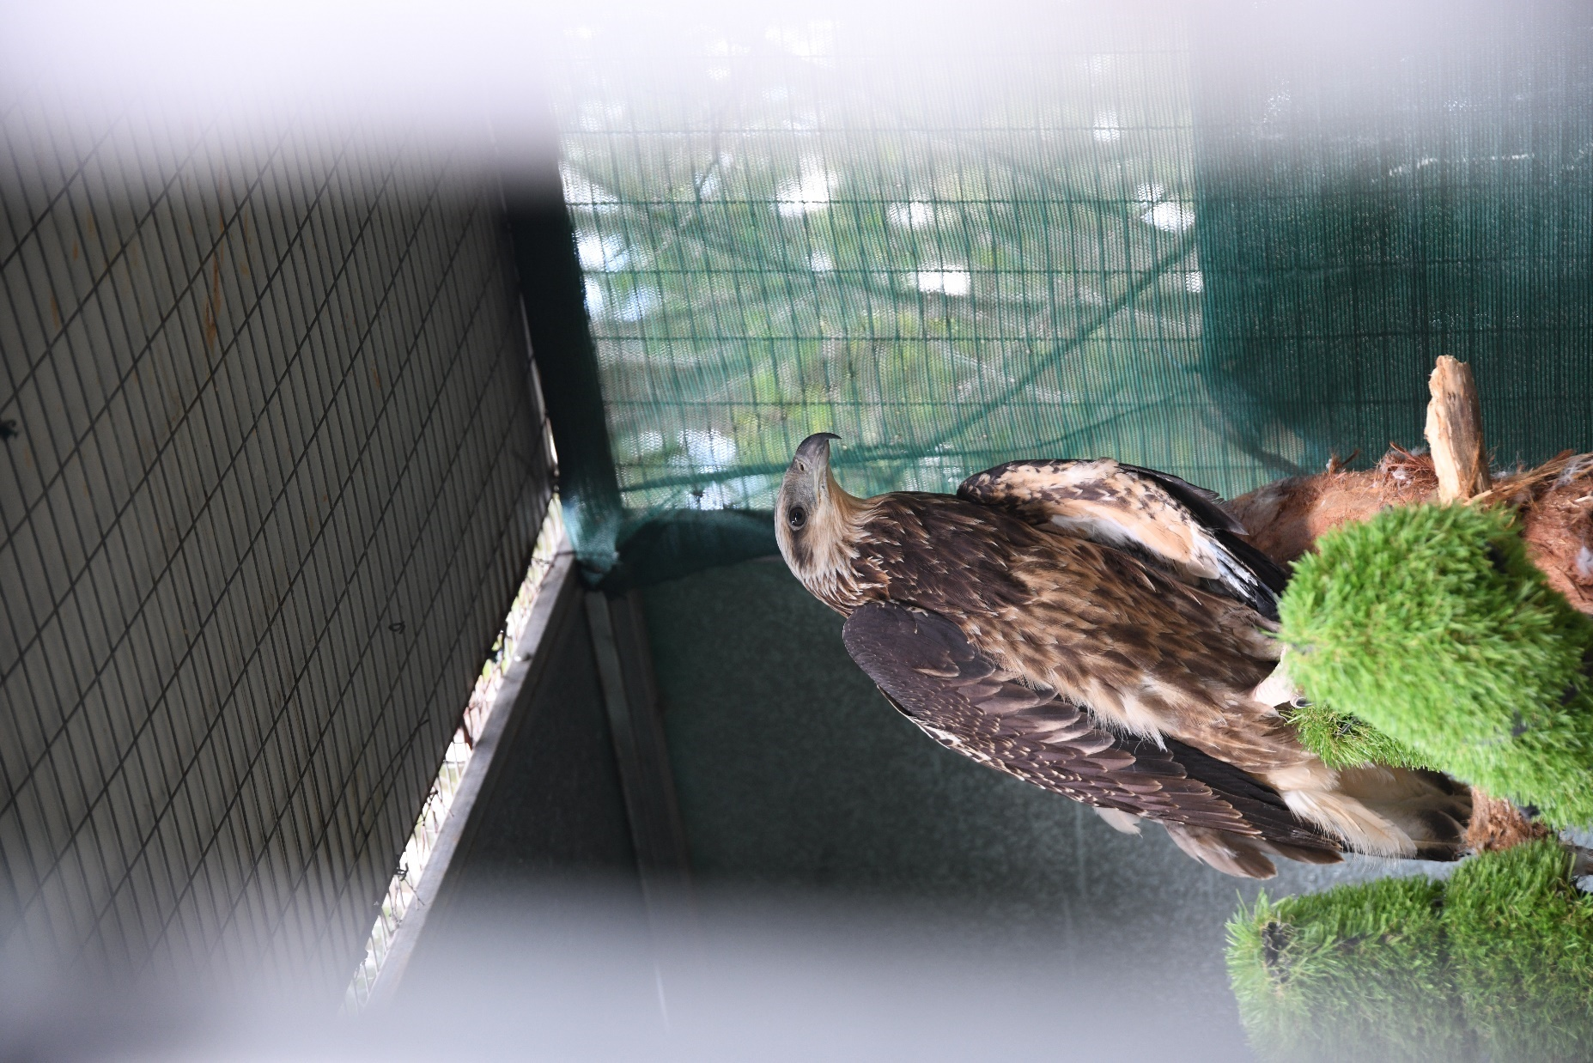

Figure 5 Juvenile bird of prey

Photo: Aditi Sriram/DPIE.

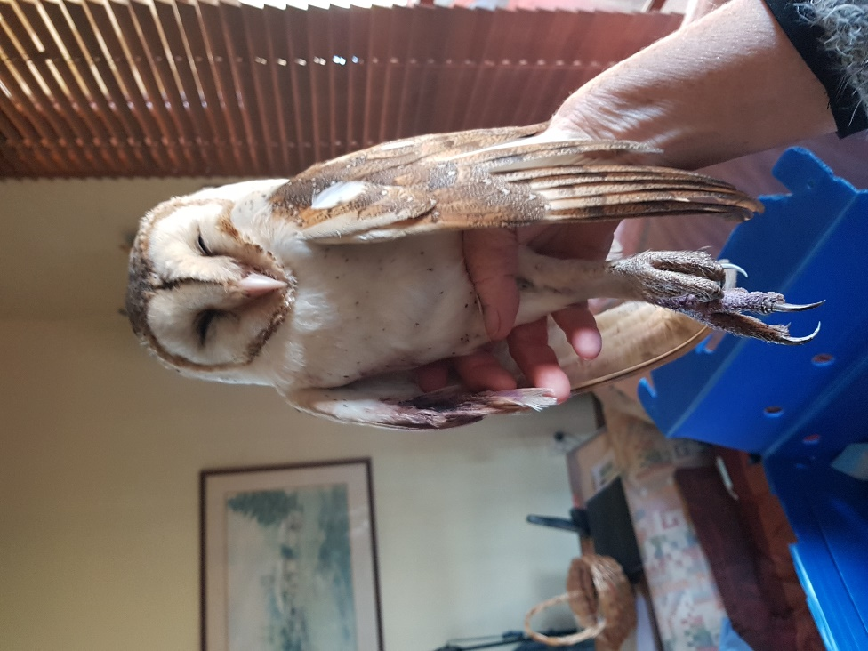

Figure 6 Injured adult bird of prey

Photo: Meredith Ryan/FAWNA.

#### Standard 8: Assessment 2 – Assessment of birds of prey

##### Trainer/Assessor instructions:

This is an example of the type of assessment tool that could be used to assess competency in relation to Standard 8. This assessment tool assesses competency for all criteria in Standard 8. This could be completed verbally while observing a live bird of prey.

##### Learner instructions:

Look at the following image of a southern boobook owl (photo: Aditi Sriram/DPIE). Identify what each line is pointing to and explain what this might tell you about the animal or what you may be looking for in this region when conducting a visual assessment. The eyes have already been completed as an example.

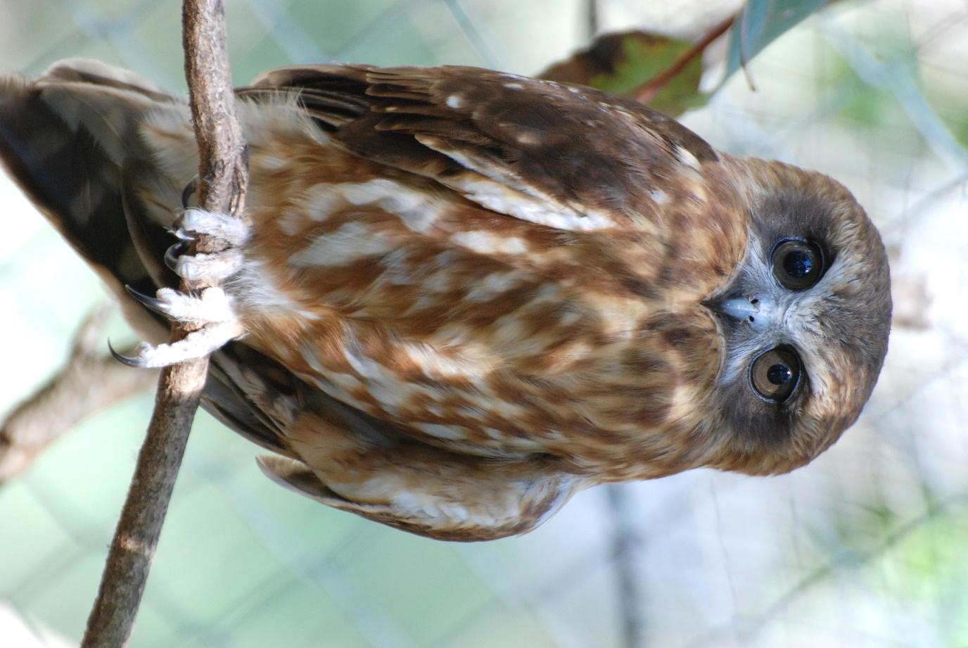

**Eyes**

When conducting a visual assessment, I would be looking for pupil size and symmetry, discharge from the eyes, or colour changes to cornea, and observe for any squinting and movement of the eyelids. This can tell me if there are any injuries or abnormal function of the eyes.

## Standard 9: Rehabilitation of birds of prey

**Objective:** To provide learners with an understanding of the requirements for the rehabilitation of birds of prey, and equip learners with the skills to provide quality rehabilitative care at the relevant stages of rehabilitation.

To comply with this standard, a rehabilitation organisation must:

9.1 Explain the importance of and process for quarantining individual birds of prey entering rehabilitation.

9.2 Detail the facilities required to safely rehabilitate birds of prey relevant to species and stage of housing (intensive, intermediate and pre-release).

9.3 Describe appropriate equipment and furniture for stages of housing.

9.4 Illustrate disease control and hygiene practices appropriate to stages of housing.

9.5 Explain how to appropriately provide food and water based on the species-specific diet requirements and condition of a bird of prey.

9.6 Detail common conditions and diseases that affect birds of prey.

9.7 Discuss how to monitor a bird of prey based on condition and stages of housing.

9.8 Demonstrate how to complete a husbandry plan.

|  |  |
| --- | --- |
| Learning outcomes | Sections in the code |
| Upon completion of this module, learners will be able to:   * + - * outline the requirements for bird of prey rehabilitation       * demonstrate correct set-up for housing birds of prey       * provide food and water appropriate to the species and condition of a bird of prey       * monitor a bird of prey undergoing rehabilitation       * apply hygiene and disease control processes to bird of prey rehabilitation       * complete a husbandry plan for a bird of prey. | 5. Euthanasia  6. Care procedures  7. Husbandry  8. Housing |

### **Training areas**

* The Bird of Prey Code can be accessed online: [Code of Practice for Injured, Sick and Orphaned Birds of Prey](https://www.environment.nsw.gov.au/research-and-publications/publications-search/code-of-practice-for-injured-sick-and-orphaned-birds-of-prey).
* Guidelines can be accessed online: Guidelines for the Initial Treatment and Care of Rescued Birds of Prey.
* Importance of and process for quarantining birds of prey could include:
  + principles of quarantine
  + monitoring for signs of infectious diseases
  + disease transmission between animals.
* Facilities to safely rehabilitate birds of prey could include:
  + requirements for various stages of housing (intensive, intermediate and pre-release housing)
  + mitigating stress (noise, visual barriers)
  + mimicking the natural environment where possible
  + privacy
  + thermal control, shelter
  + access to food and water
  + access for capture if required
  + predator-proofing
  + transfer to a facility with appropriate housing.
* Appropriate equipment and furniture could include:
  + substrate
  + thermostat, thermometer
  + predator-proof enclosures
  + benches, perches, shelves
  + browse to provide shelter
  + visual barriers.
* Disease control and hygiene practices could include:
  + washing hands thoroughly
  + wearing gloves
  + quarantining animals
  + removing faeces and pellets regularly
  + pest-proofing
  + clean food preparation area
  + disinfection of all equipment between birds of prey.
* Access to water and appropriate food could include:
  + water containers of appropriate size
  + diet specific to the species of bird of prey
  + supplementary feeding
  + storage of food.
* Common conditions and diseases could include:
  + trauma, fractures
  + ocular trauma
  + head trauma
  + hypothermia, poor body condition
  + intoxication
  + entanglement injuries.
* Monitoring birds of prey could include:
  + frequency – too much and too little
  + progression of disease or injury
  + stress
  + behaviour
  + preening and feather condition
  + mutes and pellets
  + indications of activity
  + eating patterns and food intake.
* A husbandry plan could include:
  + consultation with vets
  + medications
  + consultation with coordinators and mentors
  + enrichment
  + release site selection.

### Suggested assessments

Assessment in relation to this standard is best suited to written or verbal methods, practical assessment, or a combination of these.

#### Standard 9: Assessment 1 – Housing birds of prey, case studies

##### Trainer/Assessor instructions:

This is an example of the type of assessment that could be used to assess competency in relation to Standard 9.

##### Learner instructions:

To be completed in groups. Using one of the case studies below and the available equipment, set up housing appropriate for your bird of prey. Upon completion of the set-up, each group will be asked to:

* explain your housing set-up
* outline what hygiene and disease control procedures you would implement
* explain how your housing set-up enables you to monitor the bird of prey and what you would be monitoring.

##### Case study 1:

A whistling kite that has been in care for three months is being tested to determine whether it is fit for release.

##### Case study 2:

An adult peregrine falcon has been rescued after suspected motor vehicle trauma. The falcon is in good body condition, but is reluctant to move, very quiet and has bilateral wing droop. There is some dried blood around the nostrils and on the cere.

##### Case study 3:

A barn owl with a coracoid fracture was rescued one week ago. It has been in intensive care for this period and appears to now be self-feeding and bright.

#### Standard 9: Assessment 2 – Rehabilitation of birds of prey, quiz

##### Trainer/Assessor instructions:

This is an example of the type of assessment that could be used to assess competency in relation to Standard 9.

##### Learner instructions:

Complete the following multiple choice quiz by selecting the correct answer for each question.

1. Which of the following scenarios would require a bird of prey to be housed in intensive care?
2. A bird of prey that is being tested to determine whether it is fit for release
3. A bird of prey transitioning towards fledging
4. A bird of prey with a fractured humerus
5. None of the above.

Answer: C. a bird of prey with a fractured humerus.

1. Intensive care housing must provide enough space for birds of prey to maintain normal posture.
2. True
3. False

Answer: A. True.

1. Which of the following demonstrates good practices in hygiene and disease control?
2. Quarantining new or diseased birds of prey
3. Thoroughly washing your hands
4. Removing uneaten food from the enclosure
5. All of the above.

Answer: D. all of the above.

1. Which of the following statements about monitoring birds of prey is incorrect?
2. Birds of prey in pre-release housing must be discreetly monitored every day
3. Birds of prey in intensive care must be monitored twice a day
4. Monitoring includes looking for changes in behaviour
5. Monitoring includes noting quality and quantity of mutes and pellets

Answer: B. Birds of prey in intensive care must be monitored twice a day.

1. Which of the following enclosure floor dimensions are the minimum required for intermediate care housing for large birds of prey?
2. 3 metres long x 2 metres wide x 1 metre high
3. 6 metres long x 3 metres wide x 4 metres high
4. 2 metres long x 4 metres wide x 4 metres high
5. 3 metres long x 3 metres wide x 3 metres high

Answer: D. 3 metres long x 3 metres wide x 3 metres high.

1. Intermediate care housing must be constructed of timber or metal.
2. True
3. False

Answer: A. True.

1. Which of the following statements about providing food for birds of prey is incorrect?
2. Peregrine falcons require 100% of their diet to be from avian protein
3. At least 50% of the diet must be sourced form whole foods
4. Kestrels require insects in their diet
5. Food that is available in the wild must form the basis of a bird of prey’s diet

Answer: A. Peregrine falcons require 100% of their diet to be from avian protein.

1. Which of the following is not a requirement for pre-release housing?
2. Pre-release aviaries can be of rectangular or circular construction
3. Live prey must be provided to animals in pre-release housing
4. Pre-release housing must provide space for the bird to express a range of natural behaviours
5. Pre-release hosing must have an area where the roof is exposed to prevailing weather conditions.

Answer: B. Live prey must be provided to animals in pre-release housing.

1. Which of the following is the objective of pre-release housing?
2. Allow birds of prey to regain physical condition
3. Allow birds of prey to acclimatise to current weather conditions
4. Allow birds of prey to practice natural behaviours
5. All of the above

Answer: D. All of the above.

1. Look at the photo of an intermediate care enclosure (Figure 7). List at least 5 features that comply with the Bird of Prey Code.

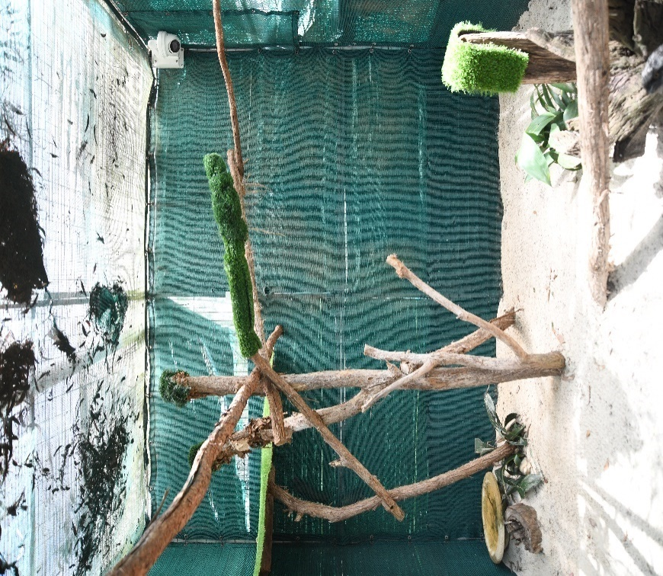

Figure 7 Intermediate care enclosure

Photo: Aditi Sriram/DPIE**.**

|  |
| --- |
| 1. |
| 2. |
| 3. |
| 4. |
| 5. |

## Standard 10: Rehabilitation of bird of prey chicks

**Objective:** To provide learners with the specialised knowledge required to rehabilitate bird of prey chicks.

To comply with this standard, a rehabilitation organisation must:

10.1 Explain the importance of and process for quarantining bird of prey chicks entering rehabilitation.

10.2 Provide the tools and understanding required to identify developmental stages in bird of prey chicks.

10.3 Describe appropriate housing for a bird of prey chick based on its condition and stage of development.

10.4 Discuss appropriate food and feeding methods for bird of prey chicks based on species and stage of development.

10.5 Explain the importance of maintaining records on growth, behaviour and feeding of chicks throughout the rehabilitation process.

10.6 Explain the hacking process and the appropriate use of this technique.

10.7 Detail common conditions and diseases that affect bird of prey chicks.

10.8 Illustrate disease control and hygiene practices appropriate to stages of housing.

10.9 Demonstrate how to complete a husbandry plan for a bird of prey chick.

10.10 Describe mechanisms to reduce stress and encourage natural behaviour in bird of prey chicks.

|  |  |
| --- | --- |
| Learning outcomes | Sections in the code |
| Upon completion of this module, learners will be able to:   * + - * outline the requirements for bird of prey chick rehabilitation       * identify stages of development for bird of prey chicks and relate these to rehabilitation       * outline requirements and criteria for hacking bird of prey chicks       * apply hygiene and disease control processes to bird of prey chick rehabilitation       * reduce stress and encourage natural behaviour in bird of prey chicks       * prepare a bird of prey for release. | 2. Case assessment  5. Euthanasia  6. Care procedures  7. Husbandry  8. Housing |

### Training areas

* The Bird of Prey Code can be accessed online: [Code of Practice for Injured, Sick and Orphaned Birds of Prey](https://www.environment.nsw.gov.au/research-and-publications/publications-search/code-of-practice-for-injured-sick-and-orphaned-birds-of-prey).
* Guidelines can be accessed online: Guidelines for the Initial Treatment and Care of Rescued Birds of Prey.
* Importance of and process for quarantining bird of prey chicks could include:
  + principles of quarantine
  + monitoring for signs of infectious diseases
  + immature immune system in chicks.
* Identifying developmental stage in bird of prey chicks could include:
  + hatchling, nestling, fledgling
  + body measurements
  + physical characteristics
  + seeking expert advice.
* Appropriate housing could include:
  + intensive care
  + nest boxes
  + outdoor enclosure or intermediate housing
  + pre-release enclosure.
* Appropriate food and feeding methods could include:
  + species-specific diet
  + supplementary feeding
  + frequency and volume of feeds
  + visual barriers when feeding.
* Maintaining records could include:
  + continuity of care
  + tracking progress
  + frequency of monitoring
  + monitoring sheets.
* Hacking process could include:
  + dimensions and positioning of the hacking box
  + landing platform
  + assessing chick’s suitability for hacking
  + predator-proof hacking box.
* Common conditions and diseases could include:
  + aspiration pneumonia
  + diarrhoea
  + dehydration
  + candidiasis
  + metabolic bone disease
  + failure to thrive.
* Hygiene and disease control could include:
  + wearing gloves
  + cleaning and replacing substrate regularly
  + sterilising equipment
  + washing hands.
* A husbandry plan could include:
  + consultation with vets
  + medications
  + consultation with coordinators and mentors
  + enrichment.
* Mechanisms to reduce stress and encourage natural behaviour could include:
  + recognising signs of imprinting
  + grouping chicks based on species, weight and stage of development
  + handling and interaction
  + enrichment
  + moving to appropriate facilities at the right stage.

### Suggested assessments

Assessment in relation to this standard is best suited to written or verbal methods, practical assessment, or a combination of these.

#### Standard 10: Assessment 1 – Bird of prey chick housing, questions

##### Trainer/Assessor instructions:

This is an example of the type of assessment that could be used to assess competency in relation to Standard 10.

##### Learner instructions:

Explain the set-up required for a pair of powerful owl chicks being hand-raised for each type of housing listed below. For each type of housing, explain what stage of development the chicks should be at, what type of food they would be eating and what actions you would implement to reduce stress and encourage natural behaviour.

1. Intensive housing:

|  |
| --- |
|  |
|  |
|  |
|  |
|  |
|  |

1. Intermediate housing:

|  |
| --- |
|  |
|  |
|  |
|  |
|  |
|  |

1. Pre-release housing:

|  |
| --- |
|  |
|  |
|  |
|  |
|  |
|  |

#### Standard 10: Assessment 2 – Rehabilitation of a bird of prey chick, quiz

##### Trainer/Assessor instructions:

This is an example of the type of assessment that could be used to assess competency in relation to Standard 10.

##### Learner instructions:

Complete the following quiz by selecting or providing an answer for each question.

1. Hand-reared birds must be soft-released.
2. True
3. False

Answer: A. True.

1. Which of the following statement about bird of prey chicks is incorrect?
2. They are extremely prone to imprinting
3. The hacking method must be applied to all bird of prey chicks
4. Ambient temperatures for chicks in intensive care is higher than temperatures for adults
5. Only chicks that are healthy and able to stand erect and pull their food are considered candidates for hacking

Answer: B. The hacking method must be applied to all bird of prey chicks.

1. Which of the following conditions is not typically seen in bird of prey chicks?
2. Metabolic bone disease
3. Arthritis
4. Dehydration
5. Candidiasis
6. Trauma

Answer: B. arthritis.

1. List 3 hygiene or disease control processes relevant to bird of prey chick rehabilitation.

|  |
| --- |
|  |
|  |
|  |

1. List 5 important considerations for maintaining hygiene when storing and feeding the following types of food:

Fish:

|  |
| --- |
|  |
|  |
|  |
|  |
|  |

Day-old chicks:

|  |
| --- |
|  |
|  |
|  |
|  |
|  |

1. Explain the rehabilitation requirements, including monitoring, feeding and housing, for each of the following species.

A white-bellied sea-eagle fledgling:

|  |
| --- |
|  |
|  |
|  |

A nankeen kestrel chick:

|  |
| --- |
|  |
|  |
|  |

1. Create a list of what you would include in a husbandry plan for a boobook owl nestling being treated with antibiotics for a wound on its wing.

|  |
| --- |
|  |
|  |
|  |
|  |
|  |
|  |
|  |

## Standard 11: Release of birds of prey

**Objective:** To ensure learners understand suitability for release and criteria for releasing birds of prey.

To comply with this standard, a rehabilitation organisation must:

11.1 Discuss release considerations for birds of prey including timing and site selection.

11.2 Explain how to determine a bird of prey’s suitability for release.

11.3 Detail the correct techniques and equipment for releasing birds of prey.

|  |  |
| --- | --- |
| Learning outcomes | Sections in the code |
| Upon completion of this module, learners will be able to:   * assess a bird of prey for release suitability * competently release a bird of prey. | 9. Suitability for release  10. Release considerations |

### **Training areas**

* The Bird of Prey Code can be accessed online: [Code of Practice for Injured, Sick and Orphaned Birds of Prey](https://www.environment.nsw.gov.au/research-and-publications/publications-search/code-of-practice-for-injured-sick-and-orphaned-birds-of-prey).
* Release considerations could include:
  + timing including time of day
  + time of year
  + weather conditions
  + developmental stage
  + release site selection.
* Suitability for release could include:
  + developmental stage, physical condition and fitness
  + recovery from injury or disease
  + behaviour
  + being acclimatised to prevailing climate conditions
  + based on consultation with an experienced bird of prey rehabilitator.
* Appropriate techniques and equipment could include:
  + soft release for hand-reared birds
  + releasing multiple animals
  + tagging, microchipping and monitoring.

### Suggested assessments

This standard is best suited to written or verbal assessment methods, practical assessment or a combination of these.

#### Standard 12: Assessment 1 – Releasing birds of prey, case studies

##### Trainer/Assessor instructions:

This is an example of the type of assessment tool that could be used to assess competency in relation to Standard 12. This can be completed verbally or in writing.

##### Learner instructions:

Read each of the rescue case studies and complete the corresponding questions.

##### Case study 1:

##### A boobook owl was found on the ground in a public park. The owl was assessed with only minor injuries and has since been rehabilitated and is ready for release.

1. Explain the criteria for assessing release suitability for this bird
2. What are the release considerations for this bird?
3. Where will you release this bird?
4. How will you release this bird?
5. How will you minimise work health and safety risks associated with the release site?

##### Case study 2:

##### Three collared sparrowhawk chicks have been held by a member of the public for two days before being handed to a licensed rehabilitation organisation for care. The exact address where these chicks were found is not known, but the general location was passed on by the member of public. Following rehabilitation, the chicks are now ready for release.

1. Explain the criteria for assessing release suitability for these chicks.
2. What are the release considerations for these chicks?
3. Where will you release these chicks?
4. How will you release these chicks?
5. How will you minimise work health and safety risks associated with the release site?

##### Case study 3:

##### A peregrine falcon was rescued by a member of the public after it was observed colliding with a car. The falcon sustained a broken wing which has healed with veterinary treatment. The bird has been rehabilitated and is currently in a pre-release enclosure.

1. Explain the criteria for assessing release suitability for this falcon.
2. What are the release considerations for this falcon?
3. Where will you release this falcon?
4. How will you release this falcon?
5. How will you minimise work health and safety risks associated with the release site?

#### Standard 12: Assessment 2 – Releasing birds of prey, quiz

##### Trainer/Assessor instructions:

This is an example of the type of assessment tool that could be used to assess competency in relation to Standard 12.

##### Learner instructions:

Complete the following multiple choice quiz by selecting the correct answer for each question.

1. Birds of prey must be released during extremes of weather or temperature so that they get used to harsh conditions quickly.
2. True
3. False

Answer: B. False. Birds of prey must not be released during extremes of weather or temperature.

1. Birds of prey must be released only after they have been assessed as being behaviourally ready.
2. True
3. False

Answer: A. True.

1. The most appropriate time of day to release a bird of prey is:
2. When it can immediately investigate its environment
3. In the middle of the day for diurnal species
4. One hour after dark for nocturnal species
5. Anytime of the day or night is fine.

Answer: A and C.

1. A bird of prey can be released into a national park only if the release has written consent from the relevant NPWS Area Manager and the release complies with the relevant Department of Planning, Industry and Environment policies on translocation.
2. True
3. False

Answer: True.

1. If there is no information about where the bird of prey was found, it can be released anywhere as long as there is suitable habitat and food sources.
2. True
3. False

Answer: B. False. If there is no information about where the bird of prey was found, it must not be released.

1. A bird of prey’s readiness for release must be assessed in consultation with an experienced bird of prey rehabilitator.
2. True
3. False

Answer: A. True.

1. When releasing adult birds of prey, the release site must be close enough for the bird to rejoin its mate.
2. True
3. False

Answer: True. Adult birds of prey pair-bond from two to three years of age, and the release site must be close enough for them to rejoin their mate.

1. If a rescued bird of prey was found in a suburban garage it needs to be released back to:
2. The garage it was rescued from
3. It cannot be released as the environment is unsuitable
4. A national park
5. A suitable environment as close to the backyard as possible.

Answer: D. a suitable environment as close to the backyard as possible.

1. As they are not dangerous animals, birds of prey that are humanised can be released.
2. True
3. False

Answer: False. An imprinted bird of prey cannot be released.

1. Which of the following is not an option for unreleasable bird of prey?
2. Keeping it in the house as a pet
3. Applying to the Department to have it placed in permanent care
4. Euthanasia
5. Notifying the Department to arrange placement with an authorised animal exhibitor licensed by the Department of Primary Industries (DPI).

Answer: A. keeping it in the house as a pet.

# Further reading

ASQA 2015, *Guide to Developing Assessment Tools*, Australian Skills Quality Authority,accessed 24/7/2019, [www.asqa.gov.au/sites/g/files/net3521/f/Guide_to_developing_assessment_tools.pdf](https://www.asqa.gov.au/sites/default/files/Guide_to_developing_assessment_tools.pdf).

Heathfield SM 2019, *Best Ice Breakers for Meetings and Training Classes,* the balance careers, accessed 24/7/19, [www.thebalancecareers.com/best-ice-breakers-for-meetings-and-training-classes-1918430](http://www.thebalancecareers.com/best-ice-breakers-for-meetings-and-training-classes-1918430).

Hill D, Hill T & Perlitz L 2011, *Vocational Training and Assessment*, McGraw-Hill Education, North Ryde, NSW.

Hill D, Hill T & Perlitz L 2013, *Professional Training and Assessment*, McGraw-Hill Education, North Ryde, NSW.

Standards for Registered Training Organisations, made under sections 185(1) and 186(1) of the *National Vocational Education and Training Regulator Act 2011*, accessed at [www.legislation.gov.au/Details/F2019C00503](https://www.legislation.gov.au/Details/F2019C00503).

NHS Education for Scotland 2012, *Train the Trainers Toolkit,* NHS Education for Scotland, accessed 24/7/2019, [www.knowledge.scot.nhs.uk/media/6866097/trainthetrainers__final_.pdf](http://www.knowledge.scot.nhs.uk/media/6866097/trainthetrainers__final_.pdf).

Smith M 2002, *Malcolm Knowles, informal adult education, self-direction and andragogy,* Infed, accessed 24/7/19, [infed.org/mobi/malcolm-knowles-informal-adult-education-self-direction-and-andragogy/](http://infed.org/mobi/malcolm-knowles-informal-adult-education-self-direction-and-andragogy/).

VARK 2019, *Introduction to VARK,* VARK Learn Limited, accessed 24/7/19, [vark-learn.com/introduction-to-vark/the-vark-modalities/](http://vark-learn.com/introduction-to-vark/the-vark-modalities/).

Appendix A: Training and assessment mapping tool

The table below is a tool you can use to determine if there are any gaps in your training. You can map your existing training materials to the standards to see if there are any parts of a standard you have omitted, or may need to add further information to. For the learning outcomes, you can match these to an assessment instrument so you can see exactly where you are determining competency of your learner against each outcome. You can change or include additional training or assessment tools if the ones listed do not match what is provided in your training.

| Standard | Training tools | | | Learning outcomes | Assessment tools | | | |
| --- | --- | --- | --- | --- | --- | --- | --- | --- |
| **Slides on PPT** | **Pages in manual** | **Other resources** | **Multiple choice or short-answer questions** | **Demonstration (real or scenario-based)** | **Verbal questioning and answering** | **Assessor checklist** |
| **Standard 1: The framework for bird of prey rehabilitation in New South Wales** | | | | | | | | |
| 1.1 Discuss the Bird of Prey Code. |  |  |  | Identify and demonstrate understanding of the Bird of Prey Code. |  |  |  |  |
| 1.2 Ensure organisational policies and procedures applicable to bird of prey rehabilitation are defined and understood by learners. |  |  |  | Identify organisational policies and procedures for bird of prey rehabilitation. |  |  |  |  |
|  |  |  |  | Recognise the objectives of bird of prey rehabilitation. |  |  |  |  |
| **Standard 2: Work, health and safety (WHS) requirements of bird of prey rehabilitation** | | | | | | | | |
| 2.1 Explain the WHS risks associated with the site, equipment or activity and how they can be minimised. |  |  |  | Identify WHS risks associated with bird of prey rehabilitation. |  |  |  |  |
| 2.2 Explain the WHS risks associated with handling and restraining birds of prey and how they can be minimised. |  |  |  | Employ techniques to minimise the WHS risks to themselves and other people. |  |  |  |  |
| 2.3 Discuss the WHS risks associated with zoonotic diseases relevant to birds of prey and how they can be minimised. |  |  |  |  |  |  |  |  |
| 2.4 Discuss rehabilitator wellbeing and the potential mental health impacts of wildlife rehabilitation. |  |  |  |  |  |  |  |  |
| **Standard 3: Record keeping** | | | | | | | | |
| 3.1 Explain the NPWS reporting requirements. |  |  |  | Keep records in accordance with NPWS and organisational requirements. |  |  |  |  |
| 3.2 Explain organisational reporting requirements. |  |  |  |  |  |  |  |  |
| **Standard 4: Biology and behaviour of birds of prey** | | | | | | | | |
| 4.1 Explain features of bird of prey biology including anatomy, physiology, flight mechanics, social structure and stages of development and relate them to bird of prey rehabilitation. |  |  |  | Relate bird of prey biology, ecology and behaviour to bird of prey rehabilitation. |  |  |  |  |
| 4.2 provide a basic understanding of bird of prey ecology including population dynamics, habitat selection, competition and predator–prey interactions. |  |  |  | Identify various species of birds of prey found in New South Wales. |  |  |  |  |
| 4.3 Provide the tools and understanding required to identify different species of birds of prey recorded in New South Wales. |  |  |  | Recognise signs of normal behaviour in birds of prey. |  |  |  |  |
| 4.4 Provide the tools and understanding required to identify normal behaviour in birds of prey. |  |  |  | Recognise signs of abnormal behaviour in birds of prey. |  |  |  |  |
| 4.5 Provide the tools an understanding required to recognise signs of abnormal behaviour in birds of prey. |  |  |  |  |  |  |  |  |
| **Standard 5: Stress management in birds of prey** | | | | | | | | |
| 5.1 Explain the effects of stress on birds of prey at various stages of rescue and rehabilitation and any differences between species. |  |  |  | Recognise signs of stress in birds of prey and its impact. |  |  |  |  |
| 5.2 Provide the tools and understanding required to recognise signs of stress in birds of prey. |  |  |  | Apply methods for minimising stress on birds of prey. |  |  |  |  |
| 5.3 Discuss methods for minimising stress in birds of prey at various stages of rescue and rehabilitation. |  |  |  |  |  |  |  |  |
| **Standard 6: Rescue of birds of prey** | | | | | | | | |
| 6.1 Outline common reasons for bird of prey rescue. |  |  |  | List the common reasons why birds of prey require rescue. |  |  |  |  |
| 6.2 Detail how to plan a situational assessment, including the use of the decision tree in the Bird of Prey Code, to establish the appropriate course of action. |  |  |  | Assess a rescue situation and plan the rescue of a bird of prey. |  |  |  |  |
| 6.3 Detail the correct method and equipment required to capture, handle and rescue a bird of prey, as suitable to common rescue situations, species, age and condition of the bird of prey. |  |  |  | Safely rescue a bird of prey using correct equipment. |  |  |  |  |
| 6.4 Detail how to rescue a bird of prey to humanely minimise pain, stress and potential injury. |  |  |  | Determine the type of intervention required at a rescue site. |  |  |  |  |
| **Standard 7: Transport of birds of prey** | | | | | | | | |
| 7.1 Demonstrate how to appropriately contain a bird of prey for transport based on species, size, age and condition. |  |  |  | Prepare a carrier for transport. |  |  |  |  |
| 7.2 Outline how to secure the transport container to prevent escape and further injury. |  |  |  | Outline transport conditions required to safely transport a bird of prey. |  |  |  |  |
| 7.3 Detail suitable transport conditions, including ambient temperature, to safely transport a bird of prey. |  |  |  | Understand the appropriate person or location to transport a bird of prey to, based on species, age, condition and organisational policies. |  |  |  |  |
| 7.4 Discuss the most suitable person or location that a bird of prey should be transported to, based on species, age, condition and organisational policies. |  |  |  |  |  |  |  |  |
| **Standard 8: Assessment of bird of prey** | | | | | | | | |
| 8.1 Explain how to conduct an initial assessment of a bird of prey. |  |  |  | Conduct an initial assessment of a bird of prey. |  |  |  |  |
| 8.2 Explain the requirements of a thorough assessment of a bird of prey. |  |  |  | Assess the health status of a bird of prey and recognise stages, signs and severity of common diseases and injuries. |  |  |  |  |
| 8.3 Emphasise the need to seek prompt advice and assistance for a bird of prey from a coordinator, veterinarian or other relevant person, as appropriate to its condition. |  |  |  | Determine the appropriate course of action for a bird of prey based on its condition. |  |  |  |  |
| 8.4 Distinguish signs of and ways to determine common diseases and injuries affecting birds of prey. |  |  |  | Outline criteria for and approved methods of euthanasia. |  |  |  |  |
| 8.5 Explain how to manage an injured or diseased bird of prey based on the severity of its condition. |  |  |  |  |  |  |  |  |
| 8.6 Outline criteria and approved methods for humane euthanasia. |  |  |  |  |  |  |  |  |
| **Standard 9: Rehabilitation of birds of prey** | | | | | | | | |
| 9.1 Explain the importance of and process for quarantining individual birds of prey entering rehabilitation. |  |  |  | Outline the requirements for bird of prey rehabilitation. |  |  |  |  |
| 9.2 Detail the facilities required to safely rehabilitate birds of prey, relevant to species and stage of housing (intensive, intermediate and pre-release). |  |  |  | Demonstrate correct set-up for housing birds of prey. |  |  |  |  |
| 9.3 Describe appropriate equipment and furniture for stages of housing. |  |  |  | Provide food and water appropriate to the species and condition of a bird of prey. |  |  |  |  |
| 9.4 Illustrate disease control and hygiene practices appropriate to stages of housing. |  |  |  | Monitor a bird of prey undergoing rehabilitation. |  |  |  |  |
| 9.5 Explain how to appropriately provide food and water based on the species-specific diet requirements and condition of a bird of prey. |  |  |  | Apply hygiene and disease control processes to bird of prey rehabilitation. |  |  |  |  |
| 9.6 Detail common conditions and diseases that affect birds of prey. |  |  |  | Complete a husbandry plan for a bird of prey. |  |  |  |  |
| 9.7 Discuss how to monitor a bird of prey based on its condition and stage of housing. |  |  |  |  |  |  |  |  |
| 9.8 Demonstrate how to complete a husbandry plan. |  |  |  |  |  |  |  |  |
| **Standard 10: Rehabilitation of bird of prey chicks** | | | | | | | | |
| 10.1 Explain the importance of and process for quarantining bird of prey chicks entering rehabilitation. |  |  |  | Outline the requirements for bird of prey chick rehabilitation. |  |  |  |  |
| 10.2 Provide the tools and understanding required to identify developmental stages in bird of prey chicks. |  |  |  | Identify stages of development for bird of prey chicks and relate these to rehabilitation. |  |  |  |  |
| 10.3 Describe appropriate housing for a bird of prey chick based on its condition and stage of development. |  |  |  | Outline requirements and criteria for hacking bird of prey chicks. |  |  |  |  |
| 10.4 Discuss appropriate food and feeding methods for bird of prey chicks based on species and stage of development. |  |  |  | Apply hygiene and disease control processes to bird of prey chick rehabilitation. |  |  |  |  |
| 10.5 Explain the importance of maintaining records on growth, behaviour and feeding of chicks throughout the rehabilitation process. |  |  |  | Reduce stress and encourage natural behaviours in bird of prey chicks. |  |  |  |  |
| 10.6 Explain the hacking process and the appropriate use of this technique. |  |  |  | Prepare a bird of prey for release. |  |  |  |  |
| 10.7 Detail common conditions and diseases that affect bird of prey chicks. |  |  |  |  |  |  |  |  |
| 10.8 Illustrate disease control and hygiene practices appropriate to stages of housing. |  |  |  |  |  |  |  |  |
| 10.9 Demonstrate how to complete a husbandry plan for a bird of prey chick. |  |  |  |  |  |  |  |  |
| 10.10 Describe mechanisms to reduce stress and encourage natural behaviours in bird of prey chicks. |  |  |  |  |  |  |  |  |
| **Standard 11: Release of birds of prey** | | | | | | | | |
| 12.1 Discuss release considerations for birds of prey including timing and site selection. |  |  |  | Assess a bird of prey for release suitability. |  |  |  |  |
| 12.2 Explain how to determine a bird of prey’s suitability for release. |  |  |  | Competently release a bird of prey. |  |  |  |  |
| 12.3 Detail the correct techniques and equipment for releasing birds of prey. |  |  |  |  |  |  |  |  |