environment.nsw.gov.au

Department of planning, Industry & ENVIRONMENT

Macropod Rehabilitation Training Standards for the Volunteer Wildlife Rehabilitation Sector

Trainers’ guide

© 2021 State of NSW and Department of Planning, Industry and Environment

With the exception of photographs, the State of NSW and Department of Planning, Industry and Environment are pleased to allow this material to be reproduced in whole or in part for educational and non-commercial use, provided the meaning is unchanged and its source, publisher and authorship are acknowledged. Specific permission is required for the reproduction of photographs.

The Department of Planning, Industry and Environment (DPIE) has compiled this report in good faith, exercising all due care and attention. No representation is made about the accuracy, completeness or suitability of the information in this publication for any particular purpose. DPIE shall not be liable for any damage which may occur to any person or organisation taking action or not on the basis of this publication. Readers should seek appropriate advice when applying the information to their specific needs.

All content in this publication is owned by DPIE and is protected by Crown Copyright, unless credited otherwise. It is licensed under the [Creative Commons Attribution 4.0 International (CC BY 4.0)](http://creativecommons.org/licenses/by/4.0/deed.en), subject to the exemptions contained in the licence. The legal code for the licence is available at [Creative Commons](http://creativecommons.org/licenses/by/4.0/legalcode).

DPIE asserts the right to be attributed as author of the original material in the following manner: © State of New South Wales and Department of Planning, Industry and Environment 2021.

Cover photo: Pademelon joey. Colleen Werner.

Published by:

Environment, Energy and Science   
Department of Planning, Industry and Environment  
Locked Bag 5022, Parramatta NSW 2124  
Phone: +61 2 9995 5000 (switchboard)  
Phone: 1300 361 967 (Environment, Energy and Science enquiries)  
TTY users: phone 133 677, then ask for 1300 361 967  
Speak and listen users: phone 1300 555 727, then ask for 1300 361 967  
Email: [info@environment.nsw.gov.au](mailto:info@environment.nsw.gov.au)   
Website: [www.environment.nsw.gov.au](http://www.environment.nsw.gov.au)

Report pollution and environmental incidents  
Environment Line: 131 555 (NSW only) or [info@environment.nsw.gov.au](mailto:info@environment.nsw.gov.au)  
See also [www.environment.nsw.gov.au](http://www.environment.nsw.gov.au)

ISBN 978-1-922558-01-5  
EES 2021/0044  
February 2021

Find out more about your environment at:

www.environment.nsw.gov.au

Contents

Summary v

Part 1: Introduction to training design, delivery and assessment 1

Training requirements of the Code 1

Designing training 2

Providing training 7

Assessment 12

Record keeping 13

Part 2: Understanding the macropod rehabilitation training standards 14

Introduction 14

Understanding the format of the training standards 14

Standard 1: The framework for macropod rehabilitation in New South Wales 15

Standard 2: Work health and safety requirements of macropod rehabilitation 20

Standard 3: Record keeping 22

Standard 4: Biology and behaviour of macropods 25

Standard 5: Stress management in macropods 28

Standard 6: Rescue of macropods 31

Standard 7: Transport of macropods 42

Standard8: Assessment of macropods 44

Standard 9: Rehabilitation of adult macropods 50

Standard 10: Rehabilitation of macropod joeys 56

Standard 11: Release of macropods 60

Further reading 64

Appendix A: Training and assessment mapping tool 65

List of figures

Figure 1 The four different learning styles of the VARK model 4

Figure 2 Reducing hazards in the training environment 8

Figure 3 Using pictures and dot points to illustrate key messages on a PowerPoint slide 10

Figure 4 Joey was in the pouch when mother was hit by a car 47

Figure 5 Joey is malnourished after being cared for by an untrained member of the public 47

Figure 6 Macropod with burn injuries to the feet 48

Figure 7 Macropod entangled in a wire fence 48

Figure 8 Macropods in pre-release enclosure 55

# Summary

1. This trainers’ guidehas been developed as a companion resource to the Department of Planning, Industry and Environment, National Parks and Wildlife Service (NPWS) [Macropod Rehabilitation Training Standards for the Volunteer Wildlife Rehabilitation Sector](https://www.environment.nsw.gov.au/research-and-publications/publications-search/macropod-rehabilitation-training-standards-for-the-volunteer-wildlife-rehabilitation-sector)(the macropod training standards). Training developers, trainers and assessors within the volunteer wildlife rehabilitation sector can use the guide as a resource to ensure their macropod rehabilitation training complies with the training standards.
2. The standards ensure compliance with the NSW [Code of Practice for Injured, Sick and Orphaned Macropods](https://www.environment.nsw.gov.au/research-and-publications/publications-search/code-of-practice-for-injured-sick-and-orphaned-macropods)(OEH 2018) and a minimum level of care for macropods across the NSW wildlife rehabilitation sector.
3. The guide is divided into two parts:

* **Part 1: Introduction to training design, delivery and assessment** provides helpful hints for planning and delivering training, and assessing competency. This section of the guide has been designed to provide an overview of training, introduce adult learning and explain how to engage learners in productive and efficient ways.
* **Part 2: Understanding the macropod rehabilitation standards** suggests topics to include in training programs, and assessment types applicable to individual standards. There are two example assessments provided for each standard. These assessments can be used to determine competency related to individual training standards.

1. The guide has been developed as a resource to support the sector in implementing the training standards.

# Part 1: Introduction to training design, delivery and assessment

## Training requirements of the Code

1. 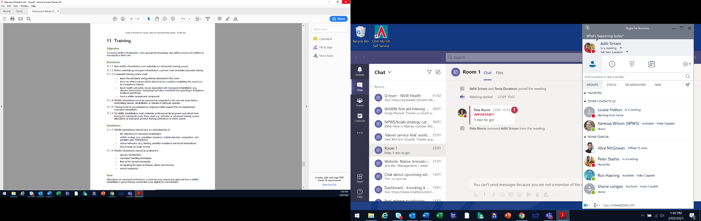The first thing you need to look at when designing or evaluating your training is the [NSW Code of Practice for Injured, Sick and Orphaned Macropods](https://www.environment.nsw.gov.au/research-and-publications/publications-search/code-of-practice-for-injured-sick-and-orphaned-macropods)(the Macropod Code).The following noteson**Section 11 – Training** explain what is required:
2. Content to be included in training
3. Macropod rehabilitation courses must teach these things and ensure that training is competency based.
4. The objectives explain the overall purpose of macropod rehabilitation training, which is to ensure the welfare of macropods that come into rehabilitation.
5. This standard is saying that there must be formal induction training for new members.
6. Refresher training must be completed **within** three years from the time your last course was completed.   
   Refresher training should include advanced topics and developments in rehabilitation practices and scientific research.
7. There **must** be an assessment completed in writing for anyone undertaking macropod rehabilitation training. The exception is for people who are working in temporary supervised facility-based roles.
8. Assessing someone as competent means the person has been assessed as capable to perform their duties (in this case rehabilitate macropods). This means that learners must meet the relevant learning outcomes listed in the training standards.
9. Coordinators, mentors or experienced macropod rehabilitators must be available to help new members.

## Designing training

1. Whether you are designing a new course or updating an existing course, there are several questions to ask to determine what your new training should look like. The best way to answer these questions is to organise them into a learning plan before jumping into the training content. To help you get started with designing your course, this section discusses what you might consider and how you might answer the broad questions: what, who, how and when.

### What is the purpose of the course?

1. Are you designing a course that will combine all the training standards and look at macropod rehabilitation holistically, or will it cover individual or multiple standards aimed at certain topics, for example, macropod rescue or joey rehabilitation?
2. The 11 training standards have been grouped into three core areas:

* **Foundations of macropod rehabilitation – Standards 1 to 5** are mostly theoretical or cover multiple aspects of macropod rehabilitation. These standards are foundational for macropod rehabilitation training.
* **Rescue of macropods** **– Standards 6 to 8** address macropod rescue.
* **Rehabilitation of macropods – Standards 9 to 11** cover the rehabilitation and release of both adult and joey macropods.

1. While you do not have to design your training according to these areas, you may want to consider if they fit with the purpose of your training.
2. Perhaps you are updating training that already exists. If so, consider whether all areas of the training standards are covered. Do you have assessments in place to determine competency and achieve the learning outcomes? If not, identify the gaps in your current program to work out what to include to ensure your updated version will meet the standards. Appendix A is a mapping tool to assist you with this exercise.
3. By understanding the reasons behind your training, you can also be clear on the pathways learners can take throughout the learning process. These pathways can then be clearly communicated to the learners, so they understand their responsibilities and you can manage their expectations. Questions to ask include:

* Will there be prerequisites and what are they?
* What will the learner be able to do after completing this training?
* What, if any, further training will be required?

1. Once you understand the purpose of the training you can start to incorporate other elements of training design into your plan.

### Who is the training designed for?

1. Understanding the ‘who’ is very important to developing successful training.
2. The audience for a program aimed at macropod rehabilitation can be diverse and include people across genders, age groups, ethnicities and education levels. Consider what you can put in place to account for this diversity and help learners who may have special learning requirements. One way to do this is to understand what skills are required for the role the learner is undertaking training for, and ensure the content and assessments are compatible with this skill level, i.e. don’t make training harder than it needs to be.
3. Some other ways to help learners include:

* Include some questions or an interview as part of the enrolment process, so you can determine whether a learner will require additional or alternative help throughout the training.
* Use simple and succinct language; for written materials use short, concise sentences.
* Use visuals such as pictures, diagrams and graphs.
* Factor in time for asking questions and evaluating information.
* Where appropriate, make reasonable adjustments to the assessment. For example, if a learner struggles with reading you could change a written test to a verbal one to determine competency.

#### Adult learning

1. One thing we do know about our learners is that they are all adults.
2. There are several theories surrounding adult learning with one of the most well-known being andragogy, which was popularised by [Malcolm Knowles](http://infed.org/mobi/malcolm-knowles-informal-adult-education-self-direction-and-andragogy/) in the 1970s. Andragogy refers to adult learning, in contrast to pedagogy, which is child learning. What the theory of andragogy tells us is that adults:

* are self-directed learners
* need to know why they are learning something
* have a problem-centred approach to learning
* bring life and work experiences, skills and biases to learning
* are more willing to learn when they think it will provide skills to develop their life situations, i.e. it is relevant to them.

1. Adults learn best by being involved in their learning process, feeling respected, and through a hands-on approach to learning. The trainer is a facilitator of learning rather than a director, providing guidance while allowing the learner greater ownership of the learning experience.
2. Understanding these concepts is important for developing effective and engaging adult learning programs.

#### Learning styles

1. Another important thing to know about your learners is their learning style. While it may not be possible to always know and account for every participant’s learning style, understanding the styles and incorporating them into your training will allow you to be a more effective trainer.
2. The VARK model separates learning styles into four types (see Figure 1), although learners don’t have to be restricted to just one learning type.
3. For more information about the VARK model, including a quiz for you to find out your preferred learning styles, see [The VARK Modalities](http://vark-learn.com/introduction-to-vark/the-vark-modalities/).
5. Figure 1 The four different learning styles of the VARK model

### How will training be delivered?

1. Three of the most common delivery methods are face-to-face, online or one-on-one training. The different delivery methods suit different learning styles and there is no-one method better than the others. When designing your program, you need to consider what resources are available and the methods that best suit your trainers’ and learners’ needs.

#### Face-to-face delivery

1. Face-to-face learning is the more traditional method for delivering training and includes presentations, lectures and demonstrations.

| 1. **Pros** | 1. **Cons** |
| --- | --- |
| * + - * Traditional, well-known to most learners       * Can be completed at a faster rate than other methods       * Additional learning can occur through interactions and exchanges between learners       * Easier to adapt based on learner needs       * Can be activity-based and increase learning by doing       * Can build personal relationships and networks that continue to facilitate learning outside the structured training       * Can be easier to ask questions and seek clarification from the trainer | * + - * Can remind adult learners of school classrooms and create disinterest       * Must be completed at a certain pace, which can leave some learners behind       * Not very flexible, courses must happen at certain times with specific agendas       * Can be expensive to attend and to run       * Certain learners can monopolise conversations and more timid learners may be unable to engage well with the content |

#### Online delivery

1. Online or eLearning is broadly defined as learning that takes place using a computer or electronic resource. eLearning has grown in popularity in recent years and has both advantages and disadvantages.

| 1. **Pros** | 1. **Cons** |
| --- | --- |
| * + - * Learning is self-paced, and can be completed in the comfort of your own home or other convenient location       * Flexible – can be accessed at any time and fit with learners’ schedules       * There is consistency in what is learnt as the content is the same for every learner       * Can be easy to pull statistics and provide feedback       * Can be more cost-effective than other types of delivery       * Can improve the learner’s electronic and technical skills | * + - * Little opportunity to engage with the trainer or other learners       * Can be too flexible – leading to a lack of motivation, commitment and ultimately lack of course completion       * Can require more of the student, e.g. more reading requirements or additional assessments       * Can be discouraging for people who are not confident with computers       * Lacks opportunities for hands-on learning       * Can be impacted by poor internet connection or technical issues       * Can require more instructions and detailed explanations than other methods where a trainer is present |

1. One option used by training providers is ‘blended delivery’ which combines online learning with face-to-face learning to obtain the advantages of both delivery methods.

#### One-on-one delivery

1. One-on-one delivery is also known as mentoring and usually occurs in the workplace. It involves a more experienced person sharing knowledge, skills and expertise with the learner.

| 1. **Pros** | 1. **Cons** |
| --- | --- |
| * + - * Sole focus is on the learner, allowing learning to be tailored to their strengths and weaknesses       * Usually practical in nature       * Feedback between mentor and learner can be instant       * Self-directed learning       * Can broaden the learner’s network quickly       * Can be flexible to allow for personal circumstances | * + - * Can be difficult to incorporate training into day-to-day tasks       * May not allow for diversity of opinions or the ability for learner to engage with other learners       * Providing feedback can be awkward and taken more personally       * Appropriate mentors can be difficult to find       * Can take longer to complete training because of both learner and mentor schedules |

#### Tips for delivery

1. When designing your learning plan it can be helpful to consider these tips:

* Effective communication is key to effective training.
* Write for your learner – don’t use jargon or big words without explaining them. Remember to consider your audience, e.g. is it a refresher course where learners will be familiar with the terminology or is it an introductory course where learners have no experience with rehabilitation and will need the terminology explained?
* Manage learner expectations by being clear at the beginning of the training what their responsibilities are and what they will be able to do upon completion of the course.
* Designing training to be accessible to all learning types will make the information more engaging and likely increase the success of the program.
* Think about your own experiences as a learner – what did you like? What didn’t you like?

1. More information on delivery can be found in the training section of this document.

### What content will be included in the training?

1. Organising training content can be one of the most enjoyable aspects of designing your training plan. It is also crucial to ensuring you are creating relevant, engaging and accurate training.
2. When deciding what will go into your training the first thing you should do is consider existing materials. This can include:

* regulatory documents for the sector including the [NSW Code of Practice for Injured, Sick and Orphaned Macropods](https://www.environment.nsw.gov.au/research-and-publications/publications-search/code-of-practice-for-injured-sick-and-orphaned-macropods) and the training standards
* relevant and useful organisational policies and procedures including standard operating procedures; constitutions; codes of ethics; work, health and safety (WHS) policies; role descriptions and risk management plans
* legislative requirements including the [Biodiversity Conservation Act 2016](https://www.legislation.nsw.gov.au/#/view/act/2016/63)
* existing materials – manuals, fact sheets, PowerPoint presentations, handouts and research papers; consider whether these are still relevant or if they need updating, and who needs to be involved in this process
* previous feedback – have you received feedback about previous courses that you could incorporate into the update of training materials?

1. Using the training standards will be vital to ensuring your content is compliant and assesses competency at the required level. A way of confirming your content aligns with the standards is to use the standards as headings during your planning phase, putting existing content under these headings. From here you can see which areas require additional information.
2. When developing resources, you need to determine what the learners will need to complete their training and become competent, and whether any further materials could assist them in their role. For example, home-based rehabilitators might require more take-home reference material than facility-based rehabilitators who are supervised and have access to materials at their facility. The method of delivery will also affect the type of resources required. For example, online training will require more instructional and detailed information than face-to-face or one-on-one learning where a trainer is present to discuss content, answer questions and provide clarification.

### When will training occur?

1. This is largely up to you and your organisation’s needs. You should consider whether the training is ongoing, requiring regular attendance, and the frequency of the training. You need to consult with your trainers on their availability.
2. If the training requires prerequisites, is there enough time to complete the required training first?

## Providing training

1. As a trainer, your role is to provide a productive, safe and supportive learning environment. As discussed in the previous section, with adult learning, trainers take on less of a director or teacher role and become more of a facilitator of learning. A facilitator is a trainer who encourages participation and takes a learner-centred approach.
2. The table below lists some common actions that trainers should and should not do.

| 1. **Do** | 1. **Do not** |
| --- | --- |
| * + - * Know your subject matter       * Be organised       * Communicate clearly       * Apply active listening skills and use positive non-verbal communication, e.g. maintaining eye contact, using gestures, nodding, paraphrasing       * Encourage questions and ensure enough time has been set aside for discussion       * Take feedback on board and adjust accordingly | * + - * Be unprepared       * Use unnecessarily difficult words or jargon       * Use negative non-verbal communication, e.g. stare, roll your eyes, cross your arms, stand too close       * Be dismissive and discourage interaction       * Get defensive if feedback is provided |

1. In addition to these behaviours, it is also important to think about the environment the training will occur in and how you can maximise its advantages and minimise its disadvantages. For example, if you are doing one-on-one training in a facility you will have access to macropods and be able to reinforce learning by having the learner complete tasks in a practical setting. Conversely, there may be emergencies that require attention, or frequent interruptions from other personnel.
2. In a venue designed for face-to-face training, you can encourage ideas and discussions between learners but you will not have access to real-life situations and may need to simulate these environments to keep the learners engaged in the topic.

### Ways to engage learners

1. Presentations are great for face-to-face training, however, an extended time without engaging the learners can create disinterest and learners may tune out altogether. Integrating more activities and engaging learners in other ways can incorporate different learning styles and enhance overall learning.
2. Some additional methods for encouraging learner participation include:

* demonstrations
* group activities
* case studies and scenarios
* group discussions
* brainstorming sessions
* blended delivery (a combination of online, face-to-face and mentor training)
* videos, graphs, images and other visual aids.

1. The following advice is based predominantly for face-to-face training but could be adapted to fit other methods of delivery as required.

### Preparation

1. Being prepared is vital to creating an effective and engaging learning environment. Develop a checklist for yourself that includes all the resources you need on the day and who is responsible for them, e.g. electronics (laptops, projectors, USB drives), training materials (presentations, handouts, manuals, reference materials), keys to the venue, catering organised, pens, notepads, power cords, backup presentations, equipment for any activities. The list can be long and will be specific to your training but having a checklist can ensure the day starts off in a positive and organised manner.
2. Another aspect of being prepared is ensuring you are familiar with all the technology needed to get started. If you don’t have access to this before the course, ensure you arrive early enough to give yourself plenty of time to work it out.

### On the day

#### Setting up

1. 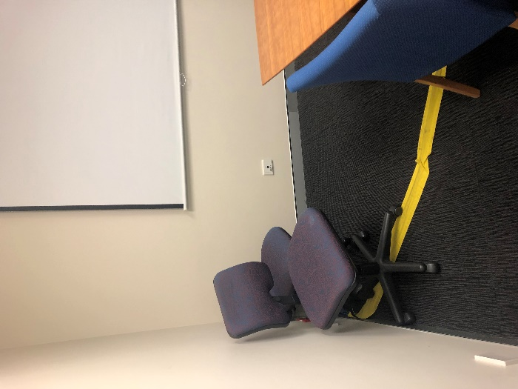It is important you arrive before the learners and with adequate time to prepare yourself and the venue. As the trainer, you are responsible for providing a safe learning environment. You should identify and minimise any risks as they arise and where this is not possible, bring them to the attention of your learners. For example, if there is an extension cord that could be a tripping hazard, tape it to the floor and ask learners to avoid the area (Figure 2). Chairs can be placed in a way that channels learners away from the hazard.
2. Other hazards to be mindful of include slippery or uneven surfaces, poor lighting, inadequate ventilation and excess or broken furniture in the room. Locate the emergency exits, notify learners of their location and keep access to them clear.
3. Arriving early also allows you to set up the room. Consider how you want the tables to be arranged. See the table below for some examples.
4. Figure 2 Reducing hazards in the training environment
5. Photo: Hannah Ryan.

| 1. Layout | 1. Description | 1. Suitability |
| --- | --- | --- |
|  | 1. Typical classroom layout with tables set out in rows facing the trainer | 1. Suited best to presentation or lecture-based training |
|  | 1. Tables are set up in a u-shape or semi-circle shape | 1. Suited best to training that has a lot of discussion and learner interaction |
|  | 1. Tables are clustered into groups | 1. Suited best to training that has a lot of group discussion and activities |

#### Agendas

1. Agendas are useful tools for organising a session. An agenda should include the day’s goal and a breakdown of what participants can expect. Be sure to allow enough time for questions and incorporate this into your agenda. No-one minds their training finishing early, but many learners become frustrated and distracted when the day diverges from the agenda.

#### Icebreakers

1. An icebreaker is a good way of starting any training program because it allows participants to relax, feel motivated and connect with other learners. The possibilities for icebreakers are endless. You can be specific to the topic and ask, ‘What is your favourite thing about macropods?’, ‘Why have you decided to come today?’ or ‘What are you hoping to get out of today?’. Alternatively, icebreakers don’t have to be about the course at all. Some other common icebreakers include ‘What is your favourite colour and why?’, ‘List two truths about yourself and one lie’ and ‘What would be your ideal holiday destination and why?’. There are many online resources with icebreaker suggestions. For example, to get started and work out which icebreakers work for you, see [The Best Ice Breakers for Meetings and Training Classes](https://www.thebalancecareers.com/best-ice-breakers-for-meetings-and-training-classes-1918430).

#### Presenting

1. Presenting training requires skill, enthusiasm and continual practice. Your presentation will be vital to the learner feeling engaged and energised by the content. To deliver an engaging presentation:

* If you are using PowerPoint, don’t just read from your presentation, use it as a guide only. You can use the ‘Notes’ feature to remind you of your points without overloading your slide. Don’t put too much text on your slides. Use brief dot points and pictures to make slides more interesting. (See Figure 3: which one do you find easier to read?)
* Summarise and question learners on key points.
* Ensure the technology is working – double-check embedded videos before starting the presentation.
* Look for visual cues from the audience – are learners reciprocating eye contact, are they interested in the content or are they looking bored or distracted? Adapt your approach accordingly.
* Go at an appropriate pace. If you feel nervous, breathe and slow down.
* Ensure all learners can hear you. Project your voice and adjust your tone.
* Be honest – if you don’t know the answer to someone’s question tell them, don’t try to fumble your way through. If you offer to find something out for them, make sure you do.
* Be positive. Smile and make eye contact.
* Be passionate. Share your experiences and anecdotes to reinforce learning.

1. 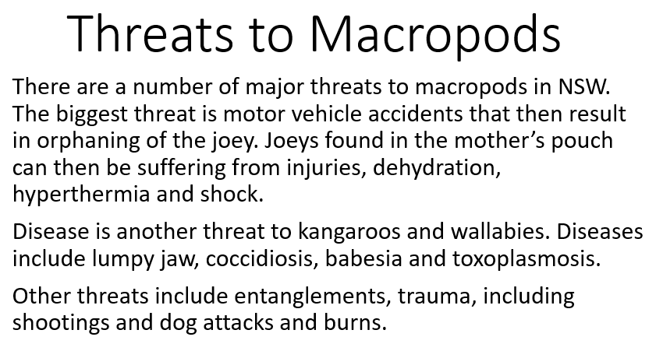

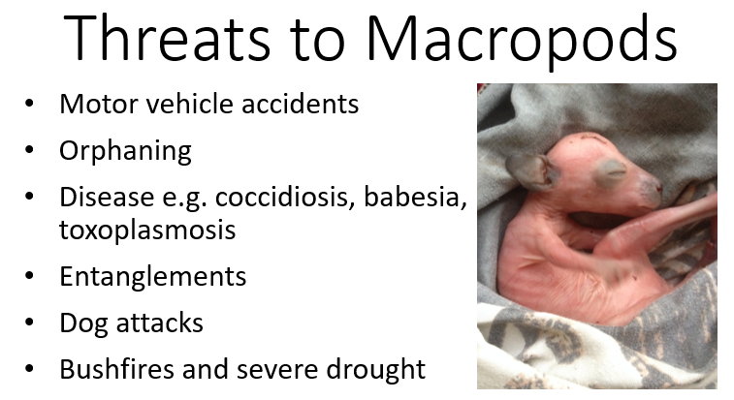

1. Figure 3 Using pictures and dot points to illustrate key messages on a PowerPoint slide

#### Dealing with difficult behaviour from learners

1. Many different types of difficult behaviours can crop up during training, and they can range from a one-off incident to disrupting the whole day. Some of the common difficult behaviours encountered during training sessions include:
2. **Have you ever witnessed these behaviours during a training session?**

* repeatedly disrupting the trainer to contradict points
* talking to other learners during a presentation
* one individual monopolising the discussion and not allowing other learners to speak
* not paying attention to the training e.g. appearing bored, using their phone
* pushing an agenda and bringing up the same argument repeatedly.

1. These behaviours can be addressed using different strategies and it can be useful to ascertain what’s causing the behaviour. For example, does the learner know the subject matter to a more advanced level, are they shy and afraid to speak to the entire group, or are they just passionate about a particular topic?
2. Setting out the ground rules at the start of the day can assist with mitigating some of these behaviours. Ground rules can include everyone showing respect for others’ opinions, or clarifying whether questions are allowed during the presentation or only at the end of each section. What do you expect from the learners and what can they expect from you?
3. Other methods you can use to manage difficult behaviours include:

* Ask the learner to hold their opinion until the end of the section.
* Address the learner who is talking to other learners by asking them their opinion on the topic, e.g. ‘What do you think, Karen?’
* Thank the learner for their opinion and ask other learners for their thoughts, e.g. ‘Thank you for sharing your opinion, what does everyone else think about this?’
* If there is a point that cannot be agreed upon, or that keeps getting brought up, you could say ‘We have spent some time on this topic and have to move on. If we have time at the end of the day, we can discuss it further.’
* If the behaviour is repeated, direct the learner to stop, e.g. ‘You are interrupting a lot, so I am going to have to stop you there and give others a chance to speak.’
* If the behaviour continues, pull the learner aside during a break and ask them why they continue to do it and request that they stop.
* If the behaviour continues and you feel it’s appropriate, ask the learner to leave the training session.

#### Getting feedback

1. Feedback is a valuable tool to evaluate your entire training program and your skills as a trainer. Don’t take feedback too personally, instead see it as an opportunity to learn, grow and improve your training.
2. There are numerous ways to obtain feedback; we will discuss a few of them here. One way to evaluate the overall effectiveness of your training and determine if your learners have obtained the relevant information is to quiz learners on the content, in accordance with the intended learning outcomes. Provide the quiz to the participants at the start of the day and then again at the end. This can be self-assessed by students, as a group or by the trainer alone. A consistent increase in scores indicates the training has been successful.
3. Feedback can also be based on informal or formal discussion throughout the day or at the end of the training. Ask learners what parts of the training they enjoyed and what could be done better. If using this method, be sure to ask specific questions and not just ones with yes or no answers. Find out why and how things can be improved.
4. A common type of feedback is asking people to complete a written questionnaire. When written well, this can be very useful for evaluating training programs. It can also be a good resource to refer back to when updating a training program, to see what worked well and what could be done better. Some tips for writing questionnaire-style feedback forms include:

* Use a sliding-scale (i.e. numbered 1–5: strongly agree – strongly disagree).
* Ask questions you want to know the answer to and that are relevant to the training.
* Don’t use language that is vague or unclear.
* Don’t rely on people writing their own answers or responses, many learners will leave this section blank.
* Keep it simple – don’t have too many questions or a busy format.

1. Some questions to consider adding to your feedback form include:

* Do you feel like you achieved the learning objectives of this training?
* Were the instructions clear and easy to follow?
* Are the course materials helpful to your learning?
* Was the facility appropriate for the training?
* Did the trainer demonstrate knowledge of the subject matter?
* Did the trainer communicate clearly?
* What did you like most about the training?
* What could be improved?
* Would you recommend this course to a friend?
* Please provide any additional feedback in the space below.

1. Be sure to make use of your feedback. Unused feedback benefits no-one.

## Assessment

What is competency-based assessment?

Competency-based assessment assesses a learner based on whether they can perform a task or have acquired the knowledge required for their workplace, i.e. do learners have the knowledge and skills required for their role in macropod rehabilitation. There is no grade in competency-based assessment, rather the learner is assessed as either competent or not yet competent.

1. In accordance with the [NSW Code of Practice for Injured, Sick and Orphaned Macropods](https://www.environment.nsw.gov.au/research-and-publications/publications-search/code-of-practice-for-injured-sick-and-orphaned-macropods), all macropod rehabilitation training requires an assessment of competency and at least one written assessment component.
2. Assessment is required to collect evidence that shows a learner is competent in an area and can perform the relevant tasks required of their role. For example, if you were running a training course on macropod rescue, without assessing the learner you have no way of knowing if they can apply the knowledge to macropod rescue, or use the skills they have learnt to safely rescue a macropod according to the learning outcomes in the standards.
3. [Standards for Registered Training Organisations (RTOs) 2015](https://www.legislation.gov.au/Details/F2019C00503) has principles of assessment and rules of evidence that are required of the vocational education and training (VET) sector. While your training may not be a VET-accredited course, these two tools are useful for ensuring your assessment methods are effective and ethical. These are summarised below.

### Principles of assessment

1. There are four principles of assessment:
2. **Fairness** – Individual needs of the learners are taken into account and an assessment method must not discriminate against specific learners or groups.
3. **Flexibility** – Assessments are flexible to accommodate individual learners through reflecting their needs, applying reasonable adjustments where appropriate and using multiple assessment methods.
4. **Validity** – Assessment is based on and assesses to the required benchmark, i.e. assessments meet the requirements in the standards. Assessment must also be based on evidence that demonstrates the learner can apply the skills and knowledge required of their role.
5. **Reliability** – Evidence is interpreted consistently and accurately regardless of who the trainer or assessor is.

### Rules of evidence

1. When assessing the competency of a learner you must consider the following four rules of evidence:
2. **Validity** – You are confident the learner has the skills and knowledge outlined in the standards.
3. **Sufficiency** – There is enough quality evidence to assess competency.
4. **Authenticity** – You are confident the work submitted is that of the learner and no-one else.
5. **Currency** – The assessment evidence has been compiled within a suitable timeframe and reflects the learner’s current level of skill and knowledge. This could be applied to the refresher time frame where further training is required to be completed every four years.

### Types of assessment methods

* **Questioning** – written or oral, e.g. conducting interviews, multiple choice quizzes, written short answer questions.
* **Direct observation** – observing performance during simulated or real-world tasks.
* **Product-based methods** – structured activities, e.g. presentations, role plays, reports and work-based projects.
* **Third-party evidence** – involves having a supervisor, manager or equivalent attest to the competency of your learner or providing a supporting statement or letter.
* **Portfolio** – a collection of evidence compiled by the learner to demonstrate competency, e.g. a logbook, photographs or videos.

1. Use a variety of methods to ensure the assessment is valid and allows the learner to demonstrate competency in different ways. This also makes the assessment process more interesting and engaging for the learner.
2. Some methods such as questioning and product-based methods are more suited to assessing competency of knowledge, whereas other methods such as direct observation and third-party evidence can be used to assess competency in skill or practical application.

## Record keeping

1. Record keeping is an important aspect of training. Having accurate records that are easily available to authorised people will go a long way to ensuring you have a smooth process in place for knowing who is trained in your organisation. As a minimum you should keep a signed attendance register and a record of whether competency was achieved by the learner for each training session. In addition to this you should keep records of each assessment event and whether competency was achieved.
2. Having these records will assist your organisation in knowing who is trained, who is due for refresher training, and when training was last held. It is also useful information to maintain in the event your organisation is audited and needs to demonstrate compliance with the codes of practice and training standards.
3. Also consider what record you might provide to the learner so they can demonstrate competency and completion of a particular training session. A certificate of competency is a useful record for the learner as they can keep it in their personal files and provide it as evidence of training completed if needed.

# Part 2: Understanding the macropod rehabilitation training standards

## Introduction

1. This section looks at the macropod rehabilitation training standards in more detail.
2. This includes possible topics that could be included in training courses (listed under the heading ‘Training areas’for each standard). Not all these topics will need to be covered, as your training may be specific to a particular type of role and certain areas may not be applicable. The suggested training areas are intended to guide you in thinking about what may be considered in the context of each standard.
3. There are also recommendations for the types of assessments. Each standard is accompanied by two examples of assessments that could be used to assess competency. The assessments are examples only and do not have to be used. You may want to use them as ideas to create your own assessments. If you do use these assessments though, you must have covered the topics in your content to ensure your assessment process is fair and accurate.

## Understanding the format of the training standards

1. **Standard 1: The framework of macropod rehabilitation in NSW**
2. Each standard has a heading that describes the overall topic of the standard.
3. The objective of a standard explains what the standards are trying to achieve, i.e. its aim.
4. These points explain what must be included within training for it to be compliant with the training standards. The organisation or trainer is responsible for ensuring this information in included in training.
5. Learning outcomes describe what a learner will be able to do upon completion of a standard. A learner is deemed competent when they can demonstrate the learning outcomes.
6. **Objective:** To familiarise learners with the relevant policies and procedures of macropod rehabilitation and provide them with an understanding of the framework that exists to support and regulate macropod rehabilitation in New South Wales. Learners must be aware of and understand the [NSW Code of Practice for Injured, Sick and Orphaned Macropods](https://www.environment.nsw.gov.au/-/media/OEH/Corporate-Site/Documents/Animals-and-plants/Wildlife-management/code-of-practice-macropods-180301.pdf) (the Macropod Code).
7. To be compliant with this standard, a rehabilitation organisation must:
   * 1. Discuss the Macropod Code.
     2. Ensure organisational policies and procedures applicable to macropod rehabilitation are defined and understood by learners.

|  |  |
| --- | --- |
| 1. Learning Outcomes | 1. Sections in the Code |
| 1. Upon completion of this module, learners will be able to:  * identify and demonstrate understanding of the [Macropod](https://www.environment.nsw.gov.au/-/media/OEH/Corporate-Site/Documents/Animals-and-plants/Wildlife-management/code-of-practice-macropods-180301.pdf) Code * identify organisational policies and procedures on macropod rehabilitation * recognise the objectives of macropod rehabilitation. | 1. All |

## Standard 1: The framework for macropod rehabilitation in New South Wales

**Objective:** To familiarise learners with the relevant policies and procedures for macropod rehabilitation and provide them with an understanding of the framework that exists to support and regulate macropod rehabilitation in New South Wales.

Learners must be aware of and understand the [NSW Code of Practice for Injured, Sick and Orphaned Macropods](https://www.environment.nsw.gov.au/research-and-publications/publications-search/code-of-practice-for-injured-sick-and-orphaned-macropods) (the Macropod Code).

To comply with this standard, a rehabilitation organisation must:

1.1 Discuss the Macropod Code.

1.2 Ensure organisational policies and procedures applicable to macropod rehabilitation are defined and understood by learners.

| 1. **Learning outcomes** | 1. **Sections in the Code** |
| --- | --- |
| 1. Upon completion of this module, learners will be able to:  * identify and demonstrate understanding of the Macropod [Code](https://www.environment.nsw.gov.au/-/media/OEH/Corporate-Site/Documents/Animals-and-plants/Wildlife-management/code-of-practice-macropods-180301.pdf) * identify organisational policies and procedures for macropod rehabilitation * recognise the objectives of macropod rehabilitation. | 1. All |

### Training areas

* The Macropod Code can be accessed online: [Code of Practice for Injured Sick and Orphaned Macropods](https://www.environment.nsw.gov.au/research-and-publications/publications-search/code-of-practice-for-injured-sick-and-orphaned-macropods).
* Organisational policies and procedures relevant to macropod rehabilitation could include:
  + standard operating procedures
  + organisational overview
  + work health and safety policies
  + code of ethics
  + code of conduct
  + role descriptions
  + constitution
  + conflict resolution
  + bullying and harassment
  + reimbursement
  + working with vets and building strong relationships
  + reporting requirements and reporting chain of command
  + release procedures
  + protocols for contacting veterinarians and more experienced wildlife rehabilitators.

### Suggested assessments

1. The information covered in this standard is largely theory and so would be best suited to written or verbal assessment.

#### Standard 1: Assessment 1 – the Macropod Code quiz

##### Trainer/Assessor instructions:

1. *This is an example of the type of assessment that could be used to assess competency in relation to Standard 1.*

##### Learner instructions:

1. *Use the Macropod Code to complete the following multiple choice quiz.*
2. The development of the Macropod Code was guided by four key principles. From the list below, select the four key principles which apply to all aspects of macropod rescue rehabilitation and release.
   1. Prioritise the welfare of macropods
   2. Avoid harm to wild macropod populations and other wildlife communities
   3. Contribute to research on macropod behaviour
   4. Minimise the risks to human health and safety
   5. Optimise capacity to care.
3. *Answer: A, B, D and E.*
4. Which of the following describes the mandatory specific actions for macropod rehabilitation, as described by the Code?
   1. Guidelines
   2. Standards
   3. Notes
   4. Objectives.
5. *Answer: B. Standards.*
6. Draw a line to match each of the following stages of development with its description:

Pouch young Weaned macropods

Young-at-foot Sexually mature macropods

Subadult Fully emerged joeys

Adult Aged macropods with rear molars only

Geriatric Unfurred joeys to joeys beginning to emerge from the pouch

1. *Answer: Can be found in ‘1.4 Stages of development in macropods’ in the Macropod Code.*
2. Rescuers must arrange for a macropod to be assessed by a veterinarian or experienced macropod rehabilitator within 48 hours of rescue.

True

False

*Answer: False, rescuers must arrange assessment within 24 hours.*

1. Which of the following is **not** an appropriate method for rescuing a macropod?
   1. Tying its legs
   2. Noosing with a rope
   3. Pursuing it for a prolonged period
   4. All of the above.
2. *Answer: D. All of the above.*
3. Covering a macropod’s head with a towel, blanket or bag will often help calm it down.
4. True
5. False
6. *Answer: True.*
7. Hessian sacks are an appropriate material to rescue and transport macropods in.
8. True
9. False
10. *Answer: False. Hessian sacks must not be used as the macropod’s claws can become entangled and threads can irritate the eyes.*
11. From which direction should you approach a recumbent macropod?
    1. Behind
    2. Front
    3. Sideways
    4. You should never approach a recumbent macropod.
12. *Answer: A. You should always approach a recumbent macropod from behind.*
13. Which of the following must a rescuer assess during rescue of a macropod?
    1. Risks to the macropod from capture and environmental hazards
    2. Risks to themselves
    3. Risks to members of the public
    4. All of the above.
14. *Answer: D. All of the above.*
15. Which of the following statements about rescuing a joey is **not** true
    1. A joey attached to the teat can be removed by applying gentle pressure to the sides of its mouth.
    2. If a joey is attached to the teat, and the mother is deceased, you can cut the teat close to the mother’s body to remove the joey from the pouch.
    3. Joeys should be removed by pulling the legs out first and gently placing in a pouch.
    4. A joey should be removed from the pouch by placing a hand behind its back and gently scooping it up.
16. *Answer: C. Joeys should not be pulled by the legs or limbs.*
17. Macropods are easily stressed.
18. True
19. False
20. *Answer: True.*
21. Which of the following is the objective of **Section 6.3 Controlling disease between animals** in the Code?
    1. To ensure the macropod has a feeding and watering regime that encourages rapid recovery
    2. To check the health of a macropod undergoing rehabilitation so that issues can be promptly identified and managed
    3. To prevent the spread of diseases among macropods undergoing rehabilitation
    4. To maintain clean rehabilitation facilities so diseases are prevented or contained.
22. *Answer: C. To prevent the spread of diseases among macropods undergoing rehabilitation.*
23. Which of the following is the minimum size recommended for pre-release housing of medium-sized macropods?
    1. 40 metres long x 30 metres wide x 2-metre-high fencing
    2. 30 metres long x 20 metres wide x 1.8-metre-high fencing
    3. 60 metres long x 40 metres wide x 1.8-metre-high fencing
    4. 20 metres long x 25 metres wide x 2-metre-high fencing.

*Answer: B.30 metres long x 20 metres wide x 1.8-metre-high fencing.*

1. During intensive housing, pouched young must be positioned in an artificial pouch in a manner that mimics the natural position in its mother’s pouch.

True

False

*Answer: True. Although some injuries may require pouch young to lie flat.*

1. A macropod must not be released until it is behaviourally ready. This has been achieved when which of the following occurs?
   1. It can recognise and consume appropriate naturally available food and water.
   2. It can recognise and avoid predators, including pets.
   3. It is not attracted to humans.
   4. All of the above.
2. *Answer: D. All of the above.*
3. If the location where the macropod was found is assessed to be an unsuitable environment for release:
   1. The macropod must not be released.
   2. The macropod must be released in a suitable environment as near as possible to this location.
   3. The macropod must still be released back into the unsuitable environment.
   4. The macropod must be released in a suitable environment as far from this location as possible.
4. *Answer: B. The macropod must be released in a suitable environment as near as possible to this location.*
5. Which of the following is **not** true about releasing a macropod.
   1. Once ready for release, it must released as soon as conditions are suitable.
   2. It must be released at a time of day with enough daylight to enable it to visually investigate its environment.
   3. It must only be done after the animal has reached sexual maturity.
   4. Hand-reared macropods must be released based on both weight and stage of development.
6. *Answer: C. It must only be done after the animal has reached sexual maturity. Hand-reared joeys should be released before reaching sexual maturity.*
7. Which of the following is not a minimum mandatory requirement for reporting?
   1. Encounter details
   2. Species name
   3. Fate
   4. Type of release.
8. *Answer: D. Type of release. While this is good information to record it is not part of the minimum mandatory reporting requirements.*

#### Standard 1: Assessment 2 – Organisational policies on macropod rehabilitation questionnaire

##### Trainer/Assessor instructions:

1. *This is an example of the type of assessment that could be used to assess competency in relation to Standard 1. This assessment can be provided as a written or verbal activity. The answers provided for each question are examples only; answers provided by learners must be specific to their organisation.*

##### Learner instructions:

1. *Provide answers to each of the questions below.*
2. What is the objective of macropod rehabilitation for your group? This might be expressed as guiding principles or a mission statement.

Click or tap here to enter text.

1. *Answers could include:*

* The main objective is to return all native fauna back to its wildlife habitat when fit to fend for itself (NATF).
* To actively rehabilitate and preserve Australian wildlife and inspire others to do the same (WIRES).

1. List three policies or documents you need to be familiar with to rehabilitate macropods.

Click or tap here to enter text.

1. *Answers could include:*

* standard operating procedures
* codes of practice, ethics or conduct
* constitution
* petrol reimbursement policy
* facility policy
* work health and safety procedures or policies.

1. Who do you need to report a macropod rescue to?

Click or tap here to enter text.

1. *Answers could include:*

* clinical director
* supervisor
* macropod coordinator
* care coordinator.

1. What are your organisation’s protocols for seeking veterinary assistance?

Click or tap here to enter text.

1. *Answers could include:*

* calling first to make an appointment
* any expensive procedures or medications must be approved by the coordinator
* required for any rescued macropod.

1. List two positions within the organisation and explain their role in macropod rehabilitation.

Click or tap here to enter text.

1. *Answers could include:*

* macropod coordinator – oversees rescues and animals brought into care
* mentor – assists new volunteers with rehabilitation, providing advice and support
* rescue coordinator – coordinates roster and rescues from the hotline
* training officer – updates macropod training and informs members of when training is available.

## Standard 2: Work health and safety requirements of macropod rehabilitation

**Objective:** To ensure that learners are able to prioritise their safety and that of the people around them when undertaking macropod rescue and rehabilitation.

To comply with this standard, a rehabilitation organisation must:

2.1 Explain the work health and safety (WHS) risks associated with the site, equipment or activity and how they can be minimised.

2.2 Explain the WHS risks associated with handling and restraining macropods and how they can be minimised.

2.3 Discuss the WHS risks associated with zoonotic diseases relevant to macropods and how they can be minimised.

2.4 Discuss rehabilitator wellbeing and the potential mental health impacts of wildlife rehabilitation.

| 1. **Learning outcomes** | 1. **Section in the Code** |
| --- | --- |
| 1. Upon completion of this module, learners will be able to:  * identify WHS risks associated with macropod rehabilitation * employ techniques to minimise the WHS risks to themselves and other people. | 1. 3. Rescue 2. 5. Euthanasia 3. 6. Care procedures 4. 7. Husbandry |

### **Training areas**

* WHS risks associated with the site, equipment or activity could include:
  + traffic
  + uneven surfaces
  + weather and extremes of temperature
  + broken equipment
  + working in low light conditions
  + sharp edges
  + chemicals and other hazardous agents.
* WHS risks associated with handling and restraining macropods could include:
  + physical injury from macropod including kicks, scratches
  + injury from heavy lifting.
* WHS risks associated with zoonotic diseases could include:
  + zoonoses associated with macropods (e.g. salmonella, Q fever, ringworm)
  + personnel safety (hygiene and disinfection practices, personal protective equipment [PPE], vaccination).
* Minimising WHS risks could include:
  + ensuring correct training has been completed before undertaking a task
  + wearing correct PPE
  + using correct equipment
  + two people lifting
  + minimising handling.

### Suggested assessments

1. For this standard, assessment would be best suited to written or verbal methods, practical assessment, or a combination of these.

#### Standard 2: Assessment 1 – WHS requirements for macropod rehabilitation

##### Trainer/Assessor instructions:

1. *This is an example of the type of assessment that could be used to assess competency in relation to Standard 2.*

##### Learner instructions:

1. *For each of the three activities listed below, explain the WHS risks associated with them and three things you could do to minimise these risks.*
2. Pouch-checking a female macropod that has been hit by a car. The macropod is deceased next to a moderately busy road.

|  |  |
| --- | --- |
| 1. **WHS risks** | 1. **How will you minimise these risks?** |
| 1. Click or tap here to enter text. | 1. Click or tap here to enter text. |
| 1. Click or tap here to enter text. | 1. Click or tap here to enter text. |
| 1. Click or tap here to enter text. | 1. Click or tap here to enter text. |

1. Rescuing a ‘fence hanger’ macropod.

| 1. **WHS risks** | 1. **How will you minimise these risks?** |
| --- | --- |
| 1. Click or tap here to enter text. | 1. Click or tap here to enter text. |
| 1. Click or tap here to enter text. | 1. Click or tap here to enter text. |
| 1. Click or tap here to enter text. | 1. Click or tap here to enter text. |

1. Rehabilitating a macropod joey with signs of ringworm infection in intensive care housing.

| 1. **WHS risks** | 1. **How will you minimise these risks?** |
| --- | --- |
| 1. Click or tap here to enter text. | 1. Click or tap here to enter text. |
| 1. Click or tap here to enter text. | 1. Click or tap here to enter text. |
| 1. Click or tap here to enter text. | 1. Click or tap here to enter text. |

#### 

#### Standard 2: Assessment 2 – Rehabilitator wellbeing

##### Trainer/Assessor instructions:

1. *This is an example of the type of assessment that could be used to assess competency in relation to Standard 2. Split the learners into smaller groups with fewer than 10 learners to a group, and get them to discuss and answer the questions below. When the groups have completed their discussions come together and discuss what each group came up with.*

##### Learner instructions:

1. *In your group discuss and answer the questions below. Once this has been completed, choose a representative to speak on behalf of your group to share your ideas.* 
   1. What is wellbeing?
   2. What are some of the potential impacts on wellbeing for rehabilitators?
   3. What are the signs of these impacts?
   4. How can you minimise these impacts?
   5. Who should you talk to in these situations?
   6. What processes does your organisation have in place to support rehabilitator wellbeing?

## Standard 3: Record keeping

**Objective:** To explain the record keeping requirements for macropod rehabilitation.

To comply with this standard, rehabilitation organisations must:

3.1 Explain the NPWS reporting requirements.

3.2 Explain organisational reporting requirements.

| 1. **Learning outcomes** | 1. **Sections in the Code** |
| --- | --- |
| 1. Upon completion of this module, learners will be able to:  * keep records in accordance with NPWS and organisational requirements. | 1. 12. Record keeping |

### Training areas

* The Code can be accessed online: [Code of Practice for Injured Sick and Orphaned Macropods](https://www.environment.nsw.gov.au/research-and-publications/publications-search/code-of-practice-for-injured-sick-and-orphaned-macropods).
* NPWS [reporting requirements](https://www.environment.nsw.gov.au/research-and-publications/publications-search/volunteer-wildlife-rehabilitation-sector-data-reporting-instructions) could include:
  + detailed record report
  + combined report
  + licence conditions
  + discussing the benefits of collecting robust data
  + an overview of where the data is being used and why it is important
  + [annual reports](https://www.environment.nsw.gov.au/research-and-publications/publications-search/nsw-wildlife-rehabilitation-annual-report-2018-19).
* Organisational reporting requirements could include:
  + husbandry plans
  + measurement of head, tail and foot length
  + body weight
  + veterinary-prescribed medications and treatment plans
  + feeding charts
  + rescue details
  + release details.

### Suggested assessments

1. The information covered in this standard is largely theory and so would be best suited to written or verbal assessment.

#### Standard 3: Assessment 1 – Record sheet

##### Trainer/Assessor instructions:

1. *This is an example of the type of assessment that could be used to assess competency in relation to Standard 3.*

##### Learner instructions:

1. *Read the case study and complete the corresponding NPWS report sheet.*
2. A young male eastern grey kangaroo (ID number: WD123456) joey was rescued from his mother’s pouch after being hit by a car on Friday 27 September 2019 on the main highway at 212 Fake Highway, Anonville. He had been impacted by the car and had a fractured arm. You have rehabilitated the macropod, who you have named Jim, and released him six months later. His release site was away from the road in more suitable habitat at 12 Eucalypt Way, Anonville.

|  |  |
| --- | --- |
| 1. Species name | 1. Click or tap here to enter text. |
| 1. ID number | 1. Click or tap here to enter text. |
| 1. Date of encounter | 1. Click or tap here to enter text. |
| 1. Encounter type | 1. Click or tap here to enter text. |
| 1. Location address | 1. Click or tap here to enter text. |
| 1. Location suburb/town | 1. Click or tap here to enter text. |
| 1. Location postcode | 1. Click or tap here to enter text. |
| 1. Animal condition | 1. Click or tap here to enter text. |
| 1. Sex | 1. Click or tap here to enter text. |
| 1. Life stage | 1. Click or tap here to enter text. |
| 1. Initial weight | 1. Click or tap here to enter text. |
| 1. Pouch condition | 1. Click or tap here to enter text. |
| 1. Rehabilitator name | 1. Click or tap here to enter text. |
| 1. Fate | 1. Click or tap here to enter text. |
| 1. Date of fate | 1. Click or tap here to enter text. |
| 1. Release location address | 1. Click or tap here to enter text. |
| 1. Release location suburb | 1. Click or tap here to enter text. |
| 1. Release location postcode | 1. Click or tap here to enter text. |
| 1. Tag/band/ colour and number | 1. Click or tap here to enter text. |
| 1. Microchip number | 1. Click or tap here to enter text. |

#### Standard 3: Assessment 2 – Record keeping in your organisation

##### Trainer/Assessor instructions:

1. *This is an example of the type of assessment that could be used to assess competency in relation to Standard 3.*

##### Learner instructions:

1. *Answer the following questions regarding your organisation’s record keeping requirements.*
2. List five types of information your organisation records for macropods in care:
   1. Click or tap here to enter text.
   2. Click or tap here to enter text.
   3. Click or tap here to enter text.
   4. Click or tap here to enter text.
   5. Click or tap here to enter text.
3. Why is record keeping important to your organisation?

|  |
| --- |
| 1. Click or tap here to enter text. |

1. Design a record sheet that could be used to comply with your organisation’s record keeping procedures. Your record sheet could include weights, observations and treatment schedules.

## Standard 4: Biology and behaviour of macropods

**Objective:** To ensure detailed knowledge of the macropod is taught to learners. This is done by providing learners with the foundational tools to understand macropod biology and behaviour and how these aspects inform interactions with macropods undergoing rehabilitation.

To comply with this standard, a rehabilitation organisation must:

4.1 Explain features of macropod biology including anatomy, physiology, social structure, stages of development, and habitat and relate them to macropod rehabilitation.

4.2 Provide the tools and understanding required to identify different species of macropods.

4.3 Provide the tools and understanding required to identify normal behaviours in macropods.

4.4 Provide the tools and understanding required to recognise signs of abnormal behaviour in macropods.

| Learning outcomes | Sections in the Code |
| --- | --- |
| Upon completion of this module, learners will be able to:   * + - * relate macropod biology and behaviour to macropod rehabilitation       * recognise signs of normal behaviour in macropods       * recognise signs of abnormal behaviour in macropods. | All |

### **Training** areas

* Features of macropod biology could include:
  + gastrointestinal anatomy and physiology
  + musculoskeletal anatomy and physiology
  + dentition
  + thermoregulation during different stages of development
  + embryonic diapause and reproduction
  + social behaviour depending on species (solitary versus gregarious)
  + merycism
  + locomotion
  + habitat.
* The macropod species in New South Wales can be found in Appendix 1 of the [Code of Practice for Injured, Sick and Orphaned Macropods](https://www.environment.nsw.gov.au/research-and-publications/publications-search/code-of-practice-for-injured-sick-and-orphaned-macropods). Tools and understanding required to identify species could include:
* how to use a field guide
* species differences during stages of development
* species that are known to occur in the local area.
* Normal behaviours for macropods could include:
  + nocturnal or crepuscular (twilight) activity
  + thermoregulatory behaviours
  + bright and alert demeanour
  + nervous behaviours (easily stressed).
* Abnormal behaviours for macropods could include:
  + not fleeing on approach
  + remaining in the same place for days
  + being unresponsive.

### Suggested assessments

1. The information covered in this standard is largely theory and so would be best suited to written or verbal assessment.

#### Standard 4: Assessment 1 – Macropod behaviour in rehabilitation

##### Trainer/Assessor instructions:

1. *This is an example of the type of assessment that could be used to assess competency in relation to Standard 4.*

##### Learner instructions:

1. *Explain why it is important for macropod rehabilitators to understand macropod behaviour. In your answer provide at least one example of normal behaviour and one example of abnormal behaviour.*

|  |
| --- |
| 1. Click or tap here to enter text. |

#### Standard 4: Assessment 2 – Macropod biology and behaviour quiz

##### Trainer/Assessor instructions:

1. *This is an example of the type of assessment tool that could be used to assess competency of Standard 4.*

##### Learner instructions:

1. *Complete the following quiz by selecting the correct choice for multiple choice questions and providing a written response for the short answer questions.*
2. Macropods are marsupials.
3. True
4. False
5. *Answer: True.*
6. Macropods have the most well insulated fur of any marsupial in Australia.
7. True
8. False
9. *Answer: False. This is true of the koala.*
10. Which of the following species is a browser?
    1. Swamp wallaby
    2. Eastern grey kangaroo
    3. Red kangaroo
    4. Western grey kangaroo
11. *Answer: A. Swamp Wallaby.*
12. Which of the following statements about macropods is **not** true?
    1. Macropods are hind-gut fermenters
    2. Macropods are prone to stress
    3. Macropods are predominantly herbivorous

* 1. Macropods are prone to imprinting

1. *Answer: A. Macropods are hind-gut fermenters. Macropods are foregut fermenters.*
2. Which of the following species make a nest in grass?
3. A.  Wallaroos
4. B.  Bettongs
5. C.  Potoroos
6. D.  Wallabies
7. *Answer: B. bettongs.*
8. Macropod milk composition changes significantly over the period of lactation.
9. True
10. False
11. *Answer: True.*
12. When a macropod is hot, which of the following thermoregulatory actions will it use to cool down?
    1. Sweating
    2. Panting
    3. Licking its forearms

* 1. All of the above.

1. *Answer: D. All of the above*
2. List three signs of a healthy macropod:
   1. Click or tap here to enter text.
   2. Click or tap here to enter text.
   3. Click or tap here to enter text.
3. List three signs of a distressed macropod:
   1. Click or tap here to enter text.
   2. Click or tap here to enter text.
   3. Click or tap here to enter text.
4. Which of the following statements is incorrect?
   1. Merycism is a normal process in macropods.
   2. Merycism is only seen in joeys.
   3. Merycism is a process of involuntary regurgitation.
   4. The function of merycism is unknown.

*Answer: B Merycism is only seen in joeys.*

## Standard 5: Stress management in macropods

**Objective:** To communicate the importance of managing stress in macropods and to provide mechanisms for minimising this stress.

To comply with this standard, rehabilitation organisations must:

5.1 Explain the effects of stress on a macropod at various stages of rescue and rehabilitation and any differences between macropod species.

5.2 Discuss myopathy in relation to stress in macropods.

5.3 Provide the tools and understanding required to recognise signs of stress in a macropod.

5.4 Discuss methods for minimising stress on a macropod at stages of rescue and rehabilitation.

| Learning outcomes | Sections in the Code |
| --- | --- |
| Upon completion of this module, learners will be able to:   * + - * recognise signs of stress in macropods and its impact       * apply methods for minimising stress on a macropod. | 3. Rescue  4. Transport  5. Euthanasia  6. Care procedures  7. Husbandry  8. Housing  10. Release considerations |

### **Training areas**

* Effects of stress could include:
  + myopathy
  + sudden death
  + decreased immune function
  + disease
  + prolonged time in rehabilitation.
* Discussion on myopathy could include:
  + causes of myopathy
  + symptoms
  + acute and chronic presentation
  + prevention.
* Signs of distress could include:
  + rapid breathing or panting
  + licking of forearms, drooling
  + coughing vocalisation
  + weight loss
  + candida infection
  + diarrhoea
* Methods for minimising stress could include:
  + covering the head
  + providing a warm, dark and quiet environment
  + pain relief
  + correct handling techniques
  + sedation
  + minimising handling
  + keeping domestic animals away
  + getting appropriate and prompt help
  + covering the cage
  + controlling temperature
  + driving carefully, i.e. no sudden movements
  + stopping activity if a macropod is too stressed.

### Suggested assessments

1. Assessment relating to this standard would be best suited to written or verbal methods, practical assessment, or a combination of these.

#### Standard 5: Assessment 1 – Signs of stress

##### Trainer/Assessor instructions:

1. *This is an example of the type of assessment that could be used to assess competency in relation to Standard 5.*

##### Learner instructions:

1. *Use the space provided to explain the effects of stress on macropods. In your answer include examples of the effect stress has on the body of a macropod, what indications you would be looking for to determine if a macropod is stressed, and what you would do to minimise this stress.*

|  |
| --- |
| Click or tap here to enter text. |

#### Standard 5: Assessment 2 – Minimising stress

##### Trainer/Assessor instructions:

1. *This is an example of the type of assessment that could be used to assess competency in relation to Standard 5. This assessment can be provided as a written or verbal activity.*

##### Learner instructions:

1. *For each of the scenarios below explain how you would minimise stress for the macropod.* 
   1. Rescuing an adult macropod by the side of the road. It is a warm day. There are many onlookers by the time you arrive, and you can see that the macropod is injured and will need veterinary attention.  
      Click or tap here to enter text.
   2. A macropod is being transported to a pre-release yard that is one hour away.   
      Click or tap here to enter text.
   3. A macropod joey has been found in the pouch of its deceased mother.   
      Click or tap here to enter text.

## Standard 6: Rescue of macropods

**Objective:** To ensure learners have the skills to safely, efficiently and humanely rescue a macropod.

To comply with this standard, a rehabilitation organisation must:

6.1 Outline common reasons for macropod rescue.

6.2 Detail how to perform an assessment, including the use of the decision tree in the Macropod Code, to establish the appropriate course of action.

6.3 Detail the correct method and equipment required to capture, handle and rescue a macropod, as suitable to the species and common rescue situations, conditions and age of a macropod.

6.4 Detail how to rescue a macropod to humanely minimise pain, stress and potential injury.

| Learning outcomes | Sections in the Code |
| --- | --- |
| Upon completion of this module, learners will be able to:   * + - * list the common reasons why macropods require rescue       * assess a rescue situation and plan the rescue of a macropod       * safely rescue a macropod using correct equipment       * determine the type of intervention required at a rescue site. | 2. Case assessment  3. Rescue  4. Transport  5. Euthanasia |

### Training areas

* The Code can be accessed online: [Code of Practice for Injured Sick and Orphaned Macropods](https://www.environment.nsw.gov.au/research-and-publications/publications-search/code-of-practice-for-injured-sick-and-orphaned-macropods).
* Guidelines can be accessed online: [Guidelines for the Initial Treatment and Care of Rescued Macropods](https://preview.environment.nsw.gov.au/research-and-publications/publications-search/guidelines-for-the-initial-treatment-and-care-of-rescued-macropods).
* Common reasons macropods need to be rescued include:
  + motor vehicle accidents
  + being orphaned
  + disease
  + being attacked or chased by dogs
  + being trapped in unsuitable places
  + bushfire
  + being caught in a fence.
* Performing an assessment could include:
  + assessing the situation – is it safe?
  + ensuring correct equipment
  + ensuring correct number of trained personnel are available to conduct the rescue
  + identifying obstacles and WHS risks
  + identifying escape routes and risks to the macropod
  + performing a distance examination before approaching the animal.
* An appropriate course of action could include:
  + rescue
  + monitoring the macropod
  + euthanasia on site
  + relocating the macropod
  + transporting the animal to a vet
  + transporting to animal to an experienced macropod rehabilitator.
* Methods for rescuing a macropod could include:
  + bagging
  + grabbing the animal by the base of the tail and bagging it
  + removing a joey attached to the teat by applying gentle pressure to the sides of the mouth or by cutting the teat close to a deceased mother’s body
  + approaching a recumbent macropod from behind
  + moving off the road before attempting a pouch check
  + enveloping the animal in a blanket
  + sedating or immobilisation of adult macropods.
* Equipment to rescue a macropod could include:
  + canvas bags
  + blankets
  + thick towels
  + binoculars for observation from a distance
  + rescue carrier or cage
  + heat source for joeys
  + surgical scissors to cut a teat
  + pouches.
* Minimising pain, stress and further injury could include:
  + ensuring correct training has been completed before undertaking a task
  + performing correct rescue and handling techniques for the condition of the animal
  + covering the animals head to minimise stress
  + removing onlookers and domestic pets
  + reducing auditory and visual stimuli.

### Suggested assessments

1. Assessment in relation to this standard would be best done through a practical assessment or in a simulated environment that accurately represents rescue conditions.

#### Standard 6: Assessment 1 – Macropod rescue case studies

##### Trainer/Assessor instructions:

1. *This is an example of the type of assessment could be used to assess competency in relation to Standard 6.*

##### Learner instructions:

1. *Read each of the rescue case studies and complete the corresponding questions.*

##### Case study 1:

1. You have been called out to rescue an adult swamp wallaby that has been hit by a car. It is laying on the side of a suburban road with a fractured leg.
2. What WHS risks have you identified for the rescue site?  
   Click or tap here to enter text.
3. What WHS risks have you identified for handling the macropod?  
   Click or tap here to enter text.
4. What will you do to minimise the WHS risks associated with this rescue scenario?  
   Click or tap here to enter text.
5. What information do you obtain from your visual assessment of the animal?   
   Click or tap here to enter text.
6. What outcome do you get when using the decision tree in the Macropod Code?  
   Click or tap here to enter text.
7. Describe how you will rescue the macropod.  
   Click or tap here to enter text.
8. What equipment will you use?  
   Click or tap here to enter text.
9. How do you intend to minimise further stress or injury to the macropod?  
   Click or tap here to enter text.

##### Case study 2:

1. You are called out to rescue an adult eastern grey kangaroo on the ground on a 35°C day. The caller said it has been sitting in the same spot for at least three hours. The kangaroo is sitting under a tree inside a fenced yard on a property with three dogs roaming around. You cannot see any signs of injury or blood when you conduct a visual assessment of the macropod.
2. What WHS risks have you identified for the rescue site?  
   Click or tap here to enter text.
3. What WHS risks have you identified for handling the macropod?  
   Click or tap here to enter text.
4. What will you do to minimise the WHS risks associated with this rescue scenario?  
   Click or tap here to enter text.
5. What information do you obtain from your visual assessment of the animal?   
   Click or tap here to enter text.
6. What outcome do you get when using the decision tree in the Macropod Code?  
   Click or tap here to enter text.
7. Describe how you will rescue the macropod.  
   Click or tap here to enter text.
8. What equipment will you use?  
   Click or tap here to enter text.
9. How do you intend to minimise further stress or injury to the macropod?  
   Click or tap here to enter text.

##### Case study 3:

1. You are called out to rescue a joey in the pouch of a deceased mother. The mother’s body is laying on the side of a busy highway. The joey is attached to the teat, has its eyes and ears open and a slight covering of fur.
2. What WHS risks have you identified for the rescue site?  
   Click or tap here to enter text.
3. What WHS risks have you identified for handling the macropod?  
   Click or tap here to enter text.
4. What will you do to minimise the WHS risks associated with this rescue scenario?  
   Click or tap here to enter text.
5. What information do you obtain from your visual assessment of the animal?   
   Click or tap here to enter text.
6. What outcome do you get when using the decision tree in the Macropod Code?  
   Click or tap here to enter text.
7. Describe how you will rescue the macropod.  
   Click or tap here to enter text.
8. What equipment will you use?  
   Click or tap here to enter text.
9. How do you intend to minimise further stress or injury to the macropod?  
   Click or tap here to enter text.

#### Standard 6: Assessment 2 – Macropod rescue practical assessment logbook

##### Trainer/Assessor instructions:

1. *This is an example of the type of assessment that could be used to assess competency in relation to Standard 6.*

##### Learner instructions:

1. *To complete this assessment learners must:*

* complete a minimum of three macropod rescues under the supervision of an appropriately qualified member of a wildlife rehabilitation organisation
* demonstrate competency in the required rescue skills
* complete the relevant section of the logbook for each rescue event and ensure the supervising member has signed and completed the relevant section for each rescue event
* return the completed logbook to the training officer.

|  |  |
| --- | --- |
| 1. **Name:** Click or tap here to enter text. | 1. **Signature:** Click or tap here to enter text. |
| 1. **Supervisor name:** 2. Click or tap here to enter text. | 1. **Supervisor signature:** 2. Click or tap here to enter text. |
| 1. **Date completed:** Click or tap here to enter text. | |

|  |  |  |  |  |  |
| --- | --- | --- | --- | --- | --- |
| 1. **Rescue 1** | | | | | |
| 1. **Rescue/call log number:**  Click or tap here to enter text. | 1. **Unique ID number of the macropod:**  Click or tap here to enter text. | | 1. **Date:**  Click or tap here to enter text. | | |
| 1. **Location:**  Click or tap here to enter text. | | | | | |
| 1. **Rescue skill** | 1. **Learner details/observations** 2. *Learner to provide response to the rescue skills and an explanation of what was done for each skill* | 1. **Competency achieved** | | | 1. **Supervisor initial and comment** 2. *Supervisor to initial and where applicable provide constructive feedback* |
| 1. **Yes** | | 1. **No** |
| 1. Risks associated with the rescue situation are assessed and options to minimise risks are evaluated and employed as appropriate | 1. Click or tap here to enter text. |  | |  | 1. Click or tap here to enter text. |
| 1. Appropriate equipment is selected for the rescue | 1. Click or tap here to enter text. |  | |  | 1. Click or tap here to enter text. |
| 1. Appropriate rescue method is chosen for the rescue situation | 1. Click or tap here to enter text. |  | |  | 1. Click or tap here to enter text. |
| 1. Options for assisting the animal are evaluated in accordance with the decision tree in the Macropod Code | 1. Click or tap here to enter text. |  | |  | 1. Click or tap here to enter text. |
| 1. Macropod is safely rescued and action is taken to minimise stress and the potential for further injury to the macropod | 1. Click or tap here to enter text. |  | |  | 1. Click or tap here to enter text. |

| 1. **Rescue 2** | | | | | |
| --- | --- | --- | --- | --- | --- |
| 1. **Rescue/call log number:**  Click or tap here to enter text. | 1. **Unique ID number of the macropod:** 2. Click or tap here to enter text. | | 1. **Date:** Click or tap here to enter text. | | |
| 1. **Location:**  Click or tap here to enter text. | | | | | |
| 1. **Rescue skill** | 1. **Learner details/observations** 2. *Learner to provide response to the rescue skills and an explanation of what was done for each skill* | 1. **Competency achieved** | | | 1. **Supervisor initial and comment** 2. *Supervisor to initial and where applicable provide constructive feedback* |
| 1. **Yes** | | 1. **No** |
| 1. Risks associated with the rescue situation are assessed and options to minimise risks are evaluated and employed as appropriate | 1. Click or tap here to enter text. |  | |  | 1. Click or tap here to enter text. |
| 1. Appropriate equipment is selected for the rescue | 1. Click or tap here to enter text. |  | |  | 1. Click or tap here to enter text. |
| 1. Appropriate rescue method is chosen for the rescue situation | 1. Click or tap here to enter text. |  | |  | 1. Click or tap here to enter text. |
| 1. Options for assisting the animal are evaluated in accordance with the decision tree in the Macropod Code | 1. Click or tap here to enter text. |  | |  | 1. Click or tap here to enter text. |
| 1. Macropod is safely rescued and action is taken to minimise stress and the potential for further injury to the macropod | 1. Click or tap here to enter text. |  | |  | 1. Click or tap here to enter text. |

| 1. Rescue 3 | | | | | |
| --- | --- | --- | --- | --- | --- |
| 1. **Rescue/call log number:**  Click or tap here to enter text. | 1. **Unique ID number of the macropod:** 2. Click or tap here to enter text. | | 1. **Date:**  Click or tap here to enter text. | | |
| 1. **Location:**  Click or tap here to enter text. | | | | | |
| 1. **Rescue skill** | 1. **Learner details/observations** 2. *Learner to provide response to the rescue skills and an explanation of what was done for each skill* | 1. **Competency achieved** | | | 1. **Supervisor initial and comment** 2. *Supervisor to initial and where applicable provide constructive feedback* |
| 1. **Yes** | | 1. **No** |
| 1. Risks associated with the rescue situation are assessed and options to minimise risks are evaluated and employed as appropriate | 1. Click or tap here to enter text. |  | |  | 1. Click or tap here to enter text. |
| 1. Appropriate equipment is selected for the rescue | 1. Click or tap here to enter text. |  | |  | 1. Click or tap here to enter text. |
| 1. Appropriate rescue method is chosen for the rescue situation | 1. Click or tap here to enter text. |  | |  | 1. Click or tap here to enter text. |
| 1. Options for assisting the animal are evaluated in accordance with the decision tree in the Macropod Code | 1. Click or tap here to enter text. |  | |  | 1. Click or tap here to enter text. |
| 1. Macropod is safely rescued and action is taken to minimise stress and the potential for further injury to the macropod | 1. Click or tap here to enter text. |  | |  | 1. Click or tap here to enter text. |

## Standard 7: Transport of macropods

**Objective:** To ensure learners have the skills to safely, efficiently and humanely transport a macropod.

To comply with this standard, a rehabilitation organisation must:

7.1 Demonstrate how to appropriately contain a macropod for transport based on different sizes, ages and conditions.

7.2 Outline how to secure the transport container to prevent escape and further injury.

7.3 Detail suitable transport conditions, including ambient temperature, to safely transport a macropod.

7.4 Discuss the most suitable personnel or location that a macropod should be transported to, based on different ages, conditions and organisational policies.

| Learning outcomes | Sections in the Code |
| --- | --- |
| Upon completion of this module, learners will be able to:   * + - * prepare a carrier for transport of a macropod       * outline the transport conditions required to safely transport a macropod       * understand the appropriate personnel or location to transport a macropod to, based on different ages, conditions and organisational policies. | 2. Case assessment  3. Rescue  4. Transport  5. Euthanasia |

### Training areas

* Containing a macropod for transport could include:
  + using pouches
  + suspending the pouch
  + using rescue carriers or canvas bags
  + providing a heat source for young.
* Transport conditions could include:
  + maintaining and monitoring ambient temperature
  + avoiding noise disturbance.
* Transporting to the most suitable personnel or location depends on the animal’s condition and could include transport to:
  + a veterinary practice
  + experienced rehabilitator
  + rehabilitation facility
  + warm, dark and quiet location.

### Suggested assessments

1. Assessment in relation to this standard would be best done through a practical assessment or in a simulated environment that accurately represents rescue conditions.

#### Standard 7: Assessment 1 – Transporting a macropod scenario

##### Trainer/Assessor instructions:

1. *This is an example of the type of assessment that could be used to assess competency in relation to Standard 7. Ensure there is enough equipment available to complete this assessment.*

##### Learner instructions:

1. *Select one of the scenarios below. Once you have chosen your scenario you will be asked to prepare a carrier for transport using the available equipment. Once you have your carrier set up you will be asked to explain why you have set the carrier up the way you have and where you will be transporting the macropod to.* 
   1. A young wallaroo has just been rescued from being entangled in a fence. It has some minor skin lacerations.
   2. A red kangaroo joey has just been rescued from its deceased mother’s pouch. The joey does not have any injuries, but it is cold.
   3. A young-at-foot swamp wallaby has just been rescued after it was found alone and dehydrated.
   4. A juvenile swamp wallaby has just been rescued and it is suspected it has an injury to the pelvis.

#### Standard 7: Assessment 2 – Transporting a macropod short answer questions

##### Trainer/Assessor instructions:

1. *This is an example of the type of assessment that could be used to assess competency in relation to Standard 7. This assessment can be completed verbally or as a written assessment.*
2. List the equipment you might need to transport a macropod joey.  
   Click or tap here to enter text.
3. Explain how you would transport an at-foot joey that has been attacked by a dog.   
   Click or tap here to enter text.
4. What are some things you can do during transport to minimise stress to a macropod?  
   Click or tap here to enter text.

## Standard8: Assessment of macropods

**Objective:** To equip learners with the skills necessary to assess the health status of a macropod.

To comply with this standard, a rehabilitation organisation must:

8.1 Explain how to conduct an initial assessment of a macropod.

8.2 Explain the requirements of a thorough assessment of a macropod.

8.3 Provide the tools and understanding required to identify developmental stages in macropod joeys.

8.4 Emphasise the need to seek prompt advice and assistance for a macropod from a coordinator, veterinarian or other relevant personnel, as appropriate to its condition.

8.5 Distinguish signs of and ways to determine common diseases and injuries affecting macropods.

8.6 Explain how to manage an injured or diseased macropod based on the severity of its condition.

8.7 Outline criteria and approved methods for humane euthanasia.

| Learning outcomes | Sections in the Code |
| --- | --- |
| Upon completion of this module, learners will be able to:   * conduct an initial assessment of a macropod * assess the health status of a macropod and recognise stages, symptoms and severity of common diseases and injuries * determine the appropriate course of action for a macropod based on its condition * outline criteria for and approved methods of euthanasia. | 5. Euthanasia  6. Care procedures  7. Husbandry  8. Housing |

### **Training areas**

* The Macropod Code can be accessed online: [Code of Practice for Injured Sick and Orphaned Macropods](https://www.environment.nsw.gov.au/research-and-publications/publications-search/code-of-practice-for-injured-sick-and-orphaned-macropods).
* Guidelines can be accessed online: [Guidelines for the Initial Treatment and Care of Rescued Macropods](https://www.environment.nsw.gov.au/research-and-publications/publications-search/guidelines-for-the-initial-treatment-and-care-of-rescued-macropods).
* Initial assessment of a macropod could include:
  + handling and restraining for assessment purposes
  + signs of stress during handling
  + demeanour and positioning
  + body weight
  + body temperature
  + sex
  + external wounds or injury
  + signs of bleeding
  + hydration status
  + circulation (mucous membranes, heart rate)
  + respiratory rate
  + palpation of limbs and tail
  + coat condition.
* Thorough assessment could include:
  + sedation or anaesthesia by a vet in order to perform a thorough physical examination
  + radiographs, ultrasound, blood tests.
* Identifying developmental stage in macropod joeys could include:
  + body measurements
  + age factor
  + growth charts
  + physical characteristics (eyes open, ears up, furred).
* Advice and assistance could include:
  + relevant coordinator
  + veterinarian
  + experienced macropod rehabilitator.
* Symptoms of common diseases and injuries could include:
  + demeanour
  + bleeding
  + bruising
  + swelling
  + dehydration (sunken eyes, skin tent)
  + cold extremities
  + mucous membrane colour
  + matted or discoloured fur
  + puncture wounds
  + respiratory rate
  + wounds.
* Common conditions, injuries and diseases could include:
  + dehydration
  + hypoglycaemia in joeys
  + musculoskeletal trauma (puncture wounds, fractures, joint dislocation)
  + burn injuries
  + myopathy and shock.
* Managing a macropod based on the severity of its condition could include:
  + initial stabilisation
  + triage
  + veterinary assistance.
* Criteria for euthanasia are provided in Section 5 of the Macropod Code. Further training could be provided to discuss the role of the coordinator and seeking assistance with making this decision.

### Suggested assessments

1. Assessment in relation to this standard would be best done using written or verbal methods, practical assessment. or a combination of these.

#### Standard 8: Assessment 1 – Assessing a macropod, case study – group exercise

##### Trainer/Assessor instructions:

1. *This is an example of the type of assessment that could be used to assess competency in relation to Standard 8.*

##### Notes about the photos:

1. *Figure 4: Joey was in the pouch when mother was hit by a car.*
2. *Figure 5: Joey is malnourished after being cared for by an untrained member of the public.*
3. *Figure 6: Macropod with burn injuries to the feet.*
4. *Figure 7: Macropod entangled in a wire fence.*

##### Learner instructions:

1. *In groups of three to five people, discuss the images on the following pages (Figures 4 to 7) and answer the questions below. Each group will need to present their findings for one image.*
2. Questions for Standard 8 – Assessment 1:
   1. What signs of injury or disease can you see?
   2. What level of severity is it at?
   3. What internal issues might you suspect in relation to this injury or disease?
   4. What is the likely prognosis for this animal?
   5. If you just rescued this animal, what would be your next steps?

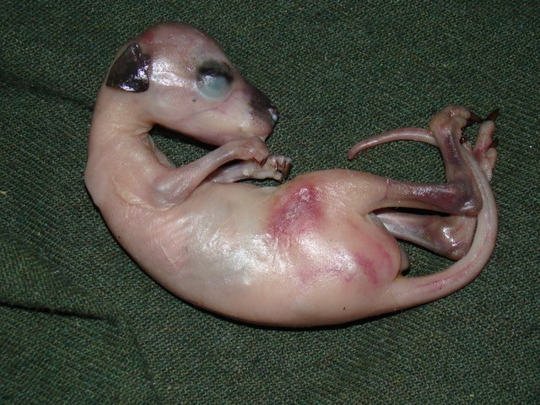

1. Figure 4 Joey was in the pouch when mother was hit by a car
2. Photo: Joan Reid.

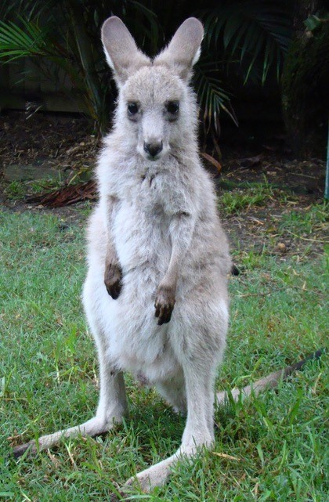

1. Figure 5 Joey is malnourished after being cared for by an untrained member of the public
2. Photo: Joan Reid.

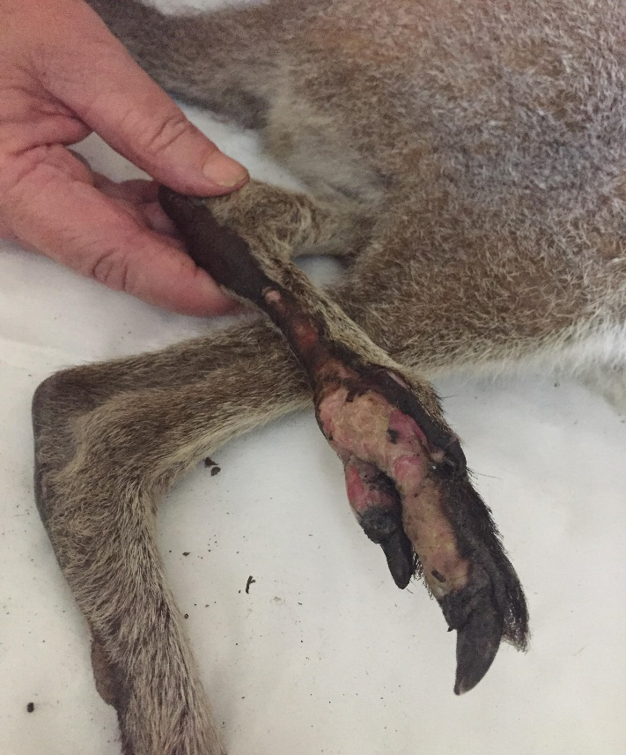

1. Figure 6 Macropod with burn injuries to the feet
2. Photo: Annette Tang.

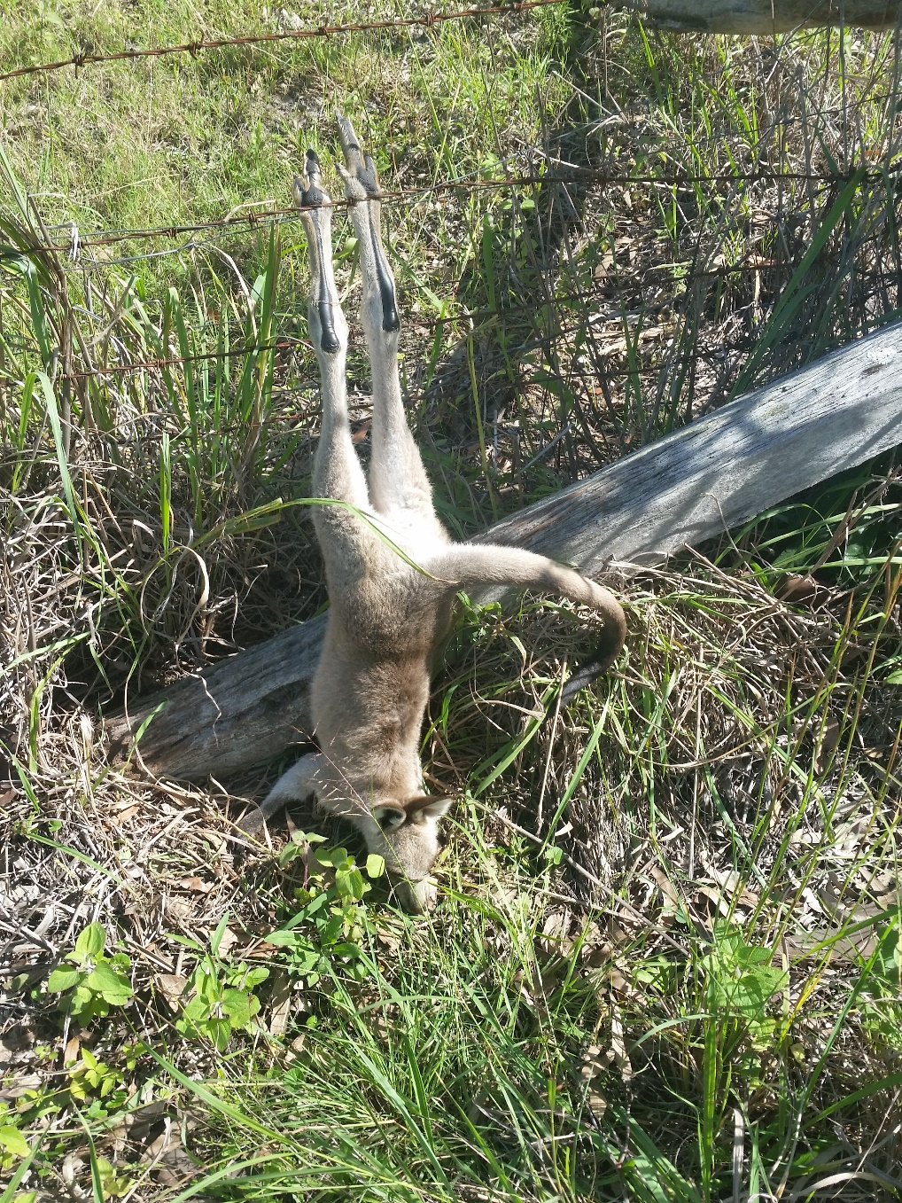

1. Figure 7 Macropod entangled in a wire fence
2. Photo: Diana Woodward.

#### Standard 8: Assessment 2 – Assessment of a macropod

##### Trainer/Assessor instructions:

1. *This is an example of the type of assessment that could be used to assess competency in relation to Standard 8. This method assesses competency for all criteria in Standard 8. This could be completed verbally while observing a live macropod or using a prop.*

##### Learner instructions:

1. *Look at the following image. Identify what each line is pointing to and explain what this might tell you about the macropod or what you may be looking for in this region when conducting a physical examination. The eyes have already been completed as an example.*
2. 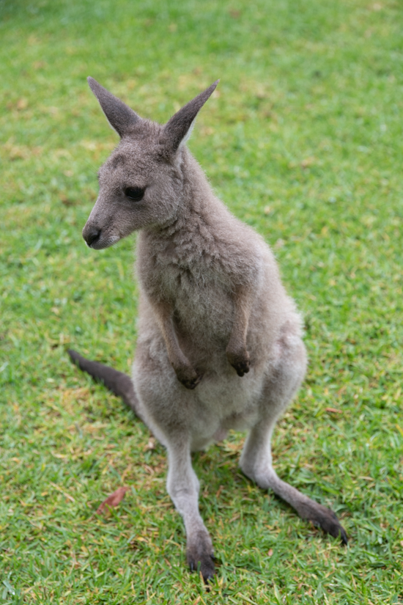
3. **Eyes**
4. When conducting a visual assessment, I would be looking for any discharge, redness, asymmetry or changes in appearance of the outermost surface of the eye. This can tell me if the animal is blind, has conjunctivitis, cataracts or trauma to the eye.

## Standard 9: Rehabilitation of adult macropods

**Objective:** To provide learners with an understanding of the requirements for the rehabilitation of adult macropods, and equip learners with the skills to provide quality rehabilitative care for adult macropods at the relevant stages of rehabilitation.

Note: The rehabilitation of adult macropods is only advised where suitable facilities and access to veterinary consultation for the prescription of sedatives are available.

To comply with this standard, a rehabilitation organisation must:

9.1 Explain the importance of and process for quarantining individual macropods entering rehabilitation.

9.2 Discuss the effects of stress and the stress mitigation techniques required to safely rehabilitate an adult macropod.

9.3 Detail the facilities required to safely rehabilitate adult macropods, relevant to stages of housing (intensive, intermediate and pre-release).

9.4 Describe appropriate equipment and furniture for stages of housing.

9.5 Illustrate disease control and hygiene practices appropriate to stages of housing.

9.6 Explain how to appropriately provide food and water based on the condition of a macropod.

9.7 Detail common conditions and diseases that affect macropods.

9.8 Discuss how to monitor a macropod in accordance with stages of housing and condition.

9.9 Demonstrate how to complete a husbandry plan.

| Learning outcomes | Sections in the Code |
| --- | --- |
| Upon completion of this module, learners will be able to:   * + - * outline the requirements for adult macropod rehabilitation       * demonstrate correct set-up for housing macropods       * provide food and water appropriate to age and condition of a macropod       * monitor a macropod undergoing rehabilitation       * apply hygiene and disease control processes to macropod rehabilitation       * complete a husbandry plan for an adult macropod. | 2. Case assessment  5. Euthanasia  6. Care procedures  7. Husbandry  8. Housing |

### **Training areas**

* The Macropod Code can be accessed online: [Code of Practice for Injured Sick and Orphaned Macropods](https://www.environment.nsw.gov.au/research-and-publications/publications-search/code-of-practice-for-injured-sick-and-orphaned-macropods).
* Guidelines can be accessed online: [Guidelines for the Initial Treatment and Care of Rescued Macropods](https://www.environment.nsw.gov.au/research-and-publications/publications-search/guidelines-for-the-initial-treatment-and-care-of-rescued-macropods).
* Importance of and process for quarantining macropods could include:
  + principles of quarantine
  + monitoring for signs of infectious diseases
  + disease transmission between animals.
* The effects of stress and stress mitigation techniques could include:
  + causes of stress in adult macropods (capture, handling, new environments)
  + myopathy
  + effects of stress on the immune system
  + sedatives and tranquilisers.
* Facilities to safely rehabilitate a macropod could include:
  + requirements for various stages of housing (intensive, intermediate and pre-release housing)
  + requirements specific to species (dimensions, furniture)
  + mitigating stress (noise, visual barriers)
  + mimicking the natural environment where possible
  + privacy
  + thermal control, shelter
  + access to food and water
  + access for capture if required
  + predator-proofing.
* Appropriate equipment and furniture could include:
  + substrate
  + thermometer and thermostat
  + avoiding obstacles in an enclosure
  + fence height and safety
  + shade cloth
  + visual barriers
  + furniture appropriate to species (e.g. rocky mounds for rock-wallabies).
* Disease control and hygiene practices could include:
  + washing hands thoroughly
  + wearing gloves
  + quarantining animals
  + removing faeces and soiled bedding daily
  + food bowls and water off the ground and pest-proof
  + clean food preparation area
  + disinfection of all equipment between macropods.
* Access to water and appropriate food could include:
  + water troughs and bowls
  + diet appropriate to species and age
  + offering hay, grass, leaf litter, dirt, native grasses and shrubs
  + supplementary feed and commercial formulas for herbivores.
* Common conditions and diseases could include:
  + myopathy
  + hyperthermia
  + periodontal disease
  + coccidiosis
  + babesiosis.
* Monitoring a macropod could include:
  + frequency – too much and too little
  + progression of disease or injury
  + stress
  + behaviour
  + reaction to housing
  + hydration
  + indications of activity
  + eating patterns and food intake
  + urine and faecal output.
* A husbandry plan could include:
  + consultation with vets
  + medications
  + consultation with coordinators and mentors
  + enrichment
  + release site selection.

### Suggested assessments

1. Assessment in relation to this standard would be best suited to written or verbal methods, practical assessment, or a combination of these.

#### Standard 9: Assessment 1 – Housing a macropod, case studies

##### Trainer/Assessor instructions:

1. *This is an example of the type of assessment that could be used to assess competency in relation to Standard 9.*

##### Learner instructions:

1. *To be completed in groups. Using one of the case studies below and the available equipment, set up housing appropriate for your macropod. Upon completion of the set-up, each group will be asked to:*

* Explain your housing set-up.
* Outline what hygiene and disease control procedures you would implement.
* Explain how your housing set-up enables you to monitor the macropod and what you would be monitoring.

##### Case study 1:

1. An adult female wallaby has been rescued and cannot be seen by the veterinarian until the next morning. The macropod is in poor body condition and is dehydrated but has no obvious signs of injury or illness.

##### Case study 2:

1. An adult male wallaby has just undergone surgery for a broken forearm after being hit by a car. He needs to be given analgesia every three hours.

##### Case study 3:

1. A juvenile eastern grey kangaroo has suffered partial burns on its feet. The burns have all healed, but the pads are pink and soft.

#### Standard 9: Assessment 2 – Rehabilitation of adult macropods quiz

##### Trainer/Assessor instructions:

1. *This is an example of the type of assessment that could be used to assess competency in relation to Standard 9.*

##### Learner instructions:

1. *Complete the following multiple choice quiz by selecting the correct answer for each question.*
2. Which of the following scenarios would require a macropod to be housed in intensive care?
   1. A macropod having its fitness tested for release
   2. A macropod recovering from a mild bacterial infection needing medication once every two weeks
   3. A macropod in shock needing frequent monitoring
   4. None of the above.
3. *Answer: C. A macropod in shock needing frequent monitoring.*
4. Intensive care housing must provide enough space for a macropod to be able to hop and jump?
5. True
6. False
7. *Answer: False.*
8. Which of the following is **not** required for intensive care housing?
   1. Soft substrate
   2. Ventilation
   3. Complete darkness
   4. thermometer.
9. *Answer: C. Complete darkness.*
10. Which of the following demonstrates good practices in hygiene and disease control?
    1. Quarantining new macropods or diseased macropods
    2. Thoroughly washing your hands
    3. Removing uneaten food and faeces from the enclosure
    4. All of the above.
11. *Answer: D. All of the above.*
12. Which of the following should **not** be offered to macropods once they are furred?
    1. Grass
    2. Dirt
    3. Chaff
    4. Leaf litter
13. *Answer: C. Chaff.*
14. Which of the following floor dimensions are the minimum dimensions recommended for intermediate care housing for a small macropod?
    1. 2 metres long x 2 metres wide x 2 metres high
    2. 0.5 metres long x 0.5 metres wide x 0.5 metres high
    3. 0.7 metres long x 1 metre wide x 0.7 metres high
    4. 3 metres long x 3 metres wide x 2 metres high.
15. *Answer: A. 2 metres long x 2 metres wide x 2 metres high.*
16. Food and water containers must be changed weekly.
17. True
18. False
19. *Answer: False. They must be changed daily.*
20. Which of the following is **not** a requirement for pre-release housing?
    1. Fresh clean water
    2. Undercover area
    3. Heating
    4. Native vegetation.
21. *Answer: C. Heating.*
22. For which species should pre-release yards have an inward facing overhang?
    1. Wallaroos and swamp wallabies
    2. Eastern grey and red kangaroos
    3. Bettongs and potoroos
    4. All wallaby species.
23. *Answer: C. Bettongs and potoroos.*
24. Which of the following is the objective of pre-release housing?
    1. Allow the macropod to regain its physical condition
    2. Allow the macropod to acclimatise to current weather conditions
    3. Allow the macropod to practice natural behaviours
    4. All of the above.
25. *Answer: D. All of the above.*

1. Look at the photo below (Figure 8). List at least five features that comply with the Macropod Code.

|  |
| --- |
| 1. 1.Click or tap here to enter text. |
| 1. 2. Click or tap here to enter text. |
| 1. 3. Click or tap here to enter text. |
| 1. 4. Click or tap here to enter text. |
| 1. 5. Click or tap here to enter text. |

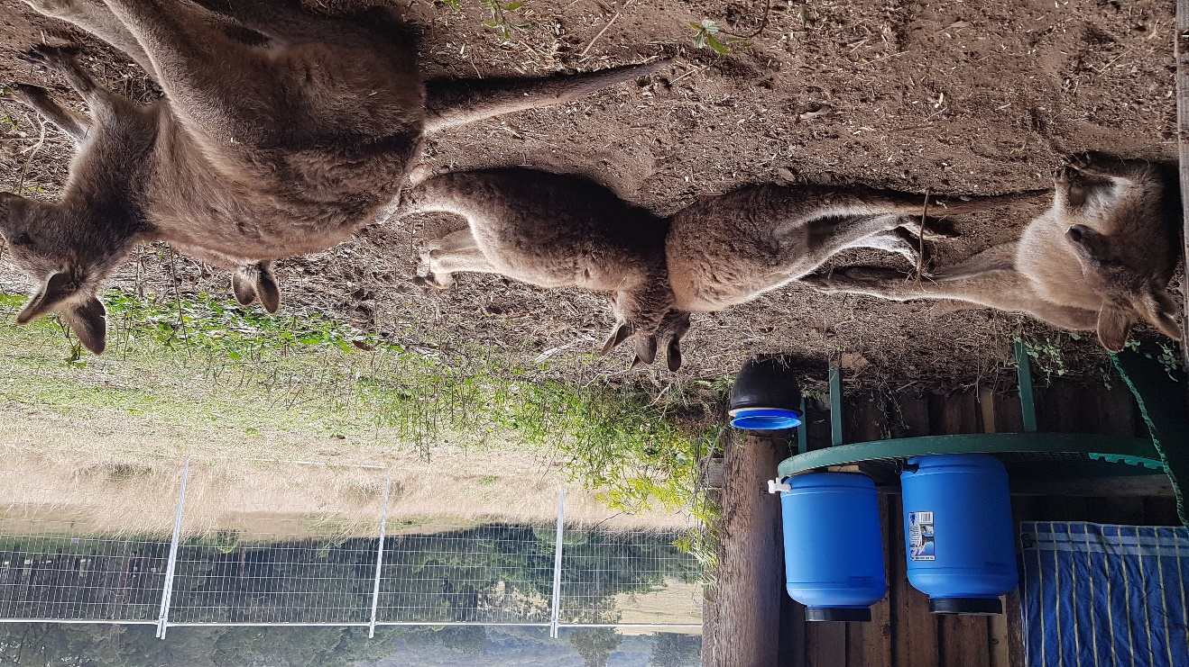

1. Figure 8 Macropods in pre-release enclosure
2. Photo: Meredith Ryan.

## 

## Standard 10: Rehabilitation of macropod joeys

**Objective:** To provide learners with the specialised knowledge required to rehabilitate a macropod joey.

To comply with this standard, a rehabilitation organisation must:

10.1 Specify key stages of joey development.

10.2 Describe appropriate housing for a macropod joey based on stage of development.

10.3 Discuss appropriate food and feeding methods for a joey based on species and stage of development.

10.4 Explain the importance of maintaining records on growth, behaviour, feeding and toileting of joeys throughout the rehabilitation process.

10.5 Detail common conditions and diseases that affect macropod joeys.

10.6 Illustrate disease control and hygiene practices appropriate to stages of housing.

10.7 Demonstrate how to complete a husbandry plan for a macropod joey.

10.8 Describe mechanisms to reduce stress and encourage natural behaviours in macropod joeys.

| Learning outcomes | Sections in the Code |
| --- | --- |
| Upon completion of this module, learners will be able to:   * + - * outline the requirements for macropod joey rehabilitation       * identify stages of development for macropod joeys and relate these to rehabilitation       * apply hygiene and disease control processes to macropod joey rehabilitation       * reduce stress and encourage natural behaviours in macropod joeys       * prepare a hand-raised macropod for release. | 2. Case assessment  5. Euthanasia  6. Care procedures  7. Husbandry  8. Housing |

### Training areas

* The Macropod Code can be accessed online: [Code of Practice for Injured Sick and Orphaned Macropods](https://www.environment.nsw.gov.au/research-and-publications/publications-search/code-of-practice-for-injured-sick-and-orphaned-macropods).
* Guidelines can be accessed online: [Guidelines for the Initial Treatment and Care of Rescued Macropods](https://www.environment.nsw.gov.au/research-and-publications/publications-search/guidelines-for-the-initial-treatment-and-care-of-rescued-macropods).
* Stages of joey development could include:
  + pouch life
  + age factor
  + viability
  + developmental milestones
  + weight
  + physical characteristics.
* Appropriate housing could include:
  + intensive care
  + pouches
  + outdoor yard or intermediate housing
  + pre-release yard
  + buddying.
* Appropriate food could include:
  + milk formula
  + water
  + dirt
  + hay (not chaff)
  + leaf litter
  + supplement feeding.
* Appropriate feeding methods could include:
  + bottles
  + teat size
  + syringe
  + cannula
  + frequency and volume of milk.
* Maintaining records could include:
  + continuity of care
  + tracking progress
  + frequency of monitoring
  + monitoring sheets.
* Common conditions and diseases could include:
  + diarrhoea
  + dehydration
  + coccidiosis
  + internal and external parasites
  + pneumonia
  + candidiasis.
* Hygiene and disease control could include:
  + toileting
  + wearing gloves
  + sterilising equipment including bottles
  + washing hands
  + cleaning pouches.
* A husbandry plan could include:
  + consultation with vets
  + medications
  + consultation with coordinators and mentors
  + enrichment.
* Mechanisms to reduce stress and encourage natural behaviours could include:
  + buddying
  + play
  + dehumanisation
  + socialisation
  + moving to appropriate facilities at the right stage.

### Suggested assessments

1. Assessment in relation to this standard would be best suited to written or verbal methods, practical assessment, or a combination of these.

#### Standard 10: Assessment 1 – Macropod joey housing questions

##### Trainer/Assessor instructions:

1. *This is an example of the type of assessment that could be used to assess competency in relation to Standard 10.*

##### Learner instructions:

1. *Explain the set-up required for a macropod joey being hand-raised at each type of housing listed below. For each type, explain what stage of development a joey should be at, what type of food they would be eating, and what actions you would implement to reduce stress and encourage natural behaviours in a macropod joey.*
2. Intensive housing:  
   Click or tap here to enter text.
3. Intermediate housing:  
   Click or tap here to enter text.
4. Pre-release housing:   
   Click or tap here to enter text.

#### Standard 10: Assessment 2 – Rehabilitation of macropod joey quiz

##### Trainer/Assessor instructions:

1. *This is an example of the type of assessment that could be used to assess competency in relation to Standard 10.*

##### Learner instructions:

1. *Complete the following section by providing an answer to each of the questions*
2. 1. Select one commonly encountered disease or condition that affects hand-raised joeys (e.g. coccidiosis, thrush) and explain the causes, symptoms and treatment options for this condition.
3. Click or tap here to enter text.

2. List three hygiene or disease control processes used in macropod joey rehabilitation.

* 1. Click or tap here to enter text.
  2. Click or tap here to enter text.
  3. Click or tap here to enter text.

3. List five techniques that could be employed to minimise stress for a macropod joey undergoing rehabilitation.

* 1. Click or tap here to enter text.
  2. Click or tap here to enter text.
  3. Click or tap here to enter text.
  4. Click or tap here to enter text.
  5. Click or tap here to enter text.

1. Explain why it is important to maintain accurate records of joeys throughout the rehabilitation process.   
   Click or tap here to enter text.
2. Explain the rehabilitation requirements, including feeding and housing, for a macropod joey of a species of your choosing at two different stages of development.
3. Velvet joey: Click or tap here to enter text.
4. Emerging joey: Click or tap here to enter text.

## Standard 11: Release of macropods

**Objective:** To ensure learners understand suitability for release and criteria for releasing a macropod.

To comply with this standard, a rehabilitation organisation must:

11.1 Discuss release considerations for macropods including timing and site selection.

11.2 Explain how to determine a macropod’s suitability for release.

11.3 Detail the correct techniques and equipment for releasing a macropod.

| Learning outcomes | Sections in the Code |
| --- | --- |
| Upon completion of this module, learners will be able to:   * + - * assess a macropod for release suitability       * competently release a macropod. | 9. Suitability for release  10. Release considerations |

### **Training areas**

* The Macropod Code can be accessed online: [Code of Practice for Injured Sick and Orphaned Macropods](https://www.environment.nsw.gov.au/research-and-publications/publications-search/code-of-practice-for-injured-sick-and-orphaned-macropods).
* Release considerations could include:
  + timing including time of day and time of year
  + release site selection
  + individual
  + social species
  + individual identification (tag or microchip) before release.
* Suitability for release could include:
  + physical fitness
  + age
  + disease profile
  + recovery from injury
  + weight
  + behaviour
  + ability to eat unaided
  + ability to recognise and avoid natural predator species
  + veterinary or experienced macropod rehabilitator approval.
* Appropriate techniques and equipment could include:
  + soft or hard release.

### Suggested assessments

1. Assessment in relation to this standard would be best suited to written or verbal methods, practical assessment, or a combination of these.

#### Standard 11: Assessment 1 – Releasing a macropod, case studies

##### Trainer/Assessor instructions:

1. *This is an example of the type of assessment that could be used to assess competency in relation to Standard 11. This can be completed verbally or in writing.*

##### Learner instructions:

1. *Read each of the rescue case studies and complete the corresponding questions.*

##### Case study 1: Hand-reared macropod

1. A macropod joey that has been hand-raised and is ready for release.
2. Explain the criteria for assessing release suitability for this macropod.  
   Click or tap here to enter text.
3. What are the release considerations for this macropod?   
   Click or tap here to enter text.
4. Where will you release this macropod?   
   Click or tap here to enter text.
5. Explain how you will release this macropod.  
   Click or tap here to enter text.
6. How will you minimise work health and safety risks associated with the release site?  
   Click or tap here to enter text.

##### Case study 2: Adult male macropod

1. An adult male bettong was attacked by a dog in a suburban backyard. He has recovered from his injuries and is now ready to be released.
2. Explain the criteria for assessing release suitability for this macropod.  
   Click or tap here to enter text.
3. What are the release considerations for this macropod?   
   Click or tap here to enter text.
4. Where will you release this macropod?   
   Click or tap here to enter text.
5. Explain how you will release this macropod.  
   Click or tap here to enter text.
6. How will you minimise work health and safety risks associated with the release site?  
   Click or tap here to enter text.

##### Case study 3: Adult female macropod

1. A juvenile female macropod was admitted with mild burn injuries to both feet. She received treatment and responded well and is now ready for release.
2. Explain the criteria for assessing release suitability for this macropod.  
   Click or tap here to enter text.
3. What are the release considerations for this macropod?   
   Click or tap here to enter text.
4. Where will you release this macropod?   
   Click or tap here to enter text.
5. Explain how you will release this macropod.  
   Click or tap here to enter text.
6. How will you minimise work health and safety risks associated with the release site?  
   Click or tap here to enter text.

#### Standard 11: Assessment 2 – Releasing a macropod quiz

##### Trainer/Assessor instructions:

1. *This is an example of the type of assessment that could be used to assess competency in relation to Standard 11.*

##### Learner instructions:

1. *Complete the following multiple choice quiz by selecting the correct answer for each question.*
2. A macropod should be released during extremes of weather or temperature so that it is used to harsh conditions.
3. True
4. False
5. *Answer: False. A macropod should not be released during extremes of weather or temperature.*
6. Hand-raised macropods that belong to social species must be released near or into a mob.
7. True
8. False
9. *Answer: True.*
10. Which of the following is a consideration for releasing a hand-reared macropod:
    1. Sexual maturity
    2. Weight
    3. Stage of development
    4. All of the above.
11. *Answer: D. All of the above.*
12. A macropod should be released at night.

True

False

1. *Answer: False. A macropod must be released at a time of day with adequate residual daylight to enable it to visually investigate its environment.*
2. Hard releasing of macropods is the preferred release technique.
3. True
4. False
5. *Answer: False. Soft release is the recommended technique for releasing macropods.*
6. A macropod’s readiness for release must be confirmed by a veterinarian or experienced macropod rehabilitator prior to it being released.
7. True
8. False
9. *Answer: True.*
10. Releasing large numbers of macropods in the same place to form a mob is recommended.

True

False

1. *Answer: False. Macropod rehabilitators should not release large numbers of individuals at a single location, as increased competition is likely to have a detrimental effect on the existing population.*
2. If a macropod was rescued in a backyard following a dog-attack, it needs to be released:
   1. In the backyard it was rescued from
   2. It cannot be released as the environment is unsuitable
   3. In the front yard
   4. In a suitable environment as close to the backyard as possible.
3. *Answer: D. In a suitable environment as close to the backyard as possible.*
4. As they are not dangerous animals, a macropod that is humanised can be released.
5. True
6. False
7. *Answer: False. A humanised macropod cannot be released.*
8. Which of the following is **not** an option for an unreleasable macropod?
   1. Keeping it in the house
   2. Applying to the Department of Planning, Industry and Environment to have it placed in permanent care
   3. Euthanasia
   4. Notifying the Department to arrange placement with an authorised animal exhibitor licensed by the Department.
9. *Answer: A. Keeping it in the house.*

# Further reading

1. ASQA 2015, *Guide to Developing Assessment Tools*, Australian Skills Quality Authority,accessed 24/7/2019, <https://www.asqa.gov.au/sites/default/files/Guide_to_developing_assessment_tools.pdf>.
2. Heathfield SM 2019, *Best Ice Breakers for Meetings and Training Classes,* The Balance Careers, accessed 24/7/19, [www.thebalancecareers.com/best-ice-breakers-for-meetings-and-training-classes-1918430](http://www.thebalancecareers.com/best-ice-breakers-for-meetings-and-training-classes-1918430).
3. Hill D, Hill T and Perlitz L 2011, Vocational Training and Assessment, McGraw-Hill Education, North Ryde, NSW.
4. Hill D, Hill T and Perlitz L 2013, Professional Training and Assessment, McGraw-Hill Education, North Ryde, NSW.
5. Standards for Registered Training Organisations, made under sections 185(1) and 186(1) of the *National Vocational Education and Training Regulator Act 2011*, can be accessed at [www.legislation.gov.au/Details/F2019C00503](https://www.legislation.gov.au/Details/F2019C00503).
6. NHS Education for Scotland 2012, *Train the Trainers Toolkit,* NHS Education for Scotland, accessed 24/7/2019, [www.knowledge.scot.nhs.uk/media/6866097/trainthetrainers__final_.pdf](http://www.knowledge.scot.nhs.uk/media/6866097/trainthetrainers__final_.pdf).
7. Smith M 2002, *Malcolm Knowles, informal adult education, self-direction and andragogy,* Infed, accessed 24/7/19, [infed.org/mobi/malcolm-knowles-informal-adult-education-self-direction-and-andragogy/](http://infed.org/mobi/malcolm-knowles-informal-adult-education-self-direction-and-andragogy/).
8. VARK 2019, *Introduction to VARK,* VARK Learn Limited, accessed 24/7/19, [vark-learn.com/introduction-to-vark/the-vark-modalities/](http://vark-learn.com/introduction-to-vark/the-vark-modalities/).
9. Appendix A: Training and assessment mapping tool
10. The table below is a tool you can use to determine whether there are gaps in your training. You can map your existing training materials to the standards to see if there are any parts of a standard you have omitted, or if you need to add further information to your training materials. You can match the learning outcomes to an assessment tool so you can see how you are determining the competency of your learner against each outcome. You can change or include additional training or assessment tools if the ones listed do not match what is provided in your training.

| Standard | Training tools | | | Learning outcomes | Assessment tools | | | |
| --- | --- | --- | --- | --- | --- | --- | --- | --- |
| **Slides on PPT** | **Pages in manual** | **Other resources** | **Multiple choice or short answer questions** | **Demonstration (real or scenario-based)** | **Verbal question and answer** | **Assessor checklist** |
| **Standard 1: The framework for macropod rehabilitation in New South Wales** | | | | | | | | |
| 1.1 Discuss the [Code of Practice for Injured, Sick and Orphaned Macropods](https://www.environment.nsw.gov.au/research-and-publications/publications-search/code-of-practice-for-injured-sick-and-orphaned-macropods). |  |  |  | Identify and demonstrate understanding of the Macropod Code. |  |  |  |  |
| 1.2 Ensure organisational policies and procedures applicable to macropod rehabilitation are defined and understood by learners. |  |  |  | Identify organisational policies and procedures on macropod rehabilitation. |  |  |  |  |
|  |  |  |  | Recognise the objectives of macropod rehabilitation. |  |  |  |  |
| **Standard 2: Work health and safety (WHS) requirements of macropod rehabilitation** | | | | | | | | |
| 2.1 Explain the WHS risks associated with the site, equipment or activity and how they can be minimised. |  |  |  | Identify WHS risks associated with macropod rehabilitation. |  |  |  |  |
| 2.2 Explain the WHS risks associated with handling and restraining macropods and how they can be minimised. |  |  |  | Employ techniques to minimise the WHS risks to themselves and other people. |  |  |  |  |
| 2.3 Discuss the WHS risks associated with zoonotic diseases relevant to macropods and how they can be minimised. |  |  |  |  |  |  |  |  |
| 2.4 Discuss rehabilitator wellbeing and the potential mental health impacts of wildlife rehabilitation. |  |  |  |  |  |  |  |  |
| **Standard 3: Record keeping** | | | | | | | | |
| 3.1 Explain the NPWS reporting requirements. |  |  |  | Keep records in accordance with NPWS and organisational requirements. |  |  |  |  |
| 3.2 Explain organisational reporting requirements. |  |  |  |  |  |  |  |  |
| **Standard 4: Biology and behaviour of macropods** | | | | | | | | |
| 4.1 Explain features of macropod biology including anatomy, physiology, social structure, stages of development and habitat and relate them to macropod rehabilitation. |  |  |  | Relate macropod biology and behaviour to macropod rehabilitation. |  |  |  |  |
| 4.2 Provide the tools and understanding required to identify different species of macropods. |  |  |  | Recognise signs of normal behaviour in macropods. |  |  |  |  |
| 4.3 Provide the tools and understanding required to identify normal behaviours in macropods. |  |  |  | Recognise signs of abnormal behaviour in macropods. |  |  |  |  |
| 4.4 Provide the tools and understanding required to recognise signs of abnormal behaviour in macropods. |  |  |  |  |  |  |  |  |
| **Standard 5: Stress management in macropods** | | | | | | | | |
| 5.1 Explain the effects of stress on a macropod at various stages of rescue and rehabilitation and any differences between macropod species. |  |  |  | Recognise signs of stress in macropods and its impact. |  |  |  |  |
| 5.2 Discuss myopathy in relation to stress in macropods. |  |  |  | Apply methods for minimising stress on a macropod. |  |  |  |  |
| 5.3 Provide the tools and understanding required to recognise signs of stress in a macropod. |  |  |  |  |  |  |  |  |
| 5.4 Discuss methods for minimising stress on a macropod at stages of rescue and rehabilitation. |  |  |  |  |  |  |  |  |
| **Standard 6: Rescue of macropods** | | | | | | | | |
| 6.1 Outline common reasons for macropod rescue. |  |  |  | List the common reasons why macropods require rescue. |  |  |  |  |
| 6.2 Detail how to perform an assessment, including the use of the decision tree in the Macropod Code, to establish the appropriate course of action. |  |  |  | Assess a rescue situation and plan the rescue of a macropod. |  |  |  |  |
| 6.3 Detail the correct method and equipment required to capture, handle and rescue a macropod, as suitable to the species and common rescue situations, conditions and age of a macropod. |  |  |  | Safely rescue a macropod using correct equipment. |  |  |  |  |
| 6.4 Detail how to rescue a macropod to humanely minimise pain, stress and potential injury. |  |  |  | Determine the type of intervention required at a rescue site. |  |  |  |  |
| **Standard 7: Transport of macropods** | | | | | | | | |
| 7.1 Demonstrate how to appropriately contain a macropod for transport based on different sizes, ages and conditions. |  |  |  | Prepare a carrier for transport of a macropod. |  |  |  |  |
| 7.2 Outline how to secure the transport container to prevent escape and further injury. |  |  |  | Outline the transport conditions required to safely transport a macropod. |  |  |  |  |
| 7.3 Detail suitable transport conditions, including ambient temperature, to safely transport a macropod. |  |  |  | Understand the appropriate personnel or location to transport a macropod to, based on different ages, conditions and organisational policies. |  |  |  |  |
| 7.4 Discuss the most suitable personnel or location that a macropod should be transported to, based on different ages, conditions and organisational policies. |  |  |  |  |  |  |  |  |
| **Standard 8: Assessment of macropods** | | | | | | | | |
| 8.1 Explain how to conduct an initial assessment of a macropod. |  |  |  | Conduct an initial assessment of a macropod. |  |  |  |  |
| 8.2 Explain the requirements of a thorough assessment of a macropod. |  |  |  | Assess the health status of a macropod and recognise stages, symptoms and severity of common diseases and injuries. |  |  |  |  |
| 8.3 Provide the tools and understanding required to identify developmental stage in macropod joeys. |  |  |  | Determine the appropriate course of action for a macropod based on its condition. |  |  |  |  |
| 8.4 Emphasise the need to seek prompt advice and assistance for a macropod from a coordinator, veterinarian or other relevant personnel, as appropriate to its condition. |  |  |  | Outline criteria for and approved methods of euthanasia. |  |  |  |  |
| 8.5 Distinguish signs of and ways to determine common diseases and injuries affecting macropods. |  |  |  |  |  |  |  |  |
| 8.6 Explain how to manage an injured or diseased macropod based on the severity of its condition. |  |  |  |  |  |  |  |  |
| 8.7 Outline criteria and approved methods for humane euthanasia. |  |  |  |  |  |  |  |  |
| **Standard 9: Rehabilitation of adult macropods** | | | | | | | | |
| 9.1 Explain the importance of and process for quarantining individual macropods entering rehabilitation. |  |  |  | Outline the requirements for adult macropod rehabilitation. |  |  |  |  |
| 9.2 Discuss the effects of stress and the stress mitigation techniques required to safely rehabilitate an adult macropod. |  |  |  | Demonstrate correct set-up for housing macropods. |  |  |  |  |
| 9.3 Detail the facilities required to safely rehabilitate adult macropods, relevant to stages of housing (intensive, intermediate and pre-release). |  |  |  | Provide food and water appropriate to age and condition of a macropod. |  |  |  |  |
| 9.4 Describe appropriate equipment and furniture for stages of housing. |  |  |  | Monitor a macropod undergoing rehabilitation. |  |  |  |  |
| 9.5 Illustrate disease control and hygiene practices appropriate to stages of housing. |  |  |  | Apply hygiene and disease control processes to macropod rehabilitation. |  |  |  |  |
| 9.6 Explain how to appropriately provide food and water based on the condition of a macropod. |  |  |  | Complete a husbandry plan for an adult macropod. |  |  |  |  |
| 9.7 Detail common conditions and diseases that affect macropods. |  |  |  |  |  |  |  |  |
| 9.8 Discuss how to monitor a macropod in accordance with stages of housing and condition. |  |  |  |  |  |  |  |  |
| 9.9 Demonstrate how to complete a husbandry plan. |  |  |  |  |  |  |  |  |
| **Standard 10: Rehabilitation of macropod joeys** | | | | | | | | |
| 10.1 Specify key stages of joey development. |  |  |  | Outline the requirements for macropod joey rehabilitation. |  |  |  |  |
| 10.2 Describe appropriate housing for a macropod joey based on stage of development. |  |  |  | Identify stages of development for macropod joeys and relate these to rehabilitation. |  |  |  |  |
| 10.3 Discuss appropriate food and feeding methods for a joey based on species and stage of development. |  |  |  | Apply hygiene and disease control processes to macropod joey rehabilitation. |  |  |  |  |
| 10.4 Explain the importance of maintaining records on growth, behaviour, feeding and toileting of joeys throughout the rehabilitation process. |  |  |  | Reduce stress and encourage natural behaviours in macropod joeys. |  |  |  |  |
| 10.5 Detail common conditions and diseases that affect macropod joeys. |  |  |  | Prepare a hand-raised macropod for release. |  |  |  |  |
| 10.6 Illustrate disease control and hygiene practices appropriate to stages of housing. |  |  |  |  |  |  |  |  |
| 10.7 Demonstrate how to complete a husbandry plan for a macropod joey. |  |  |  |  |  |  |  |  |
| 10.8 Describe mechanisms to reduce stress and encourage natural behaviours in macropod joeys. |  |  |  |  |  |  |  |  |
| **Standard 11: Release of macropods** | | | | | | | | |
| 11.1 Discuss release considerations for macropods including timing and site selection. |  |  |  | Assess a macropod for release suitability. |  |  |  |  |
| 11.2 Explain how to determine a macropod’s suitability for release. |  |  |  | Competently release a macropod. |  |  |  |  |
| 11.3 Detail the correct techniques and equipment for releasing a macropod. |  |  |  |  |  |  |  |  |