environment.nsw.gov.au

Department of planning, Industry & ENVIRONMENT

Flying-fox Camp Management Plan Template 2019

168666
Grey-headed Flying-fox (Pteropus poliocephalus)

© 2019 State of NSW and Department of Planning, Industry and Environment

With the exception of photographs, the State of NSW and Department of Planning, Industry and Environment are pleased to allow this material to be reproduced in whole or in part for educational and non-commercial use, provided the meaning is unchanged and its source, publisher and authorship are acknowledged. Specific permission is required for the reproduction of photographs.

The Department of Planning, Industry and Environment (DPIE) has compiled this report in good faith, exercising all due care and attention. No representation is made about the accuracy, completeness or suitability of the information in this publication for any particular purpose. DPIE shall not be liable for any damage which may occur to any person or organisation taking action or not on the basis of this publication. Readers should seek appropriate advice when applying the information to their specific needs.

All content in this publication is owned by DPIE and is protected by Crown Copyright, unless credited otherwise. It is licensed under the [Creative Commons Attribution 4.0 International (CC BY 4.0)](http://creativecommons.org/licenses/by/4.0/deed.en), subject to the exemptions contained in the licence. The legal code for the licence is available at [Creative Commons](http://creativecommons.org/licenses/by/4.0/legalcode).

DPIE asserts the right to be attributed as author of the original material in the following manner: © State of New South Wales and Department of Planning, Industry and Environment 2019.

Cover photo: Grey-headed Flying-fox (*Pteropus poliocephalus*). Dean Portelli/DPIE

Published by:

Environment, Energy and Science   
Department of Planning, Industry and Environment  
59 Goulburn Street, Sydney NSW 2000  
PO Box A290, Sydney South NSW 1232  
Phone: +61 2 9995 5000 (switchboard)  
Phone: 1300 361 967 (Environment, Energy and Science enquiries)  
TTY users: phone 133 677, then ask for 1300 361 967  
Speak and listen users: phone 1300 555 727, then ask for 1300 361 967  
Email: [info@environment.nsw.gov.au](mailto:info@environment.nsw.gov.au)   
Website: [www.environment.nsw.gov.au](http://www.environment.nsw.gov.au)

Report pollution and environmental incidents  
Environment Line: 131 555 (NSW only) or [info@environment.nsw.gov.au](mailto:info@environment.nsw.gov.au)  
See also [www.environment.nsw.gov.au](http://www.environment.nsw.gov.au)

ISBN 978-1-922317-30-8  
EES 2019/0559  
October 2019

Find out more about your environment at:

www.environment.nsw.gov.au

Contents

Flying-fox Camp Management Plan – expanded template 1

How to use this template 1

Acknowledgements 4

Acronyms and abbreviations 5

1. Overview 6

1.1 Objectives 6

2. Context 7

2.1 Camp area 7

2.2 History of the camp 7

2.3 Land tenure 8

2.4 Reported issues related to the camp 8

2.5 Management response to date 10

3. Community engagement 11

3.1 Stakeholders 11

3.2 Engagement methods 13

3.3 Community feedback – management options 14

4. Legislation and policy 15

4.1 State 15

4.2 Commonwealth 16

5. Other ecological values of the site 19

6. Flying-fox ecology and behaviour 21

6.1 Ecological role 21

6.2 Flying-foxes in urban areas 21

6.3 Under threat 22

6.4 Camp characteristics 22

6.5 Species profiles 23

7. Human and animal health 27

7.1 Disease and flying-fox management 27

8. Camp management options 28

8.1 Level 1 actions: routine camp management 28

8.2 Level 2 actions: in situ management 32

8.3 Level 3 actions: disturbance or dispersal 33

8.4 Unlawful activities 35

8.5 Site-specific analysis of camp management options 36

9. Planned management approach 42

9.1 Stop work triggers 51

10. Assessment of impacts to flying-foxes 53

10.1 Regional context 53

10.2 Flying-fox habitat to be affected 54

10.3 Standard measures to avoid impacts 54

11. Assessment of impacts to other threatened species or communities 62

12. Evaluation and review 63

13. Plan administration 64

13.1 Monitoring of the camp 64

13.2 Reporting 64

13.3 Management structure and responsibilities 64

13.4 Adaptive management 68

13.5 Funding commitment 68

14. References and additional resources 69

Appendix 1: Expert assessment requirements 75

Flying-fox expert 75

Ecologist 75

Appendix 2: Example maps 77

Example camp area map 77

Example management areas map 78

Example regional context map 79

Example potential habitat map 80

Appendix 3: Summary of other key legislation likely to apply at some camps 81

Local government legislation 81

State legislation 81

State Environmental Planning Policies 82

Appendix 4: Desktop ecological assessment guideline 84

Buffer 84

Sources of information for database searches 84

Appendix 5: Additional human and animal health information 85

Australian bat lyssavirus 85

Hendra virus 86

Menangle virus 86

Genera l health considerations 87

Appendix 6: Dispersal results summary 88

Appendix 7: Biodiversity conservation licence application form 90

Appendix 8: Example flying-fox rescue protocol 91

Reference documents: 91

Purpose 91

Requirements 91

Human first aid 91

Equipment 92

Work instructions 92

List of tables

Table 1 Stakeholders in the camp and Plan 12

Table 2 Threatened species and ecological communities that may occur at the site 19

Table 3 Analysis of management options 37

Table 4 Example of management approach overview 43

Table 5 Planned action for potential impacts during management 52

Table 6: Roles and responsibilities 65

List of figures

Figure 1 Black flying-fox indicative species distribution (adapted from DPIE 2019a) 23

Figure 2 Grey-headed flying-fox indicative species distribution (adapted from DPIE 2019a) 24

Figure 3 Little red flying-fox indicative species distribution (adapted from DPIE 2019a) 25

Figure 4 Indicative flying-fox reproductive cycle 26

Figure 5 Possible components of an education program 28

Figure 6 Example flowchart to demonstrate the planned process for management decision-making 50

Figure 7 Assessment process 92

# Flying-fox Camp Management Plan – expanded template

A Camp Management Plan (the Plan) is an important document because it records the decisions a land manager has made about managing a flying-fox camp (or a number of camps). This expanded template has been developed by the Department of Planning, Industry and Environment and consultants Ecosure, in line with the [NSW Flying-fox Camp Management Policy 2015](http://www.environment.nsw.gov.au/resources/threatenedspecies/150070-flyingfoxcamp-policy.pdf). The aim of the expanded template is to streamline Plan preparation and processing, reducing the level of resource input required by land managers, and time between development and implementation.

When preparing the Plan, you should refer to available literature and expert opinions, and consider establishing an advisory committee to help guide its development and implementation.

The Plan should be developed within the context of a community engagement strategy for flying-fox management (see Section 3) in order to build a shared understanding of the approach and ensure it is relevant to the local area. The Plan should be placed on public exhibition and made available online and in hard copy at an appropriate location for at least 30 days. Stakeholder consultation, including community engagement, should pre-date the Plan’s development, and continue through its development and implementation.

## How to use this template

Land managers can work directly into a copy of this template. Alternatively, this document could be used as a checklist of issues to consider in developing a plan. The information provided in this template is a guide only and may be deleted or modified to suit the needs of the land manager.

Instructions and prompts are in text boxes. These should be deleted as you work through the template.

Lists of options are provided (e.g. objectives on page 1). Non-relevant options can be deleted, or you may need to input or adapt options if those provided are not directly suited to your camp.

Some sections of the template (e.g. flying-fox ecology) do not require further input unless you choose to add or change some information.

Some sections provide detailed guidance that may be reworked or moved to an appendix according to your needs. Note that in-text section cross-references may need to be updated if sections are deleted or moved.

Other sections will be template paragraphs that can be left as provided, with some minor site-specific input. Where input is required from the land manager, prompts are in blue text enclosed in square brackets.

Input from stakeholders and suitably qualified experts will be required at points in the Plan’s development. Symbols shown in the table below are used throughout the template to highlight a likely requirement.

table of diagrams

# 



(Camp Name)

# Camp Management Plan

(Month Year)

(Proponent name)

# Acknowledgements

Your Plan should acknowledge all stakeholders who had input into its development. The sentence below should also be retained in the acknowledgements section of your Plan.

We acknowledge input by the NSW Department of Planning, Industry and Environment, and consultants Ecosure, in developing the template on which this Camp Management Plan was based. Peggy Eby also provided advice which was included in the template.

# Acronyms and abbreviations

|  |  |
| --- | --- |
| ABLV | Australian bat lyssavirus |
| BC Act | *Biodiversity Conservation Act 2016* (NSW) |
| BFF | black flying-fox (*Pteropus alecto*) |
| the Code of Practice | Flying-fox Camp Management Code of Practice 2018 (NSW) |
| DEE | Commonwealth Department of the Environment and Energy |
| DPIE | Department of Planning, Industry and Environment (NSW) |
| EP&A Act | *Environmental Planning and Assessment Act 1979* (NSW) |
| EPA | Environment Protection Authority (NSW) |
| EPBC Act | *Environment Protection and Biodiversity Conservation Act 1999* (Commonwealth) |
| GHFF | grey-headed flying-fox (*Pteropus poliocephalus*) |
| the Guideline | Referral guideline for management actions in grey-headed and spectacled flying-fox camps 2015 (Commonwealth) |
| LGA | local government area |
| LGNSW | Local Government NSW |
| LRFF | little red flying-fox (*Pteropus scapulatus*) |
| MNES | matters of national environmental significance |
| NPWS | National Parks and Wildlife Service (NSW) |
| PEPs | protection of the environment policies |
| the Plan | Camp Management Plan |
| POEO Act | *Protection of the Environment Operations Act 1997* (NSW) |
| the Policy | Flying-fox Camp Management Policy 2015 (NSW) |
| SEPPs | State Environmental Planning Policies |
| SIS | species impact statement |
| TEC | threatened ecological community |

1. Overview
   1. Objectives

Objectives should be consistent with the objectives of the [NSW Flying-fox Camp Management Policy 2015](http://www.environment.nsw.gov.au/resources/threatenedspecies/150070-flyingfoxcamp-policy.pdf) (the Policy) (OEH 2018) and should capture the purpose of the management plan.

You may choose relevant objectives from the example list below, adapt  
 them to suit your camp, or develop your own.



Stakeholder concerns should be considered when developing objectives.

The objectives of this Camp Management Plan (the Plan) are to:

* minimise impacts to the community, while conserving flying-foxes and their habitat
* provide a reasonable level of amenity for the surrounding community
* manage public health and safety risks
* clearly define roles and responsibilities
* enable land managers and other stakeholders to use a range of suitable management responses to sustainably manage flying-foxes
* effectively communicate with stakeholders during planning and implementation of management activities
* enable long-term conservation of flying-foxes in appropriate locations
* ensure management is sympathetic to flying-fox behaviours and requirements
* improve community understanding and appreciation of flying-foxes, including their critical ecological role
* ensure flying-fox welfare is a priority during all works
* ensure camp management is consistent with broader conservation management strategies that may be developed to protect threatened species/communities
* ensure camp management does not contribute to loss of biodiversity or increase threats to threatened species/communities
* clearly outline the camp management actions that have been approved and will be utilised at the camp
* ensure management activities are consistent with the NSW Flying-fox Camp Management Policy (OEH 2018)
* facilitate licence approval (where required) for actions at the camp
* implement an adaptive management approach to camp management based on evidence collected
* augment and align with other relevant land use and community planning documentation [insert plan names].

1. Context
   1. Camp area

Describe the camp area including its location and size. Provide high   
 resolution maps of the area and photos where relevant. Define the typical   
 size and configuration of the camp as well as the minimum and maximum   
 occupancy range (area occupied and number). Include all available information pertaining to the history of the camp. An example camp area map is provided in Appendix 2.



The camp is located in [description of site/site name] between [road/creek names to describe location], [suburb name] (refer to map).

The camp extent as at [date] is shown in Figure [number]. The camp currently covers [hectares], with approximately [hectares] of suitable contiguous camp habitat remaining.

* 1. History of the camp

The camp was first recorded in [month, year], and is [permanently/seasonally/occasionally] occupied [is it a maternity site?] by [species]. The maximum total number of flying-foxes ever recorded at the camp was [total number, and proportion of each species] in [month, year]. The maximum recorded for each species to date has been [number of each species recorded and month, year].

This section should also detail species-specific history, including historical occupancy of each species and seasonal changes if they have been observed.

Insert/append historical data and graph where possible. Provide information on the source of data where possible. See the Australian Government’s flying-fox web viewer: [Monitoring Flying-Fox Populations](http://www.environment.gov.au/biodiversity/threatened/species/flying-fox-monitoring). Alternatively, contact the Department of Planning, Industry and Environment for more information.

Map historic camp extents where possible and refer to this map in the Plan.   
 Calculate the maximum historical camp extent and compare with remaining   
 contiguous habitat available. These figures should be considered when   
 determining appropriate management options – for example, buffers should aim to retain sufficient habitat for the maximum number of flying-foxes that have historically used the site, and other requirements detailed in Section 6.4. If historic camp extents are not available, the approximate area required for the maximum number should be calculated using the current number and their known extent as a proportion of the site area.



Describe any changes over time or seasonally, e.g. ‘flying-foxes tend to move to the eastern area of the site during summer’. Briefly discuss any observed or anecdotal link between camp occupation and flowering/fruiting events in the area.

Information sources should be identified, as well as methods used to obtain these historical records (e.g. was it an estimate, or rigorously mapped?).

* 1. Land tenure

Identify whether the land is council, Crown, Commonwealth or private, and establish who has legal responsibilities for the camp area and its surroundings. Camps can often occur across property boundaries. All relevant landowners and managers should be identified. An understanding of the tenure of land adjacent to the camp may also be useful.

Land tenure details in the Plan could also include:

* information on land zoning (under the relevant Local Environmental Plan)
* a description and map of land uses within a locally-relevant radius of the camp
* any adopted local area or regional strategic plans that relate to the land on which the camp is located (conservation and development strategies, planning proposals, etc.), including any planning processes underway or forthcoming.
  1. Reported issues related to the camp

Identify issues that have led to the Plan being developed, including specific impacts on the local community. Issues relating to the camp may include health, amenity and safety concerns. Information about actual disease risk is provided in Section 7.

Also include details on any positive reports about the camp.

Example lists for both positive and negative impacts are provided below. Add/adapt as required and delete those that do not apply.

It is also helpful to identify times of the year when complaints reduce, certain areas that do not seem to cause as many issues, and species occupancy that changes the level or type of impacts. Include relevant information and use it to inform potential management aims.

If useful include a map that identifies general areas that are impacted by   
 particular issues.



Stakeholder consultation is required to ensure issues (and solutions) are   
 reflective of actual community concerns.



The following list is a collation of the issues related to the camp that have been reported by the community. The list has been compiled from information collected via a range of reporting and consultation methods. Further discussion about community engagement efforts and outcomes can be found in Section 3.

Reported issues include:

* noise as flying-foxes depart or return to the camp [if acoustic testing has been done, provide results – although care should be taken not to imply that a particular reading will determine whether or not someone is being impacted by the noise]
* noise from the camp during the day [specify the most problematic times of the day/year, along with activities that may be causing the disturbance; if acoustic testing has been done, provide results]
* flying-foxes overhanging pathways/residential properties
* faecal drop on outdoor areas, cars and washing lines, and estimated resources [time, cost] associated with cleaning areas adjacent to the camp
* smell [specify the most problematic times including day/year and seasonal conditions]
* fear of disease
* health and/or wellbeing impacts (e.g. associated with lack of sleep, anxiety)
* reduced general amenity
* damage to vegetation
* increased need for bush regeneration and associated costs
* impacts on other native animals
* impacts on businesses
* property devaluation
* diminished rental return.

The majority of issues related to the camp are recorded around [time of year/in the years] which tends to coincide with [increase in numbers of flying-foxes, season, tourist numbers, etc.].

The majority of issues recorded are related to the [area] of the camp.

A total of [number] complaints have been received from [number] complainants in the past [timeframe]. This represents [percentage] of the total population living within [distance] of the camp [suggested distance is within 300 metres of the camp – see Section 8.2.1]. There are also [number] people in the surrounding area who enjoy the camp and would prefer it be managed in situ. Reported positive feedback stems from people who:

* recognise the landscape-scale benefits flying-foxes provide through seed dispersal and pollination
* acknowledge the need to conserve flying-foxes as an important native species
* enjoy watching flying-foxes at the camp and/or flying out or in
* appreciate the intrinsic value of the camp
* see the value of the camp as a tourism opportunity/attraction
* appreciate the natural values of the camp and habitat
* feel the camp does not negatively impact on their lifestyle
* value the opportunity the camp provides for them and their family to get close to nature
* recognise the need for people and wildlife to live together
* appreciate opportunities to learn more about flying-foxes
* feel reassured after learning the facts about flying-foxes and human health
* appreciate the balanced role council brings
* benefit from working with neighbours and council on common issues.
  1. Management response to date

What management of the camp has occurred to date? When assessed against Plan objectives, have management actions been successful or not, and why?

1. Community engagement

Community engagement should be an ongoing process. All stakeholders   
 with an interest in the camp should be engaged prior to and during   
 development of the Plan, which should be guided by a specific community   
 engagement plan. It is strongly recommended that community feedback is sought on both the impacts of the camp and outcomes they hope management will achieve, which will assist in developing the management strategy. It will also be important to communicate to the community the legal framework within which flying-foxes and their camps can be managed (see Section 4).



The Department is committed to working with land managers and communities to manage the challenges of living with flying-foxes. To assist this, and the engagement process generally, The Department has developed the [Working with communities living with flying-foxes](http://www.environment.nsw.gov.au/animals/flying-fox-working.htm) webpage.

Flying-fox Engage, an online stakeholder engagement and decision-support tool, may be used as a mechanism for stakeholders to learn about and rank their preferred camp management options. Results then allow land managers to make informed decisions with consideration of stakeholder concerns and preferences. An example of Flying-fox Engage can be found at [flyingfoxengage.com/example](http://flyingfoxengage.com/example). The Department can provide further advice about Flying-fox Engage and assist in creating a camp-specific survey for your community.

The Department has also initiated a Flying-fox Land Managers’ Network for land managers of flying-fox camps. Participating in this forum can assist networking with relevant stakeholders and learning from other land managers’ experience. Contact [flying.fox@environment.nsw.gov.au](mailto:flying.fox@environment.nsw.gov.au) to register your interest in the network.

* 1. Stakeholders

Identify stakeholders impacted by the camp, or those who have an interest in the camp, and what their impacts/interests are. Delete those in the table that are not relevant, and add others as required.

A range of stakeholders are directly or indirectly affected by the flying-fox camp or are interested in its management. Stakeholders include those shown in Table 1.

Table 1 Stakeholders in the camp and Plan

| **Stakeholder** | **Interest/reported impacts** |
| --- | --- |
| Residents | [Outline reported impacts/interests specific to residents.] |
| Business owners | [Outline specific interests/impacts.] |
| Indigenous community | [Outline specific interests/impacts.] |
| Schools | [Outline specific interests/impacts.] |
| Hospitals | [Outline specific interests/impacts.] |
| Airports | Airport managers have a responsibility to reduce the risk of wildlife–aircraft strike. [Provide location of any airport within 20 kilometres of the camp (see Section 10.3.6). Outline specific interests/impacts.] |
| Equine facilities and vets | Equine facility managers and local vets should be aware of Hendra virus risk and appropriate mitigation measures. Where feasible, all horse owners within 20 kilometres of the camp should be included in such communications. [Provide location of horse facilities[1].] |
| Orchardists and fruit growers | Fruit growers may be impacted by flying-foxes feeding in orchards. [Provide location of orchards and fruit farms nearby (within 20 kilometres recommended as common foraging distance) and specific impacts.] |
| Other/adjoining landholders; these may include government departments such as Crown Lands, Transport for NSW/Roads and Maritime Services, or neighbouring councils | [Outline specific interests/impacts. Management responsibility generally lies with the land manager, and each body will have its own policy for initiating management in response to community concerns. With land manager permission council may be able to conduct management activities on non-council land.] |
| Civic leaders and influencers (including local, state and federal politicians) | [Outline specific interests/impacts where complaints about the camp are made directly to civic leaders who become involved in building a solution.] |
| Local government | Local government has responsibilities to the community and environment of the area for which it is responsible in accordance with the *Local Government Act 1993*.  Council is also responsible for administering local laws, plans and policies, and appropriately managing assets (including land) for which it is responsible. |
| Local Government NSW (LGNSW) | LGNSW is an industry association that represents the interests of councils in New South Wales. |
| Department of Planning, Industry and Environment | The Department of Planning, Industry and Environment is responsible for administering legislation relating to (among other matters) the conservation and management of native plants and animals, including threatened species and ecological communities. |
| Commonwealth Department of the Environment and Energy (DEE) (relevant to camps with grey-headed flying-foxes or other matters of national environmental significance) | DEE is responsible for administering federal legislation relating to matters of national environmental significance, such as the grey-headed flying-fox and any other federally-listed values of the camp site. |
| Wildlife carers and conservation organisations | Wildlife carers and conservation organisations have an interest in flying-fox welfare and conservation of flying-foxes and their habitat. |
| Researchers/universities/CSIRO | Researchers have an interest in flying-fox behaviour, biology and conservation. |

* 1. Engagement methods

Identify the types of community engagement that have been undertaken and why they were undertaken. Choose from the list below or adapt as required.

Extensive effort has been made to engage with the community regarding the flying-fox camp to:

* understand the issues, directly and indirectly, affecting the community
* raise awareness within the community about flying-foxes
* correct misinformation and allay fears
* share information and invite feedback about management responses to date
* seek ideas and feedback about possible future management options
* invite people to join advisory and/or plan development committees.

The types of engagement that have been undertaken include:

* promotion of contact details of responsible officers
* telephone conversations to record issues and complaints
* face-to-face meetings and telephone calls with adjacent residents
* media (radio, television, print, social media)
* brochures and other educational material
* website pages and links
* direct contact with adjacent residents including letters, brochures and emails
* on-site signage
* public meetings
* face-to-face opportunities in shopping centres, community centres and markets
* online surveys.

You may like to include a consultation timeline and some more detailed feedback information in an appendix. It is important to reassure the community that their needs have been considered in the development of the Plan.

Planned methods of engaging with the community and other stakeholders during Plan implementation should also be detailed.

* 1. Community feedback – management options

Summarise response numbers and key themes identified through different engagement opportunities. Choose from the list below or adapt as required.

A summary of the main feedback received is as follows:

* [number] valid submissions were made to [x platform]
* [number] valid submissions were made to [y platform]
* [number] valid submissions were made to [z platform].

The overall feedback from the community received via engagement favoured flying-fox camp management measures that:

* were of low financial cost to residents and businesses near the site
* were of low financial cost to local ratepayers
* provided a long-term solution
* ensured the risk of transmission of flying-fox pathogens, viruses and disease remains low
* were able to be undertaken quickly
* reduced the impact of noise and odour on nearby residents and businesses
* reduced the impact of flying-fox excrement
* would/would not be likely to cause the camp or impacts to move to other areas
* would be unlikely to disrupt residents and businesses during implementation
* would be unlikely to have a negative impact on the flying-foxes
* would not change the natural or ecological values of the site
* would not impact on the visual appeal or recreational opportunities at the site.

1. Legislation and policy

There is a range of legislation and policy that needs to be considered when   
 developing your Plan.



This section should outline all legislation and approvals that apply to management options discussed within the Plan.

Legislation that is applicable to flying-fox management is provided below. Additional key legislation likely to be relevant for activities at some camps is summarised in Appendix 3. Any legislation from Appendix 3 (or otherwise identified) applicable to your Plan should be included in this section, and site-specific relevance detailed.

* 1. State
     1. Flying-fox Camp Management Policy 2015

The [Flying-fox Camp Management Policy 2015](http://www.environment.nsw.gov.au/resources/threatenedspecies/150070-flyingfoxcamp-policy.pdf) (the Policy) has been developed to empower land managers, principally local councils, to work with their communities to manage flying-fox camps effectively. It provides the framework within which the Department will make regulatory decisions. In particular, the Policy strongly encourages local councils and other land managers to prepare Camp Management Plans for sites where the local community is affected.

* + 1. *Biodiversity Conservation Act 2016*

The [*Biodiversity Conservation Act 2016*](https://www.legislation.nsw.gov.au/#/view/act/2016/63) (BC Act) replaced the *Threatened Species Conservation Act 1995* on 25 August 2017.

The purpose of the BC Act includes to conserve biodiversity at the bioregional and state scales. Under this Act, a person who harms or attempts to harm an animal of a threatened species, an animal that is part of a threatened ecological community, or a protected animal, is guilty of an offence.

The grey-headed flying-fox is listed as threatened under the BC Act (see also [Why the grey-headed flying-fox is listed as threatened](https://www.environment.nsw.gov.au/topics/animals-and-plants/native-animals/native-animal-facts/flying-foxes/flying-fox-a-threatened-species)).

A biodiversity conservation licence under Part 2 of the BC Act may be required if the proposed action is likely to result in one or more of the following:

* + 1. harm to an animal that is a threatened species, or part of a threatened population
    2. the picking of a plant that is a threatened species, or part of a threatened population or ecological community
    3. damage to habitat of a threatened species, population or ecological community
    4. damage to a declared area of outstanding biodiversity conservation value.

An assessment of impacts is required for any threatened species or their habitat, population, or ecological community that may be impacted by actions proposed in the Plan. Further detail is provided in Sections 10 and 11.

If the Department assesses a biodiversity conservation licence application and determines that a significant impact is unlikely, a biodiversity conservation licence will be granted (the appendix to the Policy lists standard conditions for flying-fox management approvals).

The Department regulates flying-fox camp management through two options provided to land managers:

* authorisation under the [Flying-fox Camp Management Code of Practice](https://www.environment.nsw.gov.au/topics/animals-and-plants/wildlife-management/flying-fox-management/code-of-practice-for-flying-fox-camp-management-actions) for public land managers
* licensing for public and private land managers.

The Code of Practice provides a defence under the BC Act for public land managers, as long as camp management actions are carried out in accordance with the Code of Practice.

Proposed actions that would otherwise constitute an offence under the BC Act can be authorised under another law.

* + 1. *Prevention of Cruelty to Animals Act 1979*

It may be an offence under this Act if there is evidence of unreasonable/unnecessary torment associated with management activities. Adhering to welfare and conservation measures provided in Section 10.3 will ensure compliance with this Act.

* + 1. *Environmental Planning and Assessment Act 1979*

The objects of the *Environmental Planning and Assessment Act 1979* (EP&A Act) are to encourage proper management, development and conservation of resources, for the purpose of the social and economic welfare of the community and a better environment. It also aims to share responsibility for environmental planning between different levels of government and promote public participation in environmental planning and assessment.

The EP&A Act is administered by the Department of Planning, Industry and Environment.

Development control plans under the Act should consider flying-fox camps so that planning, design and construction of future developments is appropriate to avoid future conflict.

Development under Part 4 of the Act does not require licensing under the BC Act.

Where public authorities such as local councils undertake development under Part 5 of the EP&A Act (known as ‘development without consent’ or ‘activity’), assessment and licensing under the BC Act may not be required; however, a full consideration of the development’s potential impacts on threatened species will be required in all cases.

Where flying-fox camps occur on private land, landowners are not eligible to apply for development under Part 5 of the EP&A Act. Private landowners should contact council to explore management options for camps that occur on private land.

* 1. Commonwealth
     1. *Environment Protection and Biodiversity Conservation Act 1999*

The Commonwealth’s *Environment Protection and Biodiversity Conservation Act 1999* (EPBC Act) provides protection for the environment, specifically matters of national environmental significance (MNES). A referral to the Commonwealth Department of the Environment and Energy (DEE) is required under the EPBC Act for any action that is likely to significantly impact on an MNES.

MNES under the EPBC Act that relate to flying-foxes include:

* world heritage sites (where those sites contain flying-fox camps or foraging habitat)
* wetlands of international importance (where those wetlands contain flying-fox camps or foraging habitat)
* nationally threatened species and ecological communities.

The grey-headed flying-fox (GHFF) is listed as a vulnerable species under the EPBC Act, meaning it is an MNES. It is also considered to have a single national population. DEE has developed the [Referral guideline for management actions in GHFF and SFF[2] camps](http://www.environment.gov.au/system/files/resources/6d4f8ebc-f6a0-49e6-a6b6-82e9c8d55768/files/referral-guideline-flying-fox-camps.pdf) (DoE 2015) (the Guideline) to guide whether referral is required for actions pertaining to the GHFF.

The Guideline defines a nationally important GHFF camp as one that has either:

* contained ≥10,000 GHFF in more than one year in the last 10 years
* been occupied by more than 2500 GHFF permanently or seasonally every year for the last 10 years.

Provided management at nationally important camps follows the mitigation standards below, DEE has determined that a significant impact on the population is unlikely, and referral is not likely to be required.

Referral will be required if a significant impact to any other MNES is considered likely as a result of management actions outlined in the Plan. Self-assessable criteria are available in the [Significant Impact Guidelines 1.1](http://www.environment.gov.au/epbc/publications/significant-impact-guidelines-11-matters-national-environmental-significance) (DoE 2013) to assist in determining whether a significant impact is likely; otherwise consultation with DEE will be required.

#### Mitigation standards

* The action must not occur if the camp contains females that are in the late stages of pregnancy or have dependent young that cannot fly on their own.
* The action must not occur during or immediately after climatic extremes (heat stress event[3], cyclone event[4]), or during a period of significant food stress[5].
* Disturbance must be carried out using non-lethal means, such as acoustic, visual and/or physical disturbance or use of smoke.
* Disturbance activities must be limited to a maximum of 2.5 hours in any 12-hour period, preferably at or before sunrise or at sunset.
* Trees are not felled, lopped or have large branches removed when flying-foxes are in or near to a tree and likely to be harmed.
* The action must be supervised by a person with knowledge and experience relevant to the management of flying-foxes and their habitat, who can identify dependent young and is aware of climatic extremes and food stress events. This person must assess the relevant conditions and advise the proponent whether the activity can go ahead consistent with these standards.
* The action must not involve the clearing of all vegetation supporting a nationally important flying-fox camp. Sufficient vegetation must be retained to support the maximum number of flying-foxes ever recorded in the camp of interest.

These standards have been incorporated into mitigation measures detailed in Section 10.3. If actions cannot comply with these mitigation measures, referral for activities at nationally important camps is likely to be required.

1. Other ecological values of the site

Identify vegetation composition and structure of the camp, whether it is a   
 threatened ecological community (TEC), includes threatened plants or   
 animals, or has any other ecological values. These must be described and   
 mapped where possible. This may include regionally rare, inadequately reserved or significant vegetation types, wetlands, old-growth habitat that provides important ecosystem services functions such as water quality protection, landscape or aesthetic values, biodiversity or carbon sequestration. The range of values of a bushland remnant must be considered in the management of any camp.



A guideline for desktop ecological assessment is provided in Appendix 4. Expert assistance may be required to identify ecological values, and at a minimum, a suitably qualified ecologist will need to review and ground-truth ecological values identified via desktop assessment before this Plan is finalised.

Ecological values of the site must be considered when analysing management options (Section 8.5). The Department requires an assessment of impacts for any threatened species or community that may be impacted by proposed management actions (Sections 10 and 11).

Vegetation is mapped as [vegetation type/TEC]. This was ground-truthed during site assessment and is consistent with the vegetation type on-site.

A list of threatened species known to occur within 10 kilometres of the site is provided in Table 2, including the likelihood of each occurring on-site.

Table 2 Threatened species and ecological communities that may occur at the site

| Species name | Common name | Status | Likelihood of occurring |
| --- | --- | --- | --- |
| Threatened animals | | | |
| Enter text | Enter text | Enter text | Enter text |
| [Insert all threatened animal and plant species identified as occurring within 10 kilometres of the site.] | Enter text | Enter text | [Detail the likelihood of each species occurring on the site, including results of ecologist site assessment/ground-truthing.] |
| Enter text | Enter text | Enter text | Enter text |
| Enter text | Enter text | Enter text | Enter text |
| Threatened plants | | | |
| 1. Enter text | 1. Enter text | 1. Enter text | 1. Enter text |
| 1. Enter text | 1. Enter text | 1. Enter text | 1. Enter text |
| 1. Enter text | 1. Enter text | 1. Enter text | 1. Enter text |
| Threatened ecological communities | | | |
| 1. Enter text | 1. Enter text | 1. Enter text | 1. Enter text |
| 1. Enter text | 1. Enter text | 1. Enter text | 1. Enter text |
| 1. Enter text | 1. Enter text | 1. Enter text | 1. Enter text |

1. Flying-fox ecology and behaviour

General information about flying-fox ecology, behaviour and human and animal health is provided in Sections 6 and 7. Delete information for those species not known to occur at your camp. You may wish to move some or all of this information (e.g. species profiles) into an appendix.

* 1. Ecological role

Flying-foxes make a substantial contribution to ecosystem health through their ability to move seeds and pollen over long distances (Southerton et al. 2004). This directly assists gene movement in native plants, improving the reproduction, regeneration and viability of forest ecosystems (DEE 2019b). Some plants, particularly *Corymbia* spp., have adaptations suggesting they rely more heavily on nocturnal visitors such as bats for pollination than daytime pollinators (Southerton et al. 2004).

Grey-headed flying-foxes may travel 100 kilometres in a single night with a foraging radius of up to 50 kilometres from their camp (McConkey et al. 2012) and have been recorded travelling over 500 kilometres in two days between camps (Roberts et al. 2012). In comparison bees, another important pollinator, move much shorter foraging distances of generally less than one kilometre (Zurbuchen et al. 2010).

Long-distance seed dispersal and pollination make flying-foxes critical to the long-term persistence of many plant communities (Westcott et al. 2008; McConkey et al. 2012), including eucalypt forests, rainforests, woodlands and wetlands (Roberts et al. 2006). Seeds that are able to germinate away from their parent plant have a greater chance of growing into a mature plant (DES 2018). Long-distance dispersal also allows genetic material to be spread between forest patches that would normally be geographically isolated (Parry-Jones & Augee 1992; Eby 1991; Roberts 2006). This genetic diversity allows species to adapt to environmental change and respond to disease pathogens. Transfer of genetic material between forest patches is particularly important in the context of contemporary fragmented landscapes.

Flying-foxes are considered ‘keystone’ species given their contribution to the health, longevity and diversity among and between vegetation communities. These ecological services ultimately protect the long-term health and biodiversity of Australia’s bushland and wetlands. In turn, native forests act as carbon sinks (Roxburgh et al. 2006), provide habitat for other animals and plants, stabilise river systems and catchments, add value to production of hardwood timber, honey and fruit (e.g. bananas and mangoes; Fujita 1991), and provide recreational and tourism opportunities worth millions of dollars each year (DES 2018).

* 1. Flying-foxes in urban areas

Flying-foxes appear to be roosting and foraging in urban areas more frequently. There are many possible drivers for this, as summarised by Tait et al. (2014):

* loss of native habitat and urban expansion
* opportunities presented by year-round food availability from native and exotic species found in expanding urban areas
* disturbance events such as drought, fires, cyclones
* human disturbance at non-urban roosts or culling at orchards
* urban effects on local climate
* refuge from predation
* movement advantages, e.g. ease of manoeuvring in flight due to the open nature of the habitat or ease of navigation due to landmarks and lighting.
  1. Under threat

Flying-foxes roosting and foraging in urban areas more frequently can give the impression that their populations are increasing; however, the grey-headed flying-fox is in decline across its range and in 2001 was listed as vulnerable by the NSW Government through the *Threatened Species Conservation Act 1995* (now BC Act).

At the time of listing, the species was considered eligible for listing as vulnerable, as counts of flying-foxes over the previous decade suggested the national population had declined by up to 30%. It was also estimated the population would continue to decrease by at least 20% in the next three generations given the continuation of the current rate of habitat loss, culling and other threats.

The main threat to grey-headed flying-foxes in New South Wales is clearing or modification of native vegetation. This removes appropriate roosting and breeding sites and limits the availability of natural food resources, particularly winter–spring feeding habitat in north-eastern NSW. The urbanisation of the coastal plains of south-eastern Queensland and northern NSW has seen the removal of annually-reliable winter feeding sites, which is continuing.

There is a wide range of ongoing threats to the survival of the grey-headed flying-fox, including:

* habitat loss and degradation
* conflict with humans (including culling at orchards)
* infrastructure-related mortality (e.g. entanglement in barbed wire fencing and fruit netting, power line electrocution, etc.)
* exposure to extreme natural events such as cyclones, drought and heatwaves.

Flying-foxes have limited capacity to respond to these threats and recover from large population losses due to their slow sexual maturation, low reproductive output, long gestation and extended maternal dependence (McIlwee & Martin 2002).

* 1. Camp characteristics

All flying-foxes are nocturnal, typically roosting during the day in communal camps. These camps may range in number from a few to hundreds of thousands, with individual animals frequently moving between camps within their range. Typically, the abundance of resources within a 20 to 50-kilometre radius of a camp site will be a key determinant of the size of a camp (SEQ Catchments 2012). Many flying-fox camps are temporary and seasonal, tightly tied to the flowering of their preferred food trees; however, understanding the availability of feeding resources is difficult because flowering and fruiting are not reliable every year, and can vary between localities (SEQ Catchments 2012). These are important aspects of camp preference and movement between camps and have implications for long-term management strategies.

Little is known about flying-fox camp preferences; however, research indicates that apart from being in close proximity to food sources, flying-foxes choose to roost in vegetation with at least some of the following general characteristics (SEQ Catchments 2012; Eco Logical Australia 2018):

* closed canopy >5 metres high
* dense vegetation with complex structure (upper, mid- and understorey layers)
* within 500 metres of permanent water source
* within 50 kilometres of the coastline or at an elevation <65 metres above sea level
* level topography (<5° incline)
* greater than one hectare to accommodate and sustain large numbers of flying-foxes.

Optimal vegetation available for flying-foxes must allow movement between preferred areas of the camp. Specifically, it is recommended that the size of a patch be approximately three times the area occupied by flying-foxes at any one time (SEQ Catchments 2012).

* 1. Species profiles
     1. Black flying-fox (*Pteropus alecto*)

1. 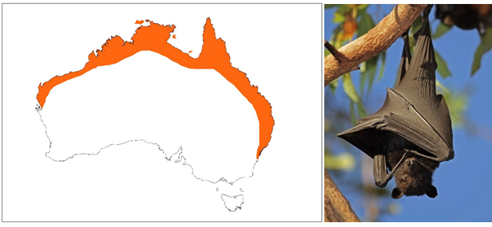

Figure Black flying-fox indicative species distribution (adapted from DPIE 2019a)

The black flying-fox (BFF) (Figure 1) has traditionally occurred throughout coastal areas from Shark Bay in Western Australia, across northern Australia, down through Queensland and into New South Wales (Churchill 2008; DPIE 2019a). Since it was first described there has been a substantial southerly shift by the BFF (Webb & Tidemann 1995).

They forage on the fruit and blossoms of native and introduced plants (Churchill 2008; DPIE 2019a), including orchard species at times.

BFF are largely nomadic animals with movement and local distribution influenced by climatic variability and the flowering and fruiting patterns of their preferred food plants. Feeding commonly occurs within 20 kilometres of the camp site (Markus & Hall 2004).

BFF usually roost beside a creek or river in a wide range of warm and moist habitats, including lowland rainforest gullies, coastal stringybark forests and mangroves. During the breeding season, camp sizes can change significantly in response to the availability of food and the arrival of animals from other areas.

* + 1. Grey-headed flying-fox (*Pteropus poliocephalus*)

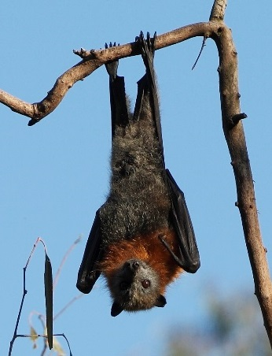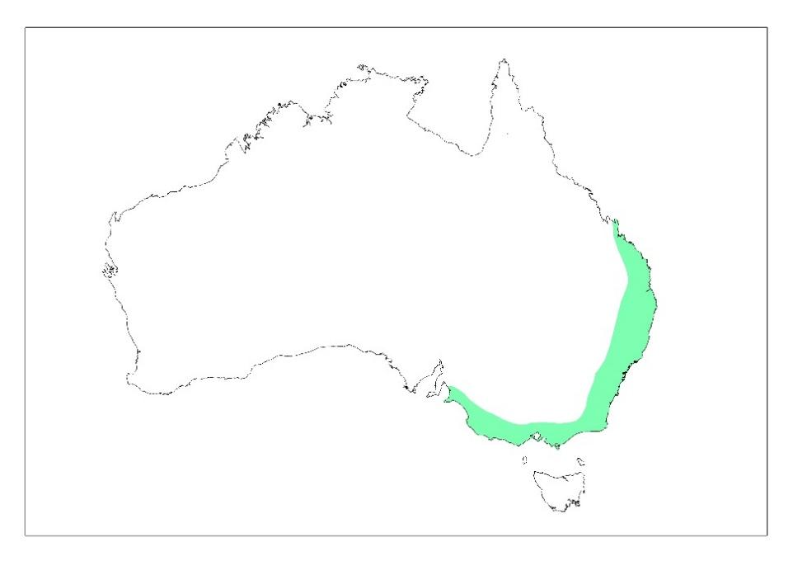

Figure Grey-headed flying-fox indicative species distribution (adapted from DPIE 2019a)

The grey-headed flying-fox (GHFF) (Figure 2) is found throughout eastern Australia, generally within 200 kilometres of the coast, from Finch Hatton in Queensland to Melbourne, Victoria (DPIE 2019c). This species now ranges into South Australia and individual flying-foxes have been reported on the Bass Islands and mainland Tasmania (Driessen et al. 2011). It requires foraging resources and camp sites within rainforests, open forests, closed and open woodlands (including melaleuca swamps and banksia woodlands). This species is also found throughout urban and agricultural areas where food trees exist and will feed in orchards at times, especially when other food is scarce (DPIE 2019a).

All the GHFF in Australia are regarded as one population that moves around freely within its entire national range (Webb and Tidemann 1996; DoE 2015). GHFF may travel up to 100 kilometres in a single night with a foraging radius of up to 50 kilometres from their camp (McConkey et al. 2012). They have been recorded travelling over 500 kilometres over 48 hours when moving from one camp to another (Roberts et al. 2012). GHFF generally show a high level of fidelity to camp sites, returning year after year to the same site, and have been recorded returning to the same branch of a particular tree (SEQ Catchments 2012). This may be one of the reasons flying-foxes continue to return to small urban bushland blocks that may be remnants of historically used larger tracts of vegetation.

The GHFF population has a generally annual southerly movement in spring and summer, with their return to the coastal forests of north-east NSW and south-east Queensland in winter (Ratcliffe 1932; Eby 1991; Parry-Jones & Augee 1992; Roberts et al. 2012). This results in large fluctuations in the number of GHFF in New South Wales, ranging from as few as 20% of the total population in winter up to around 75% of the total population in summer (Eby 2000). They are widespread throughout their range during summer, but in spring and winter are uncommon in the south. In autumn they occupy primarily coastal lowland camps and are uncommon inland and on the south coast of New South Wales (DECCW 2009).

There is evidence the GHFF population declined by up to 30% between 1989 and 2000 (Birt 2000; Richards 2000 cited in DPIE 2019a). There is a wide range of ongoing threats to the survival of the GHFF, including habitat loss and degradation, culling in orchards, conflict with humans, infrastructure-related mortality (e.g. entanglement in barbed wire fencing and fruit netting, and power line electrocution) and competition and hybridisation with the BFF (DECCW 2009). For these reasons it is listed as vulnerable to extinction under NSW and federal legislation (see Section 4).

* + 1. Little red flying-fox (*Pteropus scapulatus*)

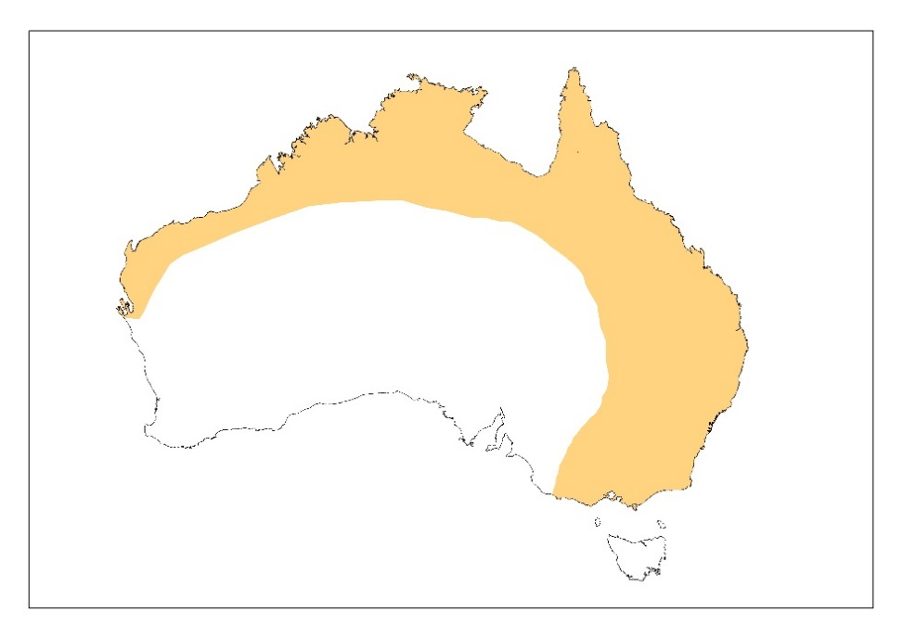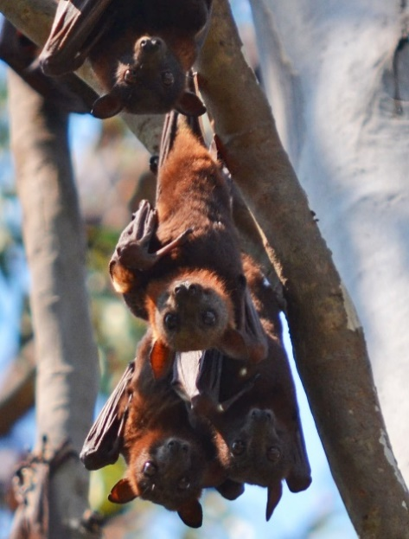

Figure Little red flying-fox indicative species distribution (adapted from DPIE 2019a)

The little red flying-fox (LRFF) (Figure 3) is widely distributed throughout northern and eastern Australia, with populations occurring across northern Australia and down the east coast into Victoria.

The LRFF forages almost exclusively on nectar and pollen, although it will eat fruit at times and occasionally feeds in orchards (Australian Museum 2010). LRFF often move very long distances in search of sporadic food supplies. The LRFF is the most nomadic species of flying-fox in New South Wales. They are strongly influenced by the availability of food resources, predominantly the flowering of eucalypt species (Churchill 2008). This means the duration of their stay in any one place is generally very short.

Habitat preferences of this species are quite diverse and range from semi-arid areas to tropical and temperate areas, and can include sclerophyll woodland, melaleuca swamplands, bamboo, mangroves and occasionally orchards (Eby & Roberts 2016). LRFF frequently roost with other flying-fox species. In some colonies, LRFF individuals can number many hundreds of thousands and they are unique among *Pteropus* species in their habit of clustering in dense bunches on a single branch. As a result, the weight of roosting individuals can break large branches and cause significant structural damage to roost trees, in addition to elevating soil nutrient levels through faecal material (SEQ Catchments 2012).

Throughout its range, populations within an area or occupying a camp can fluctuate widely. There is a general migration pattern in LRFF, whereby large congregations of over one million individuals can be found in northern camp sites (e.g. Northern Territory, North Queensland) during key breeding periods (Vardon & Tidemann 1999). LRFF travel south to visit the coastal areas of south-east Queensland and New South Wales during the summer months. Outside these periods LRFF undertake regular movements from north to south during winter–spring (July–October) (Milne & Pavey 2011).

* + 1. Reproduction

#### Black and grey-headed flying-foxes

Males initiate contact with females in January with peak conception occurring around March to April/May; this mating season represents the period of peak camp occupancy (Markus 2002). Young (usually a single pup) are born six months later from September to November (Churchill 2008). The birth season becomes progressively earlier, albeit by a few weeks, in more northerly populations (McGuckin & Blackshaw 1991); however, out of season breeding is common, with births occurring later in the year.

Young are highly dependent on their mother for food and thermoregulation. They are suckled and carried by the mother until approximately four weeks of age (Markus & Blackshaw 2002). At this time, they are left at the camp during the night in a crèche until they begin foraging with their mother in January and February (Churchill 2008) and are usually weaned by six months of age around March. Sexual maturity is reached at two years of age with a life expectancy up to 20 years in the wild (Pierson & Rainey 1992).

As such, the critical reproductive period for GHFF and BFF is generally from August (when females are in their final trimester) to the end of peak conception around April. Dependent pups are usually present from September to March (see Figure 4).

#### Little red flying-fox

The LRFF breeds approximately six months out of phase with the other flying-foxes. Peak conception occurs around October to November, with young born between March and June (McGuckin & Blackshaw 1991; Churchill 2008) (Figure 4). Young are carried by their mother for approximately one month then left at the camp while she forages (Churchill 2008). Suckling occurs for several months while young are learning how to forage. LRFF generally birth and rear young in temperate areas (rarely in New South Wales).

|  |  |  |  |  |  |  |  |  |  |  |  |  |
| --- | --- | --- | --- | --- | --- | --- | --- | --- | --- | --- | --- | --- |
|  | 1. **Jan** | 1. **Feb** | 1. **Mar** | 1. **Apr** | 1. **May** | 1. **Jun** | 1. **Jul** | 1. **Aug** | 1. **Sep** | 1. **Oct** | 1. **Nov** | 1. **Dec** |
| 1. GHFF |  |  |  |  |  |  |  |  |  |  |  |  |
| 1. BFF |  |  |  |  |  |  |  |  |  |  |  |  |
| 1. LRFF |  |  |  |  |  |  |  |  |  |  |  |  |

|  |  |
| --- | --- |
|  | Peak conception |
|  |  |
|  | Final trimester |
|  |  |
|  | Peak birthing |
|  |  |
|  | Crèching (young left at roost) |
|  |  |
|  | Lactation |

Figure Indicative flying-fox reproductive cycle

Note that LRFF rarely birth and rear young in New South Wales. The breeding season of all species is variable between years and location, and expert assessment is required to accurately determine phases in the breeding cycle and inform appropriate management timing.

1. Human and animal health

Flying-foxes, like all animals, carry pathogens that may pose human health risks. Many of these are viruses that cause only minor infections with no clinical signs in flying-foxes themselves, but may cause significant disease in other animals that are exposed. In Australia the most well-defined of these include Australian bat lyssavirus (ABLV), Hendra virus and Menangle virus. Specific information on these viruses is provided in Appendix 5.

Outside of an occupational cohort, including wildlife carers and vets, human exposure to these viruses is extremely rare and similarly, transmission rates and incidence of human infection are very low. In addition, Hendra virus infection in humans apparently requires transfer from an infected intermediate equine host and direct transmission from bats to humans has not been reported. Thus, despite the fact that human infection with these agents can be fatal, the probability of infection is extremely low, and the overall public health risk is judged to be low (Qld Health 2016).

* 1. Disease and flying-fox management

A recent study at several camps before, during and after disturbance (Edson et al. 2015) showed no statistical association between Hendra virus prevalence and flying-fox disturbance; however, the consequences of chronic or ongoing disturbance and harassment and its effect on Hendra virus infection were not within the scope of the study and are therefore unknown.

The effects of stress are linked to increased susceptibility and expression of disease in both humans (AIHW 2012) and animals (Henry & Stephens-Larson 1985; Aich et al. 2009), including reduced immunity to disease. Therefore, it can be assumed that management actions that may cause stress (e.g. dispersal), particularly over a prolonged period or at times where other stressors are increased (e.g. food shortages, habitat fragmentation, etc.), are likely to increase the susceptibility and prevalence of disease within the flying-fox population, and consequently the risk of transfer to humans.

Furthermore, management actions or natural environmental changes may increase disease risk by:

* forcing flying-foxes into closer proximity to one another, increasing the probability of disease transfer between individuals and within the population
* resulting in abortions and/or dropped young if inappropriate methods are used during critical periods of the breeding cycle. This will increase the likelihood of direct interaction between flying-foxes and the public, and potential for disease exposure
* adoption of inhumane methods with the potential to cause injury which would increase the likelihood of the community coming into contact with injured/dying flying-foxes.

The potential to increase disease risk should be carefully considered as part of a full risk assessment when determining the appropriate level of management and the associated mitigation measures required.

1. Camp management options

Below is an overview of commonly used management options to consider in the development of your Plan. These are categorised as Level 1, 2 or 3 in accordance with the Policy. The text can be tailored according to the needs of your Plan or moved into an appendix to the Plan.

* 1. Level 1 actions: routine camp management
     1. Education and awareness programs

This management option involves undertaking a comprehensive and targeted flying-fox education and awareness program to provide accurate information to the local community about flying-foxes.

Such a program would include managing risk and alleviating concern about health and safety issues associated with flying-foxes, options available to reduce impacts from roosting and foraging flying-foxes, an up-to-date program of works being undertaken at the camp, and information about flying-fox numbers and flying-fox behaviour at the camp.

Residents should also be made aware that faecal drop and noise at night is mainly associated with plants that provide food, independent of camp location. Staged removal of foraging species such as fruit trees and palms from residential yards, or management of fruit (e.g. bagging, pruning) will greatly assist in mitigating this issue. Approval from the local council may be required for the removal of some trees.

Collecting and providing information should always be the first response to community concerns in an attempt to alleviate issues without the need to actively manage flying-foxes or their habitat. Where it is determined that management is required, education should similarly be a key component of any approach. See also Section 3 and incorporate an education and awareness program into any community engagement plan.

An education program may include components shown in Figure 5.

1. 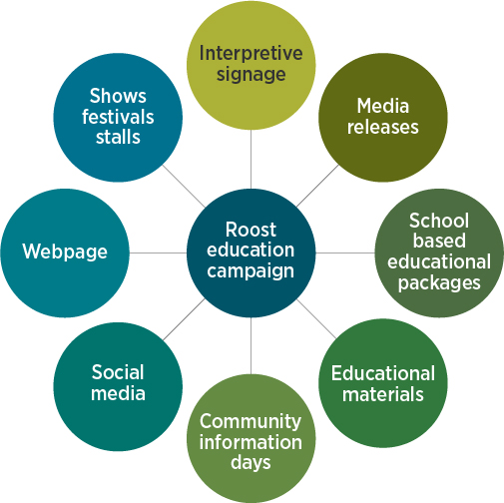

Figure Possible components of an education program

By adopting these strategies, the likelihood of improving community understanding of flying-fox issues is high; however, the extent to which that understanding will help alleviate conflict issues is probably less so. Extensive education for decision-makers, the media and the broader community may be required to overcome negative attitudes towards flying-foxes.

It should be stressed that a long-term solution to the issue resides with a better understanding of flying-fox ecology and applying that understanding to careful urban planning and development.

* + 1. Property modification without subsidies

The managers of land on which a flying-fox camp is located would promote or encourage the adoption of certain actions on properties adjacent or near to the camp to minimise impacts from roosting and foraging flying-foxes (note that approval may be required for some activities, refer to Section 4 for further information):

* Create visual/sound/smell barriers with fencing or hedges. To avoid attracting flying-foxes, species selected for hedging should not produce edible fruit or nectar-exuding flowers, should grow in dense formation between two and five metres (Roberts 2006) (or be maintained at less than five metres). Vegetation that produces fragrant flowers can assist in masking camp odour where this is of concern.
* Manage foraging trees (i.e. plants that produce fruit/nectar-exuding flowers) within properties through pruning/covering with bags or [wildlife friendly netting](http://www.wildlifefriendlyfencing.com/WFF/Netting.html), early removal of fruit, or tree replacement.
* Cover vehicles, structures and clothes lines where faecal contamination is an issue, or remove washing from the line before dawn/dusk.
* Move or cover eating areas (e.g. barbecues and tables) that are close to a camp or foraging tree to avoid droppings by flying-foxes.
* Install double-glazed windows, insulation and use air-conditioners when needed to reduce noise disturbance and smell associated with a nearby camp.
* Follow horse husbandry and property management guidelines provided at the [Hendra virus webpage](https://www.dpi.nsw.gov.au/animals-and-livestock/horses/health-and-disease/hendra-virus) (DPIE 2019d).
* Include suitable buffers and other provisions (e.g. covered car parks) in planning of new developments.
* Consider removable covers for swimming pools and ensure working filters and regular chlorine treatment.
* Appropriately manage rainwater tanks, including installing first-flush systems.
* Avoid disturbing flying-foxes during the day as this will increase camp noise.

**The cost would be borne by the person or organisation who modifies the property; however, o**pportunities for funding assistance (e.g. environment grants) may be available for management activities that reduce the need to actively manage a camp.

* + 1. Property modification subsidies

**Fully funding or providing subsidies to property owners for property modifications may be considered to manage the impacts of the flying-foxes. Providing subsidies to install infrastructure may improve the value of the property, which may also offset concerns regarding perceived or actual property value or rental return losses.**

**The level and type of subsidy would need to be agreed to by the entity responsible for managing the flying-fox camp.**

* + 1. Service subsidies

**This management option involves providing property owners with a subsidy to help manage impacts on their property and the lifestyle of residents. The types of services that could be subsidised include clothes washing, cleaning outside areas and property, car washing or power bills. Rate reductions could also be considered.**

Critical thresholds of flying-fox numbers at a camp and distance to a camp may be used to determine when subsidies would apply.

* + 1. Routine camp maintenance and operational activities

Examples of routine camp management actions are provided in the Policy. These include:

* removal of tree limbs or whole trees that pose a genuine health and safety risk, as determined by a qualified arborist
* weed removal, including removal of terrestrial and aquatic weeds under the Commonwealth *Biosecurity Act 2015*, or species listed as undesirable by a council
* trimming of understorey vegetation or the planting of vegetation
* minor habitat augmentation for the benefit of the roosting animals
* mowing of grass and similar grounds-keeping actions that will not create a major disturbance to roosting flying-foxes
* application of mulch or removal of leaf litter or other material on the ground.

Protocols should be developed **for carrying out operations that may disturb flying-foxes, which can result in excess camp noise. Such protocols could include limiting the use of disturbing activities to certain days or certain times of day in the areas adjacent to the camp and advising adjacent residents of activity days. Such activities could include lawn-mowing, using chainsaws, whipper-snippers, using generators and testing alarms or sirens.**

* + 1. Revegetation and land management to create alternative habitat

**This management option involves revegetating and managing land to create alternative flying-fox roosting habitat through improving and extending existing low conflict camps or developing new roosting habitat in areas away from human settlement.**

Selecting new sites and attempting to attract flying-foxes to them has had limited success in the past, and ideally, habitat at known camp sites would be dedicated as a flying-fox reserve. However, if a staged and long-term approach is used to make unsuitable current camps less attractive, while concurrently improving appropriate sites, it is a viable option (particularly for the transient and less selective LRFF). **Supporting further research into flying-fox camp preferences may improve the potential to create new flying-fox habitat.**

When improving a site for a designated flying-fox camp, preferred habitat characteristics detailed in Section 6.4 should be considered.

Foraging trees planted amongst and surrounding roost trees (excluding in/near horse paddocks) may help to attract flying-foxes to the desired site. They will also assist with reducing foraging impacts in residential areas. Consideration should be given to tree species that will provide year-round food, increasing the attractiveness of the designated site. Depending on the site, the potential negative impacts to a natural area will need to be considered if introducing non-indigenous plant species.

The presence of a water source is likely to increase the attractiveness of an alternative camp location. Supply of an artificial water source should be considered if unavailable naturally; however, this may be cost-prohibitive.

Potential habitat mapping using camp preferences (see Section 6.4) and suitable land tenure can assist in initial alternative site selection. A feasibility study would then be required prior to site designation to assess the likelihood of success and determine the warranted level of resource allocated to habitat improvement.

* + 1. Provision of artificial roosting habitat

**This management option involves constructing artificial structures to augment roosting habitat in current camp sites or to provide new roosting habitat. Trials using suspended ropes have been of limited success as flying-foxes only used the structures that were very close to the available natural roosting habitat. It is thought that the structure of the vegetation below and around the ropes is important.**

* + 1. Protocols to manage incidents

**This management option involves implementing protocols for managing incidents or situations specific to particular camps. Such protocols may include ‘bat watch’ patrols at sites that host vulnerable people, management of pets at sites popular for walking dogs, or** **preparation for heat stress incidents (when the camp is subjected to extremely high temperatures leading to flying-foxes changing their behaviour and/or dying).**

* + 1. Participation in research

This management option involves participating in research to improve knowledge of flying-fox ecology to address the large gaps in our knowledge about flying-fox habits and behaviours and why they choose certain sites for roosting. Further research and knowledge sharing at local, regional and national levels will enhance our understanding and management of flying-fox camps.

* + 1. Appropriate land use planning

Land use planning instruments may be able to be used to ensure adequate distances are maintained between future residential developments and existing or historical flying-fox camps. While this management option will not assist in the resolution of existing land use conflict, it may prevent issues for future residents.

* + 1. Property acquisition

Property acquisition may be considered if negative impacts cannot be sufficiently mitigated using other measures. This option will clearly be extremely expensive; however, is likely to be more effective than dispersal and in the long-term may be less costly.

* + 1. Do nothing

**The management option to ‘do nothing’ involves not undertaking any management actions in relation to the flying-fox camp and leaving the situation and site in its current state.**

* 1. Level 2 actions: in situ management
     1. Buffers

Buffers can be created through vegetation removal and/or the installation of permanent/semi-permanent deterrents.

**Creating buffers may involve planting low-growing or spiky plants between residents or other conflict areas and the flying-fox camp. Such plantings can create a visual buffer between the camp and residences or make areas of the camp inaccessible to humans.**

**Buffers greater than 300 metres are likely to be required to fully mitigate amenity impacts (SEQ Catchments 2012). The usefulness of a buffer to mitigate odour and noise impacts generally declines if the camp is within 50 metres of human habitation (SEQ Catchments 2012); however, any buffer will assist and should be as wide as the site allows.**

#### Buffers through vegetation removal

Vegetation removal aims to alter the area of the buffer habitat sufficiently so that it is no longer suitable as a camp. The amount required to be removed varies between sites and camps, ranging from some weed removal to removal of most of the canopy vegetation.

Any vegetation removal must be done using a staged approach, with the aim of removing as little native vegetation as possible. This is of particular importance at sites with other values (e.g. ecological or amenity), and in some instances, the removal of any native vegetation will not be appropriate. Thorough site assessment (further to desktop searches, see Appendix 4) will inform whether vegetation management is suitable (e.g. can impacts to other wildlife and/or the community be avoided?).

Removing vegetation can also increase visibility into the camp and noise issues for neighbouring residents, which may create further conflict.

Suitable experts (Appendix 1) should be consulted to assist selective vegetation trimming/removal to minimise vegetation loss and associated impacts.

The importance of under- and mid-storey vegetation in the buffer area also requires consideration. Under- and mid-storey vegetation should be retained in the buffer area of camps that are known or likely to be affected by heat stress events.

#### Buffers without vegetation removal

Permanent or semi-permanent deterrents can be used to make buffer areas unattractive to flying-foxes for roosting, without the need for vegetation removal. This is often an attractive option where vegetation has high ecological or amenity value.

While many deterrents have been trialled in the past with limited success, there are some options worthy of further investigation:

* Visual deterrents – Visual deterrents such as plastic bags, fluoro vests (GeoLINK 2012) and balloons (Ecosure 2016, pers. comm.) in roost trees have shown to have localised effects, with flying-foxes deterred from roosting within 1–10 metres of the deterrents. The type and placement of visual deterrents would need to be varied regularly to avoid habituation.
* Noise emitters on timers – Noise needs to be random, varied and unexpected to avoid flying-foxes habituating. As such these emitters would need to be portable, on varying timers and a diverse array of noises would be required. It is likely to require some level of additional disturbance to maintain its effectiveness, and ways to avoid disturbing flying-foxes from desirable areas would need to be identified. This is also likely to be disruptive to nearby residents.
* Smell deterrents – Bagged python excrement has been hung in trees at some sites; however, its effectiveness as a deterrent remains unproven. The smell of certain deterrents may also impact nearby residents, while flying-foxes may become used to it.
* Canopy-mounted water sprinklers – This method has been effective in deterring flying-foxes during dispersals (Ecosure personal experience), and current trials in Queensland and New South Wales are showing promise for keeping flying-foxes out of designated buffer zones. This option can be logistically difficult (installation and water sourcing) and may be cost-prohibitive. Design and use of sprinklers needs to be considerate of animal welfare and features of the site; for example, misting may increase humidity and exacerbate heat stress events, and overuse may impact other environmental values of the site and/or lead to flying-foxes becoming habituated.

Note that any deterrent with a high risk of causing inadvertent dispersal may be considered a Level 3 action.

The use of visual deterrents, in the absence of effective maintenance, could potentially lead to an increase in rubbish in the natural environment.

The type, location and timing of deterrents need to be clearly described in your Plan so the Department can assess whether there is a considerable risk of inadvertently dispersing some or all of the camp.

Measures to prevent inadvertent dispersal should also be detailed to allow this assessment. For example, active deterrents such as canopy-mounted sprinklers should not be turned on during fly-in or fly-out, but rather used in short intervals during the day to encourage flying-foxes away from the area.

* + 1. Noise attenuation fencing

Noise attenuation fencing could be installed in areas where the camp is particularly close to residents. This may also assist with odour reduction, and perspex fencing could be investigated to assist fence amenity. Although expensive to install, this option could negate the need for habitat modification, maintaining the ecological values of the site, and may be more cost-effective than ongoing management.

* 1. Level 3 actions: disturbance or dispersal
     1. Nudging

Noise and other low-intensity active disturbance restricted to certain areas of the camp can be used to encourage flying-foxes away from high conflict areas. This technique aims to actively ‘nudge’ flying-foxes from one area to another, while allowing them to remain at the camp site.

Unless the area of the camp is very large, nudging should not be done early in the morning as this may lead to inadvertent dispersal of flying-foxes from the entire camp site. Disturbance during the day should be limited in frequency and duration (e.g. up to four times per day for up to 10 minutes each) to avoid welfare impacts. As with dispersal, it is also critical to avoid periods when dependent young are present (as identified by a flying-fox expert).

* + 1. Dispersal

Dispersal aims to encourage a camp to move to another location, through either disturbance or habitat modification.

There is a range of potential risks, costs and legal implications that are greatly increased with dispersal (compared with in situ management as above). See Appendix 6 for more details. These include:

* impact on animal welfare and flying-fox conservation
* splintering the camp into other locations that are equally or more problematic
* shifting the issue to another area
* impact on habitat value
* effects on the flying-fox population, including potential increase in disease susceptibility and associated public health risk
* impacts to nearby residents associated with ongoing dispersal attempts
* excessive initial and/or ongoing effort and financial investment required
* negative public perception and backlash
* unsuccessful management requiring multiple attempts, which may exacerbate all of the above.

Despite these risks, there are some situations where camp dispersal may be considered. Dispersal can broadly be categorised as ‘passive’ or ‘active’ as detailed below.

#### Passive dispersal

Removing vegetation in a staged manner can be used to passively disperse a camp. This gradually makes the habitat unattractive to flying-foxes so they will disperse of their own accord over time with relatively little stress compared to active dispersal. This greatly reduces the risk of splinter colonies forming in other locations. Flying-foxes are more likely to move to other known sites within their camp network when not being forced to move immediately, as in active dispersal.

Generally, a significant proportion of vegetation needs to be removed in order to achieve dispersal of flying-foxes from a camp or to prevent camp re-establishment. For example, flying-foxes abandoned a camp in Bundall, Queensland once 70% of the canopy/mid-storey and 90% of the understorey had been removed (Ecosure 2011). Ongoing maintenance of the site is required to prevent vegetation structure returning to levels favourable for colonisation by flying-foxes. Importantly, at nationally important camps (defined in Section 4.2.1) sufficient vegetation must be retained to accommodate the maximum number of flying-foxes recorded at the site.

Vegetation removal may be preferable in situations where the vegetation is of relatively low ecological and amenity value, and alternative known permanent camps are located nearby with capacity to absorb the additional flying-foxes. While the likelihood of splinter colonies forming is lower than with active dispersal, if they do form following vegetation modification there will no longer be an option to encourage flying-foxes back to the original site. This must be carefully considered before modifying habitat.

**There is also potential to make a camp site unattractive by removing access to water sources; however, at the time of writing this method had not been trialled so the likelihood of this causing a camp to be abandoned is unknown. It would also likely only be effective where there are no alternative water sources in the vicinity of the camp.**

#### Active dispersal through disturbance

Dispersal is more effective in the short term when a wide range of tools are used on a randomised schedule, with animals less likely to habituate (Ecosure pers. obs. 1997–2015). Each dispersal team member should have at least one visual and one aural tool that can be used at different locations on different days (and preferably swapped regularly for alternate tools). The exact location of these and positioning of personnel will need to be determined on a daily basis in response to flying-fox movement and behaviour, as well as prevailing weather conditions (e.g. wind direction for smoke drums).

Active dispersal will be disruptive for nearby residents given the timing and nature of activities, and this needs to be considered during planning and community consultation.

This method does not explicitly use habitat modification as a means to disperse the camp; however, if dispersal is successful, some level of habitat modification should be considered. This will reduce the likelihood of flying-foxes attempting to re-establish the camp and the need for follow-up dispersal as a result. Ecological and aesthetic values will need to be considered for the site, with options for modifying habitat the same as those detailed for buffers above.

It should be noted that active dispersal generally requires ongoing dispersal attempts to prevent flying-foxes re-establishing the camp. The cost of ongoing dispersal attempts is likely to be prohibitive for most land managers.

#### Early dispersal before a camp is established at a new location

**This management option involves monitoring local vegetation for signs of flying-foxes roosting in the daylight hours and then undertaking active or passive dispersal options to discourage the animals from establishing a new camp. Even though there may only be a few animals initially using the site, this option is still treated as a dispersal activity; however, it may be easier to achieve dispersal at these new sites than it would in an established camp. It may also avoid the considerable issues and management effort required should the camp be allowed to establish in an inappropriate location.**

**It is important that flying-foxes feeding overnight in vegetation are not mistaken for animals establishing a camp.**

#### Maintenance dispersal

Maintenance dispersal refers to active disturbance following a successful dispersal to prevent the camp from re-establishing. It differs from initial dispersal by aiming to discourage occasional over-flying individuals from returning, rather than attempting to actively disperse animals that have been recently roosting at the site. As such, maintenance dispersal may have fewer timing restrictions than initial dispersal, provided that appropriate mitigation measures are in place (see Section 10).

* 1. Unlawful activities
     1. Culling

**Culling is addressed here as it is often raised by community members as a preferred management method;** however, culling is contrary to the objects of the BC Act and will not be permitted as a method to manage flying-fox camps.

* 1. Site-specific analysis of camp management options

Table 3 should be edited so that it is specific to your camp to demonstrate you have assessed all available management options.

When completing the table and deciding on appropriate management actions you should consider:

* Which suite of actions is most likely to be efficient, effective and legally defensible with respect to balancing community concerns and neighbourhood amenity with environmental outcomes? Justify the decision by referring to available advice, community consultation, available literature, scientific reports, other Camp Management Plans and the Policy.
* A regional and long-term approach, including potential impacts on nearby land managers such as neighbouring councils.
* Current risk associated with the camp with consideration of flying-fox use of the site, current and future land use, proximity to residents, schools, childcare centres, hospitals, aged care centres, businesses, equine facilities, airports and public use areas.
* Risk associated with management with consideration of potential impacts to the site, animal welfare, conservation of threatened species, likely resource requirements, effects on disease, potential to exacerbate impacts at the site or at other locations.
* Estimated costs and who would contribute funding. Local government, public authorities and land managers should be aware that there are substantial costs associated with dispersals.

Summary results from previous dispersal actions are provided in Appendix 6 if dispersal is being considered.

After analysing all camp management options and determining the most appropriate for your camp, provide further site-specific detail on your planned management approach in Sections 9 and 10.



Expert assessment will assist in the analysis of management options.

Table 3 Analysis of management options

Definitions and descriptions of each management option are provided in Section 8.

| Management option | Relevant impacts | Cost | Advantages | Disadvantages |
| --- | --- | --- | --- | --- |
| Level 1 actions | | | | |
| Education and awareness programs | Fear of disease  Noise  Smell  Faecal drop | $ | Low cost, promotes conservation of flying-foxes, contributes to attitude change which may reduce general need for camp intervention and reduce anxiety, increasing awareness and providing options for landholders to reduce impacts can be an effective long-term solution, can be undertaken quickly, will not impact on ecological or amenity value of the site. | Education and advice itself will not mitigate all issues and may be seen as not doing enough. |
| Property modification | Noise  Smell  Faecal drop  Health/wellbeing  Property devaluation  Lost rental return | $–$$ | Property modification is one of the most effective ways to reduce amenity impacts of a camp without dispersal (and associated risks), relatively low cost, promotes conservation of flying-foxes, can be undertaken quickly, will not impact on the site, may add value to the property. | May be cost-prohibitive for private landholders, unlikely to fully mitigate amenity issues in outdoor areas. |
| Fully-fund/subsidise property modification | Noise  Smell  Faecal drop  Health/wellbeing  Property devaluation  Lost rental return | $–$$ | Potential advantages as per property modification, but also overcomes the issue of cost for private landholders. | Costs to the land manager will vary depending on the criteria set for the subsidy including proximity to site, term of subsidy, level of subsidy. Potential for community conflict when developing the criteria, and may lead to expectations for similar subsidies for other issues. |
| Service subsidies including rate rebates | Noise  Smell  Faecal drop  Health/wellbeing  Property devaluation  Lost rental return | $–$$ | May encourage tolerance of living near a camp, promotes conservation of flying-foxes, can be undertaken quickly, will not impact on the site, would reduce the need for property modification. | May be costly across multiple properties and would incur ongoing costs, may set unrealistic community expectations for other community issues, effort required to determine who would receive subsidies. |
| Routine camp management | Health/wellbeing | $ | Will allow property maintenance, likely to improve habitat, could improve public perception of the site, will ensure safety risks of a public site can be managed. Weed removal has the potential to reduce roost availability and reduce numbers of roosting flying-foxes. To avoid this, weed removal should be staged and alternative roost habitat planted, otherwise activities may constitute a Level 3 action. | Will not generally mitigate amenity impacts for nearby landholders. |
| Alternative habitat creation | All | $$–$$$ | If successful in attracting flying-foxes away from high conflict areas, dedicated habitat in low conflict areas will mitigate all impacts, promotes flying-fox conservation. Rehabilitation of degraded habitat that is likely to be suitable for flying-fox use could be a more practical and faster approach than habitat creation. | Generally costly, long-term approach so cannot be undertaken quickly, previous attempts to attract flying-foxes to a new site have not been known to succeed. |
| Provision of artificial roosting habitat | All | $–$$ | If successful in attracting flying-foxes away from high conflict areas, artificial roosting habitat in low conflict areas will assist in mitigating all impacts, generally low cost, can be undertaken quickly, promotes flying-fox conservation. | Would need to be combined with other measures (e.g. buffers/alternative habitat creation) to mitigate impacts; previous attempts have had limited success. |
| Protocols to manage incidents | Health/wellbeing | $ | Low cost, will reduce actual risk of negative human/pet–flying-fox interactions, promotes conservation of flying-foxes, can be undertaken quickly, will not impact the site. | Will not generally mitigate amenity impacts. |
| Research | All | $ | Supporting research to improve understanding may contribute to more effectively mitigating all impacts, promotes flying-fox conservation. | Generally cannot be undertaken quickly, management trials may require further cost input. |
| Appropriate land use planning | All | $ | Likely to reduce future conflict, promotes flying-fox conservation. Identification of degraded sites that may be suitable for long-term rehabilitation for flying-foxes could facilitate offset strategies should clearing be required under Level 2 actions. | Will not generally mitigate current impacts, land use restrictions may impact the landholder. |
| Property acquisition | All for specific property owners  Nil for broader community | $$$ | Will reduce future conflict with the owners of the acquired property. | Owners may not want to move, only improves amenity for those who fit criteria for acquisition, very expensive. |
| Do nothing | Nil | Nil | No resource expenditure. | Will not mitigate impacts and unlikely to be considered acceptable by the community. |
| Level 2 actions | | | | |
| Buffers through vegetation removal | Noise  Smell  Health/wellbeing  Property devaluation  Lost rental return | $–$$ | Will reduce impacts, promotes flying-fox conservation, can be undertaken quickly, limited maintenance costs. | Will impact the site, will not generally eliminate impacts, vegetation removal may not be favoured by the community. |
| Buffers without vegetation removal | Noise  Smell  Health/wellbeing  Damage to vegetation  Property devaluation  Lost rental return | $$ | Successful creation of a buffer will reduce impacts, promotes flying-fox conservation, can be undertaken quickly, options without vegetation removal may be preferred by the community. | May impact the site, buffers will not generally eliminate impacts, maintenance costs may be significant, often logistically difficult, limited trials so likely effectiveness unknown. |
| Noise attenuation fencing | Noise  Smell  Health/wellbeing  Property devaluation  Lost rental return | $$ | Will eliminate/significantly reduce noise impacts, will reduce other impacts, limited maintenance costs. | Costly, likely to impact visual amenity of the site, will not eliminate all impacts, may impact other wildlife at the site. |
| Level 3 actions | | | | |
| Nudging | All | $$–$$$ | If nudging is successful, this may mitigate all impacts. | Costly, flying-foxes will continue attempting to recolonise the area unless combined with habitat modification/deterrents. |
| Passive dispersal through vegetation management | All at that site but not generally appropriate for amenity impacts only (see Section 8) | $$–$$$ | If successful can mitigate all impacts at that site, compared with active dispersal: less stress on flying-foxes, less ongoing cost, less restrictive in timing with ability for evening vegetation removal. | Costly, will impact site, risk of removing habitat before outcome known, potential to splinter the camp creating problems at other locations (although less than active dispersal), potential welfare impacts, disturbance to community, negative public perception, unknown conservation impacts, unpredictability makes budgeting and risk assessment difficult, may increase disease risk (see Section 7.1), potential to impact on aircraft safety. |
| Passive dispersal through water management | All at that site but not generally appropriate for amenity impacts only (see Section 8) | $$–$$$ | Potential advantages as per passive dispersal through vegetation removal; however,’ likelihood of success unknown. | Potential disadvantages as per passive dispersal through vegetation removal; however, likelihood of success unknown. |
| Active dispersal | All at that site but not generally appropriate for amenity impacts only (see Section 8) | $$$ | If successful can mitigate all impacts at that site, often stated as the preferred method for impacted community members. | May be very costly, often unsuccessful, ongoing dispersal generally required unless combined with habitat modification, potential to splinter the camp creating problems in other locations, potential for significant animal welfare impacts, disturbance to community, negative public perception, unknown conservation impacts, unpredictability makes budgeting and risk assessment difficult, may increase disease risk (see Section 7.1), potential to impact on aircraft safety. |
| Early dispersal before a camp is established at a new location | All at that site | $$–$$$ | Potential advantages as per other dispersal methods, but more likely to be successful than dispersal of a historic camp. | Potential disadvantages as per other dispersal methods, but possibly less costly and slightly lower risk than dispersing a historic camp. Potential to increase pressure on flying-foxes that may have relocated from another dispersed camp, which may exacerbate impacts on these individuals. |

1. Planned management approach

This section should clearly identify any camp management actions that are intended to be undertaken over the life of the Plan. Actions should be categorised as Level 1, 2 or 3 in accordance with the Policy, and the management approach must be consistent with the Policy.



Expert advice is recommended to confirm whether planned management   
 actions are the most appropriate for your camp.

Public land managers must apply for a licence under the BC Act (see   
 Section 4 and Appendix 7), or implement actions as prescribed by the   
 [Flying-fox Camp Management Code of Practice](https://www.legislation.nsw.gov.au/regulations/2018-721.pdf).



Private land managers must obtain a licence under the BC Act.

Examples of licences for camp management are available to view on the   
 public register on the [Public register of threatened species licences](http://www.environment.nsw.gov.au/threatenedspecies/S91TscaRegisterBydate.htm).



Supporting maps should be provided showing proposed management areas, camp area to be retained, etc. See Appendix 2 for an example management areas map.

This section should also include details on how the success of camp management actions will be evaluated, and triggers to progress through management levels within the context of the hierarchical management approach outlined in the Policy.An example of how this may be done is provided below in the template (Table 4). This sets out clear management aims and success measures to evaluate each level of management and determine the need for further management. A flowchart has been developed which summarises the suggested approach to management as discussed in the above sections, and this may be modified for use in your Plan (Figure 6).

Triggers for when management will be ceased should also be established and included in the Plan, and examples are provided in Section 9.1.If it is clear how you will evaluate each level of management, determine whether further management is required, and define when management will not progress, The Department may be able to approve an entire plan up-front. This will limit the need for further approvals and offer land managers a level of independence in decision-making based on an approved plan.

If the decision-making process and triggers are not clearly defined at this point, further consultation with Department staff will be required before progressing to Level 3 management and it is likely that the Plan and licence will require a variation.

Establish a management aim for each issue relevant to your camp, and develop one clear measure per aim to evaluate whether management has been successful or whether further actions are required. Clearly define which management activities may be actioned to mitigate each issue, and which will not be considered. For instance, in the example below management will never progress to Level 3 for noise, overhanging flying-foxes, faecal drop, smell, etc. as these impacts can be mitigated with Level 1 and 2 actions.

The example table aims to capture all key issues and provide the most appropriate list of potential actions for each so that it can form the basis of a similar table in your Plan. Delete those issues that are not relevant to you, actions that would not be considered, and amend the table so it clearly outlines your planned approach for which you are seeking Department approval.

Table 4 Example of management approach overview

| 1. **Issue** | 1. **Management aim** | 1. **Example success measures (recommend one measure only per aim)** | 1. **Management actions to be considered** | | |
| --- | --- | --- | --- | --- | --- |
| 1. **Level 1 actions** | 1. **Level 2 actions** | 1. **Level 3 actions** |
| Noise | Mitigate noise impacts | Reduce average noise to within legislated thresholds (seasonal sampling required)  Reduce complaints/ complainants by 70%  Reasonable level of amenity achieved based on independent assessment | * + - * Property modification (including providing subsidies if possible)       * Appropriate land use planning       * Dense planting to create screens at boundaries       * Revegetate and manage land to create alternative habitat       * Provision of artificial roosting habitat away from conflict areas | * + - * Buffers       * Noise attenuation fencing | * + - * Level 3 actions will not be considered to mitigate this issue |
| Flying-foxes overhanging pathways/ residential properties | Prevent flying-foxes overhanging pathways/ properties | No roosting flying-foxes overhanging used pathways/residential properties | * + - * Divert/temporarily close paths | * + - * Trim overhanging vegetation/install deterrents (deterrents may constitute a Level 3 action, provide details) | * + - * Level 3 actions will not be considered to mitigate this issue |
| Faecal drop | Mitigate impacts of faecal drop | Reduce faecal drop by 50% (random quadrat sampling may be used to quantify)  Reduce impacts of faecal drop by 80% (e.g. minimal financial impact of cleaning through subsidies) | * + - * Education and awareness (e.g. managing foraging attractants and tips to reduce impacts/fear of disease)       * Property modification (including providing subsidies if possible)       * Subsidise services to reduce impacts       * Appropriate land use planning       * Adequate hygiene protocols (e.g. cleaning at schools prior to students arriving)       * Support and promote research to understand site-specific movements/ trials to influence fly-out/in | * + - * Buffers | * + - * Level 3 actions will not be considered to mitigate this issue |
| Smell | Mitigate impacts of smell | Reduce odour by 70% (seasonal odour sampling required to quantify)  Reduce complaints/complainants by 70%  Reasonable level of amenity achieved based on independent assessment | * + - * Education and awareness programs (e.g. ensuring community understand not associated with uncleanliness)       * Property modification (including providing subsidies if possible)       * Appropriate land use planning       * Dense planting at boundaries (including use of fragrant flowers to mask odour)       * Revegetate to create alternative habitat       * Provision of artificial roosting habitat away from conflict areas       * Support research to determine odour masking techniques | * + - * Buffers | * + - * Level 3 actions will not be considered to mitigate this issue |
| Fear of disease | Promote awareness that actual disease risk is low | All concerned community members have received and have access to factual information on disease  Surrounding community is no longer concerned about disease (poll may be required) | * + - * Education and awareness programs (e.g. ensuring community understand actual low risk of disease transfer and simple mitigation measures)       * Protocols to prevent incidents | * + - * Trim roost vegetation overhanging properties where hygiene protocols may not be sufficient (e.g. childcare centres) | * + - * Level 3 actions will not be considered to mitigate this issue |
| Health/ wellbeing impacts | Mitigate health and wellbeing impacts | Health and wellbeing impacts are not being created by the camp as assessed by an independent professional  Reduce complaints/complainants by 70%  No negative human/flying-fox interactions | * + - * Education and awareness programs       * Property modification (including subsidies) to prevent wellbeing impacts associated with noise       * Protocols to prevent incidents       * Routine management actions to improve the site       * Revegetate land to create alternative habitat | * + - * Buffers       * Noise attenuation fencing | * + - * Nudging       * Dispersal may be considered if unable to be mitigated any other way |
| Damage to vegetation | Mitigate impacts to vegetation | Long-term viability of vegetation not at risk/can be rehabilitated (need to assess cost/benefit of impacts associated with damage to vegetation against environmental services provided by flying-foxes and risks of other impacts if camp is dispersed) | * + - * Routine management actions to improve the site       * Provision of artificial roosting habitat       * Revegetate land to create alternative habitat | * + - * Deterrents from select trees (e.g. netting, wires, sprinklers, etc.) (may constitute a Level 3 action, provide details) | * + - * Nudging       * Dispersal possibly appropriate if threatened/historic vegetation is being damaged so that it will not recover, and unable to be mitigated any other way |
| Property devaluation | Reduce economic loss associated with potential property devaluation | Property value not being impacted for owners that purchased property prior to camp formation, as assessed through independent valuation | * + - * Property modification (including subsidies)       * Subsidise services to reduce impacts       * Offset through funding or incentives (e.g. rate reduction)       * Appropriate land use planning       * Dense planting to create screens at residential boundaries       * Revegetate to create alternative habitat | * + - * Buffers       * Noise attenuation fencing | * + - * Nudging       * Dispersal if unable to be mitigated any other way |
| Lost rental return | Reduce economic loss associated with lost rental return | Rental return is not being impacted for owners that purchased property prior to camp formation, as assessed through an independent valuation | * + - * Property modification (including subsidies)       * Subsidise services to reduce impacts       * Offset through funding or incentives (e.g. rate reduction)       * Appropriate land use planning       * Dense planting to create screens at residential boundaries       * Revegetate to create alternative habitat | * + - * Buffers       * Noise attenuation fencing | * + - * Nudging       * Dispersal if unable to be mitigated any other way |

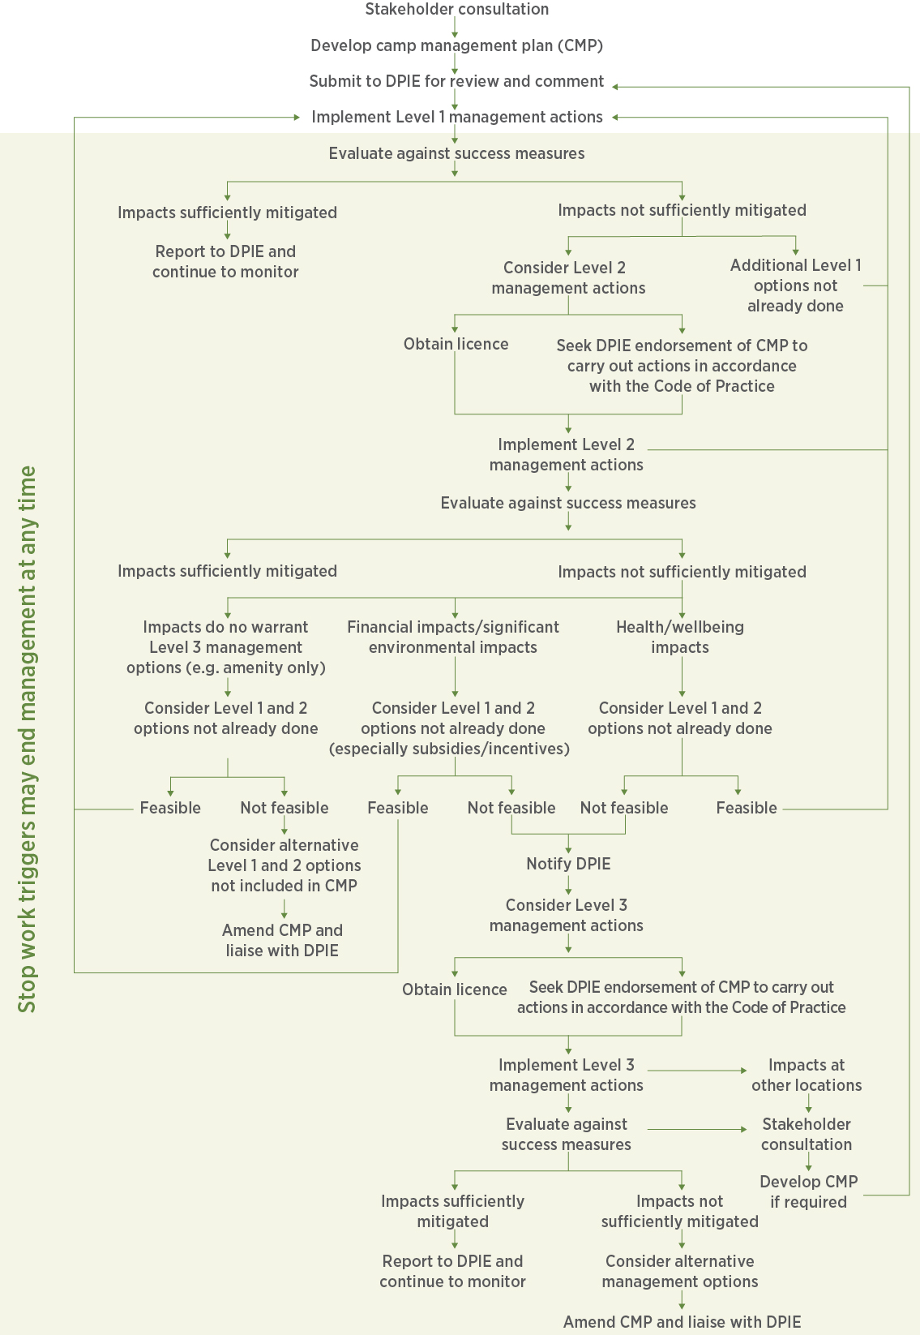

Figure Example flowchart to demonstrate the planned process for management decision-making

* 1. Stop work triggers

Triggers to stop management should be clearly defined. Examples are provided below; delete those that do not apply and add/adapt as required.

The management program will cease and will not recommence or progress to subsequent levels without consulting the Department if:

* any of the animal welfare triggers occur on more than two days during the program, such as unacceptable levels of stress (see Table 5)
* there is a flying-fox injury or death
* a new camp/camps appear to be establishing
* impacts are created or exacerbated at other locations
* there appears to be potential for conservation impacts (e.g. reduction in breeding success identified through independent monitoring)
* standard measures to avoid impacts (detailed in Section 10.3) cannot be met.

Management may also be terminated at any time if:

* unintended impacts are created for the community around the camp
* allocated resources are exhausted.

Dispersal will cease if:

* in the opinion of the land manager or the Department of Planning, Industry and Environment, there is an ongoing proliferation of splinter colonies in unsuitable locations (as determined by the land manager or the Department)
* splinter camps become established in inappropriate locations and for ecological, social or other reasons, a dispersal at the splinter location is not appropriate (as determined by the land manager or the Department).

If a dispersal program is stopped it may be permanently abandoned and other strategies considered, or reassessed and resumed in consultation with the Department.

Table 5 Planned action for potential impacts during management

A person with experience in flying-fox behaviour (as per Appendix 1) will monitor for welfare triggers and direct works in accordance with the criteria below.

| Welfare trigger | Signs | Action |
| --- | --- | --- |
| Unacceptable levels of stress | If any individual is observed:   * + - * panting       * saliva spreading       * located on or within two metres of the ground | * + - * Works to cease for the day |
| Fatigue | In situ management   * + - * more than 30% of the camp takes flight       * individuals are in flight for more than five minutes       * flying-foxes appear to be leaving the camp | * + - * In situ management       * Works to cease and recommence only when flying-foxes have settled* / move to alternative locations at least 50 metres from roosting animals |
| Dispersal   * + - * low flying       * laboured flight       * settling despite dispersal efforts | * + - * Dispersal       * Works to cease for the day |
| Injury/death | * + - * a flying-fox appears to have been injured/killed on-site (including aborted foetuses)       * any flying-fox death is reported within one kilometre of the dispersal site that appears to be related to the dispersal       * loss of condition evident | * + - * Works to cease immediately and the Department notified       * Rescheduled       * Adapted sufficiently so that significant impacts (e.g. death/injury) are highly unlikely to occur, as confirmed by an independent expert (see Appendix 1)       * Stopped indefinitely and alternative management options investigated. |
| Reproductive condition | * + - * females in final trimester       * dependent/crèching young present | * + - * Works to cease immediately and the Department notified       * Rescheduled       * Stopped indefinitely and alternative management options investigated. |

*maximum of two unsuccessful attempts to recommence work before ceasing for the day.

1. Assessment of impacts to flying-foxes

This section should address potential impacts of proposed camp management actions. Standard measures to avoid impacting flying-foxes at the camp during management are provided in Section 10.3. An assessment of impacts, along with proposed mitigation measures, will be required if these standard measures cannot be complied with at any camp.

In addition, an assessment of flying-fox impacts in a regional context (Section 10.1), and detail on the amount of flying-fox habitat that is going to be affected (Section 10.2), are required.

A suitably qualified and experienced person must undertake the assessment of impacts (see Appendix 1). The assessment of impacts must consider all direct, indirect and related impacts of proposed management actions.

* 1. Regional context

Potential impacts of planned management actions should be assessed in a regional context with respect to flying-fox distribution (known flying-fox camp sites within 25–50 kilometres depending on location and the number of camps in the surrounds) and potential habitat in the local area.

The [National Flying-fox Monitoring Program](http://www.environment.nsw.gov.au/animals/NFFMP.htm) mapping can assist with   
 identifying other camps in the region. Camp sites in the region should be   
 mapped and an example is provided in Appendix 2.



Potential habitat may be identified by modelling camp preferences provided in Section 6.3 and/or mapping habitat in the local area that is similar to habitat at the current camp. Identifying and assessing the likely suitability of potential habitat in the local area (minimum six-kilometre radius from the camp), with respect to both likelihood of flying-foxes using the habitat and likelihood of alternative sites impacting the community, is required prior to any Level 3 action. An example potential habitat map is in Appendix 2.

In order for the Department to assess potential cumulative impacts, a posed Level 3 action must include detail on any other Level 3 action that has occurred (e.g. in the past five years) or is planned to occur at known camps within a 50-kilometre radius.

The Department can assist if required. Similarly, prior to early intervention dispersal, an assessment should consider whether other nearby camps have recently been abandoned for another reason. If this is found to be the case, resources may be better directed at reinstating preferred conditions at the initial camp site.



* 1. Flying-fox habitat to be affected

Provide details of the type (including plant composition and structure), area and condition of habitat both in and adjacent to the camp that may be affected by the action. Mitigation measures and/or offsets should also be detailed. Refer back to the map of the site including vegetation communities present.

The [Biodiversity Assessment Method](https://www.environment.nsw.gov.au/biodiversity/assessmentmethod.htm) is recommended to assess the biodiversity values of the habitat to be affected. Site attributes collected in the field include:

* native woody and non-woody vegetation cover
* native over-storey cover
* number of large trees
* tree stem size class
* high threat exotic vegetation cover
* number of hollow-bearing trees
* tree regeneration
* litter cover
* total length of fallen logs.

An assessment of impacts on biodiversity values also needs to consider general site condition impacts. For example, vegetation removal may lead to erosion, water quality issues, weed infestation, more favourable conditions for vertebrate pests, etc.



Expert assessment is likely required.

* 1. Standard measures to avoid impacts

The following standard mitigation measures relevant to your planned activities should be retained in your Plan. The list below aims to be comprehensive and no further flying-fox specific conditions are likely to be required if these are retained. If amendments to these standard measures are required, you will need to be clear within the Plan how potential impacts will be mitigated. Additional consultation with the Department during Plan assessment is likely to be required where mitigation measures below are modified.

Measures to avoid impacts to other ecological values (e.g. to protect a threatened ecological community in or near the camp) should also be detailed.

The following mitigation measures will be complied with at all times during Plan implementation.

* + 1. All management activities

These flying-fox specific measures should be included in any Plan to avoid   
 impacts. Additional site-specific measures may also be required.   
 N.B. Timing has been set around GHFF and BFF breeding only, as LRFF   
 rarely birth and rear young in New South Wales; however, if LRFF are present during their normal birthing and rearing period (i.e. March – October) or are identified as being in their final trimester / with dependent young, you will need to consult with the Department to determine appropriate management timing.



Further background information on management activities is provided on the following webpages:

* [Routine camp management (Level 1) actions](http://www.environment.nsw.gov.au/animals/flying-fox-routine.htm)
* [Creation of buffers (Level 2) actions](http://www.environment.nsw.gov.au/animals/flying-fox-buffer.htm)
* [Camp disturbance or dispersal (Level 3) actions](http://www.environment.nsw.gov.au/animals/flying-fox-dispersal.htm).
* All personnel will be appropriately experienced, trained and inducted. Induction will include each person’s responsibilities under this Plan.
* All personnel will be briefed prior to the action commencing each day and debriefed at the end of the day.
* Works will cease and the Department consulted in accordance with the ‘stop work triggers’ section of the Plan.
* Large crews will be avoided where possible.
* The use of loud machinery and equipment that produces sudden impacts/noise will be limited. Where loud equipment (e.g. chainsaws) is required they will be started away from the camp and allowed to run for a short time to allow flying-foxes to adjust.
* Activities that may disturb flying-foxes at any time during the year will begin as far from the camp as possible, working towards the camp gradually to allow flying-foxes to habituate.
* Any activity likely to disturb flying-foxes so that they take flight will be avoided during the day during the sensitive GHFF/BFF birthing period (i.e. when females are in their final trimester or the majority are carrying pups, generally August – December) and avoided altogether during crèching (generally November/December to February).
* Where works cannot be done at night after fly-out during these periods, it is preferable they are undertaken in the late afternoon close to or at fly-out. If this is also not possible, a person experienced in flying-fox behaviour will monitor the camp for at least the first two scheduled actions (or as otherwise deemed to be required by that person) to ensure impacts are not excessive and advise on the most appropriate methods (e.g. required buffer distances, approach, etc.).
* The Department will be contacted immediately if LRFF are present between March and October or are identified as being in their final trimester/with dependent young.
* Non-critical maintenance activities will ideally be scheduled when the camp is naturally empty. Where this is not possible (e.g. at permanently occupied camps) they will be scheduled for the best period for that camp (e.g. when the camp is seasonally lower in numbers and breeding will not be interrupted, or during the non-breeding season, generally May to July).
* Works will not take place in periods of adverse weather including strong winds, sustained heavy rains, extreme heat, cold temperatures or during periods of likely population stress (e.g. food shortages). Wildlife carers will be consulted to determine whether the population appears to be under stress.
* Works will be postponed on days predicted to exceed 35°C (or ideally 30°C), and for one day following a day that reached ≥35°C. If an actual heat stress event has been recorded at the camp or at nearby camps, a rest period of several weeks will be scheduled to allow affected flying-foxes to fully recover. See the webpage about [Responding to heat stress in flying-fox camps](http://www.environment.nsw.gov.au/animals/flying-fox-heat.htm).
* Evening works may commence after fly-out. Noise generated by the works should create a first stage disturbance, with any remaining flying-foxes taking flight. Works should be paused at this stage to monitor for any remaining flying-foxes (including crèching young, although December – February should be avoided for this reason) and ensure they will not be impacted. All Level 1 and 2 works (including pack-up) will cease by 0100 to ensure flying-foxes returning early in the morning are not inadvertently dispersed. Works associated with Level 3 actions may continue provided flying-foxes are not at risk of being harmed.
* If impacts at other sites are considered, in the Department’s opinion, to be a result of management actions under this Plan, assistance will be provided by the proponent to the relevant land manager to ameliorate impacts. Details of this assistance are to be developed in consultation with the Department.
* Any proposed variations to works detailed in the Plan must be approved, in writing, by the Department before any new works occur.
* The Department may require changes to methods or cessation of management activities at any time.
* Ensure management actions and results are recorded to inform future planning. See the webpage about [Monitoring, evaluating and reporting on flying-fox camp management actions](http://www.environment.nsw.gov.au/animals/flying-fox-monitor.htm).

It is the responsibility of the land manager and contractors to conduct a risk assessment and determine workplace health and safety requirements; however, minimum requirements are provided below.

#### Human safety

* All personnel to wear protective clothing including long sleeves and pants; additional items such as eye protection and a hat are also recommended. People working under the camp should wash their clothes daily. Appropriate hygiene practices will be adopted such as washing hands with soap and water before eating/smoking.
* All personnel who may come into contact with flying-foxes will be vaccinated against ABLV with current titre.
* A wash station will be available on-site during works along with an anti-viral antiseptic (e.g. Betadine) should someone be bitten or scratched.
* Details of the nearest hospital or doctor who can provide post-exposure prophylaxis will be kept on-site.

#### Post-works

* Reports for Level 1 actions will be provided to the Department annually. Reports for Level 2 and 3 actions will be submitted to the Department one month after commencement of works and then quarterly for the life of the Plan (up to five years) (for all Level 3 actions and in periods where works have occurred for Level 2 actions). Each report is to include:
  + results of pre- and post-work population monitoring
  + any information on new camps that have formed in the area
  + impacts at other locations that may have resulted from management, and suggested amelioration measures
  + an assessment of how the flying-foxes reacted to the works, with particular detail on the most extreme response and average response, outlining any recommendations for what aspects of the works went well and what aspects did not work well
  + further management actions planned, including a schedule of works
  + an assessment[6] of how the community responded to the works, including details on the number and nature of complaints before and after the works
  + detail on any compensatory plantings undertaken or required
  + expenditure (financial and in-kind costs)
  + Plan evaluation and review (see Section 12).
    1. All Level 2 and 3 actions

These measures apply if your Plan includes any Level 2 or 3 actions.

#### Prior to works

* Residents adjacent to the camp will be individually notified one week prior to on-ground works commencing. This will include information on what to do if an injured or orphaned flying-fox is observed, a reminder not to participate in or interfere with the program, and details on how to report unusual flying-fox behaviour/daytime sightings. Relevant contact details will be provided (e.g. Program Coordinator). Resident requests for retention of vegetation and other concerns relating to the program will be taken into consideration.
* Where the Plan is being implemented by council, information will be placed on council’s website along with contact information.
* The Department will be notified at least 48 hours before works commence.
* A protocol for flying-fox rescue, in accordance with the [NSW Code of Practice for Injured, Sick and Orphaned Flying-foxes](https://www.environment.nsw.gov.au/resources/wildlifelicences/120026flyingfoxcode.pdf) (OEH 2012), will be developed including contact details of rescue and rehabilitation organisations. This protocol will be made available to all relevant staff, residents and volunteers prior to the action commencing. See Appendix 8 for an example protocol.
* A licensed wildlife carer trained in flying-fox rescue and appropriately vaccinated will be notified prior to beginning works in the event that rescue/care is required.

#### Monitoring

* A flying-fox expert (identified in Section 13.3) will undertake an on-site population assessment prior to, during works and after works have been completed, including:
  + number of each species
  + ratio of females in their final trimester
  + approximate age of any pups present including whether they are attached or likely to be crèched
  + visual health assessment
  + mortalities.
* Counts will be done at least:
  + once immediately prior to works
  + daily during works
  + immediately following completion
  + one month following completion
  + 12 months following completion.

#### During works

* A flying-fox expert (identified in Section 13.3) will attend the site as often as the Department considers necessary to monitor flying-fox behaviour and ensure compliance with the Plan and the Policy. They must also be able to identify pregnant females, flightless young, individuals in poor health and be aware of climatic extremes and food stress events. This person will assess the relevant conditions and advise the supervisor/proponent whether the activity can go ahead.
* Deterrents in buffer areas will be assessed by a flying-fox expert so those that may cause inadvertent dispersal (e.g. canopy-mounted sprinklers) are not used during fly-in.
* At least one flying-fox rest day with no active management will be scheduled fortnightly, preferably weekly. Static deterrents (e.g. canopy-mounted sprinklers) may still be used on rest days.
  + 1. Vegetation trimming/removal

These measures apply for actions involving any vegetation removal.

* Deadwood and hollows will be retained on-site where possible as habitat.
* Vegetation chipping is to be undertaken as far away from roosting flying-foxes as possible (at least 100 metres).
* Vegetation removal should not involve the clearing of all vegetation supporting a nationally important flying-fox camp. Sufficient vegetation must be retained to support the maximum number of flying-foxes ever recorded in the camp.
  + 1. Canopy vegetation trimming/removal

These measures apply if your Plan includes any roost tree trimming or removal.

#### Prior to works

* Trees to be removed or lopped will be clearly marked (e.g. with flagging tape) prior to works commencing, to avoid unintentionally impacting trees to be retained.

#### During works

* Any tree lopping, trimming or removal is undertaken under the supervision of a suitably qualified arborist (minimum qualification of Certificate III in Horticulture (Arboriculture) who is a member of an appropriate professional body such as [Arboriculture Australia](http://arboriculture.org.au)).
* Trimming will be in accordance with relevant Australian Standards (e.g. AS4373 Pruning of Amenity Trees), and best practice techniques used to remove vegetation in a way that avoids impacting other fauna and remaining habitat.
* No tree in which a flying-fox is roosting will be trimmed or removed. Works may continue in trees adjacent to roost trees only where a person experienced in flying-fox behaviour assesses that no flying-foxes are at risk of being harmed. A person experienced in flying-fox behaviour is to remain on-site to monitor when canopy trimming/removal is required within 50 metres of roosting flying-foxes.
* While most females are likely to be carrying young (generally September – January) vegetation removal within 50 metres of the camp will only be done in the evening after fly-out, unless otherwise advised by a flying-fox expert.
* Tree removal as part of management will be offset at a ratio of at least 2:1. Where threatened vegetation removal is required, the land manager will prepare an Offset Strategy to outline a program of restoration works in other locations (in addition to existing programs). The strategy will be submitted to the Department for approval at least two months prior to commencing works.
  + 1. Bush regeneration

These measures apply if your Plan includes any regeneration/revegetation activities.

* All works will be carried out by suitably qualified and experienced bush regenerators, with at least one supervisor knowledgeable about flying-fox habitat requirements (and how to retain them for Level 1 and 2 actions) and trained in working under a camp.
* Vegetation modification, including weed removal, will not alter the conditions of the site such that it becomes unsuitable flying-fox habitat.
* Weed removal should follow a mosaic pattern, maintaining refuges in the mid- and lower storeys at all times.
* Weed control in the core habitat area will be undertaken using hand tools only (or in the evening after fly-out while crèching young are not present).
* Species selected for revegetation will be consistent with the habitat on-site, and in buffer areas or conflict areas should be restricted to small shrubs/understorey species to reduce the need for further roost tree management in the future.
  + 1. Additional measures for Level 3 actions

These measures apply, in addition to those for Level 2 and 3 actions above, if your Plan includes any Level 3 actions.

#### Prior to dispersal

* Prepare a communications plan (see Section 3) in relation to the program and provide a copy to the Department.
* Councils that manage camps within 50 kilometres, and airports within 50 kilometres, will be informed of the intended start date and likely duration and encouraged to report any change in flying-fox movements.
* Council will liaise with the Environment Protection Authority (EPA) in regard to management of noise issues.

#### Monitoring

Additional monitoring requirements for dispersal actions (including maintenance dispersal and splinter camp dispersal):

* potential flying-fox habitat within three kilometres of the site monitored within two weeks of works commencing and at the completion of works
* daily checks of ‘potential flying-fox habitat’ within 600 metres, twice-weekly checks of 'potential flying-fox habitat' within three kilometres and weekly checks of known camps within 20 kilometres of the site
* where weekly counts are already being undertaken by flying-fox experts at other camps within 20 kilometres, counts at these camps are not required, provided there is an agreement with these experts to access these data.

A count is also required at any known camp site within a 25 kilometres radius, once within two weeks of works commencing, and again at the completion of works.

#### During dispersal

* At least one person experienced in dispersal, vaccinated against ABLV and able to rescue flying-foxes if required, is to be present at all times. For maintenance dispersals only, this person may be on-call rather than on-site; however, maintenance dispersal personnel will still have suitable experience in flying-fox behaviour and monitoring.
* Dispersal of an occupied camp will only occur when females are not in their final trimester and dependent young are not present (generally May and July). If flying-foxes in the region are recorded as being visibly pregnant dispersal will cease.
* Dispersal methods will not directly harm flying-foxes and may include only noise, spotlights, laser pointers, smoke from contained fires, canopy-mounted sprinklers, and visual deterrents such as balloons.
* Dispersal may continue for up to a total of 2.5 hours in a 12-hour period, early morning and/or in the evening. Morning dispersal will not continue past sunrise. Evening dispersal will not begin before sunset. If flying-foxes are showing signs of distress or are tiring, dispersal will cease for the day as per ‘stop work triggers’ in the Plan.
* The duration of dispersal each day will be minimised as much as possible.
* A section of the camp will be designated as a rest area for flying-foxes during dispersal, to be progressively reduced in size over time, unless the nominated flying-fox expert justifies a reason not to do so.
* During any dispersal action, liaison with wildlife carers is required to monitor whether there is an increase in the number of flying-foxes being taken into care or showing signs of stress. If increases are apparent, the Department will be consulted before continuing the action.
* Maintenance dispersal activities (i.e. deterring flying-foxes from recolonising a dispersed or otherwise empty camp) may be undertaken. During November to February, it is essential that camps are checked to ensure there are no crèched young in the camp or individuals in visibly poor health, as determined by a suitably qualified expert. While females are likely to be in their final trimester or carrying young (generally August to January), maintenance dispersal will be implemented at a reduced intensity using smoke, lights, continuous noise (no sudden noises) and passive deterrents (e.g. canopy-mounted sprinklers turned on prior to possible fly-in, visual deterrents, etc.).
* Residents will be notified of a maintenance action, within a timeframe as agreed to by the residents.
* Splinter camp dispersals are subject to the conditions above. Adequate consultation will be undertaken with neighbouring landowners and land managers.
* No actions are to be undertaken at any splinter camps without consulting the Department.
  + 1. Additional mitigation measures for any activity at a nationally important grey-headed flying fox camp

In addition to those detailed above, the following measures are required for any activity other than routine camp management (Level 1 actions) at a nationally important GHFF camp. In circumstances where mitigation standards are not applied, significant impacts are likely and the proposed action is more likely to require referral under the EPBC Act. See Section 4.2.1 for further detail.

* The action will not occur if the camp contains females that are in the late stages of pregnancy or have dependent young that cannot fly on their own (generally August to February).
* Disturbance activities will be limited to a maximum of 2.5 hours in any 12-hour period, preferably at or before sunrise or at sunset. Disturbance activities can be defined as any activity, other than routine activities, that disturbs the camp and therefore this may apply to both Level 2 and 3 activities.
* The action will not involve the clearing of all vegetation supporting a nationally important flying-fox camp. Sufficient vegetation will be retained to support the maximum number of flying-foxes ever recorded in the camp of interest.

1. Assessment of impacts to other threatened species or communities

For developments likely to affect other threatened species, populations or ecological communities (identified in Section 5), a [species impact statement](http://www.environment.nsw.gov.au/threatenedspecies/tsaguide.htm) (SIS) may be required as outlined in section 7.20 of the BC Act.

All statements:

* need to conform to the requirements of the legislation under which the project will be assessed
* must be prepared by either a project applicant or by a qualified consultant working on their behalf.

Applicants may choose to submit an SIS with their application to streamline   
 the process. Expert assessment is likely to be required for this section,   
 particularly if an SIS is required.



1. Evaluation and review

Detail your Plan evaluation and review schedule, including triggers and   
 timeframes. The suggested schedule below can be used if appropriate, or   
 amended if required.



The Plan will have a scheduled review annually, which will include evaluation of management actions against measures shown in Section 8.

The following will trigger additional reviews of the Plan:

* completion of a management activity
* progression to a higher level of management
* changes to relevant policy/legislation
* new management techniques becoming available
* outcomes of research that may influence the Plan
* incidents associated with the camp.

Results of each review will be included in reports to the Department (as per reporting timing outlined in Section 10.3.1).

If the Plan is to remain current, a full review including stakeholder consultation and expert input will be undertaken in the final year of the Plan’s life prior to being resubmitted to the Department.

1. Plan administration

Outline the administrative details of your Plan to establish a framework for implementation. The subheadings suggested below can be used to guide implementation of the Plan if appropriate or amended if required.

* 1. Monitoring of the camp

Monitoring of the camp must establish a standard precedent for regular monitoring of the area, size and composition of the camp over the life of the Plan, as well as the results of any management actions undertaken (consolidating information from Sections 10.3.2 and 10.3.6, and making reference to the [monitoring webpage](https://www.environment.nsw.gov.au/topics/animals-and-plants/wildlife-management/flying-fox-management/flying-fox-camp-management/monitoring-evaluating-and-reporting-on-flying-fox-camp-management-actions) associated with the Policy).

* 1. Reporting

Establish the reporting framework for the Plan, including any reporting obligations related to licences or certificates associated with proposed works.

* 1. Management structure and responsibilities

Identify in Table 6 who is responsible for what, including specific contractors and experts planned to be involved in management implementation. Where specific contractors are not provided in the Plan, you will need to detail them in relevant licence applications for the Department approval.

The recommended template is provided below with spaces for you to identify who will fill each role. Brief information demonstrating that each person has the required experience should also be provided in your Plan.

When assessing the Plan, the Department will assess whether each proposed team member has the required skills and experience for the role.

A project health and safety plan that includes all relevant contact details should be developed prior to implementing the Plan, for team reference.

Table 6: Roles and responsibilities

|  |  |  |  |  |
| --- | --- | --- | --- | --- |
| Role | Name | Required experience/approvals | Responsibilities/authority | Communication lines |
| Program Coordinator | [insert] | Project management  Human resource management  Community engagement  Reporting | Inform and consult with stakeholders and interested parties  Community engagement  Evaluate program  Submit reports to DPIE/DEE  Ensure all landowners have provided consent prior to works | Reports to: [insert]  Direct reports: Project Manager |
| Project Manager | [insert] | Project management  Team leadership and coordination  Data management | Coordinate field teams and ensure all personnel are appropriately experienced and trained for their roles  Induct all personnel to the program  Collect and collate data  Liaise with DPIE and DEE  Liaise with wildlife carers/veterinarians (for orphaned/injured wildlife only) | Reports to: Program Coordinator  Direct reports: Supervisor, Contractor |
| Supervisor | [insert] | Knowledgeable in flying-fox biology, behaviour and camp management (see Appendix 1 for detail)  ABLV-vaccinated and trained in flying-fox rescue  Team training, leadership and supervision | Pre- and post-management monitoring  Surrounding camp monitoring  Coordinate daily site briefings  Coordinate daily activities  Monitor flying-fox behaviour  Rescue flying-foxes if required (and no carer/vet on-site)  Determine daily works end point  Participate in management activities | Reports to: Project Manager  Direct reports: Team members, Observers/support |
| Team member | [insert] | Recommended ABLV-vaccinated (employer to assess risk)  Ideally, all team knowledgeable in flying-fox biology, behaviour and camp management; however, not required | Attend daily site briefings  Participate in relevant management activities | Reports to: Supervisor  Direct reports: Nil |
| Contractor  [insert type  e.g. arborist] | [insert] | Relevant licences and experience in field | Conduct specified activities (e.g. tree trimming)  Adhere to all directions given by Supervisor | Reports to: Project Manager  Direct reports: Nil |
| Observer/support | [insert] | Approval to access site | Provide care of injured/orphaned wildlife (under licence) if required | Reports to: Supervisor  Direct reports: Nil |
| Flying-fox expert | [insert] | See Appendix 1 | On-site population assessment, monitor flying-fox behaviour and ensure compliance with the Plan | Reports to: Supervisor  Direct reports: Nil |

* 1. Adaptive management

Identify mechanisms for amending the Plan based on lessons from implementation, feedback from the community and any other feedback mechanisms.

* 1. Funding commitment

Identify how much the actions in the Plan would cost and the sources of funds to implement Plan actions.

1. References and additional resources

Aich P, Potter AA and Griebel PJ 2009, Modern approaches to understanding stress and disease susceptibility: a review with special emphasis on respiratory disease, *International Journal of General Medicine*, vol.2, pp.19–32.

Atlas of Living Australia 2015, viewed 1 July 2019, [www.ala.org.au](https://www.ala.org.au/).

Australasian Bat Society 2013, viewed 1 July 2019, [ausbats.org.au](%20https://ausbats.org.au).

Australian Institute of Health and Welfare (AIHW) 2012, *Risk factors contributing to chronic disease*, cat no. PHE 157, viewed 1 July 2019, [www.aihw.gov.au/reports/chronic-disease/risk-factors-contributing-to-chronic-disease/contents/table-of-contents](https://www.aihw.gov.au/reports/chronic-disease/risk-factors-contributing-to-chronic-disease/contents/table-of-contents).

Australian Museum 2010, *Little Red Flying-fox*, viewed 1 July 2019, [australianmuseum.net.au/learn/animals/bats/little-red-flying-fox](https://australianmuseum.net.au/learn/animals/bats/little-red-flying-fox/).

Birt P 2000, Summary information on the status of the Grey-headed (*Pteropus poliocephalus*) and Black (*P. alecto*) Flying-Fox in New South Wales, pp.78–86 in *Proceedings of Workshop to Assess the Status of the Grey-headed Flying-fox in New South Wales*, University of Sydney, Sydney NSW.

Centers for Disease Control and Prevention (CDC) 2014, *Hendra Virus Disease (HeV): Transmission*, updated 17 March 2014, viewed 1 July 2019, [www.cdc.gov/vhf/hendra/transmission/index.html](https://www.cdc.gov/vhf/hendra/transmission/index.html).

Churchill S 2008, *Australian Bats*, Allen and Unwin, Crows Nest NSW.

Degeling C, Gilbert GL, Annand E, Taylor M, Walsh MG, Ward MP, Wilson A and Johnson J 2018,Managing the risk of Hendra virus spillover in Australia using ecological approaches: a report on three community juries*, PLOS One*, vol.13: e0209798.

Department of Agriculture and Fisheries (DAF) 2012, *Diseases that can spread from animals to humans*, updated 28 March 2019, viewed 1 July 2019, [www.daf.qld.gov.au/animal-industries/animal-health-and-diseases/zoonoses](https://www.daf.qld.gov.au/animal-industries/animal-health-and-diseases/zoonoses).

Department of Environment and Science (DES) 2018, *Importance of flying-foxes*, updated 11 July 2018, viewed 1 July 2019, [environment.des.qld.gov.au/wildlife/livingwith/flyingfoxes/importance.html](https://environment.des.qld.gov.au/wildlife/livingwith/flyingfoxes/importance.html).

Department of Environment and Science (DES) 2019, *Authorised flying-fox roost management*, viewed 1 July 2019, [environment.des.qld.gov.au/wildlife/livingwith/flyingfoxes/roost-management.html](https://environment.des.qld.gov.au/wildlife/livingwith/flyingfoxes/roost-management.html).

Department of Environment and Climate Change NSW (DECC) 2007, *Threatened species assessment guidelines: the assessment of significance*, Department of Environment and Climate Change NSW, Sydney, [www.environment.nsw.gov.au/resources/threatenedspecies/tsaguide07393.pdf](https://www.environment.nsw.gov.au/resources/threatenedspecies/tsaguide07393.pdf).

Department of Environment and Climate Change NSW (DECC) 2008, *Best practice guidelines for the grey-headed flying-fox*, Department of Environment and Climate Change NSW, Sydney, [www.environment.nsw.gov.au/resources/threatenedspecies/08540tsdsflyingfoxbpg.pdf](https://www.environment.nsw.gov.au/resources/threatenedspecies/08540tsdsflyingfoxbpg.pdf).

Department of Environment, Climate Change and Water NSW (DECCW) 2009, ‘Draft National Recovery Plan for the Grey-headed Flying-fox *Pteropus poliocephalus*’*,* prepared by Dr Peggy Eby for Department of Environment, Climate Change and Water NSW, Sydney, [www.environment.nsw.gov.au/resources/threatenedspecies/08214dnrpflyingfox.pdf](https://www.environment.nsw.gov.au/resources/threatenedspecies/08214dnrpflyingfox.pdf).

Department of the Environment and Energy (DEE) 2019a, *Flying-foxes*,viewed 1 July 2019, [www.environment.gov.au/biodiversity/threatened/species/flying-fox-law](https://www.environment.gov.au/biodiversity/threatened/species/flying-fox-law).

Department of the Environment and Energy (DEE) 2019b, *Species Profile and Threats Database:* Pteropus poliocephalus *– Grey-headed Flying-fox*, viewed 1 July 2019, [www.environment.gov.au/cgi-bin/sprat/public/publicspecies.pl?taxon_id=186](https://www.environment.gov.au/cgi-bin/sprat/public/publicspecies.pl?taxon_id=186).

Department of the Environment and Energy (DEE) 2019c, *Monitoring Flying-Fox Populations*, viewed 1 July 2019, [www.environment.gov.au/biodiversity/threatened/species/flying-fox-monitoring](https://www.environment.gov.au/biodiversity/threatened/species/flying-fox-monitoring).

Department of the Environment (DoE) 2013, *Matters of National Environmental Significance: Significant Impact Guidelines 1.1,* Environment Protection and Biodiversity Conservation Act 1999, [www.environment.gov.au/system/files/resources/42f84df4-720b-4dcf-b262-48679a3aba58/files/nes-guidelines_1.pdf](https://www.environment.gov.au/system/files/resources/42f84df4-720b-4dcf-b262-48679a3aba58/files/nes-guidelines_1.pdf).

Department of the Environment (DoE) 2015, *Referral guideline for management actions in grey-headed and spectacled flying-fox camps*, [www.environment.gov.au/system/files/resources/6d4f8ebc-f6a0-49e6-a6b6-82e9c8d55768/files/referral-guideline-flying-fox-camps.pdf](https://www.environment.gov.au/system/files/resources/6d4f8ebc-f6a0-49e6-a6b6-82e9c8d55768/files/referral-guideline-flying-fox-camps.pdf).

Department of Planning, Industry and Environment (DPIE) 2001, *Grey-headed flying-fox vulnerable species listing: NSW Scientific Committee final determination*, updated 28 May 2019, viewed 12 January 2019, [www.environment.nsw.gov.au/determinations/GreyheadedFlyingFoxVulSpListing.htm](https://www.environment.nsw.gov.au/determinations/GreyheadedFlyingFoxVulSpListing.htm).

Department of Planning, Industry and Environment (DPIE) 2019a, *Flying-foxes*, viewed 1 July 2019, [www.environment.nsw.gov.au/topics/animals-and-plants/native-animals/native-animal-facts/flying-foxes](https://www.environment.nsw.gov.au/topics/animals-and-plants/native-animals/native-animal-facts/flying-foxes).

Department of Planning, Industry and Environment (DPIE) 2019b*, Flying-fox Camp Management Plan Template 2019*, viewed 1 July 2019, [www.environment.nsw.gov.au/research-and-publications/publications-search/flying-fox-camp-management-plan-template-2016](https://www.environment.nsw.gov.au/research-and-publications/publications-search/flying-fox-camp-management-plan-template-2016).

Department of Planning, Industry and Environment (DPIE) 2019c, *Grey-headed flying-fox threatened species profile*, viewed 1 July 2019, [www.environment.nsw.gov.au/threatenedSpeciesApp/profile.aspx?id=10697](https://www.environment.nsw.gov.au/threatenedSpeciesApp/profile.aspx?id=10697)

Department of Planning, Industry and Environment (DPIE) 2019d, *Hendra virus*, viewed 12 January 2019, [www.dpi.nsw.gov.au/animals-and-livestock/horses/health-and-disease/hendra-virus](https://www.dpi.nsw.gov.au/animals-and-livestock/horses/health-and-disease/hendra-virus).

Department of Planning, Industry and Environment (DPIE) 2019c, *Australian bat lyssavirus and other bat health risks*, viewed 1 July 2019, [www.dpi.nsw.gov.au/biosecurity/animal/humans/bat-health-risks](https://www.dpi.nsw.gov.au/biosecurity/animal/humans/bat-health-risks).

Department of Primary Industries (DPI) 2017, *Australian bat lyssavirus – information for the public*, July 2017, Primefact 1291 3rd edition, Department of Primary Industries, NSW, [www.dpi.nsw.gov.au/__data/assets/pdf_file/0011/461873/Australian-Bat-Lyssavirus.pdf](https://www.dpi.nsw.gov.au/__data/assets/pdf_file/0011/461873/Australian-Bat-Lyssavirus.pdf).

Department of Primary Industries (DPI) 2018, *Hendra virus*, June 2018 Primefact 970 11th edition, Department of Primary Industries, NSW, [www.dpi.nsw.gov.au/__data/assets/pdf_file/0019/310492/Hendra-Virus-Primefact-970-1.pdf](https://www.dpi.nsw.gov.au/__data/assets/pdf_file/0019/310492/Hendra-Virus-Primefact-970-1.pdf).

Department of State Development, Infrastructure and Planning (DSDIP) 2014, *Queensland State Planning Policy July 2014*, Department of State Development, Infrastructure and Planning, Brisbane, Queensland.

Driessen M, Brereton R and Pauza M 2011, ‘Status and conservation of bats in Tasmania’, pp.324–336 in Law B, Eby P, Lunney D and Lumsden L (eds), *The Biology and Conservation of Australasian Bats*, Royal Zoological Society of New South Wales, Mosman, NSW.

Eby P 1991,Seasonal movements of grey-headed flying-foxes, *Pteropus poliocephalus* (Chiroptera: Pteropodidae) from two maternity roosts in northern New South Wales, *Wildlife* *Research*, vol.18, pp.547–59.

Eby P 1995, *The Biology and Management of Flying-foxes in NSW: Species Management Report Number 18*, Llewellyn L (ed.), National Parks and Wildlife Service, Hurstville, NSW.

Eby P 2000, ‘The results of four synchronous assessments of relative distribution and abundance of grey-headed flying-fox *Pteropus poliocephalus*’, pp.66–77 in *Proceedings from Workshop to Assess the Status of the Grey-headed Flying-fox in New South Wales*.

Eby P 2006, ‘Site management plan for the grey-headed flying-fox camp at the Sydney Desalination Plant Site’, prepared for Sydney Water Corporation, Sydney.

Eby P and Lunney D 2002, *Managing the Grey-headed Flying-fox as a Threatened Species in New South Wales*, Royal Zoological Society of New South Wales, Mosman, NSW.

Eby P and Roberts B 2016, *Little red flying-fox*, International Union for the Conservation of Nature, viewed 1 July 2019, [www.iucnredlist.org/species/18758/22087637](https://www.iucnredlist.org/species/18758/22087637).

Eco Logical Australia 2018, ‘Habitat characteristics of flying-fox camps: Hunter region of NSW’, unpublished report to Department of Planning, Industry and Environment, Sydney.

Ecosure 2011, ‘Hendra virus risk assessment for the Gold Coast Equine Precinct: residual risk report’, unpublished report to City of Gold Coast.

Ecosure 2014, ‘Cannes Reserve flying-fox management strategy’, prepared for Pittwater Council, Sydney.

Ecosure 2014, ‘Outcomes of a new flying-fox management framework: review of management actions 2013–2014’, unpublished data collected in collaboration with Griffith University (Industry Affiliates Program).

Edson D, Field H, McMichael L, Jordan D, Kung N, Mayer D and Smith C 2015, Flying-fox roost disturbance and Hendra virus spillover risk, *PLoS ONE*, vol.10: e0125881.

Environment Protection Authority (EPA) 2013, *Noise Guide for Local Government*, Environment Protection Authority, Sydney, [www.epa.nsw.gov.au/-/media/epa/corporate-site/resources/noise/20130127nglg.pdf](https://www.epa.nsw.gov.au/-/media/epa/corporate-site/resources/noise/20130127nglg.pdf)

Field H 2002, ‘The role of Grey-headed Flying-foxes in the ecology of Hendra virus, Menangle virus and Australian bat lyssavirus’, pp.139–141 in Eby P and Lunney D, *Managing the Grey-headed Flying-fox as a Threatened Species in New South Wales*, Royal Zoological Society of New South Wales, Mosman, NSW.

Fujita MS 1991, *Flying-fox (Chiroptera: Pteropodidae) pollination, seed dispersal, and economic importance: a tabular summary of current knowledge*, Resource Publication No. 2, Bat Conservation International.

GeoLINK 2010, *Maclean Flying-fox Management Strategy*, prepared for Clarence Valley Council on behalf of the Maclean Flying-Fox Working Group.

GeoLINK 2012, *Lorn Flying-fox Management Strategy,* prepared for Maitland City Council.

Goldspink LK, Edson DW, Vidgen ME, Bingham J, Field HE and Smith GS 2015, Natural Hendra virus infection in flying-foxes – tissue tropism and risk factors, *PLOS One*, vol.10: e0128835.

Halim S, Polkinghorne B, Bell G, van den Berg D and Sheppeard V 2015, Outbreak-related Hendra virus infection in a NSW pet dog, *Public Health Research and Practice*, vol.25: e2541547.

Hall L and Richards G 2000, *Flying foxes: Fruit and Blossom Bats of Australia*, UNSW Press, Sydney.

Henry JP and Stephens-Larson P 1985, ‘Specific effects of stress on disease processes’, pp.161–175 in Moberg GP (ed.), *Animal Stress*, American Physiological Society.

Kirkland PD 2017, Menangle virus: one of the first of the novel viruses from fruit bats, *Microbiology Australia*, vol.1, pp.22–24.

Ku-ring-gai Council 2013, *Ku-ring-gai Flying-fox Reserve Management Plan*, Ku-ring-gai Council, Gordon, NSW.

Lunney D, Richards G and Dickman C 2008, Grey-headed flying-fox, International Union for the Conservation of Nature, viewed 1 July 2019, [www.iucnredlist.org/species/18751/8554062](https://www.iucnredlist.org/species/18751/8554062).

Markus N 2002, Behaviour of the black flying-fox *Pteropus alecto*: 2. Territoriality and courtship, *Acta Chiropterologica*, vol.4, pp.153–166.

Markus N and Blackshaw JK 2002, Behaviour of the black flying-fox *Pteropus alecto*: 1. An ethogram of behaviour, and preliminary characterisation of mother-infant interactions, *Acta Chiropterologica*, vol.4, pp.137–152.

Markus N and Hall L 2004, Foraging behaviour of the black flying-fox (*Pteropus alecto*) in the urban landscape of Brisbane, Queensland, *Wildlife Research*, vol.31, pp.345–355.

McCall BJ, Field H, Smith GA, Storie GJ and Harrower BJ 2005, Defining the risk of human exposure to Australian bat lyssavirus through potential non-bat animal infection, *Communicable Diseases Intelligence*, vol.29, pp.200–203.

McConkey KR, Prasad S, Corlett RT, Campos-Arceiz A, Brodie JF, Rogers H and Santamaria L 2012, Seed dispersal in changing landscapes, *Biological Conservation*, vol.146, pp.1–13.

McGuckin MA and Blackshaw AW 1991, Seasonal changes in testicular size, plasma testosterone concentration and body weight in captive flying-foxes (*Pteropus poliocephalus* and *P. scapulatus*), *Journal of Reproduction and Fertility*, vol.92, pp.339–346.

McIlwee AP and Martin IL 2002, On the intrinsic capacity for increase of Australian flying-foxes, *Australian Zoologist*, vol.32, pp.76–100.

Milne DJ and Pavey CR 2011, ‘The status and conservation of bats in the Northern Territory’, pp.208–225 in Law B, Eby P, Lunney D and Lumsden L (eds), *The Biology and Conservation of Australasian Bats*, Royal Zoological Society of New South Wales, Mosman, NSW.

NSW Health 2012, *Flying-foxes and health*, viewed 1 July 2019, [www.health.nsw.gov.au/environment/factsheets/Pages/flying-foxes.aspx](http://www.health.nsw.gov.au/environment/factsheets/Pages/flying-foxes.aspx).

NSW Health 2015, *Rabies and Australian bat lyssavirus infection*, viewed 1 July 2019, [www.health.nsw.gov.au/Infectious/factsheets/Pages/Rabies-Australian-Bat-Lyssavirus-Infection.aspx](http://www.health.nsw.gov.au/Infectious/factsheets/Pages/Rabies-Australian-Bat-Lyssavirus-Infection.aspx).

Office of Environment and Heritage (OEH) 2011, *NSW Code of Practice for Injured, Sick and Orphaned Protected Fauna*, Office of Environment and Heritage, Sydney, [www.environment.nsw.gov.au/resources/wildlifelicences/110004FaunaRehab.pdf](https://www.environment.nsw.gov.au/resources/wildlifelicences/110004FaunaRehab.pdf).

Office of Environment and Heritage (OEH) 2012, NSW Code of Practice for Injured, Sick and Orphaned Flying-foxes, Office of Environment and Heritage, Sydney, [www.environment.nsw.gov.au/-/media/OEH/Corporate-Site/Documents/Animals-and-plants/Wildlife-management/Flying-foxes/flying-foxes-injured-sick-orphaned-code-of-practice-120026.pdf](https://www.environment.nsw.gov.au/-/media/OEH/Corporate-Site/Documents/Animals-and-plants/Wildlife-management/Flying-foxes/flying-foxes-injured-sick-orphaned-code-of-practice-120026.pdf).

Office of Environment and Heritage (OEH) 2014, Policy and procedural guidelines for the mitigation of commercial crop damage by flying-foxes, Office of Environment and Heritage, Sydney, [www.environment.nsw.gov.au/resources/wildlifelicences/140480FlyfoxPol.pdf](https://www.environment.nsw.gov.au/resources/wildlifelicences/140480FlyfoxPol.pdf)

Office of Environment and Heritage (OEH) 2018, *Flying-fox Camp Management Policy 2015*, Office of Environment and Heritage, Sydney, [www.environment.nsw.gov.au/resources/threatenedspecies/150070-flyingfoxcamp-policy.pdf](http://www.environment.nsw.gov.au/resources/threatenedspecies/150070-flyingfoxcamp-policy.pdf).

Parry-Jones KA and Augee ML 1992, Movements of the grey-headed flying-foxes (*Pteropus poliocephalus*) to and from a colony site on the central coast of New South Wales, *Wildlife Research*, vol.19, pp.331–340.

Parry-Jones K and Augee M 2001, Factors affecting the occupation of a colony site in Sydney, New South Wales by the grey-headed flying-fox *Pteropus poliocephalus* (Pteropodidae), *Austral Ecology*, vol.26, pp.47–55.

Pierson ED and Rainey WE 1992, ‘The biology of flying foxes of the genus *Pteropus*: a review’, pp.1–17 in Wilson DE and Graham GL (eds.), *Pacific Island Flying Foxes*: *Proceedings of an International Conservation Conference*, US Department of the Interior – Biological Report no. 90.

Queensland Health 2016, *Bats and human health*, viewed 1 July 2019, [conditions.health.qld.gov.au/HealthCondition/condition/14/33/14/bats-and-human-health](http://conditions.health.qld.gov.au/HealthCondition/condition/14/33/14/bats-and-human-health).

Ratcliffe F 1932, Notes on the fruit bats (*Pteropus* spp.) of Australia, *Journal of Animal Ecology*, vol.1, pp.32–57.

Roberts B 2005, ‘Habitat characteristics of flying-fox camps in south-east Queensland’, BSc. Honours Thesis, Griffith University, Brisbane QLD.

Roberts BJ 2006, *Management of urban flying-fox roosts: issues of relevance to roosts in the Lower Clarence, NSW*, prepared for Valley Watch Inc, Maclean.

Roberts B and Eby P 2013, *Review of past flying-fox dispersal actions between 1990–2013*.

Roberts BJ, Catterall CP, Eby P and Kanowski J 2012, Long-distance and frequent movements of the flying-fox *Pteropus poliocephalus*: implications for management, *PLoS ONE*, vol.7: e42532.

Roberts BJ, Eby P, Catterall CP, Kanowski J and Bennett G 2011, ‘The outcomes and costs of relocating flying-fox camps: insights from the case of Maclean, Australia’, pp.277–287 in Law B, Eby P, Lunney D and Lumsden L (eds.), *The Biology and Conservation of Australasian Bats*, Royal Zoological Society of New South Wales, Mosman, NSW.

Roberts B, Kanowski J and Catterall C 2006, Ecology and management of flying-fox camps in an urbanising region, *Rainforest CRC Tropical Forest Landscapes*, Issue 5, [rainforest-crc.jcu.edu.au/issues/ITFL_flyingfox.pdf](http://rainforest-crc.jcu.edu.au/issues/ITFL_flyingfox.pdf).

Roxburgh SH, Wood SW, Mackey BG, Woldendorp G and Gibbons P 2006, Assessing the carbon sequestration potential of managed forests: a case study from temperate Australia, *Journal of Applied Ecology*, vol.43, pp.1149–1159.

SEQ Catchments 2012, *Management and restoration of flying-fox roosts: guidelines and recommendations*, SEQ Catchments Ltd funded by the Australian Government’s Caring for Our Country.

Shinwari MW, Annand EJ, Driver L, Warrilow D, Harrower B, Allcock RJN, Pukallus D, Harper J, Bingham J, Kung N and Diallo IS 2014, Australian bat lyssavirus infection in two horses, *Veterinary Microbiology*, vol.173, pp.224–231.

Southerton SG, Birt P, Porter J and Ford HA 2004, Review of gene movement by bats and birds and its potential significance for eucalypt plantation forestry, *Australian Forestry*, vol.67, pp.45–54.

Stanvic S, McDonald V and Collins L 2013, Managing heat stress in flying-foxes colonies, [www.fourthcrossingwildlife.com/HeatStress-StanvicMcDonaldCollins.pdf](https://www.fourthcrossingwildlife.com/HeatStress-StanvicMcDonaldCollins.pdf).

Tait J, Perotto-Baldivieso HL, McKeown A and Westcott DA 2014, Are flying-foxes coming to town? Urbanisation of the spectacled flying-fox (*Pteropus conspicillatus*) in Australia, *PLoS ONE*, vol.9: e109810.

Tidemann C, Eby P, Parry-Jones K and Vardon M 1999, ‘Grey-headed flying-fox’, pp.31–35 in Duncan A, Baker GB and Montgomery N (eds), *The Action Plan for Australian Bats*, Environment Australia, Canberra ACT.

Tolga Bat Hospital Wildlife Friendly Fencing Project, Tolga Bat Hospital partly funded by grants from WWF and Australian Government Caring for Our Country, viewed 1 July 2019, [www.wildlifefriendlyfencing.com/WFF/Home.html](https://www.wildlifefriendlyfencing.com/WFF/Home.html).

Vardon MJ and Tidemann CR 1999, Flying-foxes (*Pteropus alecto* and *P. scapulatus*) in the Darwin region, north Australia: patterns in camp size and structure, *Australian Journal of Zoology*, vol.47, pp.411–423.

Vardon MJ, Brocklehurst PS, Woinarski JCZ, Cunningham RB, Donnelly CF and Tidemann CR 2001, Seasonal habitat use by flying-foxes, *Pteropus alecto* and *P. scapulatus* (Megachiroptera), in monsoonal Australia, *Journal of Zoology London*, vol.253, pp.523–535.

Webb N and Tidemann C 1995, Hybridisation between black (*Pteropus alecto*) and grey-headed (*P. poliocephalus*) flying-foxes (Megachiroptera: Pteropodidae), *Australian Mammalogy*, vol.18, pp.19–26.

Webb NJ and Tidemann CR 1996, Mobility of Australian flying-foxes, *Pteropus* spp. (Megachiroptera): evidence from genetic variation, *Proceedings of the Royal Society B*, vol.263, pp.497–502.

Welbergen JA, Klose SM, Markus N and Eby P 2008, Climate change and the effects of temperature extremes on Australian flying-foxes, *Proceedings of the Royal Society of London B: Biological Sciences*, vol.275, pp.419–425.

Westcott DA, Dennis AJ, Bradford MG, McKeown A and Harrington GN 2008, ‘Seed dispersal processes in Australia’s Wet Tropics rainforests’, pp.210–223 in Stork N and Turton S (eds.), *Living in a Dynamic Tropical Forest Landscape*, Blackwells Publishing, Malden, Massachusetts.

Westcott DA, McKeown A, Murphy HT and Fletcher CS 2011, A monitoring method for the grey-headed flying-fox, *Pteropus poliocephalus*, Commonwealth Science and Industrial Research Organisation, Atherton, QLD, [www.environment.gov.au/biodiversity/threatened/species/pubs/310112-monitoring-methodology.pdf](http://www.environment.gov.au/biodiversity/threatened/species/pubs/310112-monitoring-methodology.pdf).

Zurbuchen A, Landert L, Klaiber J, Muller A, Hein S and Dorn S 2010, Maximum foraging ranges in solitary bees: only few individuals have the capability to cover long-foraging distances, *Biological Conservation*, vol.142, pp.669–676.

Appendix 1: Expert assessment requirements

The Plan template identifies where expert input is required. The following are the minimum required skills and experience which must be demonstrated by each expert.

1. Flying-fox expert

### Essential

* Knowledge of flying-fox habitat requirements.
* Knowledge and experience in flying-fox camp management.
* Knowledge of flying-fox behaviour, including ability to identify signs of flying-fox stress.
* Ability to differentiate between breeding and non-breeding females.
* Ability to identify females in final trimester.
* Ability to estimate age of juveniles.
* Experienced in flying-fox population monitoring including static and fly-out counts, demographics and visual health assessments.

### Desirable

* It is strongly recommended that the expert is independent of the Plan owner to ensure transparency and objectivity. The Department may be able to help with finding flying-fox experts.
* ABLV-vaccinated (N.B. This is often an essential requirement during management implementation as detailed within the template).
* Trained in flying-fox rescue (N.B. This is often an essential requirement during management implementation as detailed within the template).
* Local knowledge and experience.

1. Ecologist

### Essential

* At least five years demonstrated experience in ecological surveys, including identifying fauna and flora to species level, fauna habitat and ecological communities.
* The ability to identify flora and fauna, including ground-truthing of vegetation mapping.
* Formal training in ecology or similar, specifically flora and fauna identification.

### Desirable

* Tertiary qualification in ecology or similar.
* Local knowledge and experience.
* Accredited Biodiversity Assessment Method assessor under the *Biodiversity Conservation Act 2016*.
* Practising member of the Ecological Consultants Association of NSW.

Depending on the site, for example, when vegetation management is proposed for an endangered ecological community or an area with a high likelihood of containing other threatened flora and fauna species, a specialist in that field (e.g. specialist botanist) may be required.

Appendix 2: Example maps

1. Example camp area map

(used with permission from Northern Beaches Council)

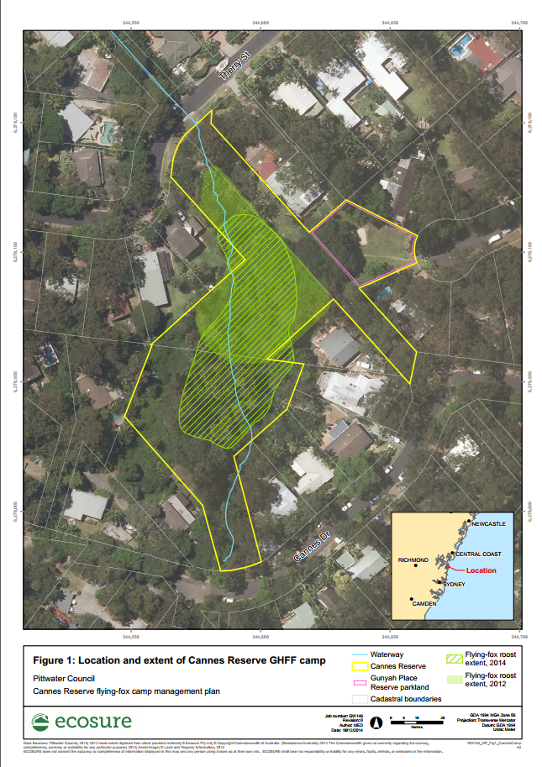

1. Example management areas map

(used with permission from Northern Beaches Council)

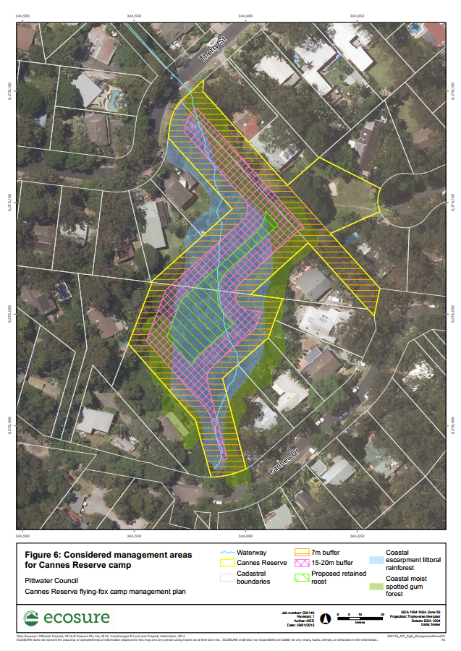

1. Example regional context map

(used with permission from Northern Beaches Council)

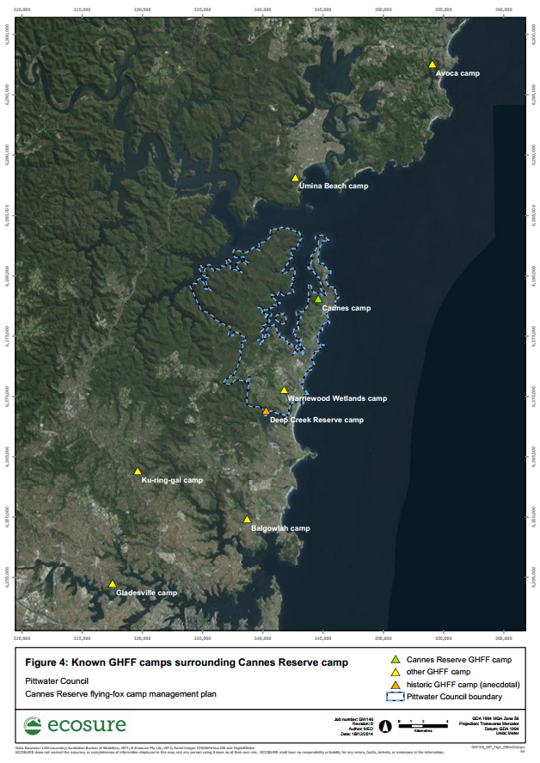

1. Example potential habitat map

(used with permission from Northern Beaches Council)

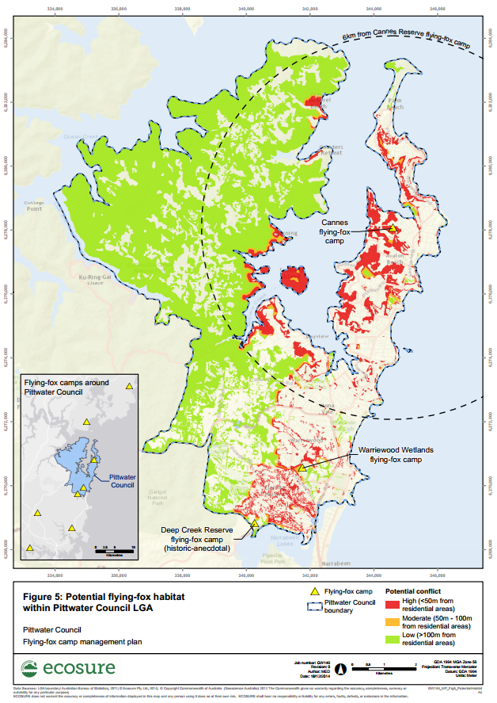

Appendix 3: Summary of other key legislation likely to apply at some camps

The Department recommends that councils and other land managers prepare a Camp Management Plan using this template, regardless of the legislation under which the proposed management activities are to be assessed. This will ensure that the land manager and surrounding communities are clear about the proposed management, and that appropriate consideration is given to the conservation and welfare of threatened species, the needs and interests of the surrounding community, and a range of other factors.

1. Local government legislation

Local government is required to prepare planning schemes (including environmental planning instruments and development control plans) consistent with provisions under the *Environmental Planning and Assessment Act 1979* (EP&A Act; see Section 4.1.4 of the template).

Local environment plans are environmental planning instruments that are legal documents and that relate to a local government area. Other environmental planning instruments, such as state environmental planning policies (SEPPs), may relate to the whole or part of the state. A development control plan provides detailed planning and design guidelines to support the planning controls in a Local Environment Plan, but they are not legal documents.

Planning schemes enable a local government authority to manage growth and change in their local government area (LGA) through land use and administrative definitions, zones, overlays, infrastructure planning provisions, assessment codes and other administrative provisions. A planning scheme identifies the kind of development requiring approval, as well as zoning all areas within the LGA based on the environmental values and development requirements of that land. Planning schemes could potentially include a flying-fox habitat overlay and may designate some habitat as flying-fox conservation areas.

1. State legislation

### *Rural Fires Act 1997*

The objects of this Act are to prevent, mitigate and suppress bushfires, coordinate bush firefighting, while protecting persons from injury or death and property from damage from fire. A permit is generally required from the Rural Fire Service for any fires in the open that are lit during the local Bush Fire Danger Period as determined each year. This may be relevant for fires used to disperse flying-foxes, or for any burning associated with vegetation management.

### *Protection of the Environment Operations Act 1997*

The main object of the *Protection of the Environment Operations Act 1997* (POEO Act) is to set out explicit protection of the environment polices (PEPs) and adopt more innovative approaches to reducing pollution.

The use of smoke as a dispersal mechanism may constitute ‘chemical production’ under Schedule 1, clause 8 of the POEO Act, so this type of dispersal activity may require a licence under Chapter 3 of the Act.

The POEO Act also regulates noise including ‘offensive noise’. The Protection of the Environment Operations (Noise Control) Regulation 2017 (Part 4) provides information on the types of noise that can be ‘offensive’ and for which the Environment Protection Authority (EPA) can issue fines. This may include noise generated as a part of dispersal activities. It is best to discuss the types of noise makers and the sound levels and times these will be generated, along with identified noise receptors, with council prior to any dispersal. Detailed advice and guidance on noise regulation can be found in the EPA’s [Noise Guide for Local Government](https://www.epa.nsw.gov.au/-/media/epa/corporate-site/resources/noise/20130127nglg.pdf) (EPA 2013).

### *Crown Land Management Act 2016*

The principles of Crown land management include the observance of environmental protection principles and the conservation of its natural resources, including water, soil, flora, fauna and scenic quality. Any works on land that is held or reserved under the *Crown Land Management Act 2016* (including vegetation management and dispersal activities) are an offence under the Act without prior authorisation obtained through Department of Planning, Industry and Environment (Lands).

### *Local Government Act 1993*

The primary purpose of this Act is to provide the legal framework for the system of local government. Most relevant to flying-fox management is that it also provides encouragement for the effective participation of local communities in the affairs of local government and sets out guidance on the use and management of community land which may be applicable to land which requires management of flying-foxes.

1. State Environmental Planning Policies

SEPPs are environmental planning instruments that address specific planning issues within New South Wales. These SEPPs often remove power from local councils in order to control specific types of development or development in specific areas. SEPPs often transfer decision-making from councils to the Planning Minister. While there may be others, some of the SEPPs likely to apply at some flying-fox camps are outlined below.

### SEPP (Coastal Management) 2018

The aim of this policy is to promote an integrated and coordinated approach to land use planning in the coastal zone in a manner consistent with the objects of the *Coastal Management Act 2016*.

Development consent must be obtained before any clearing of native vegetation, earthworks, construction of levees, draining or environmental protection works can occur on a mapped coastal wetland or littoral rainforest.

Camps are unlikely to fall within the bounds of a mapped coastal wetland, but additional restrictions for vegetation management in these areas may be required if they do. It is unlikely that clearing for flying-fox management in mapped littoral rainforest would be considered significant enough to trigger this policy, but this should be confirmed if the site is within a mapped littoral rainforest.

### SEPP 19 – Bushland in Urban Areas

The aim of this policy is to protect and preserve bushland within urban areas defined in Schedule 1 of the SEPP. Broadly, this covers most LGAs within the Greater Sydney Region. It does not cover:

* land reserved or dedicated under the *National Parks and Wildlife Act 1974*
* state forests, flora reserves or timber reserves under the *Forestry Act 1916*
* land to which SEPP (Western Sydney Parklands) 2009 applies.

Bushland within the designated LGAs may not be disturbed without the consent of the council unless the disturbance is for: bushfire hazard reduction, facilitating recreational use of the bushland in accordance with a plan of management referred to in clause 8 of the policy, or essential infrastructure such as electricity, sewerage, gas or main roads. If the land owned by the proponent is zoned as SEPP 19 bushland, council approval would be required under this SEPP.

Council should be contacted to discuss any potential disturbance associated with camp management.

Appendix 4: Desktop ecological assessment guideline

1. Buffer

Desktop assessments should include the camp and a suitable buffer area. The suggested buffer for ecological assessments is 10 kilometres; however, this may be reviewed on a case by case basis.

1. Sources of information for database searches

Depending on the location and extent of the project, the following databases may provide information on flora and fauna species and ecological communities for the site and surrounds.

### Sources of ecological information

| Source | Description | Links |
| --- | --- | --- |
| Atlas of Living Australia | Biodiversity knowledge contributed by Australia’s academic, scientific, environmental and general communities | [www.ala.org.au](https://www.ala.org.au/) provides a link to a mapping and analysis page where you can view records within an area of interest |
| Protected Matters Search Tool | Used to generate a list of matters of national environment significance within an area of interest | [www.environment.gov.au/epbc/protected-matters-search-tool](https://www.environment.gov.au/epbc/protected-matters-search-tool) |
| NSW BioNet | Contains government-held information about plants and animals in New South Wales. The following organisations provide data: Department of Planning, Industry and Environment; National Parks and Wildlife Service; Royal Botanic Gardens and Domain Trust; Department of Primary Industries; Forestry Corporation of NSW; Australian Museum. Users can register for a log-in version which provides additional detail and functionality. | [www.bionet.nsw.gov.au/](http://www.bionet.nsw.gov.au/) |
| Critical Habitat Register | Declarations of critical habitat and maps of these sites for species listed under the BC Act | [www.environment.nsw.gov.au/criticalhabitat/criticalhabitatprotectionbydoctype.htm](http://www.environment.nsw.gov.au/criticalhabitat/criticalhabitatprotectionbydoctype.htm) |
| BioNet Vegetation Classification | Information about the NSW vegetation communities | [www.environment.nsw.gov.au/research/Visclassification.htm](https://www.environment.nsw.gov.au/research/Visclassification.htm) |
| Sharing and Enabling Environmental Data (SEED) | Spatial datasets available for download, including SEPPs | [www.seed.nsw.gov.au](https://www.seed.nsw.gov.au/) |
| SIX maps | Provides maps showing cadastral and topographic information | [six.nsw.gov.au](https://six.nsw.gov.au/) |
| Threatened Species Profile Database | Provides a search tool for NSW threatened species including a description and indicative distribution | [www.environment.nsw.gov.au/topics/animals-and-plants/threatened-species](https://www.environment.nsw.gov.au/topics/animals-and-plants/threatened-species) |

Appendix 5: Additional human and animal health information

The level of detail below may not be relevant to your Plan; however, it may be useful to provide to the community to ensure they are aware of the actual (low) risk of disease transfer, and prevention measures. It should also be communicated to anyone working in and around the camp and used to inform risk management protocols. The most important message to the public is that there is no health risk from flying-foxes as long as people don’t touch them.

Flying-fox camps in public places, such as parks, school grounds and residential areas can sometimes raise concerns for community members about possible health risks. Human infections with viruses borne by flying-foxes are very rare. There is no risk of being infected with these viruses as long as people do not come into physical contact with flying-foxes.

1. Australian bat lyssavirus

Australian Bat Lyssavirus (ABLV) is a rabies-like virus that may be found in all flying-fox species on mainland Australia. It has also been found in an insectivorous microbat and it is assumed it may be carried by any bat species. The probability of human infection with ABLV is very low with less than 1% of the flying-fox population being affected (DPI 2017) and transmission requiring direct contact with an infected animal that is secreting the virus. In Australia, three people have died from ABLV infection since the virus was identified in 1996 (NSW Health 2015).

Domestic animals are also at risk if exposed to ABLV. In 2013, ABLV infections were identified in two horses (Shinwari et al. 2014). There have been no confirmed cases of ABLV in dogs in Australia; however, transmission is possible (McCall et al. 2005) and consultation with a veterinarian should be sought if exposure is suspected.

Transmission of the virus from bats to humans is through a bite or scratch but may have potential to be transferred if bat saliva directly contacts the eyes, nose, mouth or broken skin. ABLV is unlikely to survive in the environment for more than a few hours, especially in dry environments that are exposed to sunlight (NSW Health 2015).

Transmission of closely related viruses suggests that contact or exposure to bat faeces, urine or blood does not pose a risk of exposure to ABLV, nor does living, playing or walking near bat roosting areas (NSW Health 2015).

The incubation period in humans is assumed similar to rabies and variable between two weeks and several years. Similarly, the disease in humans presents essentially the same clinical picture as classic rabies.

Once clinical signs have developed the infection is invariably fatal; however, infection can easily be prevented by avoiding direct contact with bats (i.e. handling).

Pre-exposure vaccination provides reliable protection from the disease for people who are likely to have direct contact with bats, and it is generally a mandatory workplace health and safety requirement that all persons working with bats receive pre-exposure vaccination and have their level of protection regularly assessed. Like classic rabies, ABLV infection in humans also appears to be effectively treated using post-exposure vaccination and so any person who suspects they have been exposed should seek immediate medical treatment. Post-exposure vaccination is usually ineffective once clinical manifestations of the disease have commenced.

If a person is bitten or scratched by a bat they should:

* wash the wound with soap and water for at least five minutes (**do not scrub**)
* contact their doctor immediately to arrange for post-exposure vaccinations.

If bat saliva contacts the eyes, nose, mouth or an open wound, flush thoroughly with water and seek immediate medical advice.

1. Hendra virus

Flying-foxes are the natural host for Hendra virus, which can be transmitted from flying-foxes to horses. Infected horses sometimes amplify the virus and can then transmit it to other horses, humans and on two occasions, dogs (DPI 2018). There is no evidence that the virus can be passed directly from flying-foxes to humans or to dogs (Halim et al. 2015). Clinical studies have shown cats, pigs, ferrets and guinea pigs can carry the infection (DPI 2018).

Although the virus is periodically present in flying-fox populations across Australia, the likelihood of horses becoming infected is low and consequently, human infection is extremely rare. Horses are thought to contract the disease after ingesting forage or water contaminated with urine from an infected flying-fox (CDC 2014).

Humans may contract the disease after close contact with an infected horse. Hendra virus infection in humans presents as a serious and often fatal respiratory and/or neurological disease and there is currently no effective post-exposure treatment or vaccine available for people. The mortality rate in horses is greater than 70% (DPI 2018). Since 1994, more than 100 horses have died (Degeling et al. 2018) and four of the seven infections in humans were fatal (Goldspink et al. 2015).

Previous studies have shown that infections of horses have been associated with foraging flying-foxes rather than camp locations. Therefore, risks are considered similar at any location within the range of flying-fox species and all horse owners should be vigilant. Vaccination of horses can protect horses and subsequently humans from infection (DPI 2018), as can appropriate horse husbandry (e.g. covering food and water troughs, fencing flying-fox foraging trees in paddocks, etc.).

Although all human cases of Hendra virus to date have been contracted from infected horses and direct transmission from bats to humans has not yet been reported, particular care should be taken by select occupational groups that could be uniquely exposed. For example, persons who may be exposed to high levels of Hendra virus via aerosol of heavily contaminated substrate should consider additional personal protective equipment (PPE), e.g. respiratory filters, and potentially dampening down dry dusty substrate.

1. Menangle virus

Menangle virus (also known as bat paramyxovirus no. 2) was first isolated from stillborn piglets from a NSW piggery in 1997. Little is known about the epidemiology of this virus, except that it has been recorded in flying-foxes, pigs and humans (Field 2002; Kirkland 2017). The virus caused reproductive failure in pigs and severe febrile (flu-like) illness in two piggery workers employed at the same Menangle piggery where the virus (Field 2002). The virus is thought to have been transmitted to the pigs from flying-foxes via an oral–faecal matter route (Kirkland 2017). Flying-foxes had been recorded flying over the pig yards prior to the occurrence of disease symptoms. The two infected piggery workers made a full recovery, and this has been the only case of Menangle virus recorded in Australia.

1. General health considerations

Flying-foxes, like all animals, carry bacteria and other microorganisms in their guts, some of which are potentially pathogenic to other species. Direct contact with faecal material should be avoided and general hygiene measures taken to reduce the low risk of gastrointestinal and other diseases.

Contamination of water supplies by any animal excreta (birds, amphibians and mammals such as flying-foxes) poses a health risk to humans. Household tanks should be designed to minimise potential contamination, such as using first-flush diverters to divert contaminants before they enter water tanks. Trimming vegetation overhanging the catchment area (e.g. the roof of a house) will also reduce wildlife activity and associated potential contamination. Tanks should also be appropriately maintained and flushed, and catchment areas regularly cleaned to remove potential contaminants.

Public water supplies are regularly monitored for harmful microorganisms and are filtered and disinfected before being distributed. Management plans for community supplies should consider whether any large congregation of animals, including flying-foxes, occurs near the supply or catchment area. Where they do occur, increased frequency of monitoring should be considered to ensure early detection and management of contaminants.

Appendix 6: Dispersal results summary

Roberts and Eby (2013) summarised 17 known flying-fox dispersals between 1990 and 2013, and made the following conclusions:

* In all cases, dispersed animals did not abandon the local area[7].
* In 16 of the 17 cases, dispersals did not reduce the number of flying-foxes in the local area.
* Dispersed animals did not move far (in approx. 63% of cases the animals only moved <600 metres from the original site, contingent on the distribution of available vegetation). In 85% of cases, new camps were established nearby.
* In all cases, it was not possible to predict where replacement camps would form.
* Conflict was often not resolved. In 71% of cases, conflict was still being reported either at the original site or within the local area years after the initial dispersal actions.
* Repeat dispersal actions were generally required (all cases except where extensive vegetation removal occurred).
* The financial costs of all dispersal attempts were high, ranging from tens of thousands of dollars for vegetation removal to hundreds of thousands for active dispersals (e.g. using noise, smoke, etc.).

Ecosure, in collaboration with a Griffith University Industry Affiliates Program student, researched outcomes of management in Queensland between November 2013 and November 2014 (the first year since the current Queensland state flying-fox management framework was adopted on 29 November 2013).

An overview of findings[8] is summarised below.

* There were attempts to disperse 25 separate roosts in Queensland (compared with nine roosts between 1990 and June 2013 analysed in Roberts and Eby (2013)). Compared with the historical average (less than 0.4 roosts/year) the number of roosts dispersed in the year since the framework was introduced has increased by 6250%.
* Dispersal methods included fog[9], birdfrite, lights, noise, physical deterrents, smoke, extensive vegetation modification, water (including cannons), paintball guns and helicopters.
* The most common dispersal methods were extensive vegetation modification alone and extensive vegetation modification combined with other methods.
* In nine of the 24 roosts dispersed, dispersal actions did not reduce the number of flying-foxes in the LGA.
* In all cases, it was not possible to predict where new roosts would form.
* When flying-foxes were dispersed, they did not move further than six kilometres away.
* As at November 2014 repeat actions had already been required in 18 cases.
* Conflict for the council and community was resolved in 60% of cases, but with many councils stating they feel this resolution is only temporary.
* The financial costs of all dispersal attempts were considerable, regardless of methods used, ranging from $7500 to more than $400,000 (with costs ongoing).

Appendix 7: Biodiversity conservation licence application form

At the time the Plan is submitted to the Department for approval, it should include a completed biodiversity conservation licence application form. The form can include information already contained in the Plan. Alternatively, the land manager should inform the Department that the proposed works are to be assessed under Part 5 of the EP&A Act and will not require a licence application under the BC Act.

The licence application is available at: [Biodiversity Conservation Licence](https://www.environment.nsw.gov.au/licences-and-permits/wildlife-licences/licences-to-control-or-harm/licences-to-harm-threatened-species).

Appendix 8: Example flying-fox rescue protocol

Development of a flying-fox rescue protocol may be included as a condition of a biodiversity conservation licence. The following may be used as a template, and this may be proactively submitted with your Plan.

Note that a protocol does not negate the requirement to have a licensed bat carer present at times specified above. When developing such a protocol you should seek input from the carer you plan to work with to ensure the protocol aligns with their preferred rescue approach.

1. Reference documents:

Office of Environment and Heritage (OEH) 2012, [NSW Code of Practice for Injured, Sick and Orphaned Flying-foxes](https://www.environment.nsw.gov.au/research-and-publications/publications-search/code-of-practice-for-injured-sick-and-orphaned-flying-foxes), Office of Environment and Heritage, Sydney.

Office of Environment and Heritage (OEH) 2011, [NSW Code of Practice for Injured, Sick and Orphaned Protected Fauna](https://www.environment.nsw.gov.au/research-and-publications/publications-search/code-of-practice-for-injured-sick-and-orphaned-protected-fauna), Office of Environment and Heritage, Sydney.

1. Purpose

These work instructions are intended for licensed and ABLV-vaccinated wildlife rescue personnel on-site during dispersal activities to monitor, capture or provide first aid treatment for sick or injured flying-foxes that may require human intervention for their survival. Flying-fox rescue must only be attempted by personnel trained and experienced in flying-fox rescue and handling.

This work instruction provides rescuers with information regarding capture and first aid until a flying-fox is in the specialist care of a veterinarian or licensed bat carer.

1. Requirements

Wildlife rescue personnel involved in flying-fox rescue must:

* be trained and experienced in flying-fox rescue and handling
* be vaccinated against ABLV (titre levels checked at least once every two years)
* be aware of the hazards and risks of coming into contact with bats
* utilise appropriate PPE and equipment for capture, transport and treatment of flying-foxes
* undertake a risk assessment before carrying out a rescue – do not endanger yourself or others during a rescue
* have the contact details for a local veterinarian or bat carer who will accept the sick or injured flying-fox.

1. Human first aid

All bats in Australia should be viewed as potentially infected with ABLV. If bitten or scratched by a bat, immediately wash the wound with soap and water (do not scrub) and continue for at least five minutes, followed by application of an antiseptic with anti-viral action (e.g. Betadine), and immediate medical attention (post-exposure vaccinations may be required). Similarly, medical attention should be immediately sought if exposed to an animal’s saliva or excreta through the eyes, nose or mouth.

1. Equipment

* lidded plastic carry basket or ‘pet-pack’ with bedding (juveniles) / transport container with hanging perch, tall enough for bat to hang without hitting its head (in accordance with Section 5.1 of the NSW Code of Practice for Injured, Sick and Orphaned Flying-foxes (OEH 2012))
* warm water bottle/cold brick
* wraps /towels
* teats for small bottle
* extension pole or broom
* bat first aid kit – juice drink/glucose powder, syringes, cloths for wounds, Betadine/saline, dummy for flying-fox pups. Flying-foxes are only to be offered liquids under advice from a licensed bat carer.

1. Work instructions

### Case assessment

Observe, assess and then determine if/what intervention is required using the decision tree below, adapted from the [NSW Code of Practice for Injured, Sick and Orphaned Protected Fauna](https://www.environment.nsw.gov.au/research-and-publications/publications-search/code-of-practice-for-injured-sick-and-orphaned-protected-fauna) (OEH 2011).

1. 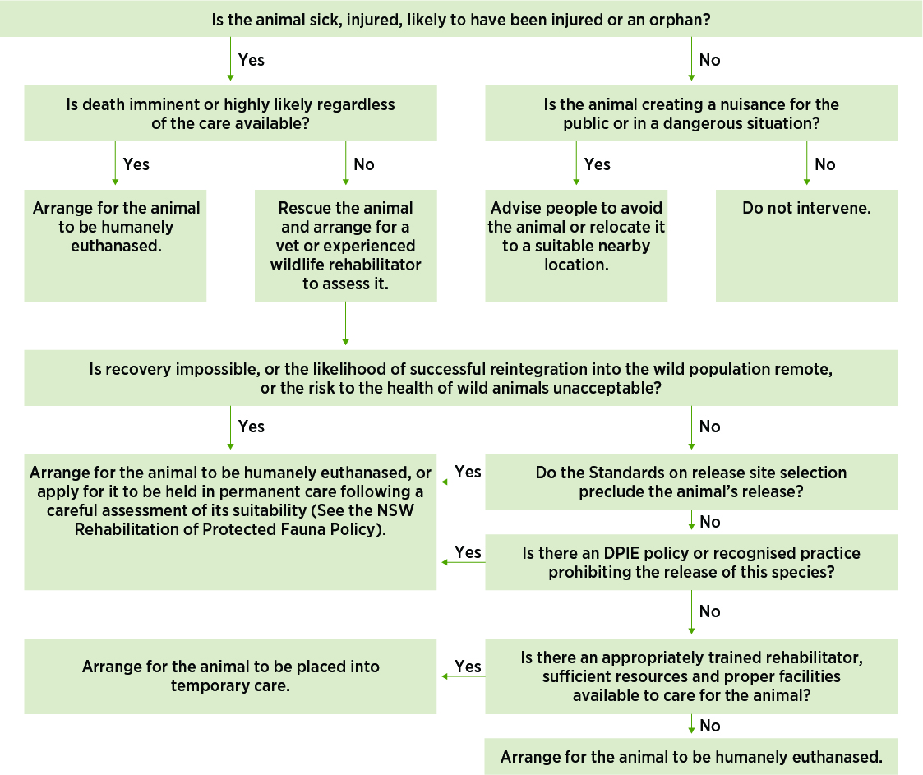

Figure Assessment process

Personnel should approach stressed flying-foxes cautiously. If flying-foxes panic or fly this will waste energy; retreat and continue to monitor behaviour.

Stressed flying-foxes can be identified by the following clinical signs:

* Dehydration: Eyes dull or depressed in skull, change to skin elasticity, skin stays pinched, animal cold, wing membranes dry, mouth dry.
* Heat stress: wing fanning, shade seeking, clustering/clumping, salivating, panting, roosting at the base of trees, on the ground, falling from tree.
* Obvious injury: bleeding, broken bones.

### Rescue instructions

As per Section 4 of the NSW Code of Practice for Injured, Sick and Orphaned Flying-foxes (OEH 2012):

* + - 1. The objective is to rescue a flying-fox while minimising further stress and injury to the animal.
      2. Before a rescue attempt, rescuers must assess the risks to the flying-fox from environmental hazards and from capture.
      3. Rescuers must employ the correct rescue equipment for the condition and location of the flying-fox and be trained in its use.

#### Example scenarios

* 1. Bat low in tree:
  + quickly place towel around bat before it can move away
  + grab hold of feet, toes may curl over rescuer’s fingers
  + place in carry basket/transport container.
  1. Bat high in tree:
  + place pole wrapped in towel in front of bat
  + coax bat onto towel
  + once on towel, quickly move away from branches and lower to ground
  + once on ground, cover with towel and place into carry basket/transport container.
  1. A bat caught on barbed wire fence:
  + two people only – one to restrain with towel, while the other untangles
  + put towels on the wire strands under or around to avoid further entanglement
  + if the membrane has dried onto wire, syringe or spray water onto wing
  + use pliers or wire cutter if necessary.

### Animal first aid

**Physical assessment:** Keep animal wrapped and head covered, only expose one part at a time. Examine head. Unwrap one wing and extend. Wrap and extend other wing. Check legs. Examine front and back of body.

**Dehydration:** Offer water/juice (low acid juice only, e.g. apple/mango) orally with syringe (under supervision/advice from licensed wildlife carer **only**).

**Heat stress:** Reduce temperature in heat exhausted bats by spraying wings with tepid water.

**Hypothermia:** May be seen in pups separated from mother – keep head covered and warm core body temperature slowly by placing near (not on) warm water bottle covered by towel.

**Bleeding:** Clean wounds with room temperature saline or diluted Betadine.

### Transport to veterinarian/wildlife carer

See Section 5 of the NSW Code of Practice for Injured, Sick and Orphaned Flying-foxes (OEH 2012) summarised below.

#### Objective

To transport a flying-fox so as to minimise further stress and injury to the animal.

#### Standards

* + 1. The transport container must be tall enough for the flying-fox to hang by its feet without hitting its head on the floor.
    2. The container must be designed, set up and secured to prevent injuries to the flying-fox. The sides of the container must prevent the flying-fox from poking its head or wings out.
    3. The container must be designed to prevent the flying-fox from escaping.
    4. The flying-fox must be allowed to hang by its feet from the top of the container or if it is unable to hang, wrapped in material (e.g. sheet or flannel) and placed in a sling so its feet are higher than its head.
    5. The container must be kept at a temperature which is appropriate for the age and condition of the flying-fox. A range of 25–27°C is appropriate for an adult. A temperature of 28°C is appropriate for an orphan. A cool or warm water bottle may be required.
    6. The container must be ventilated so air can circulate around the flying-fox.
    7. The container must minimise light, noise and vibrations and prevent contact with young children and pets.
    8. During transport, a container holding a flying-fox must have a clearly visible warning label that says ‘Warning – live bat’.
    9. A flying-fox must not be transported in the back of an uncovered utility vehicle or a car boot that is separate from the main cabin.

#### Guidelines

* Flying-fox transport should be the sole purpose of the trip and undertaken in the shortest possible time.
* The wildlife rehabilitation group’s contact details should be written on the transport container in case of an emergency.

1. It is recommended that the entire community and neighbouring councils are made aware of camp management activities that may increase flying-fox stress and/or movements (e.g. dispersal), which could change the risk of Hendra virus exposure. Past Hendra virus events have been more strongly linked to foraging flying-foxes than to camp location, so theoretically risk is equal for any horse within the foraging range of flying-foxes. However, it is assumed that foraging resources within close proximity to a camp will have a greater number of visiting flying-foxes than those far from a camp, which may increase the likelihood of a Hendra virus event. There are a range of site-specific factors that will change the true risk (including foraging attractants in and around equine properties, camp location, size and use, etc.) that need to be considered when determining the need for additional specific consultation with surrounding equine property owners.
2. spectacled flying-fox (*P. conspicillatus*)
3. A ‘heat stress event’ is defined for the purposes of the Australian Government’s [Referral guideline for management actions in GHFF and SFF camps](http://www.environment.gov.au/system/files/resources/6d4f8ebc-f6a0-49e6-a6b6-82e9c8d55768/files/referral-guideline-flying-fox-camps.pdf) as a day on which the maximum temperature does (or is predicted to) meet or exceed 38°C.
4. A ‘cyclone event’ is defined as a cyclone that is identified by the Australian Bureau of Meteorology ([www.bom.gov.au/cyclone/index.shtml](http://www.bom.gov.au/cyclone/index.shtml)).
5. Food stress events may be apparent if large numbers of low body weight animals are being reported by wildlife carers in the region.
6. A similar approach should be taken to pre-management engagement (see Section 3) to allow direct comparison, and responses should be assessed against success measures (Section 9) to evaluate success.
7. Local area is defined as the area within a 20-kilometre radius of the original site = typical feeding area of a flying-fox.
8. This was based on responses to questionnaires sent to councils; some did not respond and some omitted responses to some questions.
9. Fog refers to artificial smoke or vapours generated by smoke/fog machines. Many chemical substances used to generate smoke/fog in these machines are considered toxic.